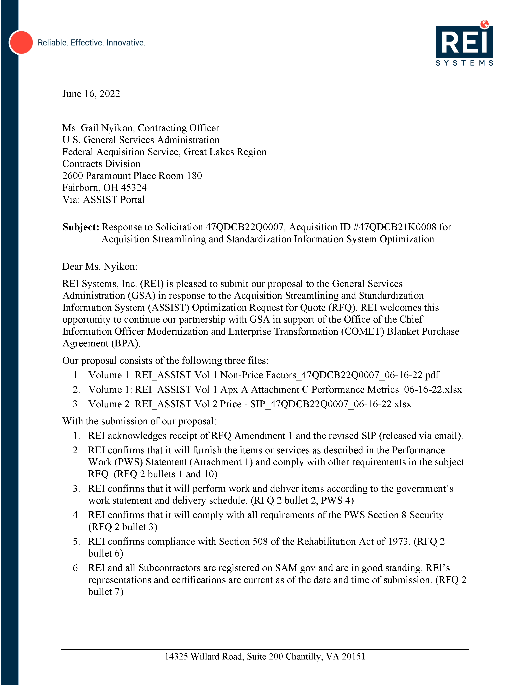

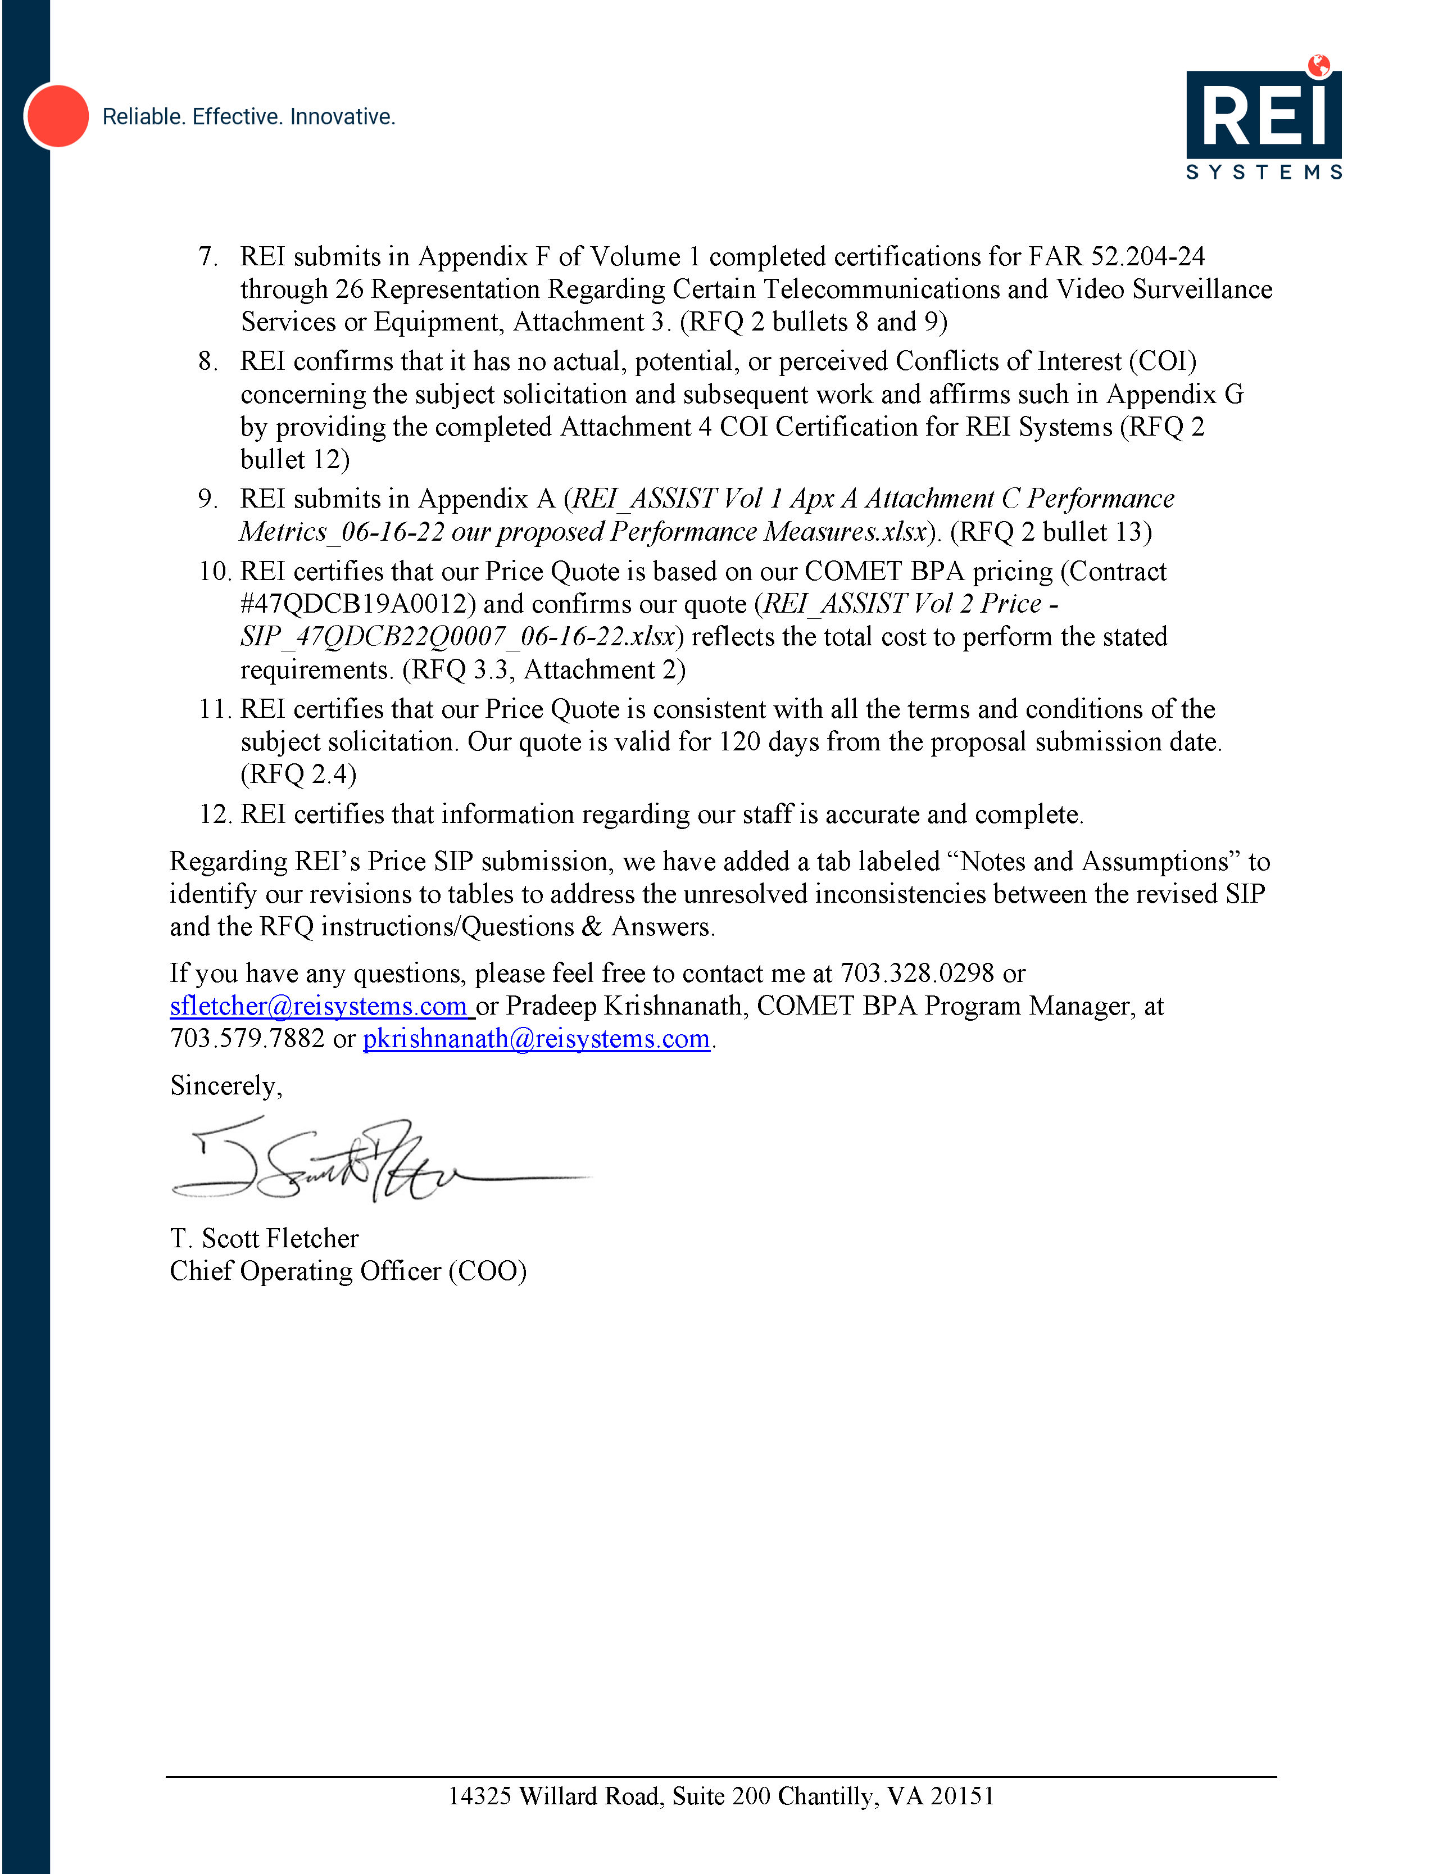

Table of Contents

1. Factor 1 – Technical Approach and Expertise 1

1.1 Team REI Understanding of ASSIST 2

1.1.1 Understanding of Project Goals and End-State 2

1.1.2 Understanding of the FAS IT Playbook 3

1.1.3 Understanding of the Applicable Laws, Guidance, and Policies 3

1.2 Elements, Processes, and Functions to Accomplish the Project Goals 4

1.2.1 Approach to Deliver ASSIST Business Objectives 7

1.2.1.1 Approach to Support Complexity, Evolving Business Needs, and Business Agility 7

1.2.1.2 Approach to Improve Consistency Across ASSIST 7

1.2.1.3 Approach to Automate Functional Gaps 9

1.2.1.4 Approach to Data Analytics and Visualization 10

1.2.1.5 Approach to Improve Integration Across Applications 10

1.3 Team REI’s Approach to Addressing the PWS Requirements with Minimum Performance and Cost Risk 11

1.3.1 Provide Development Modernization and Enhancements (PWS 2B.1) 12

1.3.1.1 ASSIST System DME 12

1.3.1.2 Business Analysis/Emerging Technology DME (PWS 2B.1.2) 14

1.3.2 Operations and Maintenance Support, Including PMO and Help Desk 16

1.3.2.1 Operations and Maintenance (PWS 2B2.1) 16

1.3.2.2 Project Management Office (PMO) (PWS 2B.2.2) 18

1.3.2.3 Help Desk Support (PWS 2B.2.3) 18

1.3.3 Surge 20

1.4 Sample Task Approach 1

1.4.1 Understanding of the Data Visualization and Reports Modernization Sample Task 1

1.4.2 Technical Approach for the Sample Task 1

1.4.2.1 ASSIST Data Analytics Platform 1

1.4.3 Staffing Approach for the Sample Task 3

2. Factor 2 – Management and Staffing Plan (RFQ 3.1, F2, PWS 2A.3.1) 1

2.1 Cross-Impact Teams 1

2.2 O&M Project Teams 2

2.3 DME Project Teams 3

2.4 Labor Categories, Labor Mix, and Levels of Effort 4

2.5 Proposed Personnel Technical Experience, Qualifications, Certifications, Clearances, and Government Acquisition Experience (RFQ 3.1, Factor 2) 5

3. Factor 3 – Phase-In / Transition Plan (PWS 2A.3.3) 1

3.1 Transition Plan 1

3.1.1 Planning 3

3.1.2 Execution 3

3.1.3 Closeout 4

3.2 Approach to Maintaining Quality and Minimizing Disruption 4

3.3 Development and Dissemination of Operating Instructions, Procedures, and Control Directives 5

3.4 Preliminary Risk Assessment and Mitigation Strategies 5

4. Factor 4 – Past Performance 1

4.1 REI – NASA A-TASS 1

4.2 REI – DHS USCIS ODOS II 4

4.3 REI – HHS HRSA – EHBs SDS 7

5. Factor 5 – Management Approach (RFQ 3.1, F5, PWS 2A.3.1&2) 1

5.1 Organizational Lines of Authority and Communication (PWS 2A.3.1, PWS 6) 1

5.2 Proposed Key Personnel, Technical Experience, and Qualifications (PWS 6.4) 3

5.3 Approach to Effectively Deliver the PWS Requirements (PWS 2A.2. and 2A3) 4

5.4 Phase-In Support (PWS 2A.3.3) 6

5.5 Phase-Out Plan (PWS 2A.3.4) 6

5.6 Subcontract Management (PWS 2A.4) 6

5.7 Quality Assurance Approach and Performance Measures (PWS 3) 6

5.8 Deliverables (PWS 4) 7

5.9 Other PWS Requirements (PWS 5, 7, 8, 9) 7

5.10 Risk Mitigation and Problem Resolution Methodology(PWS 2A.3.2) 7

5.11 Problem Resolution Methodology (RFQ 3.1) 7

5.12 Approach to Hiring, Retaining, and Replacing Personnel (PWS 2A.1.7) 8

5.13 Surge Support (PWS 2B.3) 10

Appendix A Attachment C Performance Metrics 1

Appendix B KEY PERSONNEL RESUMES (PWS 6.4) & LETTERS OF COMMITMENT 1

B1 Susan Sparks – Program Manager (PWS 6.4) 1

B1.1 Letter of Commitment – Susan Sparks 3

B2 Matías Niño, PMP, ACP, CSP, SAFe RTE – DME Manager / RTE (PWS 6.4) 4

B2.1 Letter of Commitment – Matias Nino 6

B3 Sandeep Kumar – Solution Architect (PWS 6.4) 7

B3.1 Letter of Commitment – Sandeep Kumar 9

B4 Ashish Kaushal – Database Architect (PWS 6.4) 10

B4.1 Letter of Commitment - Ashish Kaushal 12

B5 Sameer Vajre – Transition Manager 13

B5.1 Letter of Commitment – Sameer Vajre 15

Appendix C ASSUMPTIONS 1

C1 Technical Assumptions (Factor 1) 1

C2 Staffing and Management Plan Assumptions (Factor 2) 1

C3 Phase-In/Transition Plan Assumptions (Factor 3) 1

C4 Management Approach Assumptions (Factor 5) 2

Appendix D Draft Project management Plan 1

Appendix E Qualification Certification Letter 1

Appendix F ATTACHMENT 3 – FAR 52.204-24 through 26 1

Appendix G Attachment 4 – Conflict of Interest Clauses & Certification 1

Appendix H Subcontracting Plan 1

Appendix I Teaming Agreements 1

I1 IntelliBridge, LLC Teaming Agreement 1

I2 Tripoint Solutions, LLC Teaming Agreement 9

I3 cBEYONData, Inc. Teaming Agreement 18

I4 TechSur Solutions Teaming Agreement 26

List of Figures

Figure 1: ASSIST Business Objectives 2

Figure 2: GSA ASSIST Future State – Flexible Microservices with Reusable Shared Services 2

Figure 3: Team REI’s ASSIST Optimization Framework – Increasing Business Agility While Reducing Risks 4

Figure 4: Team REI’s Delivery Train – Using the Freedom Pipeline to Reduce Risk 5

Figure 5: Team REI's HCD System Design – Built from the Human Perspective 8

Figure 6: Cloud-Native 12-Factor Microservice Template (“Chassis”) Approach 8

Figure 7: Cloud-Native Architecture – Creating Loosely Coupled Microservices Built on the FCS 9

Figure 8: Team REI’s Process Automation Framework – Delivery of High-Quality Results 9

Figure 9: Team REI AOF for DME and O&M for High Performance and Low Risk 11

Figure 10: Team REI’s DME Approach to Executing PWS Requirements 12

Figure 11: Team REI’s Roadmap for ASSIST Optimization Through Optimal FTE Footprint 14

Figure 12: Team REI’s Comprehensive Approach to Business Analysis/Emerging Technology 15

Figure 13: Notional Tech Radar for ASSIST 15

Figure 14: Team REI’s O&M Approach Provides Enhanced Efficiency and Continuous Improvement 16

Figure 15: Team REI's Training Approach 17

Figure 16: Team REI’s Help Desk Approach Maximizes Responsiveness and User Experience 19

Figure 17: Team REI’s Technical Design for the Modern ADAP 1

Figure 18: Report Migration Approach for Existing Data and Reports 2

Figure 19: Implementation Activities and PI Timeline 3

Figure 20: Team REI's Detailed Phase-In Schedule 2

Figure 21: Team REI Management Approach 1

Figure 22: Team REI Organization Chart 2

Figure 23: Team REI's Task Order Management Approach 5

Figure 24: Team REI's Quality Assurance Methodology 6

Figure 25: Team REI's Risk Management Process 7

Figure 26: REI's Problem Resolution Methodology 8

Figure 27: Team REI's Staffing and Retention Approach 8

List of Tables

Table 1: Team REI’s Experience and Expertise for GSA ASSIST Success 1

Table 2: The Team REI Value Proposition for ASSIST 1

Table 3: Approach to Deliver ASSIST Optimization Objectives 6

Table 4: Team REI’s Approach to Realize Year 1 Priorities 13

Table 5: Approach to further Optimize & Mature ASSIST O&M 18

Table 6: Approach to Implement ASSIST PMO 18

Table 7: Approach to Further Optimize ASSIST Help Desk 20

Table 8: Approach to Addressing ASSIST Surge Needs 20

Table 9: Team REI’s Technical Engineering Group Roles and Responsibilities 1

Table 10: Team REI’s PMO Team Roles and Responsibilities 2

Table 11: Team REI’s Help Desk Team Roles and Responsibilities 2

Table 12: Team REI’s O&M Team Roles and Responsibilities 3

Table 13: Team REI’s Product Teams Roles and Responsibilities 3

Table 14: Team REI’s Cloud Platform Team Roles and Responsibilities 3

Table 15: Team REI’s Data Platform Team Roles and Responsibilities 4

Table 16: Team REI’s Labor Mix and Level of Effort 4

Table 17: Transition Team Leadership 1

Table 18: Transition Scope 2

Table 19: Team REI Planning Phase Activities and Expected Results 3

Table 20: Team REI's Execution Phase Activities and Expected Results 3

Table 21: Team REI Closeout Phase Activities and Expected Results 4

Table 22: Preliminary Risk Analysis for ASSIST Transition-In 5

Table 23: Key Elements of the REI Management Approach 1

Table 24: Personnel Qualifications, Relevant Experience, and Training 3

Table 25: Team REI's Preliminary Risks 8

Compliance Matrix

| **Page** | **Requirements From GSA ASSIST Optimization Solicitation** | **Proposal Document Location** |
| --- | --- | --- |
| **RFQ Instructions and Evaluation Criteria** |
| 5 of 24 | **Submission Instructions** |  |
| 5 of 24 | 1. Confirm that the offeror will furnish the item(s) or services described in the attached PWS. | Cover Letter, F 1, F 1.3.2.1, F 1.3.2.3, F5, APX D |
| 6 of 24 | 2. Confirm that the offeror will perform work and deliver items according to the government’s work statement and delivery schedule. | Cover Letter, All sections |
| 6 of 24 | 3 Verify compliance with any contract security requirements stated in the PWS Section 8. | Cover Letter, Vol 1 Factor 5 |
| 6 of 24 | 4. Reference the BPA and Solicitation number provided in the title of this document. | Title page, Cover Letter, |
| 6 of 24 | 5. Warranty: Not Applicable. | N/A |
| 6 of 24 | 6. Confirm compliance with Section 508 of the Rehabilitation Act of 1973. [All services and/or products provided in response to this solicitation shall comply with Section 508 of the Rehabilitation Act of 1973 (29 U.S.C. 794d), and the Architectural and Transportation Barriers Compliance board Electronic and Information Technology (EIT) Accessibility Standards (36 CRF Part 1194).] | Cover Letter , Vol 1 F 1 1.1.3, F 1.3.2.1, F 1.4.2.1 |
| 6 of 24 | 7. Confirm SAM (System for Award Management) registration [The Contractor must be registered in SAM to receive an award in response to this solicitation. Vendors may register at http://www.sam.gov.] | Cover Letter |
| 6 of 24 | 8. Complete the certification found in FAR 52.204-24 Representation Regarding Certain Telecommunications and Video Surveillance Services or Equipment(Attachment 3). | Vol 1 APX F |
| 6 of 24 | 9. Confirm compliance with FAR 52.204-25 Prohibition on Contracting for Certain Telecommunications and Video Surveillance Services or Equipment (Attachment 3). | Vol 1 APX F |
| 6 of 24 | 10. Comply with other requirements in this RFQ. | Cover Letter, all sections |
| 6 of 24 | 11. Be clear, concise, and shall include sufficient detail for effective evaluation and for substantiating the validity of stated claims. The offer should not simply rephrase or restate the Government’s requirements, but rather shall provide convincing rationale to address how the offeror intends to meet these requirements. Offerors shall assume that the Government has no prior knowledge of their facilities and experience, and will base its evaluation on the information presented in the offer. | Vol 1 all Factors plus appendices. |
| 6 of 24 | 12. Conflict of Interest (COI) Certification: The contractor is required to complete and sign a COI Certification (Attachment 4). The contractor must represent either that (1) It is not aware of any facts which create any actual or potential COI relating to the award of this contract, or (2) It has included information in its proposal, providing all current information bearing on the existence of any actual or potential COI that the contractor believes can be avoided, neutralized or mitigated and has included a mitigation plan for Government review | Vol 1 APX G |
| 6 of 24 | 13. The offeror shall provide Performance Measures as appropriate to its quote that meet or exceed the current Performance Measures provided by the Government as PWS Attachment C. The offeror may propose improved performance metrics for current Performance Measures or new Performance Measures. The offeror shall provide performance metrics for each of the quoted new Performance Measures in the same format as the current Performance Measures. | Vol 1 Factor 5 APX A - Attachment C |

| **Page** | **Requirements From GSA ASSIST Optimization Solicitation** | **Proposal Document Location** |
| --- | --- | --- |
| **RFQ Instructions and Evaluation Criteria** |
| 6 of 24 | **Quote Contents – Technical (Non-Price Volume)** |  |
| 6 of 24 | Provide a quote to include an explanation of the technical approach that is being proposed for accomplishing the work and information demonstrating the relevance of the offeror’s past experience performing the type of work described in the PWS. The offeror should address the specific factors listed in Section 3, below, which are briefly summarized as follows: | Vol 1 all components, Factor 1, Vol 1 Factor 4 |
| 7 of 24 | 1. Explain how you will accomplish the work. This explanation could include the management approach, tools and techniques, and best practices based on prior experience. | Vol 1 Factors 1, 2, 4, 5 |
| 7 of 24 | 2. Demonstrate a clear understanding of the subject matter and technical requirements stated in the PWS. In addition, demonstrate sound technical and agile program management capabilities by executing the requirements described in the Sample Task. | F 1.1 F1.2, F1.3, F1.4, F5.3, APX D PMP |
| 7 of 24 | 3. Demonstrate that proposed personnel have the capabilities, qualifications, training, and certification to perform the functions to which they will be assigned. | Vol 1 Factor 2 and APX B Resume |
| 7 of 24 | 4. Provide a Staffing Plan that includes the proposed approach for organizing the staff (key and non-key personnel) to effectively execute this task order, identifying labor categories and the functions to which they will be assigned. | Vol 1 Factor 2, APX D PMP |
| 7 of 24 | 5. For Mandatory Key Personnel, provide resumés that clearly identify the requested qualifications. | Vol 1 APX B |
| 7 of 24 | 6. Provide the description of three prime contractor projects that have been or are being performed to demonstrate experience with work that is relevant to this requirement. Additionally, provide the description of one relevant project from each proposed principal subcontractor (A principal subcontractor is defined as one who will perform more than 20% of the labor dollars of this task order.) | F4 past performance |
| 7 of 24 | **Quote Contents – Schedule of Items and Prices (price volume)** |  |
|  | 1. Each offeror shall submit a price quote based on its respective BPA labor rates, which are the lower of the rates in the COMET BPA or the rates in the contractor’s current MAS contract. | Vol 2 Price Att 2 |
| 12 of 24 | **2.8 Ability to Perform** |  |
| 12 of 24 | The quote shall demonstrate the offeror’s ability to perform the functions and meet the needs and stated requirements of the Government as set forth in the PWS (Performance Work Statement) and any associated, accompanying, or referenced laws, regulation, provisions, or documents. | Acknowledged, F1.1.3 - F5 |
| 12 of 24 | **2.9 Accurate and True Statements** |  |
| 12 of 24 | All information presented in the quote shall be accurate and true according to the offeror’s best belief. The penalty for making false statements in quotes is prescribed in 18 U.S.C. 1001. | Confirmed |
| 12 of 24 | **2.10 Assumptions** |  |
| 12 of 24 | The quote shall clearly state, in a separate section, all or any assumptions, conditions of engagement, contingencies, or exceptions to the solicitation made by the offeror. These must be cross referenced to the portion of the quote to which they pertain. If none are noted, the government will presume that there are none and that the offeror agrees with all of the terms, conditions, and requirements of the solicitation. It is not the responsibility of the Government to seek out and identify assumptions, conditions, contingencies, or exceptions buried within the offeror’s quote. Any assumptions, conditions of engagement, contingencies, or exceptions to the solicitation may affect the level of confidence score given by the government during the evaluation of quotes or may render the quote unacceptable or non-responsive. | APX C assumptions C1-C5 and SIP Att 2 Assumptions tab |
| 13 of 24 | **2.14 MAS Contract and COMET BPA Reference** |  |
| 13 of 24 | The quote must reference the offeror’s COMET BPA and MAS contract. | Acknowledged, Cover letter, Title Page & SIP Att 2 |
| 14 of 24 | **3. EVALUATION FACTORS** |  |
| 14 of 24 | The quotes will be evaluated using a three-step process in accordance with the following requirements and factors. All non-price factors combined will be considered more important than price when determining a final rating. Insufficient or poorly stated information will have a detrimental effect on this evaluation. Failure of the offer to address any element of the following factors will be rated as though the offeror does not have that capability. | Acknowledged |
| 14 of 24 | **3.1 Step 1 – Evaluation of Technical Capability** |  |
| 14 of 24 | In this step the government will evaluate and assign an adjectival or numerical rating to each of the non-price evaluation factors. These factors will be evaluated in descending order of importance. | Acknowledged |
| 14 of 24 | • Non-Price Factor 1 – Technical Expertise and Technical Approach | Acknowledged |
| 14 of 24 | • Non-Price Factor 2 – Management and Staffing Plan | Acknowledged |
| 14 of 24 | • Non-Price Factor 3 – Phase-In/Transition Plan | Acknowledged |
| 14 of 24 | • Non-Price Factor 4 – Past Performance Relevance | Acknowledged |
| 14 of 24 | • Non-Price Factor 5 – Management Approach | Acknowledged |
| 14 of 24 | If any factor is evaluated as Not Confident, then the quote will be eliminated from the competition and will not be eligible for award. | Acknowledged |
| 14 of 24 | **Factor 1 – Technical Approach** |  |
| 14 of 24 | The government will evaluate the technical approach portion of the proposal to determine the degree to which the application of the offered technical approach will accomplish the goals of this requirement with minimum performance and cost risk to the government. Specifically, the government will evaluate --- | Vol 1 Factor 1all sections |
| 14 of 24 | The government will evaluate the technical approach portion of the proposal to determine the degree to which the application of the offered technical approach will accomplish the goals of this requirement with minimum performance and cost risk to the government. Specifically, the government will evaluate --- | Vol 1 Factor 1 all sections |
| 14 of 24 | • The degree to which the offeror demonstrates a clear understanding of the project goals and end state. | Vol 1 Factor 1 all sections |
| 14 of 24 | • The degree to which the offeror demonstrates a clear understanding of the FAS IT Playbook, individual elements, processes, and functions that the solution must have to accomplish the project goals, including recommendations or solutions as appropriate. | Vol 1 Factor 1 all sections |
| 14 of 24 | • The degree to which the offeror demonstrates a comprehensive understanding of the applicable laws, guidance and policies as noted in the PWS. | Vol 1 Factor 1 all sections |
| 14 of 24 | • The degree to which the offeror demonstrates a successful approach for the sample task order. | Vol 1 section 1.4 |
| 14 of 24 | **Factor 2 – Management & Staffing Plan** |  |
| 14 of 24 | The government will evaluate the management and staffing plan to determine the degree to which the staffing capabilities will result in successful accomplishment of this requirement, with minimum performance and cost risk to the government. Specifically, the government will evaluate: | Vol 1 Factor 2 section 2.4 and APX D PMP |
| 15 of 24 | • The degree to which the staffing plan includes labor categories, a labor mix, and levels of effort (labor hours) appropriate for accomplishing this requirement. This specifically includes the makeup and management of DME, Operations and Maintenance (including the Project Management Office and Help Desk) personnel. | Vol 1 Factor 2 section F2.1- 2.5 and APX D PMP |
| 15 of 24 | • The degree to which the proposed personnel (including subcontractor personnel, if proposed) possess technical experience, qualifications, and certifications per the COMET Labor Categories, security clearances necessary to successfully perform this requirement, and experience with Government acquisitions. | Vol 1 Factor 2 section F2.5 and APX D, Resumes in APX B |
| 15 of 24 | • Commitment letters from all personnel proposed in the staffing plan indicating current employment of the Prime or Subcontractor, if applicable. Commitment letters for 12 months of employment for all key personnel are required. | Vol 1 Factor 2 section 2.5 APX B |
| 15 of 24 | • Supporting documentation (e.g., resumes) for all personnel proposed in the staffing plan indicating their experience aligns to the COMET labor category descriptions/requirement, and if applicable, to the desired skills listed in the PWS. The Contractor shall validate the candidate’s experience and certifications (if applicable) cited in the resumes. | APX B resumes, letter of certification |
| 15 of 24 | **Factor 3 – Phase-In/Transition Plan** |  |
| 15 of 24 | The government will evaluate the offeror’s transition plan per the minimum requirements identified in the RFQ package and recommendations proposed by the offeror. The proposer’s solution for phase-in/transition into this contract that presents a clear understanding of the phase-in tasks and delivery of required services including a detailed plan-of-action and milestones to transition the functions identified in the PWS, approach to maintaining quality and minimizing disruptions during the phase-in, development and dissemination of operating instructions, procedures, and control directives. | Vol 1 Factor 3 sectionsF3.1-3.4 and Factor 5.2 |
| 15 of 24 | **Factor 4 - Past Performance Relevance** |  |
| 15 of 24 | The government will evaluate performance on 3 recent (within the past three years) or present successful projects which are similar in size, scope, complexity, and cost to that of this requirement. Higher ratings will be given for those that are more similar and lower ratings to those that are less similar. The government may use other sources [e.g., projects listed in the Contractor Performance Assessment Rating System (CPARS)] to evaluate Past Performance Relevance to add confidence to the Past Performance Relevance rating. | Factor 4 Sections 4.1- 4.3, and PPQs |
| 15 of 24 | **Factor 5 - Management Approach** |  |
| 15 of 24 | Evaluation will be based on the Government’s level of confidence in your company’s capability and approach to effectively deliver the PWS requirements and avoid schedule, cost, and scope creep. The level of confidence will be based on the following: | Acknowledged |
| 16 of 24 | • Your company’s management methodology for optimizing lines of authority and communication, organizational structure, and problem resolution methodologies. Your company shall discuss how personnel will be held accountable for performance. | Vol 1 Factor 2 section F5.1-F5.3 F5.6 F5.7 F5.9 F5.10 F5.11 and F5. 12 |
| 16 of 24 | • Your company’s approach to risk management during performance from both a technical and management perspective, and the planned actions to mitigate or eliminate risks. | Vol 1 Factor 2 section F5.10 and APX D |
| 16 of 24 | • Your company’s approach and rationale for choosing personnel for this effort. Your company shall describe how each person will be involved in the potential contract, and how her/his qualifications make them uniquely qualified for the position. | Vol 1 Factor 2 section F2.5, and Resumes in APX B |
| 16 of 24 | • Your company’s approach to hiring, retaining and replacing personnel throughout the life of the contract (including all option periods). | Vol 1 Factor 2 section F5.12 |

# Factor 1 – Technical Approach and Expertise

GSA’s Office of Assisted Acquisition Services (AAS) provides full lifecycle acquisition support to advance the missions of client agencies across a vast range of technical and professional services. The [Acquisition Streamlining and Standardization Information System (ASSIST)](https://portal.fas.gsa.gov/public/login) is a complex, mission-critical system that enables AAS and its government customers to effectively and efficiently manage acquisitions and contracts. It supports more than 6,000 government clients, 24K contractors, and 1,400 GSA users who use it daily. By managing additional business complexity and adding innovative technical capabilities, AAS aspires to provide superior acquisition lifecycle support for all its customers and seeks to position ASSIST to adapt to evolving customer needs to handle future acquisition growth.

REI Systems, Inc. (REI) has thoughtfully assembled a team of large and small businesses (**Table 1**) that bring the depth, breadth, and niche experience required to provide the comprehensive services necessary to achieve AAS’ vision for an optimized system at all layers.

Table 1: Team REI’s Experience and Expertise for GSA ASSIST Success

| **Team Member** | **Value Brought to ASSIST** |
| --- | --- |
|  | * 2021 Government Contractor of the Year and five-time Washington Post Best Workplace. * Trusted GSA partner with 13+ years of success on Transportation Audit Management (TAMS), DATA.GOV, Integrated Award Environment (IAE), Enterprise Content Application Services (ECAS), and Office of Government-wide Policy, and Federal Acquisition Service (FAS)/Government-wide IT Category and IT Vendor Management Office (ITVMO). * Supported GSA Office of Citizen Services and Innovative Technologies (OCSIT) and the White House in developing high-profile sites, including Recovery.gov, USASpending.gov, the IT Dashboard, BusinessUSA, and Performance.gov. * Expertise in large-scale enterprise Scaled Agile Framework (SAFe) delivery at GSA and the Food and Drug Administration (FDA). |
|  | * 8(a), Woman-Owned Disadvantaged Small Business (EDWOSB). * Deep experience in Cloud-native development, Containerization, and SecDevOps at GSA and U.S. Citizenship and Immigration Service (USCIS), Government Accountability Office (GAO), and Institute Of Museum and Library Sciences (IMLS). |
|  | * Three-time Washington Post Best Places to Work, Large Business with Cloud-native Modernization experience. * Authored components of the U.S. Web Design System (USWDS) standard while working with the 18F Team. * Currently supports the Digital Innovation for GSA Infrastructure Technologies (DIGIT) contract. * Expertise in modernizing User Experience (UX) for large-scale Help Desks at the Treasury and the Department of Defense (DoD). |
|  | * Government Innovation Award 2021, Large Business with Data Analytics, Reporting, and Automation experience. * Deep experience implementing financial system integrations with Momentum at the Department of Justice (DoJ). * Familiarity with the core 400+ Momentum tables and underlying G-Invoicing data. |
|  | * ServiceNow Public Sector Partner Program participant and Enterprise Service Management experts. * Manage ServiceNow licenses at U.S. Army Corps of Engineers (USACE) and DoJ |

Team REI is the right partner for GSA to continue evolving ASSIST for better adaptability and increased efficiency, and to meet future acquisition demand, as summarized in **Table 2** below.

Table 2: The Team REI Value Proposition for ASSIST

|  |
| --- |
| **1. Proven Track Record of Building Large-Scale Applications that Continue to Evolve and Adapt** |
| * **Modernization to Optimization:** At the Health Resources and Services Administration (HRSA), the Electronic Handbooks (EHBs) have evolved from one Application module to an enterprise system supporting the entire grants lifecycle for 3,000+ staff and 50,000+ external users. Using the EHBs, in 2020, HRSA was the first agency to issue COVID-19 funding and did so just 12 days after the pandemic declaration. * **Agile Delivery Experts:** At USCIS, the Electronic Immigration System (ELIS) collects, tracks, and adjudicates over 1,000,000 immigration applications for 20,000+ users annually. REI delivers new code to Production daily with Zero Down Time. |
| 2. Specialized Expertise for ASSIST |
| * **Acquisitions:** Over 30 years of experience implementing federal grants management systems that closely align with the acquisitions lifecycle. * **User Experience:** Extensive experience in user research, creating user profiles, low and high-fidelity mockups, and impactful user design. * **Cloud-native at GSA:** Direct experience with FAS Cloud Services (FCS) and Freedom Pipeline on our IAE, TAMS, and Data.gov programs. * **G-Invoicing:** Financial systems proficiency and readiness to support G-Invoicing with our CGI Momentum Integration experience at DoJ. * **Help Desk:** Proactive customer support with Help Desk services using ServiceNow for the Navy, Army, DoJ, and Customs and Border Patrol (CBP). |
| 3. Thought Leadership in Data and Analytics |
| * **Prized Data Solution:** Our ACT-IAC award-winning solution for HRSA’s Modern Data Analytics Platform (MDAP) reduced time-to-insights by 15%. * **GSA Visualizations:** We built the Data Bank at IAE that provides data insights generation through powerful transactional and visualization reports. * **Financial Data:** We built dashboards for Momentum at DoJ and a financial enterprise data warehouse at the Federal Bureau of Investigation (FBI). |

Team REI brings exceptional technical capability with FCS, Human-Centered Design (HCD), Design Thinking (DT), Data Analytics, and emerging technology required to optimize the next generation of ASSIST. We focus on delivering greater consistency, integration, automation, data analytics, and visualization to support more complex and diverse acquisition solutions. **Section 1.1** below describes Team REI’s understanding of the project goals and end state (Evaluation Factor 1 – Bullet 1), alignment to the FAS IT Playbook (Evaluation Factor 1 – Bullet 2), and the laws, guidelines, and regulations that impact ASSIST (Evaluation Factor 1 – Bullet 3). **Section 1.2** describes the components necessary to optimize ASSIST’s business and technical objectives for better adaptability and scaling for growth (Evaluation Factor 1 – Bullet 2). Finally, **Section 1.3** summarizes our approach to the Performance Work Statement (PWS) requirements with minimum performance and cost risk (Evaluation Factor 1).

## Team REI Understanding of ASSIST

|  |
| --- |
| Graphical user interface, text  Description automatically generated  Figure 1: ASSIST Business Objectives |

ASSIST 2.0 provides a single, modernized platform for all financial management and contract reporting functionality. AAS seeks to build on the recent success of the modernized ASSIST 2.0 by optimizing existing capabilities and delivering increased business value for its customers. As shown in **Figure 1**, AAS envisions ASSIST 3.0 will achieve business objectives at all levels, including UX, processes, automation, integrations, data, and architecture, with minimum disruption to users.

### 1.1.1 Understanding of Project Goals and End-State

ASSIST currently manages over 9,000 Awards, representing $13B annually through the robust, full-spectrum solution modernized in FY22. However, ASSIST needs to continue to adapt to the unprecedented growth expected in the assisted acquisition marketplace over the next five years. New AAS staff onboarding must occur rapidly to support the future increase in acquisition workload. Changes in future regulations must be supported, like the authorization of Commercial Solution Offerings (CSOs) through the National Defense Authorization Act (NDAA) of FY22. More automation is needed to allow staff to focus on higher-value work like engaging with customers and industry partners to establish and refine acquisition requirements. Finally, greater consistency and standardization are required to better balance the workload across AAS regions. **Figure** **2** below depicts our understanding of a fully optimized ASSIST that provides stakeholders with business agility and services organized as products for increased operational efficiency on the FCS platform.

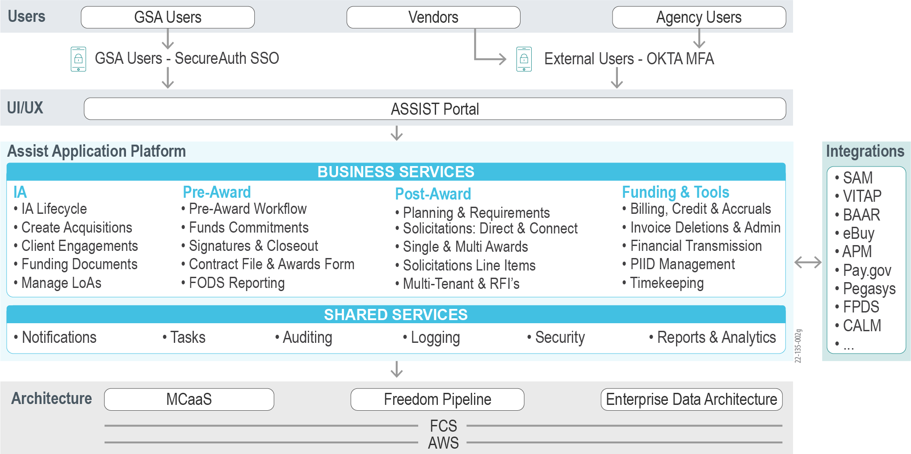

Figure 2: GSA ASSIST Future State – Flexible Microservices with Reusable Shared Services

AAS envisions optimization that encapsulates all the layers of the ASSIST 3.0, specifically:

* **Users and UI/UX.** Maturing HCD techniques, integrating user feedback, FAS Digital Experience efforts, as well as replacing identity and access management with FAS ID and Secure Auth.
* **Processes.** Enhanced acquisition workflows with fewer steps, automation of low-value-add steps, faster and more frequent releases, and error prevention via automation.
* **ASSIST Application Platform.** Eliminating functional gaps, refactoring to support reusability and greater complexity, integrating with additional systems, and enhancing existing interfaces.
* **Architecture and Data and Analytics.** Stabilizing in FCS, alignment with FAS IT Playbook, improving SecDevOps and business outcomes, migrating data from Oracle to PostgreSQL, modernizing data sharing and reports, improving forecasting using predictive data analytics, and embedding visualizations and telemetry.

This future-state solution will empower GSA acquisition staff, agency customers, and vendors to execute their mission to facilitate the high-quality, cost-effective acquisition of goods and services.

### Understanding of the FAS IT Playbook

The FAS IT Playbook is FAS’ definitive guide to creating modern, cloud-native Information Technology (IT) services with direction, guidance, templates, and policy compliance for faster, high-quality delivery execution. One of the key technical goals of ASSIST 3.0 is to align with the FAS IT Playbook in terms of adopting standards, templates, and patterns for User Experience, Agile processes, and security and leveraging the cloud ecosystem with cloud smart journey and cloud offerings.

Deep Experience with FCS

* We were the first application team to move Data.gov to FCS.
* Our IAE and TAMS modernizations provided us the opportunity to align and contribute to FCS development through fully managed Evidence Based Technical Analysis (EBTA) and the development of the semi-managed CaaS platform.
* We have also implemented the IAE databank on FCS, which aligns with FAS Enterprise Data Architecture.

Alignment to the FAS IT Playbook is essential to leverage FAS IT investments in shared services and accelerators in the FCS ecosystem to realize economies of scale and stay within the guardrails set by FAS IT and GSA security. Moreover, fully managed services and tools, such as **Multi Container as a Service** (**MCaaS) and Freedom Pipeline**, let the Development Team focus on delivering ASSIST business value. In contrast, the FCS Team takes care of the infrastructure, also reducing the effort needed to achieve Authority to Operate (ATO). FCS’ well-established cloud smart journey effectively enables ASSIST from initial cloud migration through implementation and **Site Reliability Engineering (SRE)** optimization.

### Understanding of the Applicable Laws, Guidance, and Policies

Through our decades of experience in federal enterprise application development and sustainment, Team REI brings deep experience and continually stays up-to-date with relevant laws, guidance, and policies to deliver a future-state ASSIST, as detailed below.

*Digital Experience.* The 21st Century Integrated Digital Experience Act (IDEA) was introduced to improve the digital experience and accessibility across all products and services offered by the Federal Government to citizens and users. We have incorporated 21st century IDEA and USWDS 3.0 principles in our USCIS and IAE User Interface (UI) and design system. Team REI understands that GSA is a high-impact service provider, and the adoption of Customer Experience (CX) EO 14058 is critical. Our corporate CX Center of Excellence’s (CoE) best practices and maturity model align with the IDEA considerations, CX, and HCD, which are a critical part of UX design for ASSIST 3.0. With extensive experience developing accessible applications that meet Federal Section 508 of the Rehabilitation Act of 1973 at multiple federal agencies, we bring the knowledge and skills to ensure Section 508 Compliance for ASSIST and improve the UX for accessibility challenged users.

*Security.* Team REI closely complies with all security laws, OMB regulations, and guidelines, including FISMA, OMB Circular A-130, NIST 800, and GSA CIO 09-48, 12-2018, 17-78 guidelines, and Section 255 of the Communications Act. We understand the recent Cyber Security Executive Order 14028 and work with FAS IT and GSA Security to strengthen zero trust (NIST 800 207), implement controls, monitor and comply with reporting requirements of the Cyber Safety Review Board, and strengthen supply chain security to keep track of security across all the dependencies for the ASSIST application. We have worked closely with GSA security since 2009 and are very familiar with the guidelines and governance model. On our GSA OGP contract, we provide Zero Trust expertise and support the creation of the Zero Trust Playbook.

Security at GSA

Team REI has successfully gained ATO on every system we have modernized or supported for GSA over the last 12 years, including on ECAS in 2020 and TAMS in 2021.

*Acquisitions.* Team REI brings years of experience working with the Federal Acquisitions Regulations (FAR). As an organization supporting the National Aeronautics and Space Administration (NASA), DoD, and the Environmental Protection Agency (EPA) with SBIR solutions that house Small Business Innovation Research (SBIR) contracts, we have created FAR-compliant solutions for the last 30 years. We understand the FAR and how it applies to contract opportunities, so much so that GSA has entrusted REI with the modernization of the FAR public repository, Acquisition.gov. We ensure that Acquisition data comply with NARA policies and guidance and follow the GSA records retention schedule.

## **Elements, Processes, and Functions to Accomplish the Project Goals**

AAS seeks to build the next generation ASSIST 3.0 by optimizing ASSIST 2.0 capabilities by focusing on delivering business value for customers. The optimization is done in constant pursuit of delivering increasing value to customers with expanding business complexity and innovative technical capabilities to allow for continuous opportunities to improve. This pursuit requires establishing a fine-tuned and balanced engine of people, processes, and technologies aligned to the vision of AAS. Team REI outlines our **ASSIST Optimization Framework (AOF)** in **Figure 3,** which is our constant, integrated engine to deliver AAS’ vision for ASSIST optimization at each layer.

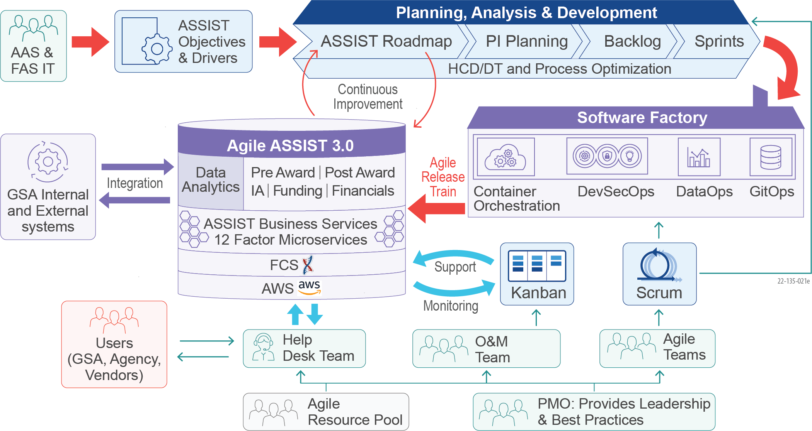

Figure 3: Team REI’s ASSIST Optimization Framework – Increasing Business Agility While Reducing Risks

Founded on the FAS IT Playbook, our **AOF** enables a SAFe delivery process and the creation of a cloud-native ASSIST platform operated through a consistent software factory. Through SAFe-certified Agile teams of engineers, designers, analysts, testers, and Subject Matter Experts (SME), the **AOF** continually delivers ASSIST business objectives of consistency across the platform, capability gap automation, mission system integration, and seamless data analytics. Our **AOF** will be applied to Development, Modernization, and Enhancements (DME), Operations and Maintenance (O&M), and other PWS objectives presented in **Section 1.3** below.

***Planning, Analysis, and Development.*** AAS has identified major business optimization areas, as described in **Section 1.1.1,** with several opportunities to improve service delivery across different value streams in ASSIST. We apply SAFe practices to deliver ASSIST optimization. Our team collaborates with AAS and FAS IT to prioritize and come up with a program-wide planned roadmap of features, experiences, integrations, and innovations. We execute the roadmap initiatives for execution through Program Increment (PI) Planning, which also includes emerging improvement opportunities for the platform. The outcome of PI planning results in a release backlog for Agile DME teams that deliver features in bi-weekly sprints. We use Continuous Integration (CI) and deliver with a build “on-cadence” and “deliver on-demand” approach to quickly deploy secure, high-quality services. We deliver features through a Software Factory built on the FAS IT infrastructure. Each feature is consistently integrated into the ASSIST platform by using building blocks and standard design systems such as the USWDS. This constant loop of planning and incorporating improvement opportunities enables a virtuous cycle of improvements. We outline our detailed approach for DME in **Section 1.3.1** and a notional Roadmap for Year 1 priorities in **Figure 11** further below.

***Software Factory.*** To deliver high-quality services, we utilize FCS platform capabilities, including MCaaS, Freedom SecDevOps Pipeline, and FAS Cloud Services-Data (FCS-D) data pipeline. Team REI accelerates optimization of ASSIST through the utilization of the FCS native Infrastructure as Code (IaC) and GitOps-based microservices deployment to realize cloud smart objectives with a standardized pipeline. Team REI has modernized and consolidated capabilities in the Data.gov, IAE, Personal Property Management System (PPMS), and TAMS portfolios, where we transformed a legacy portfolio of applications into a cloud-native microservices architecture on the FCS. Team REI has expertise with proven experience delivering quality solutions through the FCS Freedom Pipeline depicted in **Figure 4.**

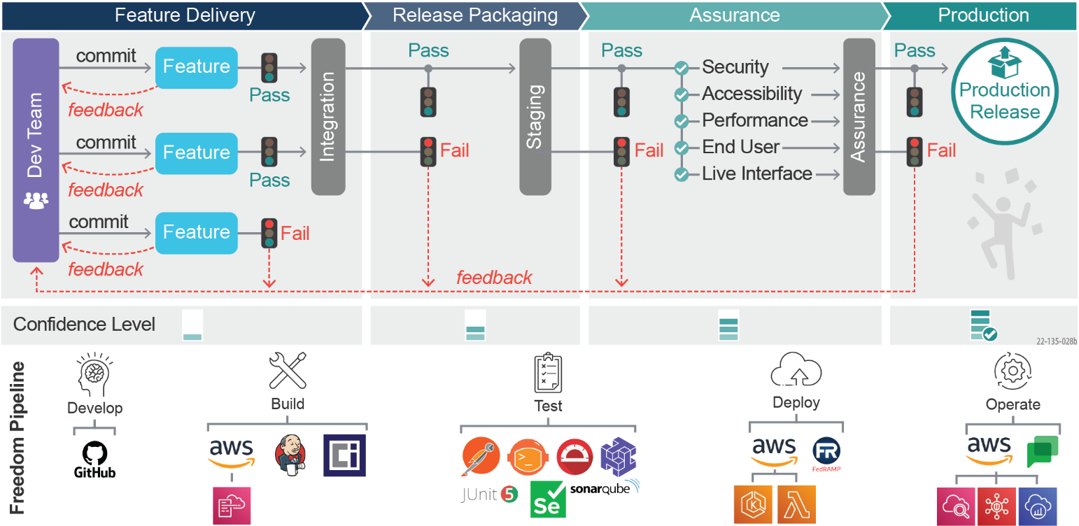

Figure 4: Team REI’s Delivery Train – Using the Freedom Pipeline to Reduce Risk

Our SecDevOps build, test, and deployment processes are automated to deliver on-demand system functionality. Team REI delivers GSA’s vision of “release on demand” using the Freedom pipeline. We configure and customize the FCS Freedom pipeline to build and deliver application changes using a secure-by-design framework that implements security requirements continuously. Our SecDevOps architecture empowers developer agility by embedding our pipeline configurations within each microservice GitHub repository and branch. As a result, developers adjust code in their development branch, avoiding conflicts with other branches or microservices. We execute stage-gate checks in the pipeline to deliver tested, compliant, and documented code. We leverage automation to enable immutable infrastructure with each system change. We provision cloud assets with the configurations injected across environments. Configurations are always synchronized to version-controlled configurations, using GitOps services using FluxV2 to prevent configuration drift. We propose to use IaC to configure and deploy containers for repeatability and elasticity. We collaborate with FCS to create IaC with Terraform or AWS Cloud Development Kit (CDK).

***Agile ASSIST 3.0.*** ASSIST 3.0 is focused on delivering greater consistency, integration, automation, data analytics, visualization, and support for more complex and diverse acquisition solutions. These optimizations must be consistently applied through Pre-Award, Post-Award, IA/Engagement, and Funds/Financial value streams by addressing specific improvement opportunities identified in PWS Section 1.4. Team REI brings expertise in evolving enterprise systems with long-term horizons to meet evolving business needs. We have operated enterprise systems in HRSA, NASA, and GSA for decades through multiple generations of technology and business evolutions. We optimized and evolved HRSA EHBs and GSA IAE to create a consistent and integrated technology platform that serves the complex and evolving business needs through a composable architecture in all layers of the platform. We use our experience, expertise, and best practices to evolve to ASSIST 3.0 through Agile delivery.

***O&M.*** We apply SRE approaches for production go-live readiness, performance monitoring, and reducing manual effort, along with ChatOps and AIOps to improve overall efficiency. We conduct production readiness, performance monitoring, testing, and log interpretation from tools such as New Relic and Splunk to troubleshoot service degradations and perform Root Cause Analyses. Our use of Organizational Change Management (OCM) tactics early and throughout ensures holistic planning across people, processes, and technologies to integrate in a way that minimizes delivery risks and guides user adoption. We develop robust communications and stakeholder engagement plans to address questions and facilitate adoption. We provide details of our O&M approach in **Section 1.3.2.**

**Table 3** shows a summary of our elements, processes, and functions to meet AAS’ business objectives.

Table 3: Approach to Deliver ASSIST Optimization Objectives

| **Optimization Objectives** | **Elements, Processes, Functions** | **Benefits** | **Evidence/Proof Points** |
| --- | --- | --- | --- |
| 1. Support complex evolving Business Needs and Business Agility | We use OCM and process optimization to find improvement opportunities and use wizards to make the implementation of complex business needs easier. | Wizards eliminate user errors, and configurable processes provide new workflow steps without custom programming. Configurable processes allow the onboarding of new contract vehicles within 90 days. | In the grants management application at HRSA, our team has architected wizards and delivered productivity gains of 25%. For HRSA EHBs, our team designed a pluggable workflow to implement new process changes 50% faster. |
| 1. Consistency within ASSIST | We leverage 12 Factor Microservices and SecDevOps using the Freedom Pipeline to deliver consistent ASSIST services with guardrails. We use HCD and DT to deliver an engaging UX. | Our 12 Factor Microservices templates provide building blocks and blueprints for rapidly building services aligned with the FAS Playbook. HCD ensures user engagement and increases user adoption. | Our UX experts at NASA improved process design to eliminate complexity and achieved 100% user satisfaction. |
| 1. Automation of Functional Gaps | We use Value Stream Mapping (VSM) to streamline processes for optimum usage. We use a Robotic Process Automation (RPA) framework to promote the intake process and analysis. | Efficient business processes increase productivity and eliminate redundant tasks. Repetitive, low-value tasks can be automated to derive a possible 10-15% improvement in productivity. | For NASA SBIR application verification, our team created UiPATH RPA-powered bots to verify complex document compliance of thousands of SBIR applications, saving 80% of the total review time. |
| 1. Data Analytics and Decision Support | We implement FAS Enterprise Data Architecture (EDA) and FCS-D by leveraging FCS Managed Services for data governance, data management, and analytics. We build a self-service Analytics Platform and use automation to convert some of the legacy Business Intelligence Reporting Tool (BIRT) reports to AWS Quicksights*.* | The modern Data and Reporting Platform ensures data quality, compliance, security, and consistent data catalogs. Our dashboard and visualizations promote high user adoption and create a seamless user experience. | At IAE, we built a Data Bank and increased the maximum rows per report five-fold, added seven additional years of historical data, and debuted a new Report Builder wizard. |
| 1. Integration across Applications | We use loosely coupled cloud-native and event-driven architecture with end-to-end observability for integration with other GSA internal and external applications. We leverage our financial integrations with Pegasys/Momentum at other agencies to rapidly implement G-Invoicing. | Our approach promotes service abstraction for faster deployments and reduced dependencies and provides robust monitoring for reduced errors and transparency. Our financial integration approach reduces G-Invoicing development time and increases the accuracy of integrations. | Team REI has successfully implemented Pegasys-based integrations for dozens of agencies. REI is modernizing GSA IAE and brings accelerators for UEI, Entity, and Opportunities integration. |

Our comprehensive, repeatable **AOF** and experience evolving and sustaining enterprise applications at GSA and other agencies ensure lock-step alignment in meeting AAS’ business objectives.

### Approach to Deliver ASSIST Business Objectives

We detail each business objective’s necessary elements, processes, and functions below.

#### Approach to Support Complexity, Evolving Business Needs, and Business Agility

FAS’ assisted acquisitions have become significantly larger (i.e., higher dollar values, more client missions supported) and significantly more complex (i.e., multiple client agencies, non-FAR-based acquisition authorities, increased use of ‘high-risk’ contracting methods, and phased acquisitions). The current ASSIST capability provides support for basic tasks that still require some offline work in Excel spreadsheets for data manipulation. Further, AAS expects several improvements to existing capabilities, such as refactoring workflows, improving usability, and enhancing cross-platform capabilities such as common search and multi-tenancy features.

We utilize process optimization approaches such as OCM and Business Process Re-Engineering ( BPR) to identify opportunities for improvement. Using OCM, we evaluate the system and process dependencies to optimize workflows. Using BPR, Team REI optimized the GSA IAE registration process by optimizing the flow and user experience, thereby cutting the lead time by 25%. We implement improvements through our DME approach detailed in **Section 1.3.1**, delivering rapidly through our **AOF** Software Factory. We also eliminate the need for offline, Excel-sheet work by simplifying complex processes and decomposing the necessary functionality using shared service capabilities. This allows us to assemble complicated business processes using smaller building blocks. We create a dedicated Cloud Engineering Platform Team focused on creating these shared services and executing optimization opportunities.

Through refactoring and optimization of the platform, we enable the configuration of steps, fields, and business rules to support unique needs while maintaining standard policies and procedures. These configurations can be saved and reused as templates, creating business agility for Contracting Officers and Acquisition Specialists. The templates can be configured for various regions, contract vehicles, and complex acquisition types. We create configuration wizards that use simple Yes/No questions to apply rules to select a template. This eliminates human errors and improves quality and productivity gains by ~10%. The pluggable process allows configuring new steps in a workflow quickly, without expensive programming, and enhances business agility. This helps rapidly create new acquisition types, such as SBIR, using a self-service UI within 90 days.

We leveraged this approach at HRSA to rapidly create configurable templates, forms, and business rules for the annual performance reporting for grant recipients in the Post Award phase. Our team designed pluggable workflows to implement new process changes 50% faster.

#### Approach to Improve Consistency Across ASSIST

ASSIST 2.0 still contains some inconsistencies in the technical stack and the UX. AAS expects a unified and consistent UX across the ASSIST platform to increase user adoption and improve productivity. We use an HCD approach aligned to the FAS IT Playbook to develop a consistent UX for GSA staff, customer agencies, and external vendors. We also create a foundation for consistency in platform services through the implementation of our **AOF** 12-Factor microservices chassis approach that bakes in technical and architecture standards.

***HCD and DT.*** Team REIs HCD and DT process, shown in **Figure 5**, ensures we design from the human perspective, to create an experience that naturally resonates with the user.

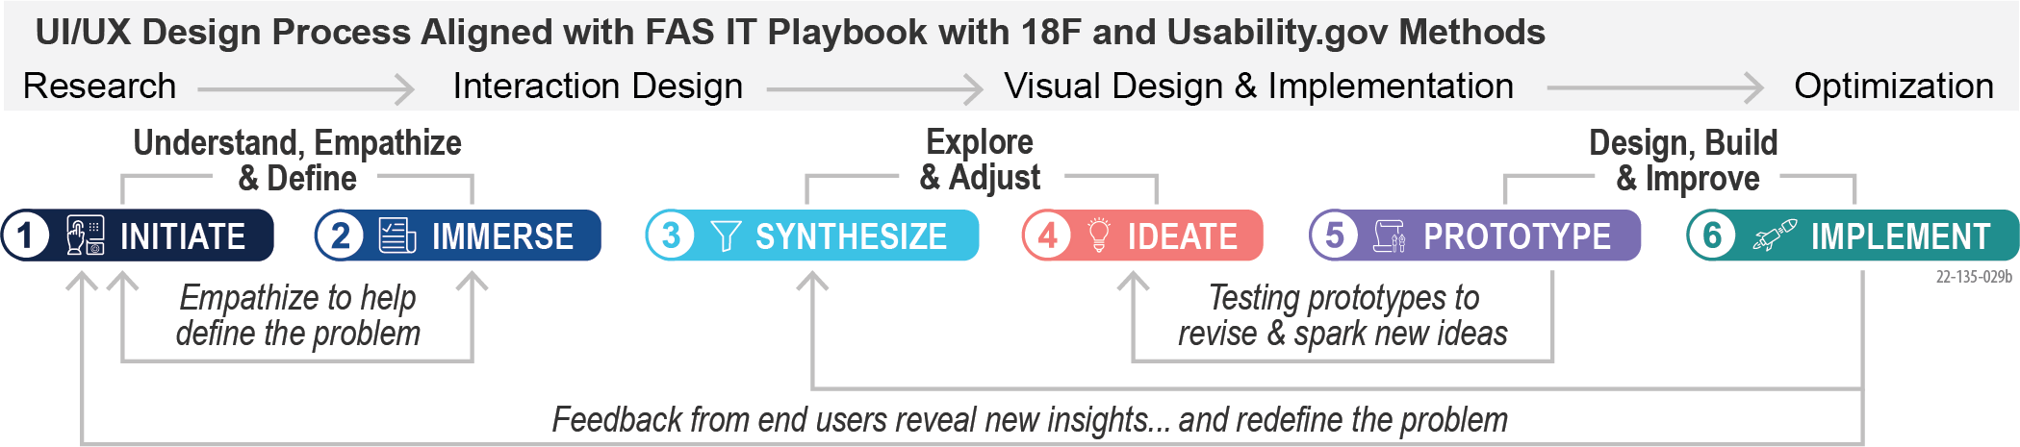

Figure 5: Team REI's HCD System Design – Built from the Human Perspective

This process relies on an inclusive and interactive approach to understanding the user’s requirements through comprehensive user research using tools such as Miro and Dovetail. It involves working with users to interactively create experiences, performing usability testing, and incorporating feedback to drive continuous improvement. The benefits are improved productivity, increased efficiency, and a consistent experience. This improves user satisfaction and increases adoption. We have applied this approach at NASA SBIR to improve Small Businesses’ application submission process, leading to a 15% increase in submissions year over year.

***Cloud-Native Microservice Chassis for Consistent Capability Implementation.*** We use a composable architecture with Domain-Driven Design (DDD) for functionality across Pre-Award, Post-Award, IA/Engagement, and Funds/Financial value streams via loosely coupled microservices. We apply a microservice template (“chassis”), depicted below in **Figure 6,** as a best practice from cloud-native design patterns. This ensures consistency of the design, implementation, and integration standards.

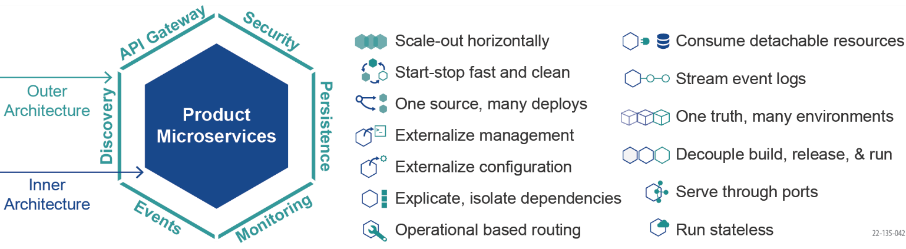

Figure 6: Cloud-Native 12-Factor Microservice Template (“Chassis”) Approach

The chassis sets secure defaults for a high degree of automation in the deployment and operation of each microservice. It is comprised of two fundamental parts: an “outer” architecture to integrate shared services and an “inner” architecture to implement core product functionality. Our proposed cloud-native architecture, infrastructure, and delivery elements are depicted in **Figure** **7** on the next page. Our architecture and development patterns are aligned with the FAS IT Playbook and comprised of a cloud-native implementation using DDD to refactor and decompose services effectively.

The “outer” architecture leverages platform and shared services, such as search, Artificial Intelligence (AI) / Machine Learning (ML), and event flow, via standard APIs used as out-of-the-box capabilities without tightly integrating the microservice to the implementation of these services. We parameterize and inject configuration through a Kubernetes Operator to support automated operation, maintaining only intentional, secure deltas between the development and production environments. We keep the microservice’s “inner” business logic and data schemas flexible to support future changes in requirements, including the introduction of new and innovative services. We enhance our microservices using open-source technologies such as Spring Boot, Java, and Angular.

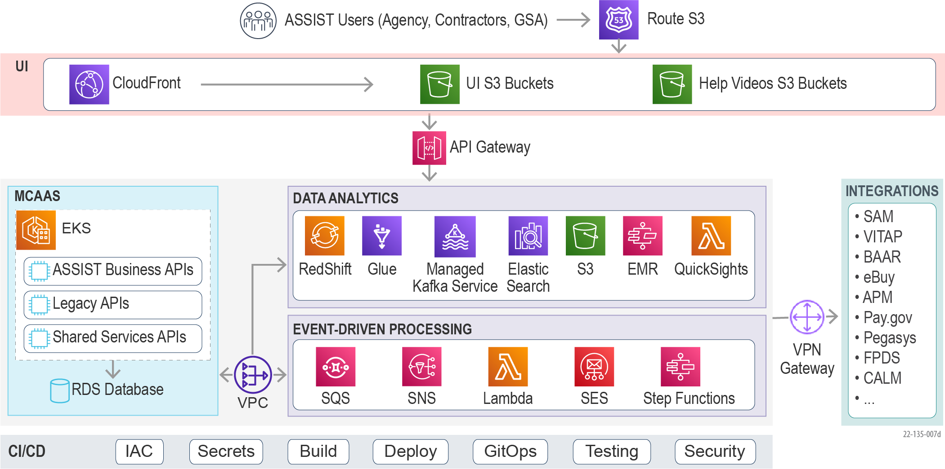

Figure 7: Cloud-Native Architecture – Creating Loosely Coupled Microservices Built on the FCS

This architecture has proven highly successful at multiple agencies, including GSA (IAE and TAMS), HRSA, USCIS, the U.S. Agency for International Development (USAID), NASA, and the Department of Energy (DOE). For the USCIS ELIS platform, we use 12-factor microservices chassis as a common microservices initializer to create common deployment, operations, observability, and secret management. This consistency helped us adopt new tools such as Hashicorp Vault, migrate to Amazon Elastic Kubernetes Service (EKS), and address Log4J issues rapidly. This enabled business agility and achieved important enterprise security and standards.

#### Approach to Automate Functional Gaps

The ASSIST 2.0 modernization resulted in capability gaps that require users to take manual steps, such as the gaps in Request for Information (RFI) Management, Debrief Management, and Undelivered Order Reviews Management. As ASSIST evolves for new contract vehicles and scales for additional acquisition growth, gaps must be identified and addressed to support increasing acquisition demands.

***Process Optimization.*** Our domain experts use **AOF** process optimization techniques such as business process modeling and Value Stream Mapping (VSM). VSM visually captures current processes and identifies process and resource wasters to inform redesign and optimize “to be” processes. When designing the target state, we factor in roles, work products, data requirements, workflows, internal controls, best practices, and FAR compliance. We ensure that technology simplifies work by automating and assisting business users instead of simply replicating their existing processes.

***RPA.*** Repetitive, low-value, and mundane tasks can be automated using RPA. As shown in **Figure 8**, Team REI uses our RPA framework to analyze, rationalize, design, and implement process automation.



Figure 8: Team REI’s Process Automation Framework – Delivery of High-Quality Results

For example, this framework can be applied to streamline the automation of pricing submission evaluations in ASSIST. We have applied this process on NASA SBIR to automate manual tasks for finding administrative deficiencies and compliance such as font size, page limits, and required attachments in the SBIR review forms. We have also leveraged RPA to identify duplicates and answer repetitive questions submitted by vendors. Using this approach, we have reduced the validation time for NASA SBIR reviewers by 80%. We have also established an RPA CoE at USAID, using the UiPath Orchestrator, which has resulted in a streamlined platform with governance.

***Complex Acquisition Workflows.*** We propose to implement complex workflows using a pluggable architecture using reusable, composable components. We also intend to use services such as AWS Step Functions to create intelligent features such as automated decisions and automated approvals when certain business rules are met. This approach allows us to implement complex multi-step and non-FAR acquisition workflows rapidly.

#### Approach to Data Analytics and Visualization

The current Data Analytics capability relies on legacy BIRT-based reports and needs additional navigation steps outside of ASSIST and offline Excel manipulation for decision making. Furthermore, it does not use FCS capabilities natively. To improve decision-making, AAS seeks to implement visualizations such as Acquisition and Solicitation Dashboards, as well as analytical tools such as Option Exercise trends and predictions.

Team REI creates a modern, cloud-native Data and Reporting capability in ASSIST 3.0 in our **AOF** basedon the FAS Enterprise Data Architecture and FCS-D platform. Team REI utilizes FCS to build a data lake in AWS S3 for ASSIST using transactional, operational, user action, and search data. We implement an AWS RedShift-based analytics data store and analytical views using AWS QuickSight to provide seamless access to business users for operational insights. The visualizations are embedded directly in ASSIST screens, exported to Excel, or viewed in an Analytics Portal. Natural Language Processing (NLP) techniques can be built into this platform to validate and extract contents from vendors’ submitted documents. Additional details of our approach to creating the Data and Reporting Platform can be found in **Section 1.4 Sample Task**.

Team REI has created innovative cloud-native data analytics and visualizations at USCIS, GSA, the Federal Emergency Management Agency (FEMA), and HRSA. We have implemented a data bank and reporting for GSA IAE and created an award-winning MDAP in HRSA. We have implemented a USCIS ELIS Operations dashboard that provides visibility into the workload for USCIS adjudication officers.

#### Approach to Improve Integration Across Applications

ASSIST 2.0 does not include integration with all the necessary systems such as eBuy Interface, SAM

Opportunities, SAM Exclusions, SAM Entities, and CPARS Interface, resulting in duplicate data entries. Further, ASSIST needs integration with the G-Invoicing Interface as well as improvements to the Federal Procurement Data System (FPDS) and Pegasys. Team REI is uniquely qualified for low-risk implementation of these interfaces through our current support of SAM.gov as well as our Pegasus/Momentum integration at DoJ and the US Marshals. We use a cloud-native architecture in the **AOF** with the following methods based on interface needs**.**

***API Based Integration.*** We implement real-time API calls from corresponding business services. Business Services use Technical Shared Services for error handling, data storage, and any other helper methods. For example, we can use SAM entity management APIs to get information for registered entities that have Unique Entity IDs (UEI) generated already. We propose to use this method to integrate ASSIST with eBuy and SAM opportunities and entities.

***Batch Job.*** We use Batch jobs to execute a sequence of functions on a recurring basis. We use AWS CloudWatch events to set up CRON jobs, which trigger a Step Function to execute Lambda functions as a state machine. For example, we can use batch jobs to retrieve CPARs data without APIs.

***Event-Driven Asynchronous Services.*** We use event-driven asynchronous services to support triggered events, such as changes in underlying data provided by a service. For example, when a new vendor registers in ASSIST and a UEI needs to be generated, multiple steps are needed to get the DUNS numbers and then generate the UEI. In those cases, an event-driven async integration approach is recommended. We propose to leverage this approach for financial integration with G-Invoicing.

Team REI has successfully used this flexible approach at USCIS ELIS to interface with multiple real-time and asynchronous interfaces. At USCIS, ELIS leverages event-driven architecture using Kafka and ActiveMQ for asynchronous integration between various services and systems, including a payment interface between USCIS ELIS and the Treasury to track payment of immigration fees.

## Team REI’s Approach to Addressing the PWS Requirements with Minimum Performance and Cost Risk

Team REI applies our **AOF** to execute PWS requirements. Our **AOF** is based on CMMI Level 3 and ISO standards for quality and process consistency. Our **AOF**, introduced in **Figure 3** and expanded to show DME and O&M in **Figure 9**, integrates Program Management, SAFe Delivery, and Change Management across delivery activities.

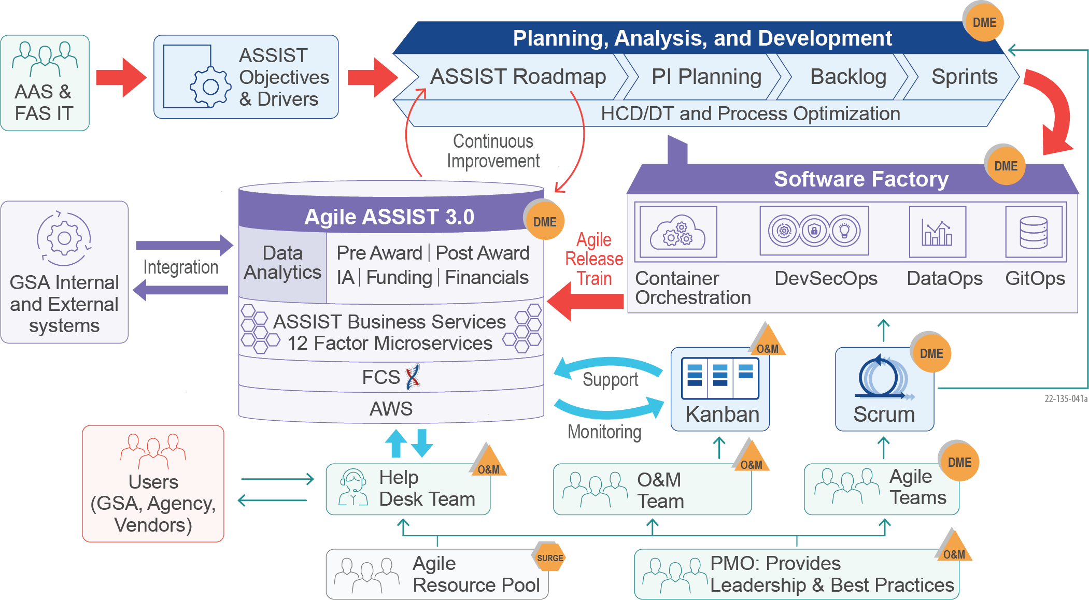

Figure 9: Team REI AOF for DME and O&M for High Performance and Low Risk

When using SAFe methodologies, our **AOF** brings rigor and repeatability for predictable delivery outcomes through strict adherence to Agile ceremonies, such as PI Planning, backlog grooming, daily standups, demos, and retrospectives. We leverage Agile Scrum for DME tasks, prioritizing scope with customer input with delivery time-boxed to balance predictability with uncertainty. We leverage Agile Kanban for O&M tasks to maximize the efficiency of work in progress. We apply comprehensive management, quality, and reporting standards and controls across all projects and report our status and progress in a uniform manner. This gives GSA stakeholders the transparency they need to make effective decisions on prioritization, allocation of resources, and performance.

We describe how we perform DME to meet ASSIST priorities in **Section 1.3.1**, how we operate and maintain ASSIST effectively in **Section 1.3.2**, and our strategies to meet surge demands in a timely manner in **Section 1.3.3**.

### Provide Development Modernization and Enhancements (PWS 2B.1)

Team REI uses our **AOF** to drive rigor in rapidly designing and delivering a cloud-native Technology Platform with an enhanced UX, implemented through Agile processes. We describe our DME approach in **Section 1.3.1.1** and our approach to Business Analysis and Emerging Technology in **Section 1.3.1.2**.

#### ASSIST System DME

***SAFe Methodology.*** Team REI structures our DME staff into Product Teams for independent execution, coordinated and aligned at the Program level through SAFe ceremonies. Team REI synchronizes PI Planning across teams to effectively plan staff time, establish a common understanding of priorities, and identify reusable capabilities across products to ensure efficient value delivery. An optimized Program cadence is developed through this approach that aligns with the quarterly PIs. Our Release Train Engineer (RTE) ensures that planned releases align with a fixed Agile Release Train (ART) schedule for predictable, high-quality releases. Product Teams work in two-week sprints, demonstrating working solutions at the end of every sprint.

***DME Approach.*** We use a framework of tools, technologies, and practices described in **Figure** **10** to create ASSIST 3.0, comply with the FAS IT Playbook, and meet optimization requirements.

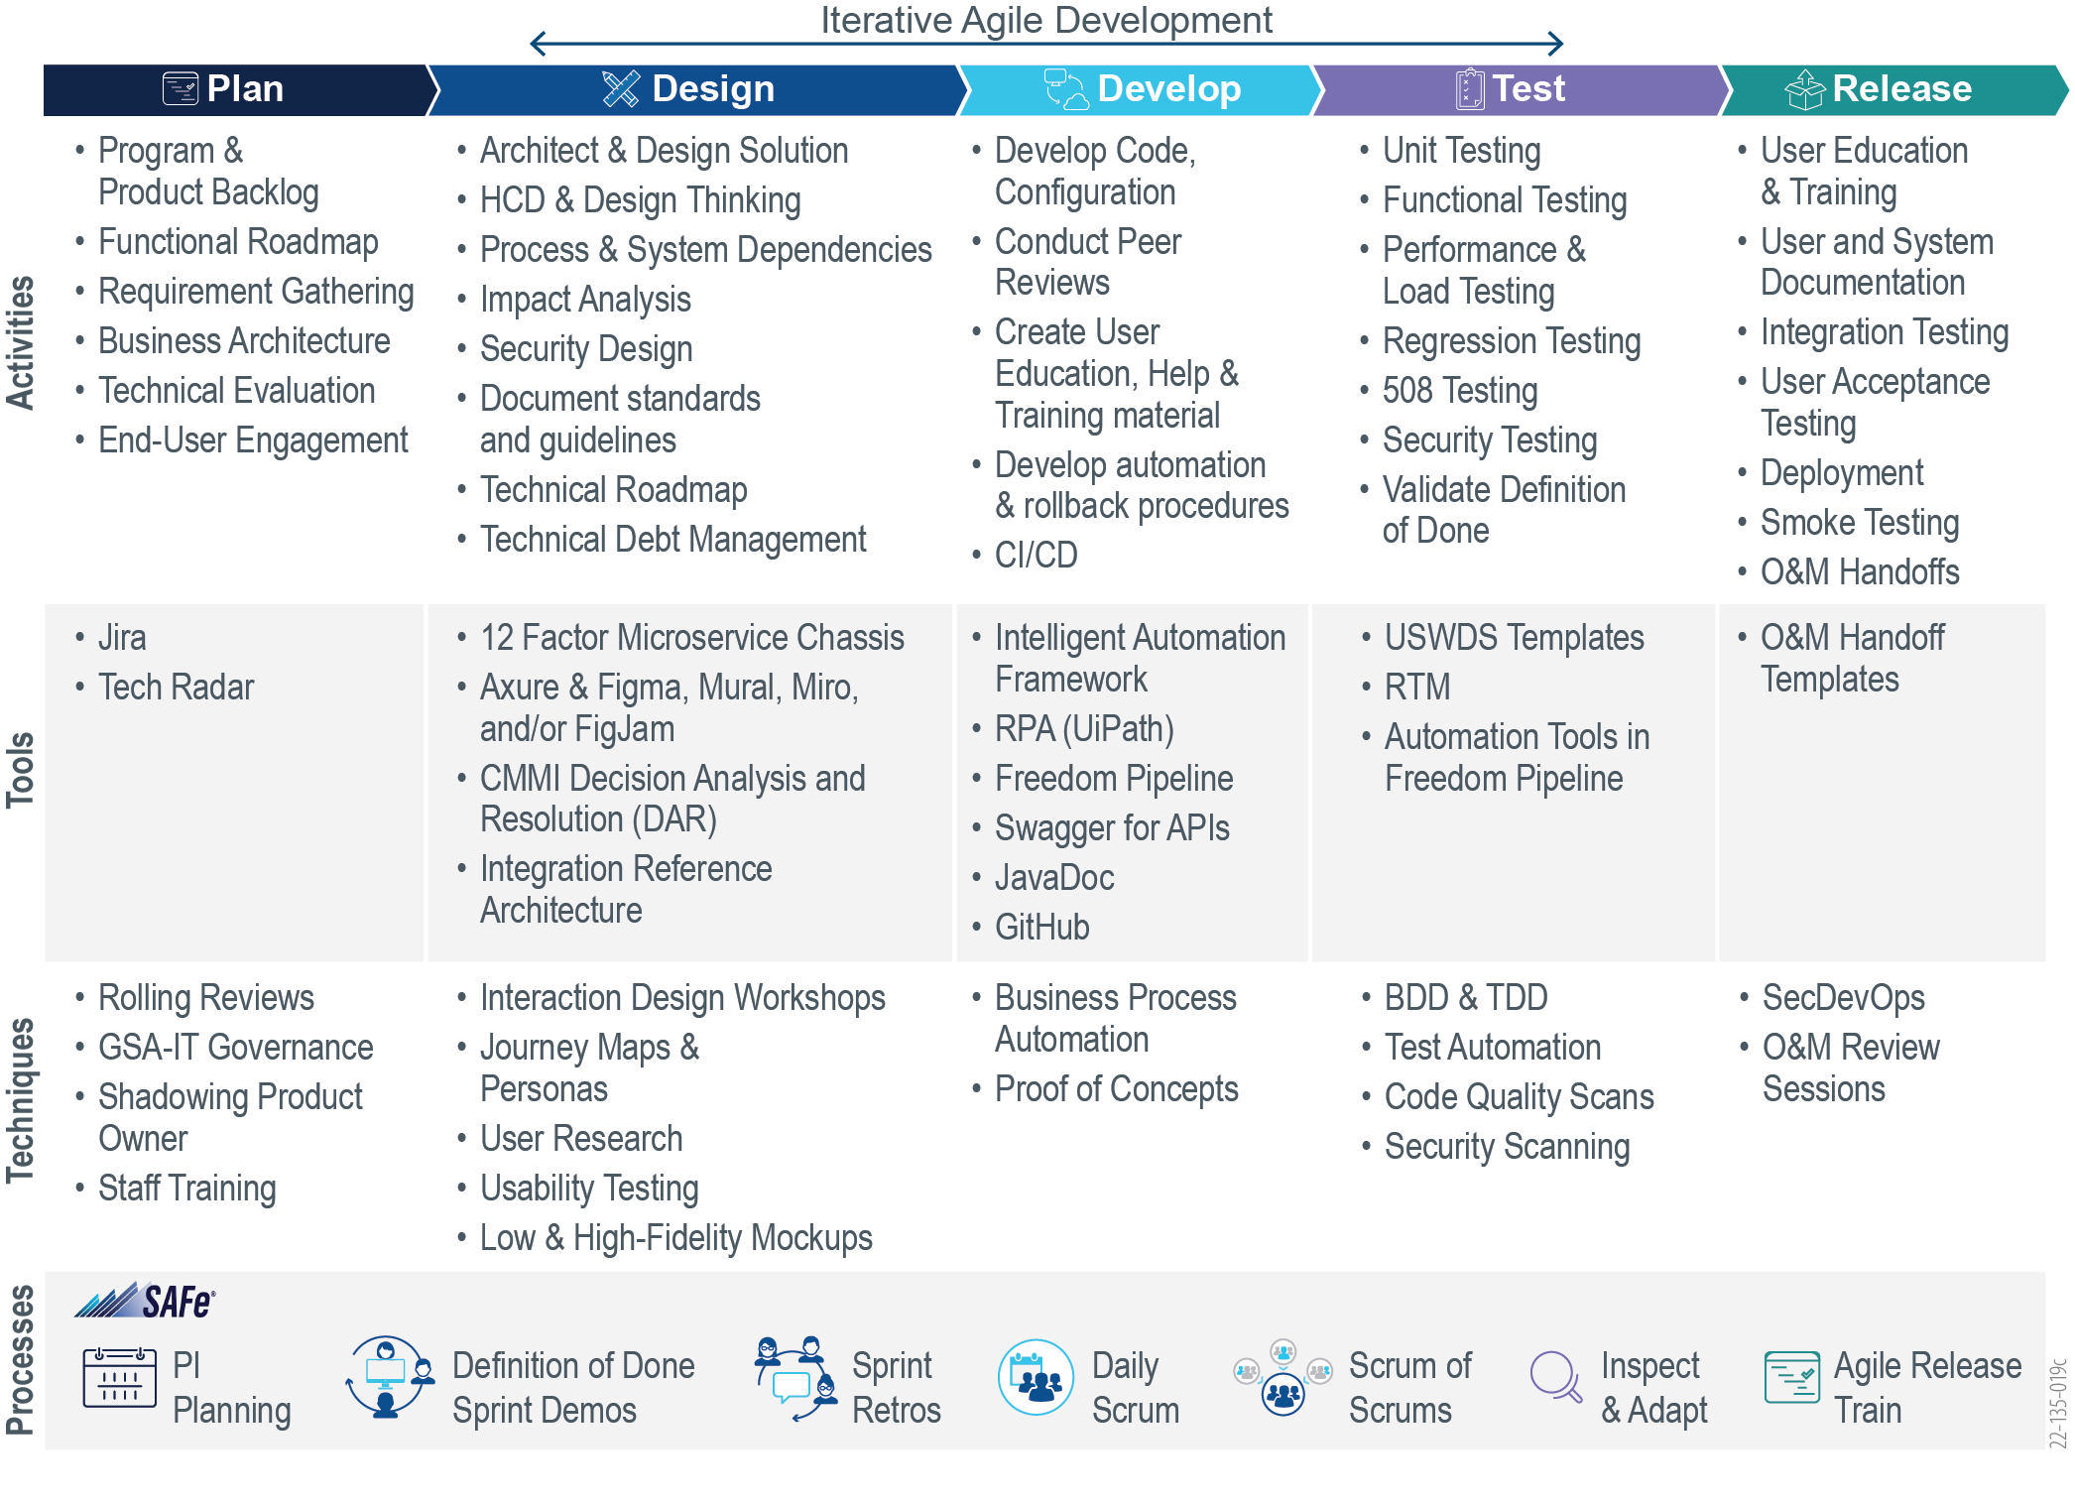

Figure 10: Team REI’s DME Approach to Executing PWS Requirements

We incorporate design in active development and meet user story acceptance criteria in each sprint. We ensure code is continuously integrated and tested to achieve a 100% releasable product every sprint and enforce a feedback loop of product innovation and enhancements with every release that contributes to the backlog for further optimization opportunities. Our end-user engagement includes enterprise and industry feedback to fully capture optimization needs. We use techniques such as shadowing the AAS Product Owner to provide decision support in prioritizing roadmap items. We continuously cross-train staff to reduce the risk of product roadmap imbalances and single points of failure. Our approach emphasizes continuous integration and delivery to improve UX, product, and process quality and reduce time-to-market through frequent feature deployments and reduce the cost of changes.

***Year 1 Priorities and Roadmap.*** We apply our DME Approach above to implement ASSIST Year 1 priorities as described on the following page in **Table** **4.**

Table 4: Team REI’s Approach to Realize Year 1 Priorities

| **Optimization Priorities** | | **Key Activities, Tools, Techniques, and Benefits** | **Similar Experience** |
| --- | --- | --- | --- |
| **Business Priorities** | **G-Invoicing** | * Establish Exchange Formats & Feed Requirements (ex: Forms 7600 A/B) * FMESB & Pagasys/CGI Momentum Integration & Reconciliation * Integration Management Plan * Benefit: Quicker and low-risk G-Invoicing implementation | **DoJ, USCIS ODOS**  *Team REI implemented CFO Control Tower at DoJ and Pay.gov interfaces at USCIS.* |
| **FAS ID and SecureAuth** | * Integrations Scenario Analysis and Use Case Development * Okta Authentication and RBAC Authorization Design * OIDC, OAuth, and SAML Standards and Patterns * MFA Flow and Device Design * GSA AD and FCS AWS IAM Integrations * Documentation to support Upstream & Downstream systems * Benefit: Enhances security posture of ASSIST | **HRSA, Administration for Children and Families (ACF), GSA IAE**  *At ACF, our SSO solution was successfully integrated with six other ACF Applications.* |
| **Registration Module Modernization** | * User Research (Journey Maps, Personas, and Mockups) * Microservice and Micro Frontend Design * Search design and implementation with tools such as Elastic Search and/or AI/ML-powered capabilities * Shared Service APIs * USWDS and 18F Templates * OCM Techniques to achieve standardization & adoption * Benefit: High user satisfaction, consistency, and adoption | **DOL, USCIS ODOS, GSA IAE**  *At HRSA, improvements to the recipient portal, including landing page and registration, led to User Satisfaction increasing from 65% to 90%.* |
| **Search Optimization** |
| **COR Management** |
| **Usability Improvements** |
| **Technical Priorities** | **Stabilize ASSIST in MCaaS** | * End to End Observability and AI/ML-powered monitoring * Configure telemetry to monitor all layers of Tech Stack in all environments * OpenTelemetry (Prometheus/Grafana) * Policy and Configuration as Code * Service Discovery and Sidecar Pattern * Zero Trust Security & Micro-Segmentation, mTLS encrypted communication * Benefit: High maintainability & security of ASSIST | **USCIS ODOS**  *Team REI implemented AI/ML models to inspect logs to rapidly identify Root Causes, improving Mean Time to Recover (MTTR) and minimizing the impacts of costly service disruptions.* |
| **Oracle to PostgreSQL Migration** | * Data Refactoring and Custom Code Rationalization * Evaluate against known challenges and PL/SQL objects * Schema Analysis and Conversion (AWS SCT) * Data Migration Service (AWS DMS) and ETL (Glue/Pentaho) * Develop data validation scripts to compare source and target systems * Parallel Testing (Simulated A/B) * Cutover, Maintenance, and Management Planning * Benefit: High data quality, low-risk migration | **NASA SBIR, DoD SBIR, IAE Data Warehouse**  *For NASA, we migrated 2,600 tables from Oracle to PostgreSQL. We developed custom scripts to automate data migration and validation, saving 95% of manual effort and costs from database licensing.* |
| **Microservice Refactoring** | * Domain-Driven Design Principles * Strangler Pattern and Service Broker to loosely couple Services * 12-Factor App Microservice Chasse * Containerization and Orchestration best practices * Benefit: High business agility from granular roadmaps | **GSA IAE, USCIS ODOS**  *For IAE, we successfully refactored 10 SAM legacy Award Systems into a platform of integrated microservices, improving the UX.* |
| **SecDevOps Maturity** | * Current state analysis of ASSIST on Freedom Pipeline * FAS IT Playbook and FCS Assets reuse and maturity * Roadmap for measured and gradual Automation * Pipeline tooling and configuration enhancements * CI/CD Automation Scripts development and reuse * Feature Toggling capability to promote zero-downtime deployments * Evaluating and adopting Blue/Green or Canary deployments * Monitor, measure, and realign the deployment frequency * Benefit: High business agility and deployment quality | **USCIS ODOS, GSA IAE**  *On ODOS, we successfully matured the SecDevOps pipeline to support zero-downtime deployments.*  *At IAE, we successfully enabled feature toggling features for on-demand deployments.* |
| **Zero Downtime Deployment** |
| **Data Analytics Platform** | * Current state analysis, user research of BIRT, GSA FCS-D * Data Governance, Sharing, Quality, and Reporting * Collaborate and align with GSA SMEs and Data Architects from FAS Data Evidence and Governance Board (DEGB) * Integrate Analytics Platform with ASSIST Portal with APIs, and ETLs * Roadmap to deliver Visualizations, report development * Benefit: Actionable insights, high data quality, a scalable data platform | **GSA IAE**  *On GSA IAE, we implemented a petabyte-scale data analytics platform in AWS RedShift Cluster to host 170GB of data, 92M Records, and 2TB of unstructured data, two million files.* |

We understand ASSIST DME requirements are diverse and demand high-performing Product Teams and a high degree of alignment and integration with ASSIST Product Owners. Using our DME approach summarized above, Team REI proposes to achieve these priorities with nine Agile Teams, as illustrated notionally in **Figure 11** below. We balance the Agile teams and engage the right mix of expertise and capacity to execute both business and technical priorities.

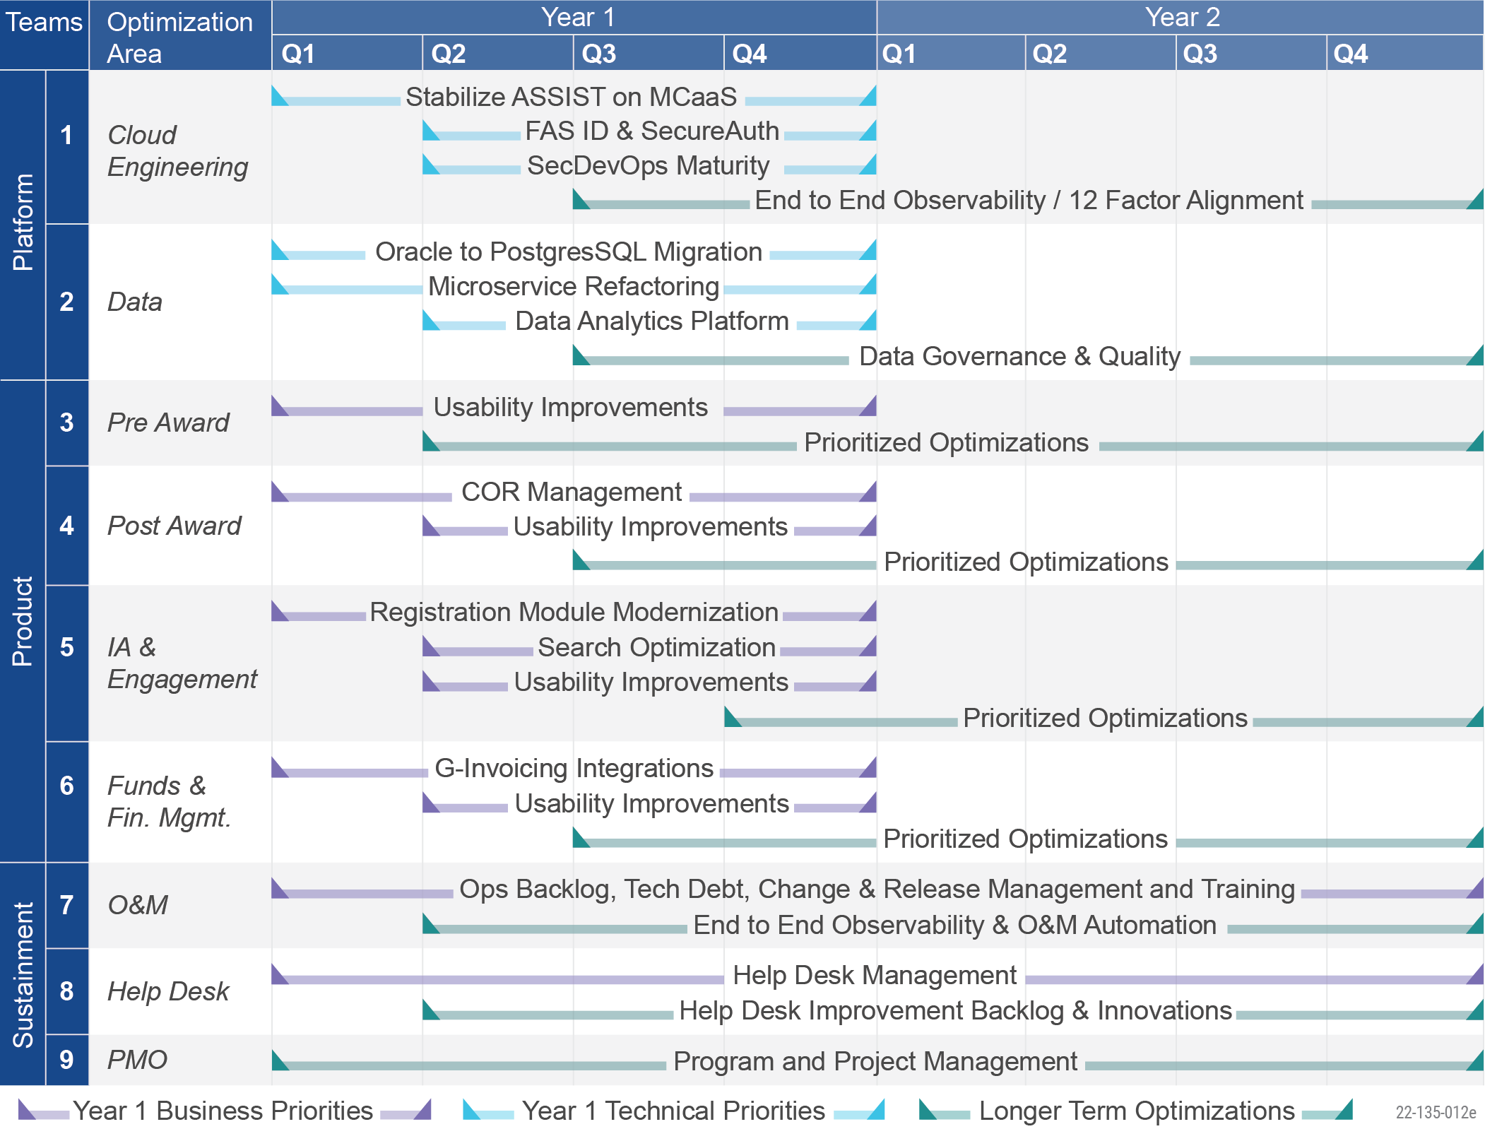

Figure 11: Team REI’s Roadmap for ASSIST Optimization Through Optimal FTE Footprint

Our proven SAFe delivery approach integrates experienced teams and best practices to effectively plan and deliver DME objectives to ***minimize performance risk while achieving high-cost efficiency***.

#### Business Analysis/Emerging Technology DME (PWS 2B.1.2)

***Business Analysis.*** As shown in **Figure 12** below, we follow a consistent planning and analysis process from our **AOF** for business analysis. Our Product Teams collaborate with ASSIST end-users and stakeholders to understand and evaluate requirements and address gaps in workflows, functionality, and integration opportunities.



Figure 12: Team REI’s Comprehensive Approach to Business Analysis/Emerging Technology

We document areas of improvement in an ASSIST Innovation Hub in Jira for tracking and visibility. We conduct a Feasibility Review and Impact Analysis for every item and possible solution based on the best available data. This analysis supports the prioritization of the various options. For every plausible option, we assess the risks to estimate risk-weighted benefits to avoid tunnel vision in our recommendations. An example of this approach might be the use of AI to conduct fuzzy searches of similar acquisitions.

Our team members interact with system users via user Workshops, Observation, UCD, Rapid Prototyping, Discovery and Requirements Sessions, and Surveys to understand their current customer experience issues and develop personas, journey maps, and service blueprints to define problems. Based on the defined problems and prioritizations, we then use an ideation process to brainstorm and identify a viable solution for each item and describe metrics and measures for validation. We then use storyboarding and prototyping to convert rough sketches to high-fidelity mockups. This approach ensures we continue to create User-Centric Customer Experiences in ASSIST.

REI Success - Analysis of Alternatives (AoA)

In collaboration with GSA Federal Aqusition Institute (FAI), REI conducted an AoA to study existing business process deficiencies and presented alternatives with a cost/benefit analysis of the recommendation. FAI implemented our recommendations to transform a fragmented process into a unified one, reducing the application footprint and O&M costs.

*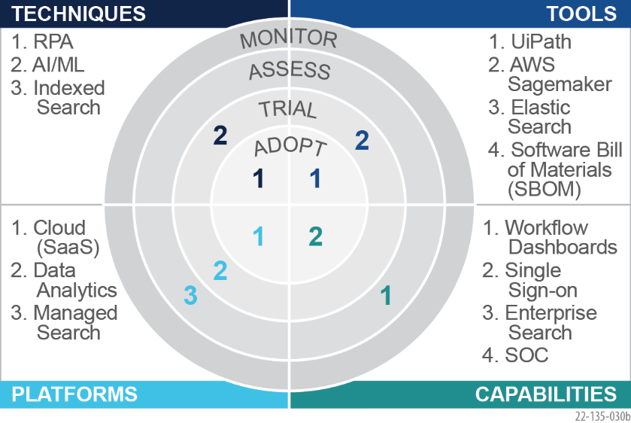****Emerging Technology.*** We leverage a best-practice Tech Radar approach as illustrated notionally in **Figure 13**. After initial assessment and hypothesis, we develop backlogs for Proofs-of-Concept (PoCs) or Prototypes in the Innovation Hub to evangelize ideas and engage Product Team resources to trial solutions. We guide our teams to measure effectiveness in the trials to determine whether to operationalize the innovations. Once proven, we contribute the validated technology to the FAS ecosystem for other applications. We provide below a few examples for ASSIST enhancements.

Figure 13: Notional Tech Radar for ASSIST

***RPA.*** Leverage RPA to automate tedious tasks such as proposal compliance validation or integrate systems such as FAS vendor experience and capabilities from past performance (CPARS) and market research (MRAS) systems to avoid switching between systems to gain speed and productivity.

***AI/ML.*** To provide end-users tools to efficiently search the existing acquisitions database, AI-powered NLP Intelligent Search engines, such as Bidirectional Encoder Representations from Transformers (BERT), can be leveraged. ML models can be leveraged to analyze workflow logs to generate critical insights on bottlenecks and processing times. We use predictive analytic models such as Classification, Clustering, and Forecasting, when generating revenue and expense forecasting.

***Context-Aware Help.*** System users benefit from situation-specific, concise help (how-to video or relevant textual help), reducing the dependency on the helpdesk or reviewing tedious how-to manuals. AI-powered NLP techniques can be leveraged to allow users to ask a question for help.

Our repeatable process for improvement identification and constant focus on identifying useful, emerging technologies ***lowers adoption risks and ensures consistent delivery of improvements***.

### Operations and Maintenance Support, Including PMO and Help Desk

AAS requires IT strategies and services to ensure that the mission-critical ASSIST is available, reliable, secure, and maintainable, and adapts to future needs. We provide our approach to O&M in **Section 1.3.2.1**, Project Management Office (PMO) in **Section 1.3.2.2**, and Help Desk in **Section 1.3.3.3**.

#### Operations and Maintenance (PWS 2B2.1)

We apply our **AOF** for O&M using the detailed approach described in **Figure 1****4** below. We developed this approach by leveraging our experience in managing O&M for large and complex mission-critical systems such as NASA SBIR, HRSA EHBs, and GSA IAE. Our approach organizes each of the critical O&M activities into four core elements to achieve ASSIST 3.0 sustainment objectives.

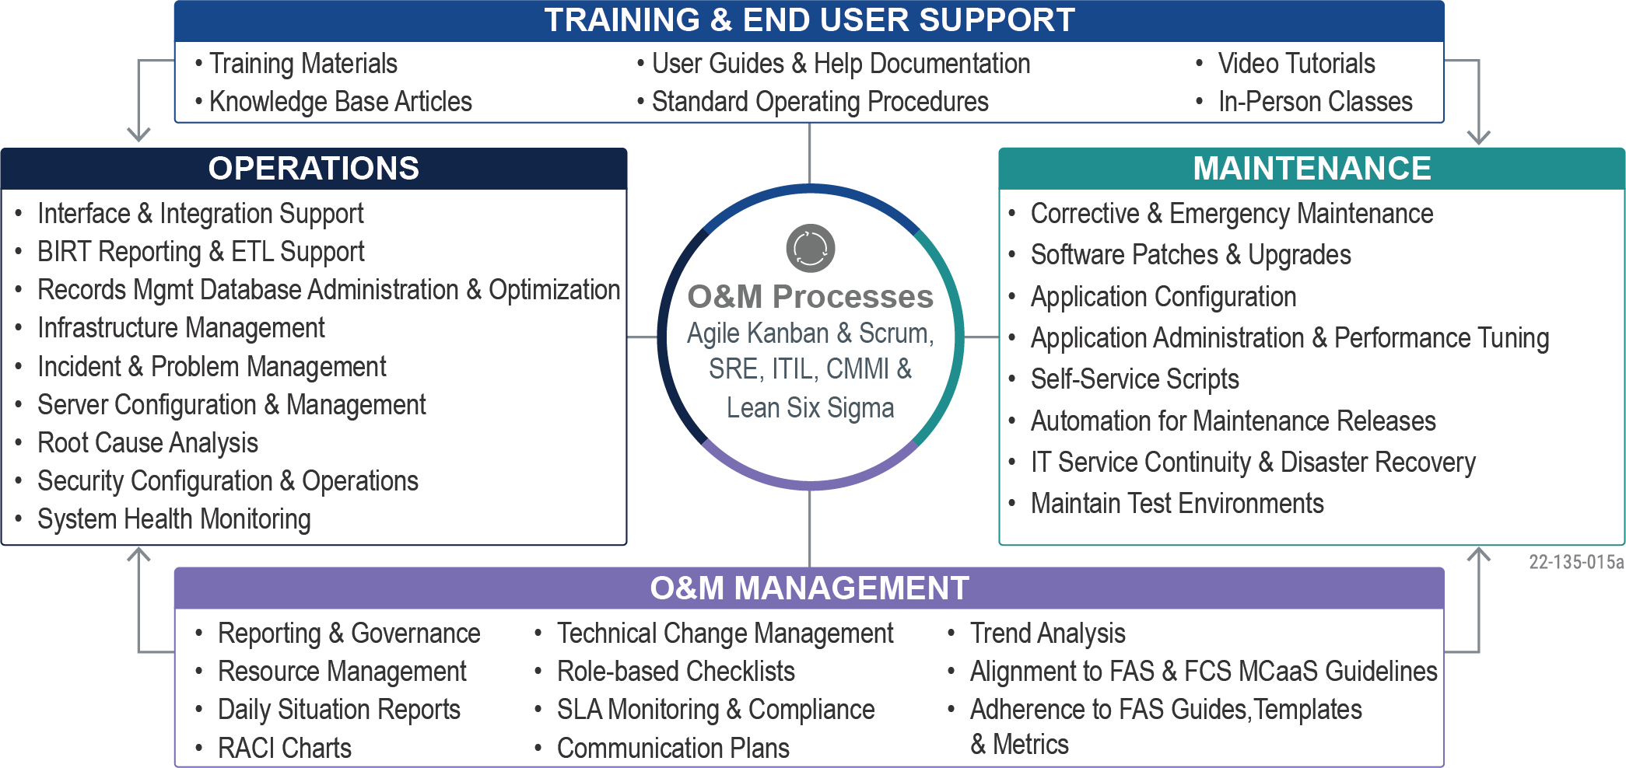

Figure 14: Team REI’s O&M Approach Provides Enhanced Efficiency and Continuous Improvement

***O&M Management.*** Our O&M Team leverages Agile Kanban methodology for operations tasks and Agile Scrum for planned releases. We implement systems management best practices such as SRE, ITIL, and Lean Six Sigma to sustain ASSIST to achieve high stakeholder confidence, ensure predictability, and lower performance risk. Our task management approach features a rapid ‘grab and go’ of tickets in ServiceNow, enabling efficient remediation of bug fixes and minor enhancements. Kanban forces teams to prioritize and resolve bottlenecks caused by too much Work in Progress (WIP), ensuring that team capacity is not exceeded. This reduces service delivery risk and maintains a sustainable pace throughout the program. This leads to greater predictability for team members, end-users, and stakeholders. We provide performance metrics, defined in **Appendix A Performance Metrics**, with full visibility and transparency through our automated program dashboard in Jira. We collaborate with FAS and FCS Stakeholders to provide recommendations and help mature the Freedom Pipeline and implement recommendations from FCS. As described in **Section 1.3.1.2**, we leverage the Tech Radar approach to introduce new tools for O&M in concurrence with FAS leadership.

***Maintenance.*** Team REI meets ASSIST objectives for efficient release management and robust configuration management using key maintenance activities, such as corrective, emergency, predictive, and general application maintenance practices. We keep interfaces up-to-date and include any changes in upcoming releases. Upon receipt of maintenance tickets, we conduct a detailed evaluation and analysis of the ticket to determine the incident type (e.g., defect, enhancement, or maintenance), the priority (e.g., emergency or planned), and the resolution. The evaluation includes an impact analysis for related systems and estimating the level of effort to resolve the issue or request. Our processes include thorough regression testing, special event testing such as disaster recovery testing, new software or hardware testing, and patching for any defects resulting from changes in enterprise tools, such as upgrades to COTS products or modifications to hosting platforms or technologies. We leverage GSA-approved testing tools and create/update the automation testing library for productivity. We assist FAS leadership with the planning, setup, and testing of Disaster Recovery regions for mission-critical applications, tools, and data. We keep system documentation up-to-date with every release.

Database Tuning and Performance

At HRSA, REI-led Database Optimization activities led to a **25%** improvement in the core application response time.

***Operations.*** The operations element of our approach incorporates activities for database, server, and security administration; backup validation; and configuration management, in addition to system health monitoring, performance tuning, IT service continuity, and service recovery for comprehensive service support. We provide comprehensive support for application patching and application security fixes on the environments. We collaborate with FCS when modifications to IaC are required for security or patches. We leverage FAS recommended tools and FCS guidelines to monitor MCaaS deployed product and test environments at all the layers of the application stack (i.e., application, data, and infra layers). We follow FCS records management guidelines and maintain/tailor Standard Operating Procedures (SOP) from the incumbent to meet the objectives. As part of DME, we mature the ASSIST system with Zero Trust Architectures (ZTA) and perform the necessary monitoring and scanning in each pillar of ZTA. For example, we run security scans of endpoints on various environments using FCS-approved tools at scheduled intervals to perform Continuous Diagnostic Monitoring. We provide vulnerability diagnostics on source code and web applications before major releases.

Rapid Resolution in Log4j Event

Our team successfully deployed patches and conducted regression tests on multiple federal systems in record time during the recent 2022 Log4j security incident.

|  |
| --- |
| Table, timeline  Description automatically generated  Figure 15: Team REI's Training Approach |

***Training and End User Support.*** Team REI’s “One Touch Customer Service” is the focal point for this element of our O&M delivery model and ensures the customer does not have to contact more than one person on our team to solve a problem.We keep existing SOPs up-to-date and enhance them to reduce knowledge gaps. We leverage user research as part of HCD to identify training needs and create maintenance guides and runbooks to achieve standardization and reduce knowledge silos. We establish a ServiceNow Knowledge Portal for O&M to store documentation to support self-service, root cause identification, and problem management.

As depicted in **Figure 15,** our multi-faceted mediums, targeted by user type, ensure the right training and outreach are provided to the right user at the right time. Our training methodology is CMMI compliant and aligned industry-standard Analysis, Design, Development, Implementation, and Evaluation (ADDIE) Instructional Design model. We leverage FAS-approved tools for communications and calendar schedules to publish release training materials and release notes. In collaboration with ASSIST product leaders, our team introduces innovative tools such as GoAnimate to produce 508-compliant help videos for frequently used features.

***Optimizing ASSIST O&M.*** Team REI brings organizational experiences of maturing O&M at multiple agencies to ASSIST 3.0 O&M to meet future growth and complexity challenges and achieve business agility. We envision additional improvements, as summarized below in **Table 5**.

Table 5: Approach to further Optimize & Mature ASSIST O&M

| **O&M Optimization** | **Key Activities, Tools, Techniques, and Benefits** | **Similar Experience** |
| --- | --- | --- |
| End-to-End Observability | * SRE to set up integrated real-time observability instrumentation (metrics, events, logs, and traces) for actionable insights * FCS recommended ServiceMesh architectures and observability tools such as DataDog, Splunk, CloudTrail, Prometheus, and Grafana to continuously monitor the health of the systems' N-S & E-W information flow at all layers and reduce Mean Time to Detect (MTTD) and Mean Time to Recovery (MTTR) * AI/ML log analytics and real-time notifications through Slack integrations * Benefit: Minimizes service disruptions/degradations | **USCIS ODOS**  *At ODOS, we implemented End to End observability to monitor the health state in a single pane of glass through New Relic.* |
| Service Level Agreement (SLA) Assurance and Quality Management | * Performance Reporting of SLA Metrics * ServiceNow dashboard to show near real-time metrics and SLA performance * Automated Dashboards, Visualizations, Recurring Reports, and Trend Analysis * Tier 2 Ticket reproduction capabilities (Production like sandboxes) * FAS recommended templates * Proactive O&M backlog development to exceed SLAs * Benefit: High customer confidence from transparency and expertise | **NASA SBIR, HRSA EHBs**  *For NASA and FDA, we developed and implemented Jira Kanban Dashboards for O&M visibility and automated SLA reporting.* |
| Agility in  Ad hoc requests | * GitOps-driven Environment Management and Pipeline Automation (e.g., Code Quality and Security Scans) to release low-risk changes automatically * Mature processes to quickly support areas, such as Data Extracts, or Train/Support new users * Identified patterns to develop self-service solutions such as Custom Reports or Dashboards * Kanban for optimized ticket processing * Benefit: Empowers users’ data and tools to make decisions effectively | **GSA IAE, USCIS ODOS**  *At IAE, we developed custom Micro Strategy reports, enabling 1,000+ advanced users to create 10,000+ reports.* |

Team REI’s robust O&M approach, coupled with the introduction of automation and Kanban***, reduces operational costs and operational risks while increasing adoption*** through self-service.

#### Project Management Office (PMO) (PWS 2B.2.2)

We understand the success of ASSIST sustainment and optimization requires a capable PMO Team to drive consistency, standardization, and reuse across all products and shared services while proactively managing risks. **Factor 5 Management Approach** describes our approach in more detail. We leverage our CCAIR (Continuously Connect, Cultivate, Architect, Integrate, and Reinforce) OCM approach to promote high user adoption. **Table 6** depicts key strategies we bring to ASSIST. Our use of OCM in the **AOF** provides an interrelated set of actions and activities to inform design and deployment. The holistic planning approach across people, processes, and technology ensures we identify and determine communication tactics to increase awareness, user ability, and understanding.

Table 6: Approach to Implement ASSIST PMO

| **PMO** | **Key Strategies and Benefits** | **Similar Experience** |
| --- | --- | --- |
| Agile Delivery | * Program portal for transparency and visibility * Proactive Risk Management at all levels * Quality Assurance (QA) and Security are integrated into every sprint. * Hands-on technical leadership for governance and standards * Management and reporting of Performance Metrics * Benefit: Low-risk, high-performance delivery | **HRSA EHB, NASA SBIR, GSA IAE, USCIS ODOS**  *At HRSA, we delivered over 50 DME projects in 2021, with over 97% of those projects executed with less than 10% cost variance, based on ITDashboard.gov.* |
| Change Management | * Change Impact Assessments * Process Optimization using Value Stream Mapping * Team REI CCAIR * Benefit: High user adoption |

Team REI’s hands-on technical leadership, true SAFe methodology, and focus on transparency and visibility ***reduce delivery risks and foster high-velocity, high-performance*** Agile teams.

#### Help Desk Support (PWS 2B.2.3)

We have proven experience in successfully transitioning, managing, and maturing medium to large-scale Help Desk operations. Our solution provides a centralized delivery model, depicted below in **Figure 16,** to ensure integrated continuity of service, security compliance, and customer service excellence.

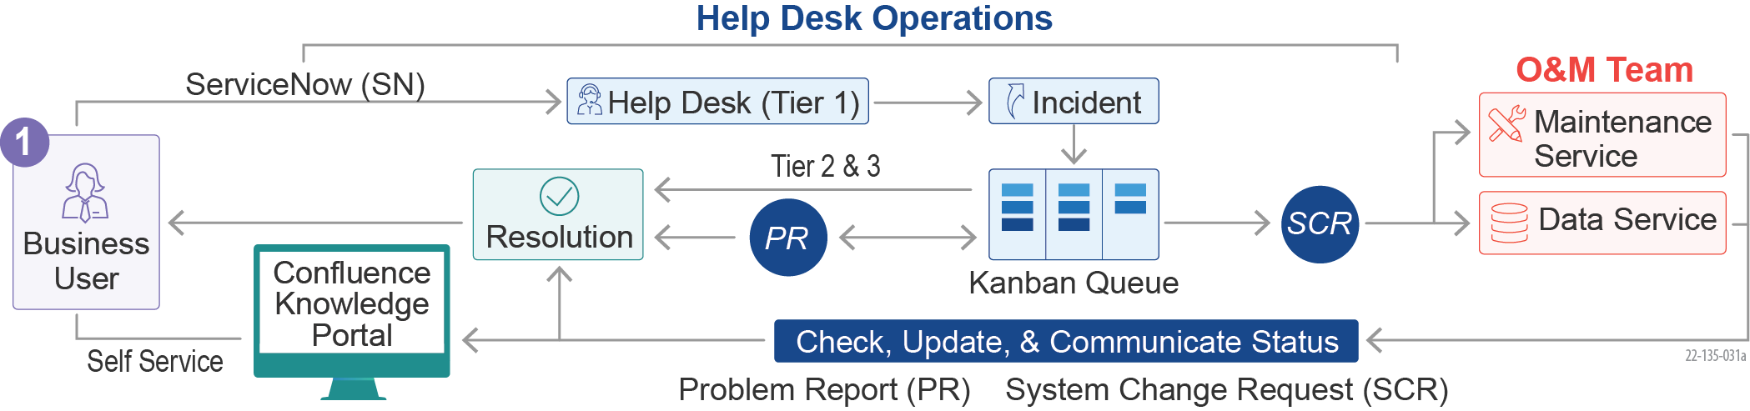

Figure 16: Team REI’s Help Desk Approach Maximizes Responsiveness and User Experience

We work with ServiceNow to transition the existing configurations and data for the ASSIST Help Desk and establish the cloud-based ASSIST ServiceNow (ASNOW) system in the Transition phase, and integrate the Mitel tool for the Automated Call Distributor (ACD) phone system, Direct Inward Dialing (DID) for call pipeline, interaction recording, warm transfers, and conference call support. Leveraging our experience acquiring ServiceNow licenses for DoJ and USACE, and managing licenses at DoD, we procure and manage the Customer Services Management Professional ServiceNow licenses.

ServiceNow Transition at DoJ

Team REI took over support of an existing ServiceNow Help Desk at DoJ in 90 days. Team REI improved the efficiency of workflows, optimzed the configurations, and increased predictability of services.

Team REI’s Help Desk team includes a roster of technical resources that provide Tier 1 & 2 support Monday through Friday during core and on-call hours to meet the SLA requirements. We ensure our help desk web portal is available 24x7x365 to offer self-service capabilities, guides, and user manuals. We provide ASSIST end-users with escalated support for tickets that cannot be resolved at the Tier 1 Help Desk. Tier 2 support handles data fixes and updates, workarounds, and complex data queries. Tier 3 support handles application code changes, software problems, and defective system capabilities detection. If a change needs a future maintenance release, we create change request tickets for the Maintenance Team. As tickets are completed, Tier 1 verifies with the ASSIST end users that the issue was resolved and receives verification of the accuracy of the completed ticket. We implement a priority escalation process for Very Important Person (VIP) requests by applying techniques such as profile groups, priority tagging, quick lookups, and call routing features.

VIP Requests at US Navy

Team REI implemented a Preventive Maintenance Inspection (PMI) program for priority users that lowered the monthly average of priority user trouble tickets by 33%.

Our helpdesk staff has access to the Knowledge Repository, which has procedures to resolve most issues. We continually update this repository through our QA processes to enhance the closing of all tickets escalated to Tier 2 and Tier 3. The daily updating of the Knowledge Repository from Tier 2 staff aids the Tier 1 Help Desk staff in resolving future tickets.

We leverage ASNOW to capture all technical diagnostics performed and any miscellaneous notes. At the end of the reporting period, Team REI compiles Help Desk data to analyze the tickets and creates reports for effective decision-making. These reports include metrics such as the number of issues received, categorization of types of issues, number of issues forwarded to the government, and unresolved issues and courses of action to resolve the issues. We conduct and collect customer satisfaction surveys to conduct performance assessments and course corrections. We leverage user forums, focus groups, system logs, and user tickets to consistently monitor adoption and user feedback for further fine-tuning, areas of improvement, and enhancements.

***Optimizing ASSIST Help Desk.*** Our **AOF** fosters continuous improvements to optimize and mature the ASSIST Help Desk. As illustrated in **Table 7** on the following page, our team brings experiences of maturing Help Desks at multiple agencies to provide a high-performing capability to meet future growth challenges.

Table 7: Approach to Further Optimize ASSIST Help Desk

| **Help Desk Optimization** | **Key Activities, Tools, Techniques, and Benefits** | **Similar Experience** |
| --- | --- | --- |
| Process Efficiency | * Implementation of ITIL best practices * Optimization of SOPs for diverse customer-centric use cases * Ticket Templates and Ticket Grouping rules (e.g., group tickets from security incidents) * Effective Integration with Tier 2 Teams with clear accountability * Benefit: High customer satisfaction and supports growth | **DOL JCDC, FDA SCAIL, NASA SBIR**  *At the Department of Labor Job Corps Data Center (JCDC), we streamlined customer communications into a single ticket with an organized workflow tailored to the JCDC environment, resulting in quicker resolution of incidents.*  *We organized JCDC Technical Assistance Center (TAC) agents based on their expertise and used Cisco Unified Communications Manager to route callers to the right TAC agent based on the nature of the call. If the TAC agent was busy, callers had the option to transfer to another agent for a shorter wait time.* |
| Self-Service | * Foster self-service in multiple channels * Mature Self-help knowledge base (FAQs, How-to Guides, Flow diagrams) * Innovative tools such as AI and RPA-powered chatbots (e.g., Access Management, password reset tasks, etc.) * Benefit: Reduces customer wait time |
| Service Innovation | * Profile groups to customize service level and effective call routing * ServiceNow and Jira Integration to develop Kanban backlog for further analysis * Voice and ServiceNow Integration for quick lookup and call redirection * AI/ML Incident classification for effective queue and resource assignment * Benefit: High customer confidence from personalization |
| Customer Success | * Focus group feedback * Feedback Analysis, Review, Plan, and Action * Optimization of backlog development and prioritization of customer satisfaction (e.g., a separate EPIC in Agile delivery) * Benefit: Highly adaptable Help Desk for customer needs |

Our proactive roster scheduling, the addition of self-service features, and close collaboration between the O&M and Product teams ***reduce risks of disruption and increase response speed*** for users.

### Surge

Team REI understands that business priorities, technical priorities, and user volume can change as AAS adjusts to evolving customer needs and growth. Our O&M and Product Teams serve as the building blocks to support the delivery of variable capacity, including surge situations, as described in **Table 8.**

Table 8: Approach to Addressing ASSIST Surge Needs

|  |  |  |
| --- | --- | --- |
| **Surge Scenario** | **Key Strategies, Techniques, and Benefits** | **Similar Experience** |
| Unplanned Surges from change deployment or adverse events | * Repeatable Program Onboarding for quick ramp-up * Emergency Drills before high-risk rollouts * Call rosters and on-call resources across the team * Proactive identification of critical areas of surge impacts * Corrective Action Plan development and execution * Proactive multi-channel communication on documentation, FAQs, and ticket notifications * Lessons learned shared across teams * Benefit: Meeting service objectives with minimal disruptions | **GSA IAE, USCIS ODOS, USPTO Trademark Product Line (TMPL), DOL JCDC**  *At JCDC, we leveraged O&M and product teams to handle unplanned surges from new change deployment and exceeded customer expectations.*  *At IAE, ODOS, and TMPL, we deployed additional Agile Teams to meet the demands of new feature releases and fast-track DME activities, achieving high customer confidence.* |
| Planned surges of new GSA applications and service implementations | * Staff rotation and cross-training of O&M and Product Teams for new feature releases * OCM Techniques and self-service assistance * Additional staff added to existing Agile teams to balance experience * Reprioritizing product backlog to rebalance the load * Benefit: Smoother transition and quicker user adoption |
| Planned surges from new features and innovations | * T-shape skilled talent pool to handle multi-functional areas * Proactively building capacity through internal training, recruiting, and badging * Corporate reach back for bench resources, recruiting, and staff rotations * Benefit: Smoother transition and quicker user adoption |

Our continuous collaboration with ASSIST stakeholders to proactively predict and prepare for resourcing needs for planned or unplanned surges ***reduces risks of support gaps and increases assistance*** for users.

## Sample Task Approach

### Understanding of the Data Visualization and Reports Modernization Sample Task

GSA’s ASSIST is a complex, mission-critical acquisition system used by 6,000+ federal procurement personnel, 1,400 GSA Contract Officers, and 24,000+ vendors. ASSIST’s complex acquisition data is viewable through 60+ standardized reports created from 800+ relational tables. ASSIST currently uses the legacy BIRT platform for data reporting and analytics, which requires users to navigate into BIRT, away from the ASSIST screens where they perform their daily tasks.

Team REI’s Proven Data Insights Platform

REI conceptualized, designed, implemented, and led the adoption of the Modern Data Analytics Platform (MDAP) at HRSA that won the *ACT-IAC Igniting Innovation Award* in 2018.

The MDAP unified 20 data sources and reduced time-to-insights by 40% for HRSA.

AAS seeks tomodernize the reporting capability to a cloud-native, intelligent reporting platform that can provide data and insights directly on the ASSIST screens for easy access and improved productivity. For example, seeing invoice burn rate data for each vendor directly on their contract page in ASSIST would alert GSA staff to immediately act on issues in low or high burn rates without additional clicks or navigation. Additionally, AAS seeks to leverage the FCS for better scalability, reliability, and operations of the reporting solution.

### Technical Approach for the Sample Task

Armed with our practical experience with FCS through implementations in the GSA IAE and TAMS programs, Team REI implements a cloud-native, FAS IT Playbook-compliant, modern Data Analytics Platform for ASSIST using the FCS ecosystem. This platform provides self-service capabilities, a consistent user experience, and advanced reporting functionality such as drill-downs. Our technical architecture establishes robust data governance and a single source for ASSIST data reporting needs. We migrate ASSIST transaction data to our platform and develop an automated, custom report migration process for the 60+ existing reports.

#### ASSIST Data Analytics Platform

Team REI creates the ASSIST Data Analytics Platform (ADAP), leveraging the FAS Enterprise Data Architecture and FCS-D platform, as depicted in **Figure 17** below

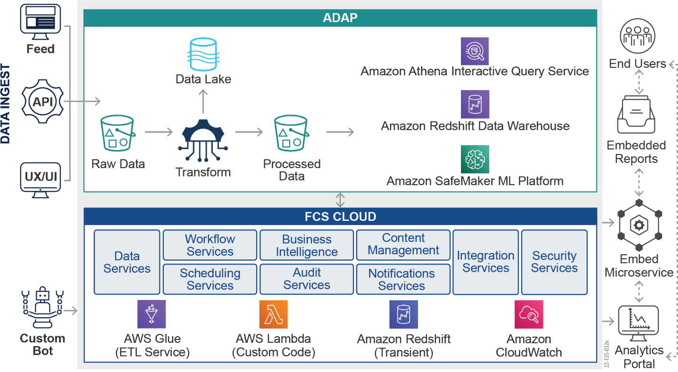

Figure 17: Team REI’s Technical Design for the Modern ADAP

***ADAP.*** Team REI utilizes FCS capabilities to build a Data Lake in AWS S3, which captures data from multiple ASSIST data sources using transactional, operational, user action, and search data. We implement an Amazon RedShift-based analytics data warehouse that surfaces analytical views using AWS QuickSight for operational business insights. We deliver additional capabilities by leveraging Natural Language Processing (NLP) techniques using Python (TensorFlow or PyTorch frameworks) and AWS SageMaker to validate and extract contents from submitted Vendor solicitation documents.

***Data.*** Team REI develops the ADAP for data ingesting, migrating, aggregating, standardizing, and visualizing for insight generation. We leverage AWS Data Ingestion Services to load the data from different sources, like FPDS-ATOM, MIS-GSS, XSB Advantage, FSS-19 VAF, and FSS-19 CMG, to the Data Lakes. We envision maintaining two separate zones in the Data Lake for raw and processed data. We leverage AWS Glue to transform and migrate the raw data into data marts and create data sets linking to the processed data for visualizations.

***Data Governance.***While the ADAP enables the sharing of data, the future state also needs a set of policies and procedures to bring in new data, make that data accessible to others, and manage data quality. Team REI’s data governance approach is based on the best practices defined in the Data Management Book of Knowledge (DMBoK). We implement data quality management by utilizing the source metadata and data definitions in the data marts and then in the visualizations. We ensure data availability, accessibility, and usability to enable sharing for all credentialed users (internal and external) to have timely, authorized access to the right data as needed. We establish quarterly working groups with AAS Data Stewards to define data elements associated with each service area and make key decisions on the format, sharing, access, and use of data.

***Reports and Dashboards.*** Team REI uses data visualization best practices from American Institute of Graphic Arts (AIGA) and Transforming Data with Intelligence (TDWI) to present, support, and communicate customer data for comparison, composition, distribution, and relationship mapping. BIRT requires custom Java and JavaScript to develop visuals, whereas QuickSight empowers data analysts to develop reports and dashboards through an intuitive user interface. Such capabilities improve the user experience and reduce development effort. We create an **Analytics Portal** that hosts all the reports and dashboards created in QuickSight in one place. They can be exported to Excel or PDF or downloaded for offline viewing. Reports can be pinned or organized as favorites, recently accessed, or last updated.

|  |
| --- |
| Logo  Description automatically generated with medium confidence  Figure 18: Report Migration Approach for Existing Data and Reports |

***Embedded Visualizations.*** The reports and dashboards created by QuickSight can be embedded directly in ASSIST screens, where users perform their daily tasks. We employ User Research conducted by our UX Specialists to identify the best location and data needed for placement. Team REI delivers an Embed microservice that embeds QuickSight visualizations directly on ASSIST screens and the Analytics Portal. This microservice generates Section 508 compliant views of the reports.

***Self-Service.*** We implement a self-service analytics capability using QuickSight by organizing the transactional acquisition data into data marts and then creating datasets that are linked to the organized data in a single layer for easy access. The capability allows ASSIST users the ability to create their own reports and organize the available transactional data for their specific analysis and reporting needs. This reduces time-to-insights and improves decision-making in the acquisition process.

***Reports Migration.***as As shown in **Figure 1****8,** our approach includes using the RPA tool UiPath to migrate the existing 60+ reports to the ADAP. This innovative approach speeds up the migration of reports from weeks to hours, reduces risk, and significantly lowers implementation costs.

Team REI’s Reports Migration Automation Framework

On the GSA IAE program, REI developed a Reports Migration Automation Framework (RMAF), an RPA solution for data migration of 16K reports created by 1,500 users, eliminating thousands of hours of manual re-creation in the new tool.

Our automated Reports Migration approach follows four steps:

* **Extract.** We create custom bots in UiPath to automate metadata extraction from BIRT. The custom bot maps the legacy metadata to the QuickSight metadata, ensuring the accuracy of migration. This helps reverse engineer visualizations and produces insights into the attributes and calculations used in BIRT.
* **Transform.** This step is the starting point for rebuilding the visualizations within QuickSight. The metadata is passed as parameters to the QuickSight Application Programming Interface (API), which accelerates the creation of the assets, such as data sources, datasets, and data scripts.
* **Load.** Once assets are re-created, Data Analysts create charts and visual components. After the new components are created, they are uploaded to QuickSight dashboards.
* **Validate.** Team REI leverages the UiPath Test Center to run automated test scripts on the loaded visualizations and data dashboards. We conduct usability testing with end-users to ensure completeness of migrated data and intuitiveness of the visualizations.

***Implementation.*** Team REI leverages the DME approach outlined in **Section 1.3.1 DME** to design, develop and release the ADAP. We ensure user engagement in each step, incorporating feedback from testing and usage in the ADAP Product Backlog.

Team REI’s modern ADAP, built in compliance with the FAS IT Playbook, provides rich visualizations to users in ASSIST, where and when they need data for decision-making. Our ADAP provides visibility into the acquisition lifecycle, financial management as well as staff workloads for AAS.

### Staffing Approach for the Sample Task

As described in **Section 1.3**, Team REI uses SAFe’s ceremonies and activities to achieve alignment in planning and execution with ASSIST Product Teams and leverage the Agile Scrum methodology to execute this task in two-week sprints. Team REI establishes an Agile Data Platform Team to execute the sample task in nine months, over three PIs, as depicted in **Figure 19**.

|  |
| --- |
| Table, timeline  Description automatically generated  Figure 19: Implementation Activities and PI Timeline |

Based on our Technical Approach above and our understanding of the FCS-D, we estimated the effort of PI 1 to establish the new ADAP. Leveraging our experience in automated migrations, we create the Reports Migration bots and begin Reports Migration for one service area (ex: Pre-Award) in the next PI. In this PI, we also enhance the ADAP with Self-Service functionality and prioritized improvements based on user feedback from the first PI. We migrate the Reports for the remaining three service areas in the last PI, along with prioritized ADAP enhancements from user feedback in the last two PIs.

The Data Platform Team requires specialized skills with QuickSight to design, implement, and roll out the new platform. This team is also responsible for migrating existing reports using bots and developing new reports that are published on the ADAP. We staff this Agile team with the following roles:

* Two Data Engineers with AWS and UiPath experience
* Two BI Developers with AWS experience
* One Business Analyst
* One Quality Assurance
* Scrum Master (shared)

# Factor 2 – Management and Staffing Plan (RFQ 3.1, F2, PWS 2A.3.1)

AAS aspires to become a federal agency’s center of excellence for assisted acquisition across the U.S. Government. To achieve that goal, ASSIST requires continuous optimization to meet the demands for excellence that agencies have come to expect from GSA, FAS, and AAS.

AAS is experiencing unprecedented business growth, and as the use of ASSIST grows, the platform must be able to scale to meet the demand and adaptability needed to support more complex and diverse acquisition solutions. Achieving ASSIST’s objectives requires finding and keeping the right resources to ensure the highest levels of delivery excellence, innovative solutions, and excellent customer service throughout the contract.

REI Builds Trusted Relationships

*“Team REI certainly established for me the standard by which contractors should be measured. REI has always been, and I’m sure will always be, a group of people who strive for excellence and achieve it.”*

Libby Harnett – Project Officer, HHS/HRSA

Team REI is the ideal partner to achieve the ASSIST objectives.

REI is an employee-owned company that has been supporting federal agencies for more than 33 years. We are unique in our industry. While many of our competitors have grown through mergers and acquisitions – basically purchasing customers and capabilities – our growth has been purely through solid, proven delivery and building trusted customer relationships that span decades. For example, we have supported multiple components of GSA, including FAS, for more than 12 years. Thus, we are deeply familiar with critical FAS processes and procedures such as resource onboarding, the FAS IT Playbook, GSA IT Security, and the FAS Federal Marketplace strategy. We know how to bring the right mix of skills to meet the FAS and AAS objectives through this Staffing Plan. The plan is a comprehensive presentation of the team composition, personnel qualifications, results they will produce, and the benefits to AAS. We developed the plan to fully support the roadmap outlined in **Section 1.3.1.1 Figure 11** and to realize GSA’s Year 1 Notional ASSIST Objectives and Priorities. This roadmap includes Year 1 Business and Technical Priorities and longer-term optimizations, which we included based on ASSIST’s Optimization Needs (**PWS Section 1.4.1**). We conducted a bottom-up assessment of the staffing needs to address the roadmap and all PWS objectives to determine our team composition and appropriate labor mix. While **Section 5.1** providesdetail on how these teams fit into our overall organizational structure, below, we describe our comprehensive Staffing Plan for ASSIST.

Proven Track Record with GSA

REI supported GSA in a successful replacement of DUNS with UEI, one of the most complex government-wide transitions in decades, delivering significant operational savings.

## Cross-Impact Teams

Our Cross-Impact Teams — Technical Engineering Group (TEG), Transition, and PMO — support and impact the entire program.

***TEG.*** A self-led team, our shared SMEs (**Table 9**) serve as technical experts and innovators across the program to drive decisions and coordinate and collaborate between FAS IT leadership and the ASSIST DME and O&M teams. They promote excellence in their respective domains by defining standards for engineering execution, usability, and quality and compliance for all deliverables, all while continuously driving Innovation as a Habit. They provide direct execution support across teams to achieve best practice implementation, alignment with the FAS IT Playbook, and functional and technical guidance.

Table 9: Team REI’s Technical Engineering Group Roles and Responsibilities

|  |  |
| --- | --- |
| Resource Type | Role / Duties |
| **Solution Architect** | Responsible for the development of the reference architecture that meets Digital Services Playbook standards. |
| **Data Architect** | Works closely with the FAS DEGB and aligns ASSIST implementation data standards and quality measures. |
| **HCD SME** | Tailors the USWDS to ASSIST. Ensures teams follow user research standards, facilitation techniques, and system designs, such as promoting high usability and adopting ASSIST product features. |
| **RPA/AI/ML Specialist** | Responsible for analysis of business process automation, AI/ML initiatives and use case development, design of POCs, and implementation plans. Evaluates ASSIST use cases and explores emerging technologies to create business value. |
| **Automation Specialist** | Responsible for maintaining the test automation framework. Works with O&M and DME teams to ensure end-to-end test automation of regression, smoke, and integration testing. |

***Transition Team.*** Comprised of resources from each of our proposed O&M teams to ensure the appropriate focus on each workstream, the Transition Team ensures a smooth, low-risk transition of duties from the existing vendor. These team members eventually move into their respective post-transition team, taking with them the knowledge gained from transition activities. This minimizes post-transition technical and process knowledge gaps and eliminates single points of failure. Our Transition Team Manager, Mr. Sameer Vajre, has led large-scale transitions similar to ASSIST in scope, size, and complexity, the most recent being the 30-day transition-in for DoD’s Defense Manpower Data Center (DMDC) $76M program.

Transition-In Success at FDA

REI successfully transitioned a large program of 225 FTEs at FDA within four months. Our team meticulously planned and executed the transition with the successful capture of key incumbent staff and onboarding of skilled resources to quickly gain FDA confidence.

***PMO Team.*** Led by Ms. Kinny Padh, our PMO Team (**Table 10**) drives the alignment of workstreams with the program vision and common goals by standardizing and streamlining processes, ensuring process compliance, and managing risk. Ms. Padh has 10+ years of experience in structured, process-oriented project management. She is a PM on our HRSA program.

PMO Success on HRSA EHBs

REI’s PMO successfully managed over 150 staff to deliver 350 projects across 54 call orders, achieving excellent and very good CPARS ratings.

Table 10: Team REI’s PMO Team Roles and Responsibilities

|  |  |
| --- | --- |
| Resource Type | Role / Duties |
| **Program Manager** | Accountable for oversight of Team REI’s ASSIST Teams, delivery of PWS objectives, and activities such as performance management, budget management, team harmony, resource realignment, and stakeholder management. |
| **DME Manager / RTE** | Responsible for orchestration and alignment of product and platform teams to deliver business value, identification of dependencies and taking optimal measures, performance monitoring of ART, and ensuring Definition of Done to assess release readiness, etc. |
| **DME Project Manager** | Responsible for planning, leading, and organizing DME teams. Works closely with Agile RTE to synchronize with the ART. |
| **O&M Manager** | Responsible for planning, leading, and organizing O&M and Help Desk Teams. Works closely with Agile RTE to synchronize with the ART. |
| **Tech Writer** | Responsible for producing release documentation and help guides, managing the knowledge portal, and conducting outreach support. |
| **Management Analyst** | Responsible for coordinating and developing performance reports as per schedule, coordinating meetings, tracking deliverables, reporting on Earned Value Management (EVM), and documenting and storing program artifacts. |

## O&M Project Teams

Mr. Sasikaran Muthuchamy will oversee the O&M Project Teams. He has more than 10 years of technical project management experience and is currently overseeing our O&M and Help Desk Teams at NASA, a customer we have been supporting for more than 25 years.

REI Help Desk Success at NASA

REI consistently receives 4+ star ratings as part of the Customer Experience Community of Practice Survey from more than 1,500 responses.

***Help Desk Team.*** This Team (**Table 11**) is the ASSIST front line and face for all users. It has the skillsets needed to provide prompt, accurate, and professional responses to all inquiries and identify improvements needed to enhance customer service. Our team structure accommodates current capacity and future incident volumes to achieve all Acceptable Quality Levels (AQL). In addition to telephone and email support, our Help Desk facilitates training and self-service capabilities.

Table 11: Team REI’s Help Desk Team Roles and Responsibilities

| Resource Type | Role / Duties |
| --- | --- |
| **Trainer** | Develops training materials and tutorials, plans and conducts training, and collects feedback. |
| **Help Desk Specialist** | Responsible for phone, email, chat queue support, ticket entry and updates, and escalation of incidents. |
| **ServiceNow Developer** | Responsible for designing, configuring, developing, troubleshooting, and implementing baseline and custom applications to enhance the ServiceNow platform. |

***O&M Team.*** Our O&M Team (**Table 12**) ensures the effective sustainment of ASSIST with high levels of responsiveness and support in managing the availability, reliability, and security of the ASSIST ecosystem. This team will be primarily responsible for the O&M support of ASSIST’s already modernized services. The team will also optimize and innovate the processes and tools that underpin O&M support.

Increasing Availability While Decreasing Costs

At HRSA, REI’s teams used automated application log monitoring, resulting in system availability uptick from 95% to 99.9% and a 12% reduction in operational costs.

Table 12: Team REI’s O&M Team Roles and Responsibilities

|  |  |
| --- | --- |
| Resource Type | Role / Duties |
| **Business Analyst** | Acts as the Tier 2 liaison, supports the knowledge base, analyzes defects, recommends fixes, supports release planning, and provides product support. |
| **Full-Stack Developer** | Corrects defects, develops enhancements, and provides Tier 2 and release support. |
| **Test Engineer** | Provides Tier 2 support, defect identification and reproduction, and defect/enhancement testing. |
| **Database Administrator** | Provides environment management for data refresh, performs backups, manages access, and applies patches. |
| **Security Engineer** | Conducts security scans, manages configuration, and provides ATO and POA&M support. |
| **Information Security Officer** | Ensures documentation and compliance of security controls in accordance with GSA IT Security policies. Works with GSA IT Security to ensure POA&M is updated with resolutions. |

## DME Project Teams

Our DME Project Teams, led by Mr. Matias Nino, are primarily responsible for optimizing the ASSIST platform. With 20 years of experience in project and program execution, Mr. Nino has multiple Agile certifications and is currently a key leader of GSA’s implementation and adoption of SAFe on the GSA IAE program.

Success of Product Teams on GSA IAE

REI successfully modernized 10 SAM.gov systems on GSA IAE using a Containerized Microservices and HCD approach. The benefits to GSA have been significant: a more modular architecture resulting in more rapid delivery cycles, less technical debt, and lower total life cycle costs.

***Product Teams.*** Our Product Teams (**Table 13**) are self-directed and autonomous in maintaining, managing, and evolving the optimization roadmap for each ASSIST value stream (i.e., Pre-Award Management, Post-Award Management, IA/Engagement Management, and Funds/Financial Management). These specialized teams execute work related to their value stream, ensuring singular focus, increased throughput, staffing continuity, and continual expansion of the knowledge base.

Table 13: Team REI’s Product Teams Roles and Responsibilities

|  |  |
| --- | --- |
| Resource Type | Role / Duties |
| **Business Analyst** | Performs Scrum Ceremonies, requirements gathering, HCD, process and functionality design, functional testing, and Tier 2 support. |
| **Full Stack Developer** | Provides functionality development, unit testing, and Tier 2 support. |
| **Test Engineer** | Responsible for maintaining the test automation framework, automation and manual testing, regression integration testing, User Acceptance Testing (UAT), Tier 2 support, and release support. |
| **Scrum Master** | Performs Scrum Ceremonies, release management, and status reporting. Motivates teams and removes impediments. |
| **Database Administrator** | Provides environment management and provisioning for all data environments. Performs data refresh, backups, and access management. Applies patches for on-prem and cloud databases. |
| **Information Security Officer** | Responsible for vulnerability testing of the code developed for ASSIST functionality. Ensures security controls are documented in accordance with GSA IT Security policies. |

***Cloud Engineering Platform Team.*** Our Cloud Engineering Platform Team (**Table 14**) plays a vital role in realizing Year 1 Technical Priorities, such as stabilizing ASSIST in FCA MCaaS, maturing the Freedom Pipeline, and ensuring Zero Downtime deployments to enable Product Teams to release features quickly. Under the guidance of our Solution Architect, Mr. Sandeep Kumar, this team evolves the roadmap to mature the ASSIST application stack in MCaaS. With more than 15 years of experience in emerging technologies, Mr. Kumar, a Certified Cloud Architect, has led multiple successful modernization projects across federal customers leveraging both open-source and closed-source technologies with expertise in cloud-native microservices architecture. Examples of optimization activities include enabling end-to-end observability in ASSIST products (i.e., containerized microservices) and supporting refactoring of the existing products using 12-factor design principles.

Success of Zero Down-time Deployments at USCIS ELIS

REI applied state-of-the-art engineering best practices in our DevSecOps pipeline to deliver new business features to Production daily with Zero Downtime.

Table 14: Team REI’s Cloud Platform Team Roles and Responsibilities

| Resource Type | Role / Duties |
| --- | --- |
| **Cloud Engineer (CI/CD)** | Performs pipeline maintenance (Git, Jenkins, etc.) and configures and supports CI/CD in test and prod environments. Stabilizes MCaaS and matures the Freedom Pipeline by optimizing existing tools or implementing new tools. Troubleshoots issues, provides platform support and FAS-FCS alignment, and ASSIST platform Roadmap development and execution. |
| **Cloud Engineer (SRE)** | Configures systems to achieve SLAs on availability, latency, performance, efficiency, change management, monitoring, emergency response, and capacity. Develops platform maturity roadmap and backlog and manages technical debt. |
| **Scrum Master** | Performs Scrum Ceremonies, release management, and status reporting. Motivates teams and removes impediments. |

***Data Platform Team.*** Guided by our Data Architect, Mr. Ashish Kaushal, the Data Platform Team (see **Table 15)** plays a vital role in key priorities such as migrating and stabilizing the ASSIST databases from Oracle to PostgreSQL and setting up and maturing a data analytics platform. Mr. Kaushal, certified in AWS Data Analytics, has more than 24 years of experience in data management and is currently the Technical Lead at USCIS for a team responsible for architecting and implementing an enterprise-wide data platform using Kafka. In addition to Year 1 Priorities, the Data Platform Team develops reports, visualizations, and dashboards, and supports data governance priorities.

Success of Data Engineering at HRSA

REI developed an award-winning Modern Data Analytics Platform that provides self-service tools for ad hoc insights on demand.

The time-to-insights metrics have decreased by 95%, thereby enabling business agility.

Table 15: Team REI’s Data Platform Team Roles and Responsibilities

|  |  |
| --- | --- |
| Resource Type | Role / Duties |
| **Data Engineer** | Works with Data Architect to perform Oracle to Postgres migration, supports DBA work, works on data governance initiatives, sets up data platform, develops ETL scripts, and performs ad hoc data requests. |
| **Database Administrator** | Responsible for overseeing the maintenance and security measures of ASSIST Oracle and PostgreSQL databases. Works closely with Data Engineers in support of the Oracle to PostgreSQL migration. |
| **Business Analyst** | Performs Scrum Ceremonies, requirements gathering, HCD, report and dashboard design, testing, and implementation support. |
| **Report/Dashboard Developer** | Supports reporting, dashboard, visualization development, and modernizes BIRT and ad hoc reports. |
| **Scrum Master** | Performs Scrum Ceremonies, release management, and status reporting of Platform Teams. |

## Labor Categories, Labor Mix, and Levels of Effort

Our experience has shown that having cross-functional teams comprised of multi-disciplined resources is key to providing continuity, ensuring efficiency, keeping communications tight, and achieving high levels of predictable velocity. Our labor mix provides the right mix of functional, technical, and management resources to meet the GSA ASSIST Objectives and deliver cost efficiencies in achieving the roadmap for ASSIST Optimization presented in **Factor 1**, **Figure 11**. **Table 16** belowshows the Labor Categories (LCATs), labor mix, and Level of Effort (LOE) needed by each role proposed in our SAFe Agile Team’s composition for the Year 1 and the Option Years. This mix will accomplish the stated optimization goals and performance standards. We have also mapped each Functional Role to the COMET LCAT with the estimated hours for the DME, O&M (including PMO and Help Desk), and Transition Teams. (Note: The TEG supports both DME and O&M.)

Table 16: Team REI’s Labor Mix and Level of Effort

| **Functional Role** | **COMET LCAT** | **DM&E Team**  **(Hours)** | | | | | **O&M Team**  **(Hours)** | | | | | **Transition**  **Team (Hours)** |
| --- | --- | --- | --- | --- | --- | --- | --- | --- | --- | --- | --- | --- |
| **Base** | **OY1** | **OY2** | **OY3** | **OY4** | **Base** | **OY1** | **OY2** | **OY3** | **OY4** | **BASE** |
| Program Manager | Program Manager (Master) | 720 | 960 | 960 | 960 | 960 | 720 | 960 | 960 | 960 | 960 | 480 |
| DME Manager / RTE | Program Manager (Senior) | 1,440 | 1,920 | 1,920 | 1,920 | 1,920 |  |  |  |  |  | 840 |
| Solutions Architect | Solutions Architect (Master) | 1,080 | 1,440 | 1,440 | 1,440 | 1,440 | 360 | 480 | 480 | 480 | 480 | 360 |
| Data Architect | Database Architect (Senior) | 1,080 | 1,440 | 1,440 | 1,440 | 1,440 | 360 | 480 | 480 | 480 | 480 | 360 |
| Scum Master | Agile Coach (Senior) | 2,880 | 3,840 | 3,840 | 3,840 | 3,840 | 1,440 | 1,920 | 1,920 | 1,920 | 1,920 |  |
| HCD SME | UI/UX Designer (Master) |  |  |  |  |  |  |  |  |  |  |  |
| Full Stack Developer, Automation Specialist and Data Engineer | Applications Software Developer (Master) | 8,640 | 11,520 | 11,520 | 13,440 | 15,360 | 1,440 | 3,840 | 5,760 | 5,760 | 5,760 | 2,760 |
| Full Stack Developers | Applications Software Developer (Senior) | 12,960 | 17,280 | 17,280 | 17,280 | 17,280 | 4,320 | 4,090 | 2,419 | 1,920 | 1,920 | 2,160 |
| Full Stack Developers | Applications Software Developer (Journeyman) | 23,040 | 30,720 | 30,720 | 23,040 | 15,446 | 5,760 | 5,760 | 3,840 | 2,164 |  | 1,440 |
| Business Analysts | Business Systems Analyst (Master) | 4,320 | 5,760 | 5,760 | 5,760 | 5,760 | 1,440 | 1,920 | 1,920 | 1,920 | 1,920 | 720 |
| Business Analysts | Business Systems Analyst (Senior) | 4,320 | 5,760 | 5,760 | 5,760 | 5,760 |  |  |  |  |  | 720 |
| Test Engineers | Software Quality Assurance Engineer and Tester (Master) | 2,938 | 3,840 | 3,840 | 3,840 | 3,840 | 2,837 | 3,782 | 3,116 | 3,116 | 3,116 | 480 |
| Test Engineers | Software Quality Assurance Engineer and Tester (Senior) | 4,320 | 5,760 | 5,760 | 5,760 | 5,760 |  |  |  |  |  |  |
| Database Administrators | Database Administrator (Senior) | 3,960 | 3,859 | 3,118 | 3,095 | 3,095 | 360 | 192 | 192 | 192 | 192 | 480 |
| Cloud Engineer (SRE) | Cloud Engineer (Master) | 1,080 | 1,440 | 576 | 576 | 576 | 360 | 480 | 480 | 480 | 384 | 480 |
| Cloud Engineers (CI/CD) | Cloud Engineer (Senior) | 2,160 | 1,507 | 1,507 | 1,507 | 1,507 | 720 | 480 | 480 | 480 | 470 | 1,106 |
| Trainer | Training and Development Specialist (Senior) |  |  |  |  |  | 2,880 | 3,840 | 3,840 | 3,840 | 3,840 |  |
| O&M Project Manager and DME Project Managers | IT Project Manager (Senior) | 2,880 | 3,840 | 3,840 | 3,840 | 3,840 | 1,440 | 1,920 | 1,920 | 1,920 | 1,920 | 1,080 |
| Help Desk Specialists | User Support Specialist (Senior) |  |  |  |  |  | 11,520 | 15,360 | 15,360 | 15,360 | 15,360 | 2,400 |
| Help Desk Specialists | User Support Specialist (Journeyman) |  |  |  |  |  | 7,200 | 9,600 | 9,600 | 9,600 | 9,600 | 600 |
| Information Security Officer | Information Systems Security Officer (Senior) | 720 | 960 | 960 | 960 | 960 | 720 | 960 | 960 | 960 | 960 | 480 |
| Report/Dashboard Developers | Business Intelligence Analyst (Senior) | 2,880 | 3,840 | 2,880 | 2,880 | 2,880 |  |  |  |  |  |  |
| Technical Writer | Technical Writer (Senior) |  |  |  |  |  | 1,440 | 1,920 | 1,920 | 1,920 | 1,920 | 120 |
| RPA/AI/ML Specialist | Solutions Architect (Senior) | 2,520 | 3,360 | 3,360 | 3,360 | 3,360 | 360 | 480 | 480 | 480 | 480 |  |
| Security Engineer | Information Security Engineer (Master) |  |  |  |  |  | 1,440 | 1,920 | 1,920 | 1,920 | 1,920 |  |
| Management Analyst | Management Analyst (Senior) |  |  |  |  |  | 1,440 | 1,920 | 1,920 | 1,920 | 1,920 | 288 |
| ServiceNow Developer | COTS Product Specialist (Senior) |  |  |  |  |  | 360 | 480 | 480 | 480 | 480 | 480 |
| **Total Hours by Base and Option Period** | | 83,938 | 109,046 | 106,481 | 100,698 | 95,025 | 48,917 | 62,784 | 60,447 | 58,272 | 56,003 | 17,834 |
| **Total FTE Count by Base and Option Period** | | **43.72** | **56.80** | **55.46** | **52.45** | **49.49** | **25.48** | **32.70** | **31.48** | **30.35** | **29.17** | **9.29** |

We have carefully selected our labor mix and skillsets to provide stability and continuity on ASSIST for GSA and its federal clients. Moreover, this labor mix will optimize the ASSIST platform to scale to greater demand and incorporate new capabilities in an ever-expanding environment. As the DME Teams complete Year 1 Priorities and migrate to FCS, certain resources such as Cloud Engineers can be reduced. For all O&M Teams, efficiencies will be gained through a stable system with more reliance on automation.

## Proposed Personnel Technical Experience, Qualifications, Certifications, Clearances, and Government Acquisition Experience (RFQ 3.1, Factor 2)

Each of Team REI’s proposed personnel have the required experience, qualifications, and certifications to meet the COMET BPA LCAT and ASSIST Key Personnel requirements. These personnel have an existing GSA clearance or are eligible to receive a clearance. Furthermore, more than 50% of REI’s staff work on government acquisition systems, and/or, as noted in **Section 5.2**, three of our five key personnel have a combined 32 years of government acquisition experience. Details regarding our proposed Key Personnel are found in **Section 5.2,** withKey Personnel resumes, certifications, qualifications, and letters of commitment included in **Appendix A** of this volume.

# Factor 3 – Phase-In / Transition Plan (PWS 2A.3.3)

ASSIST is a complex program with multiple business processes and integrations with external systems. Transitioning this program successfully to a new vendor requires proactive planning, strong customer engagement, focused oversight, and collaborative execution with the incumbent contractor staff, led by an incoming contractor with direct experience transitioning similar programs.

Team REI's Phase-In / Transition Plan minimizes risk given our 12 years of success supporting the GSA landscape combined with our proven track record of successfully transitioning programs just as complex and even larger than ASSIST. We lead from Day 1 using a proven process, leveraging lessons learned from similar transitions, and in complete lockstep with AAS priorities, all while applying the highest levels of communication, collaboration, and relentless attention to detail to ensure mission continuity.

For a comprehensive and successful transition of ASSIST, we use REI's proven transition approach, tailored for AAS and ASSIST, which consists of three phases.

1. In the **Planning Phase,** we ensure transition in and out plans are aligned and that we have AAS concurrence on the approach. We prioritize the identification and onboarding of key incumbent staff.
2. In the **Execution** **Phase**, we acquire detailed technical knowledge of ASSIST and AAS' business processes and understand how the system support them and in what manner. We ensure an understanding of the technical standards, governance requirements, and architectural roadmap. We gradually progress from shadowing the incumbent to reverse shadowing, where we demonstrate our acquired knowledge and capabilities with the incumbent’s support.
3. During the **Closeout** **Phase**, we assume uninterrupted control of work in progress and ensure mission continuity and no break in services to end-users and agency staff.

In this draft Transition Plan, we demonstrate our understanding and recognition of the importance of a comprehensive and non-disruptive Phase-In. Based on our experience transitioning large programs such as FDA SCAIL and DoD DMDC (see callout box) and Help Desks with ServiceNow at DoJ, we know that every transition invariably has risks and unexpected events that we must anticipate and mitigate, which we have done successfully multiple times. Our Phase-In maintains continuity of operations, handles complexities and system integrations, and ultimately supports the timelines of GSA's delivery roadmap after the transition is completed. Our experience and success with other transitions larger than ASSIST equip us with the people, processes, tools, expertise, and lessons learned to ensure success for GSA ASSIST.

Examples of REI’s Recent Transition-In Experience

|  |  |  |
| --- | --- | --- |
|  | **FDA SCAIL** | **DoD DMDC** |
| **FTE** | **225** | **65** |
| **Incumbent Capture** | **61**  **(100% of target)** | **50**  **(94% of target)** |
| **Transition** | **70 days** | **20 days** |
| **Applications** | **30** | **200** |
| **Complexity** | * **Mission-critical** * **24x7 operations** * **6,000+ avg. user support requests per month** | * **Mission-critical** * **65,000+ test cases transitioned** * **Over 800 releases tested per year** |

## Transition Plan

|  |  |
| --- | --- |
| Table 17: Transition Team Leadership | |
| Name | Title / Role |
| **Sameer Vajre** | Transition Manager |
| **Susan Sparks** | Program Manager |
| **Kevin White** | Contracts Manager |
| **Nidhi Khajuria** | HR Manager |
| **Arvind Sethuram** | QA Manager |

Team REI's Transition Plan provides a detailed plan of action and milestones to fully transition the functions listed in the PWS within the 60 business days provided by GSA. Our Transition Manager, Mr. Sameer Vajre, brings significant experience gained from the DMDC Transition. He transitioned the program and its 200 applications in 20 days, and today, DMDC is thrilled with our performance. He is also an experienced Program Manager with 20+ years of experience leading 100+ FTEs modernization and optimization programs. Mr. Vajre mobilizes the delivery and transition teams on Day 1. Team REI provides a dedicated Transition Team, guided by the leadership shown in **Table 1****7**, each with experience transitioning programs similar to ASSIST, to successfully execute all Phase-In activities. Our GSA Acquisition SMEs, Ms. Dunne and Mr. Garland, provide input and recommendations on the Transition Plan for maximum effectiveness and optimum schedule.

This draft Transition Plan defines the scope, high-level schedule, and required tasks. The Phase-In scope includes the transition of documentation, operating procedures, work equipment, environments, databases, code, and other related tools, including the scope described in **Table 1****8**.

Table 18: Transition Scope

| Scope Item | Scope Details |
| --- | --- |
| **Capabilities** | Inter-Agency Agreement, Funding, Acquisition, Solicitation, Award Administration, and Financial Management; Shared capabilities such as data, workflow, business intelligence, scheduling, audit, content management, notification, integration, and security services |
| **Interfaces** | eBuy, Pay.gov, Pegasys, SAM, VITAP, BOAC |
| **Environments** | Two Production environments and 11 Non-production environments |
| **Initiatives** | Usability improvements, integration across applications, consistency of products, automation opportunities, data analytics, app/platform stabilization, database migration to PostgresSQL, and zero downtime deployments |
| **Services** | Operational services such as data support, notifications, and user support |
| **Support Tools** | ServiceNow, Jira, Confluence, G-Suite, Mitel tool for Automated Call Distributor (ACD), phone system, and Direct Inward Dialing (DID) |
| **Governance** | FCS Guidelines, FAS IT Playbook, UI/UX guidance, SAFe delivery |

The Transition Team Leadership is available on Day 1 and takes ownership of Knowledge Transfer (KT). Mr. White, Ms. Khajuria, and Mr. Sethuram provide continuous corporate reach-back support to Ms. Sparks. In collaboration with AAS, we put special emphasis during the planning phase on incumbent hiring to ensure adequate retention of program knowledge held with any high-performing incumbents. Once the Transition Plan is approved by GSA stakeholders, we initiate the Execution Phase and ensure that 100% of the staff required for O&M services are available by Day 45.

**Figure 20** below provides an overview of all Phase-in milestones across the 60-day period, with the workstreams and activities detailed across the three phases of Planning, Execution, and Closeout.

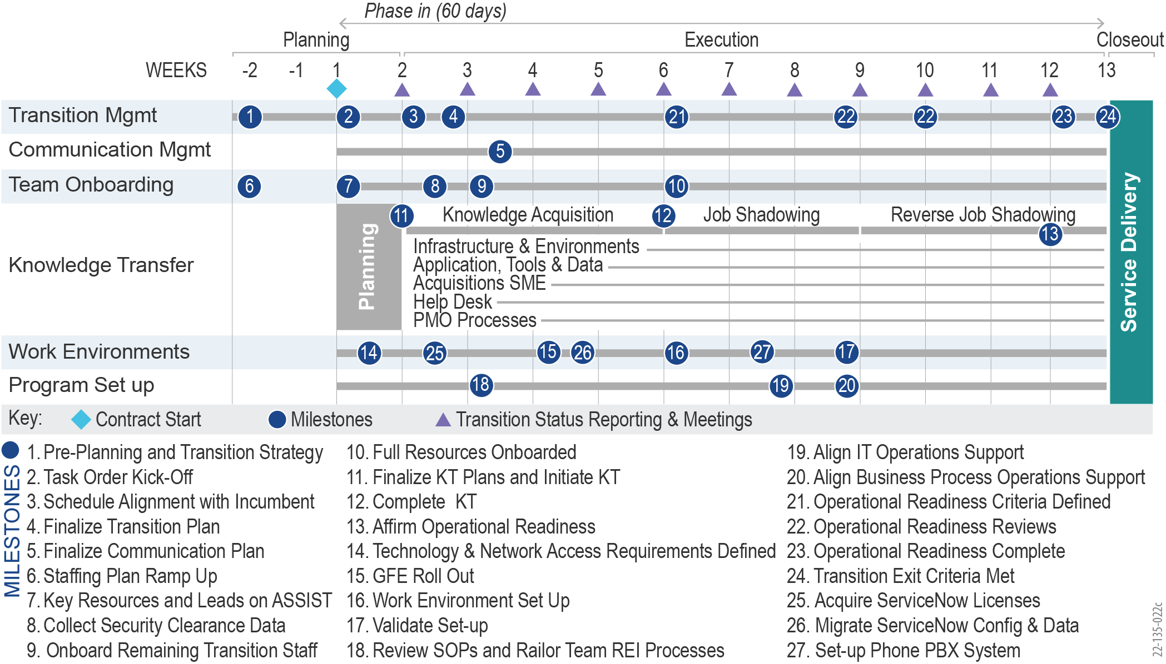

Figure 20: Team REI's Detailed Phase-In Schedule

This is the same strategy and activities we applied for the successful FDA SCAIL and DoD DMDC transitions noted earlier. In the sections below, we describe how we execute all Phase-In activities —from Planning and Execution to Closeout — to ensure a successful cutover for ASSIST within 60 business days after award, with all required deliverables, while maintaining full mission continuity.

### Planning

The ***Planning*** stage of the Phase-In is critical to aligning the transition strategy and finalizing the schedule for the entire Phase-In. The goal of this step is to gain consensus with AAS leadership, align plans with the incumbent and government staff, and set the stage for the successful execution of Phase-In. **Table 19** below summarizes the Planning Phase activities necessary to achieve the desired results.

Table 19: Team REI Planning Phase Activities and Expected Results

| Workstream | Activity | Expected Results |
| --- | --- | --- |
| **Transition and Program Management** | * Conduct Order Kick-off for CO, COR, and Program Leadership. * Conduct Transition-in Kick-off for COR, Program Leadership, and Stakeholders. * Submit Program Management Plan no later than 30 days after award. * Submit Transition-in Plan no more than two weeks after award. * Conduct Transition-in Plan Briefings with COR and Program Leadership for approval. * Identify application environment details and document gaps. * Identify network and production access to environments. * Identify incumbent team members to retain and start the hiring process. * Establish a Transition Governance model and Risk Management Plan. * Submit weekly Transition-in Status Report. | * Approval received for Order execution * Established program delivery methodology and plans * Approval received for Transition execution * Alignment achieved on Transition schedule |
| **Project Management** | * Identify stakeholders and integrate system owners and vendors. * Update and finalize Communication Plan and establish SAFe SOPs. | * Approval received for SAFe execution |
| **Resource Onboarding** | * Onboard staff on a weekly cadence with a one-week Bootcamp for each resource. * Submit security and badging forms weekly and coordinate with COR. * Track GFE status. * Update Staffing Plan weekly. | * Staffing readiness completed for the Transition Execution phase |
| **Knowledge Transfer (KT)** | * Walkthrough and KT schedule with COR, Program Leadership. * Initiate Technical Transition Briefings for Program Overview and Code Review sessions. | * KT sessions scheduled |
| **Service Delivery** | * Identify SOPs repository and document gaps. * Collaborate with GSA and document Cutover Criteria that identify, by transition workstream, the exit criteria to be satisfied and completion dates. | * Consensus achieved for cutover criteria |

### Execution

In this phase, we rapidly execute transition activities across each of the transition workstreams detailed in **Figure 20** above. Our ***Execution*** ensures the identified activities, milestones, and resources necessary for achieving the 60-day transition occur on a timely basis as requested by GSA. We conduct transition activities for Program Management & Integration, Operations/ Data, ASSIST, PMO, and Help Desk in the Execution Phase to achieve results, as summarized in **Table 20**.

Examples of Team REI’s Phase-In Experience

At DoJ, Civil Rights Division, our partner Tripoint Solutions (TPS), assumed support of an existing IT support help desk, which had recently transitioned to ServiceNow ITSM.  The existing implementation of ServiceNow was not optimized or configured to obtain maximum use or efficiency.  TPS analysis revealed inefficient legacy workflows had been migrated without being optimized for the NOW platform. TPS redesigned the processes to support transparency, accountability, and predictability of services. DoJ staff were so pleased with TPS process architecture that they transitioned O&M of the investment itself to TPS in the latest contract.

Table 20: Team REI's Execution Phase Activities and Expected Results

| **Workstream** | **Activity** | **Expected Results** |
| --- | --- | --- |
| Transition and Program Management | * Conduct Program Management activities and program governance. * Update Transition schedule and monitor and report progress. * Validate Cutover Criteria progress, and that objectives are met. * Track application environment access for staff. * Update SOPs for the environment and network access for new staff. * Establish SLAs for ongoing operations and Help Desk. * Acquire licenses and establish ServiceNow for Service Management. * Migrate existing ServiceNow configuration and data from the incumbent account. * Set up a phone PBX system integrated with ServiceNow. * Submit weekly Transition-in Status Report. | * Program Delivery managed during Transition * Transition Governance requirements are in place * All documentation is collected and analyzed * Operating agreements completed (SLAs, etc.) |
| Project Management | * Establish SAFe ceremonies and ensure SAFe Governance. * Submit monthly invoices. * Initiate execution of Communication Plan. * Finalize CPIC and EVM reporting structure if required. | * Methodology set up for Delivery * Insight provided for financials and program performance |
| Resource Onboarding | * Onboard staff on a weekly cadence with a one-week Bootcamp for each resource. * Place special emphasis on incumbent capture. * Submit security and badging forms weekly and coordinate with COR. * Track GFE status. * Update Staffing Plan. | * Program staffing ramped up during the Transition |
| Knowledge Transfer | * Conduct KT sessions and Code Review sessions. * Complete application checklists for the entire system. * Record Briefings and upload them to the repository. * Complete planned Transition Briefings. * Conduct Job Shadowing and Reverse Job Shadowing for Operations Teams. | * KT sessions occurred on schedule * System documentation acquired * O&M Tickets resolved * O&M Releases deployed |
| Service Delivery | * Tailor SOPs with Team REI processes. * Conduct Service Readiness reviews and track progress. * Submit network and production access tickets for staff. * Ensure Cutover Criteria are met. | * Cutover criteria met * Resources setup for work |

### Closeout

The goal of Team REI's ***Closeout*** Phase is to confirm that Phase-In objectives have been met. This includes no break in current service levels, no delay in support for new and ongoing projects, and full support of all services by Team REI. On our transition of FDA SCAIL, Team REI did not need any reach-back support to the incumbent vendor during the Closeout Phase. This was due to the comprehensive KTs and training done by leveraging our “*Application Questionnaire”* to document the details of each application. To achieve an effective close, our Transition Team conducts the ***Closeout*** Phase activities summarized in **Table 21** below**.**

Team REI’s Customer Kudos on FDA SCAIL

“*Thanks to the REI team for your hard work, persistence and working together collaboratively with the incumbent to come to the end of this transition. It has been a lot of hard work, and plenty of adjustments and I wanted to appreciate the effort*.

FDA SCAIL COR

Table 21: Team REI Closeout Phase Activities and Expected Results

| Workstream | Activity | Expected Results |
| --- | --- | --- |
| **Transition and Program Management** | * Conduct Program Management for Program Delivery. * Submit Weekly Transition-in Status Report. * Solicit final approval of Phase-In completion and sign-off from GSA. * Continue Program Governance cadence. | * Program Delivery managed during Transition * Transition process closed out |
| **Project Management** | * Continue SAFe ceremonies and methodology. * Continue providing monthly Financial Reports and monthly metrics. | * Insight provided for financials and program performance |
| **Resource Onboarding** | * Onboard staff on a weekly cadence with a one-week Bootcamp for each resource. * Submit security and badging forms weekly and coordinate with COR. * Track GFE status. * Update Staffing Plan. | * Program fully staffed |
| **Knowledge Transfer** | * Verify access for GSA to the KT recordings repository. | * Rapid onboarding of resources |
| **Service Delivery** | * Cutover to Program Delivery for O&M tasks. | * Program delivery conducted |

## Approach to Maintaining Quality and Minimizing Disruption

Our team employs monitoring tools to determine Phase-In status and success. We understand that it is imperative to have transparency of the transition process across our team, the incumbent vendor, AAS leadership, and stakeholders to transition successfully while maintaining service levels and minimizing disruption. We create a **Transition Management Dashboard** using Jira and disseminate the overall status, health, risks, remaining activities, and service readiness of the transition efforts. We create metrics for each of the workstreams to provide insight during Phase-in. Metrics may consist of the number of incumbents onboarded, the number of roles staffed vs. open positions, KT sessions executed vs. remaining and SLA-based sample response times through service readiness drills performed. Finally, weekly status reporting provides AAS ongoing visibility into progress and Transition-In health.

Team REI provides GSA with flexibility and adaptability to minimize disruptions that can occur. For example, on the FDA SCAIL transition of 225 FTEs, the incumbent resources transitioned out earlier than planned. However, REI anticipated this risk and applied a phased transition approach with rolling cutovers by dividing the applications into four groups spread out over two months. Each phase lasted around two weeks, with the resources and teams focused on transitioning applications in the active phase. This allowed REI to complete the transition in four months (instead of the planned six months) and let us roll over resources from the incumbent contractor to Team REI in a phased and planned manner. The FDA Office of Information Management and Technology (OIMT) stakeholders applauded this pivot in the transition strategy.

Team REI’s Transition Success at GSA

On GSA ECAS, REI completed a successful transition-in within 90 days without cooperation or support from the incumbent vendor. In the first 90 days, Team REI stood up a new GSA ECAS AWS environment, successfully installed GSA.gov, Insite.GSA.gov, USA.gov and GSA Atlassian Suite in the new environment, and obtained the ATO for ECAS AWS platform as well all the applications hosted in the environment. .....

## Development and Dissemination of Operating Instructions, Procedures, and Control Directives

Team REI's transition staff reviews the current available SOPs and documentation about existing processes, systems, and tools. We use the knowledge gained during the KT sessions to identify gaps and areas for improvement. We provide dedicated Training Team members and a Technical Writer to support the effort to address gaps in existing documentation or revise those in place, as appropriate. The team disseminates this information to both internal and external stakeholders.

## Preliminary Risk Assessment and Mitigation Strategies

**Table 22** below summarizes the initial high-impact risks Team REI identified for the Transition-In and suggested mitigation strategies to reduce the impact or mitigate the associated risks. Many of these risks were identified and successfully addressed by Team REI on our transitions for FDA SCAIL, DoD DMDC, GSA ECAS, and other programs. Throughout the Phase-In, our Transition Manager, Mr. Vajre, coordinates with ASSIST stakeholders and the Transition Team to identify, assess, and mitigate risks for the Phase-In. Please see **Section 5.10** for our overall Risk Mitigation Methodology.

Table 22: Preliminary Risk Analysis for ASSIST Transition-In

| **Risk** | **Probability** | **Impact** | **Comments / Mitigation Plan** |
| --- | --- | --- | --- |
| Team REI's Phase-In plan may not align with the Incumbent Phase-Out plan, which may lead to schedule delays in KT sessions. | 3-Likely | 3-Medium | Team REI supports GSA in aligning the Transition-In and Transition-Out plan and provides the final integrated transition plan. |
| The availability of the Incumbent staff for KT activities may impact the schedule. | 3-Likely | 3-Medium | Team REI works with GSA and the incumbent to create a mutually acceptable Transition Calendar. Once the calendar is established, we track the progress and any changes in availability during the daily standup meetings. |
| Not completing transition activities within the desired timeframe. | 3-Likely | 4- High | We use multiple quality gate checks to identify delays and corrective actions to lessen the impact, including (1) Kickoff to confirm pre-award work completed; (2) Discovery to ensure each workstream is prepared; (3) Initial Operational Readiness Assessment (ORA), as a gate check prior to Operational Readiness Review (ORR); and (4) ORR to confirm readiness and obtain final GSA approval. |
| Lack of incumbent team cooperation will impact knowledge transfer. | 3-Likely | 4- High | We ensure continuous collaboration within Team REI to identify course corrections early; inclusion of all stakeholders to drive collaboration and shared awareness; and capture of incumbent staff with required skills and knowledge. |
| Availability of GSA staff to validate and sign off on KT sessions may impact the schedule. | 3-Likely | 3-Medium | Team REI works with GSA staff to confirm the sign-off and completion process after the project Kickoff. |
| Delays in granting access for Team REI staff to GSA environments will impact the shadowing and transition of operations within the first 60 days. | 3-Likely | 4-High | GSA works with Team REI and provides the required access to Team REI staff. REI focuses and quickly starts incumbent capture and staff already cleared by GSA. We leverage partners and REI recruiting strategy and engage incumbent staff for additional recommendations. |
| During Transition, Team REI discovers inaccurate infrastructure and configurations that pose a threat to system reliability, sustainability, and performance. | 2-Low | 5-Very High | Team REI works with GSA and incumbent staff to recommend fixes to the errors, tests them in the incumbent environment, and rolls them out to production, monitoring the change to confirm improvement. |

# Factor 4 – Past Performance

## REI – NASA A-TASS

|  |  |  |  |  |  |  |  |  |  |
| --- | --- | --- | --- | --- | --- | --- | --- | --- | --- |
| Agency Project Title | **National Aeronautics and Space Administration (NASA)**  **Agency-Wide Technical and Advisory Support Services (A-TASS)** | | | | | | | | |
| Contract Number(s) | NNX16CA01C | | | | | | Role | | Prime |
| Contract Value | $51,950,421 | | | Contract Type | BPA, FFP & TM | | | | |
| Period of Performance | 04/2016 – 03/2021 (*continues under follow-on contract*) | | | | | | | | |
| Points of Contact | Kenneth Albright, Contracting Officer  NASA Shared Services Center  1111 Jerry Hlass Road  Stennis Space Center, MS 39529  kenneth.e.albright@nasa.gov  228.813.6127 | | Carlos Torrez, Contracting Officer’s Representative  NASA Ames Research Center MS 202A-3  Moffett Field, CA 94035  Carlos.Torrez@nasa.gov  650.604.5797 | | | | | | |
| End Users Supported | 6,500+ | | | Number of Systems Supported | | | | 20+ | |
| Corresponding PWS Paragraphs | | PWS 2A and 2B, 3, 4, 6, and 8 | | CPARS Available | | Yes | | | |
| Brief Description of Work, Size, Scope, and Complexity | | | | | | | | | |
| Description of Work  For many years over the course of multiple A-TASS contracts, REI has built and modernized Electronic Handbooks (EHBs), an ecosystem of applications supporting NASA Small Business Innovation Research (SBIR) / Small Business Technology Transfer (STTR) and NASA Science Mission Directorate projects. The NASA SBIR/STTR programs fund the research, development, and demonstration of technologies that fulfill NASA’s goals of innovation and commercialization. ***The ecosystem supports the entire SBIR/STTR lifecycle with applications that enable developing and disseminating solicitations, receiving, reviewing, and acting on proposals; overseeing and managing projects; calculating and distributing payments; and providing the industry with access to research and the ability to collaborate.***  Throughout this referenced contract, REI ***streamlined business processes, improved user efficiency, and enabled more advanced achievement of program goals.*** By adopting Agile principles and frameworks, ***REI increased the speed of response to emerging changes in the programs.*** REI brought DevSecOps automation and innovation to the development process, including automated builds, security checks, code checks, and automated testing. ***This resulted in ~15% year-over-year cost savings, eliminated ~1,200 hours of manual labor, and improved quality by 35% over the previous year***. In 2021, REI had ‘0’ critical defects in 40 major releases. REI established a low-effort, continuous feedback mechanism (via SurveyMonkey) with external users (entrepreneurs), resulting in a ~94% completion rate and a rating of ~7.3/10 ease of use for the technology platform. Users provided positive feedback in the improved user journey and are able to reach pertinent information with a 20% average reduction in clicks and minimal scrolling.  In 2018, we leveraged Human-Centered Design (HCD) principles and a Design Thinking approach to transform and modernize the EHB into an intuitive, user-friendly, flexible, microservices-based system that meets NASA’s objective of providing a seamless user experience which makes it more user-friendly and has promoted user adoption of the system. REI also provides PMO Program Support as well as Outreach and Communications services. ***On our most recent CPARS, we received “Very Good” and “Excellent” ratings***.  Like GSA ASSIST, NASA has heterogeneous environments to manage multiple complex, information-intensive processes. The two programs share key goals to maintain, enhance, modernize, and support mission-critical acquisition solutions and provide expert services to facilitate the management of programs and portfolios, reporting and analysis of data, and enhanced communication and collaboration.  Relevance to GSA ASSIST Optimization Program Size, Scope, and Complexity  **Size:** Total value of $51.95M with 60+ team members across six development, support, and sustainment teams.  **Scope:** The scope of this project consisted of full system life cycle support, including Architectural Design; Development, Modernization, and Enhancements (DME); Integration; Operations and Maintenance (O&M); Help Desk; Sustainment, data warehousing, data analytics solutions, and Training. Our professional services also included Public Website Support, Change Management, Program Communications and Outreach, and PMO Support, including providing professional services in program planning, capacity management, and organizational design, all supporting legislative mandates. In addition, we provided technology road mapping, proofs-of-concept, modernization and innovation, improved user experience, and implementation and support. This work continues on our follow-on contract.  **Complexity**: NASA’s mission-critical SBIR/STTR applications comprise 20+ sub-systems used by NASA program and procurement personnel and U.S. small businesses to apply for, process, score, and award $175M+ in SBIR grants annually. SBIR/STTR EHBs have more than 6,500 users, with 1,500 concurrent end-users during peak periods.  The EHBs ecosystem includes integration with multiple COTs products, including Salesforce, Google Analytics, Tableau, and Elasticsearch, and interfaces to numerous systems within NASA and other agencies, such as the Small Business Administration (SBA). ***The system performs 250,000 transactions per day, 1,800 transactions per batch, and 91,250,000 transactions annually***. | | | | | | | | | |
| Relevance to the GSA ASSIST Optimization Program PWS Requirements  PWS 2A.3 – Program/Project Management and PWS 2B2.2 – Project Management Office  Consistent with CMMI Level 3 and ISO 9001:2008 processes, for each Task Order, our certified Project Managers carried out required activities such as creating project management plans; addressing quality and risk, communication, change management, financial accounting, resource capacity management, and performance management. We developed and maintained a long-term roadmap and release plan for our clients to communicate with their stakeholders about the system modernization. It was used as an input to determine required Epics and User Stories used during each Performance Increment (PI). During project execution, the scope was closely managed and prioritized. To facilitate effective scope prioritization, disposition, tracking of new requirements and change requests, and the Change Control Board (CCB) meetings with stakeholders, we developed an online Salesforce tool to enable tracking of enhancement budgets, estimates, and status. We delivered status reports, weekly summaries, and project reviews detailing the performance metrics, upcoming work, risks and mitigation plans, and the work done across Agile teams. We continuously identified risks and reviewed them during daily Scrum meetings and weekly program-level Scrum of Scrums meetings. We assessed risks to determine probability, impact, severity, and appropriate team responses. We tracked them using a Risk Register in JIRA that was included in the monthly status report sent to NASA for each project, and the Agile teams managed them to closure.  ***REI met all objectives, budget, and schedule measures, and maintained compliance with metrics and Service Level Agreements (SLAs) throughout the A-TASS engagement.***  PWS 2A.3.3 - 4 – Transition Phase-In, Phase-Out  REI transitioned Program Support Services to the SBIR Space Technology Mission Directorate Liaison from another contractor at a different NASA Center. To support a smooth transition, REI collaborated with the outgoing contractor and NASA point of contact to obtain documentation, operating procedures, and knowledge transfer. We successfully completed the transition in 30 days.  PWS 2B.1 – Provide Development, Modernization, and Enhancements  ***Perform DME using an Agile Methodology*:** Our SAFe DME methodology used daily stand-ups, weekly Scrum-of-Scrums, and bi-weekly sprint planning sessions. The daily stand-ups and sprint planning sessions fostered highly effective communication among the team members to track O&M tasks. We worked as one organization, maintaining a Continuous Integration/Continuous Deployment (CI/CD) pipeline, taking a Behavior-Driven Development (BDD) approach, and implementing a “Test-First” strategy so we could deliver quality projects consistently. This approach helped manage the governance, user feedback, and stakeholder relationships. Each sprint concluded with a sprint demo to showcase the work product completed and a retrospective for continuous improvement. Continuous user engagement occurred through user interviews, Joint Application Design (JAD) sessions, incremental product reviews, usability testing, and UAT and brought more than 100 sessions of user feedback. REI’s work on A-TASS streamlined business processes, improved user efficiency, and enabled more advanced achievement of program goals. By adopting more Agile principles and frameworks, REI increased the speed of response to emerging changes in the contract-supported programs. ***Users provided positive feedback in the improved user journey and are able to reach pertinent information with a 20% average reduction in clicks and minimal scrolling***. We also achieved complete 508 compliance through our CI/CD framework and automated 508 tests.  ***Data Migration*:** Team REI successfully performed a complex Data Migration of an Oracle to PostgreSQL migration for the NASA SBIR/STTR program and leveraged an automated Extract, Transfer, and Load (ETL) solution for the migration and data integrity checks. We used open-source software, Pentaho/Kettle, to migrate 2,600 tables from Oracle to the PostgreSQL database. The migration process involved two tasks: 1) creation and execution of data migration scripts, and 2) verification and validation of data for accuracy and completeness. The manual approach to executing the first task involved 50 individual mouse clicks, 11 copy/paste operations, and two minutes for the scripts to run for every 2,600 tables. If we were to translate that effort, it would be 80 hours of physical time with no breaks. ***Our team developed an innovative solution using modular R scripts to automate the entire database migration and reduced the overall effort by 95% to just four hours****.* Regarding verification and validation tasks, R scripts easily compared each row and column count for each table and performed the cell-level data comparison across all tables. ***This automation resulted in a consistent, refined, and trusted process to validate 2,600 tables, ~182 million rows, ~54K columns, and ~3.1 billion data elements.***  PWS 2B.1.2 – Provide Business Analysis/Emerging Technology  To support the digital modernization of the system, REI created a target state architecture and a roadmap by researching and analyzing available alternatives and advising program leadership on needed IT and infrastructure changes. Based on the outcome of those decisions, we developed a solution architecture to transform a huge monolithic application into a lightweight microservice architecture. The application-level architecture included Application Programming Interfaces (API) to interface with internal and external systems to reduce redundancies and increase independence. REI also developed and maintained a Product Roadmap as a critical stakeholder engagement tool for the program leadership to communicate modernization milestones to all the stakeholders.  PWS 2B.2.1 – Operations and Maintenance  REI performs the maintenance, configuration, and reliable operation of all hardware and software systems required to support the NASA SBIR/STTR program, supporting over 80 virtual servers for development, Quality Assurance (QA), UAT, staging, and production environments. We also handled the administration and maintenance of Oracle databases, including performance tuning, backup/restore, auditing, and data masking for development environments. Working with NASA stakeholders, REI created and maintained the System Security Plan (SSP), which included periodic reviews and updates as the operating environment changed year to year. GitLab and JIRA were the two primary tools being used on the projects for version control and the Configuration Management (CM) repository for all the software and documentation requiring version control, along with maintaining the history of changes and communicating its progression by creating Application Release Notes for each release – major, minor, or patch. REI maintained the operations and systems support playbook (Standard Operating Procedures (SOP)) for the Help Desk (Tier-1), escalation to Tier-2/3 Technical Support, and processes and procedures for the workstreams. This included the Team Handbook for day-to-day processes and procedures and technical documentation (Technical, Business, and Data Architectures). Working with the stakeholders, REI performed periodic reviews of these processes and procedures. REI conducted Root Cause Analysis (RCA) and lessons learned as the needs arose, incorporating recommended changes into the documentation as conditions dictated. ***With a focus on relentless automation and technical debt elimination, in 2021, REI accomplished a 56% reduction in Help Desk ticket volume and a 20% reduction in annual O&M costs.***  PWS 2B.2.3 – Help Desk  REI was the primary point of contact for all support services under A-TASS. This included phone/email support from 9 am–8 pm regarding issues with the grants systems and questions about solicitations. Our Help Desk staff were trained on the latest features and functions of the applications and websites they supported. We maintained a series of FAQs and a knowledge library to provide rapid support for each product. When Help Desk staff could not address questions or fix issues directly, REI had a straightforward, defined escalation procedure to route tickets from our Tier 1 Help Desk resources to the appropriate Tier 2 resources. Our Tier 2 staff was usually either an experienced member from the Help Desk team or the systems development team. They had intimate knowledge of the systems they were developing and supporting. We used industry-standard tools such as Jira, Salesforce, and Sharepoint to manage issues. We also ensured Help Desk monitoring and feedback. As issues arose and the Help Desk was engaged, REI’s Help Desk team tracked all issues from the initial report to closure. Our Jira ticket system tracked all activities within the issue. REI performed periodic assessments of the type and frequency of tickets to improve the software applications or the business processes where needed. All Help Desk resources had access to reach back resources at REI, additional experts in grants management and the SBIR program.  PWS 2.4.4.1 – Performance Metrics  REI met all objectives, budget, and schedule measures and maintained compliance with metrics and SLAs throughout the A-TASS engagement. We ensured that all NASA SBIR/STTR work was efficient by streamlining the business processes and system workflows and providing surge support nearly every fiscal year. We helped NASA ***attract 10% more*** small business innovation idea submissions by designing, developing, and implementing a modernized system that was more user-friendly. Additionally, we helped NASA increase the number of disadvantaged vendors participating in the program by creating a simple application on the Salesforce Platform.  PWS 2B.3 – Surge Support  We provided additional staff during peak hours and after new releases to meet our help desk support SLAs. We added additional staff during peak periods, including a software engineer, to provide prompt Tier 2 and 3 support. We provided “hypercare” to end-users via extended Help Desk support hours and onsite support for all major releases and during peak load periods. This eased the users into new tool features and re-engineered business processes.  PWS 8 – Security  Due to public and business-sensitive data, the security of the application and servers was of the utmost importance and was an integral part of development and operations. Our experience implementing and maintaining multi-layered security included router access control lists, Firewalls, Virtual Private Networks, multiple intrusion detection systems, and host-based security. We provided security administration for all servers and networks supporting the program. REI worked with program staff to develop and implement risk mitigation strategies and procedures. It ensured that the Office of Management and Budget (OMB), FISMA, NIST, and NASA security standards were strictly followed. We worked closely with the NASA security team to implement new or amended NASA security policies, and the servers were audited by NASA security personnel annually. REI integrated security into development and O&M processes, making it a central part of the Agile development life cycle. We used SonarQube and CodeDX for code quality testing. Developers in a DevSecOps team were more mindful of risk and how their code could introduce unnecessary risk to software deployed in NASA’s environment. | | | | | | | | | |
| Achievements /Benefits /Results / Innovations   * As a trusted partner, in 2021, REI went above and beyond to support the NASA SBIR program award of $45 Million to 289 SBCs and 47 RIs for Phase I. Despite a ~20% increase in proposal volume from the previous years, REI completed the proposal in-processing ahead of schedule, giving three valuable days back to the NASA SBIR/STTR program. * REI conducted an Application Rationalization effort by retiring legacy products and reducing licenses based on usage, resulting in total cost savings of $150K annually as part of NASA’s cloud migration journey. By migrating from Oracle to PostgreSQL, an open-source database that avoids vendor lock-in, REI helped realize $250,000,000 savings over the next five years, **providing on-time delivery of the modernized EHBs with a user support plan in place.** This reduced the Help Desk call volume year over year after the release and provided uninterrupted access to tools. * **Successfully integrated COTs products, including Salesforce, Google Analytics, Tableau, and Elasticsearch.** This reduced NASA’s dependence on custom code, resulting in a more stable, secure, and cost-effective long-term solution. * **Developed internal and external presentations, web content, newsletters, and award-winning stakeholder outreach events.** This increased stakeholder buy-in and improved the position of the program within NASA. * **Used CI/CD framework and automated 508 tests**. REI ensured the public website and all modifications remained 508-compliant. Automated early testing resulted in the **elimination of re-work by only releasing 508-compliant content**. This also **provided innovative ways to integrate tools in a 508-compliant manner**. | | | | | | | | | |

## REI – DHS USCIS ODOS II

|  |  |  |  |  |  |  |  |  |  |
| --- | --- | --- | --- | --- | --- | --- | --- | --- | --- |
| Agency Project Title | **Department of Homeland Security (DHS) U.S. Citizenship and Immigration Services (USCIS) Outcome-Based Delivery and DevSecOps Services (ODOS) II** | | | | | | | | |
| Contract Number(s) | 70SBUR18F00000704 + 47QTCK18D0032 / 70SBUR21F0000210 (Bridge) | | | | | | Role | | Prime |
| Contract Value | $93,759,606 (Initial) / $13,019,393 (Bridge) | | | Contract Type | Hybrid: FFP & T&M | | | | |
| Period of Performance | 03/2019 – 07/2022 | | | | | | | | |
| Points of Contact | Celina Hemingway, Contracting Officer  USCIS  70 Kimball Avenue  So. Burlington, VT 05403  celina.r.hemingway@uscis.dhs.gov  802.872.4526 | | Larry Simmons, Contracting Officer’s Representative  USCIS  70 Kimball Avenue  So. Burlington, VT 05403  larry.simmons@uscis.dhs.gov  202.272.9484 | | | | | | |
| End Users Supported | 19,000 | | | Number of Systems Supported | | | | 60+ | |
| Corresponding PWS Paragraphs | | PWS 2A and 2B, 3, 4, 6, and 8 | | CPARS Available | | Yes | | | |
| Brief Description of Work, Size, Scope, and Complexity | | | | | | | | | |
| Description of Work  On ODOS II, REI supports the modernization of the USCIS Electronic Immigration System (ELIS), a case management platform that collects, tracks, and adjudicates over a million immigration applications annually. ELIS plays a crucial role in processing immigration benefits while improving operational efficiency, increasing customer engagement, enhancing national security, ensuring system integrity, and delivering mission outcomes. ELIS transforms USCIS from a fragmented, paper-based environment to a centralized, cloud-based platform using state-of-the-art technologies.  Relevance to GSA ASSIST Optimization Program Size, Scope, and Complexity  **Size:** Total contract value of $93,759,606.80 (Initial) + $13,019,393.09 (Bridge) and 94 total staff currently.  **Scope:** The scope of the ODOS II contract includes program management, software development, O&M, and cloud engineering services using a Kanban delivery methodology. Services provided by REI include modernization of a monolithic application into a microservices architecture; development of new modules to help decommission legacy systems; maintenance and enhancements of existing modules; and management of a CI/CD software development pipeline used by 200+ developers from several vendors to build, test, and deploy code to Production daily.  **Complexity:** Like GSA ASSIST, the USCIS ELIS system has large transaction volumes and process complexities. It supports the end-to-end immigration adjudication process, including case intake, pre-adjudication procedures, security screenings, case processing, applicant interviews, decision rendering, and post-adjudication processing, including delivery of benefits. ***ELIS serves 19,000 government employees and contractors working at 223 offices worldwide****.* ELIS integrates with more than 60 external enterprise-scale, mission-critical federal IT systems (e.g., those used by Customs and Border Protection, the Federal Bureau of Investigation, Immigration and Customs Enforcement, the Department of State, the Social Security Administration, the Department of Transportation, the U.S. Postal Service, and the Department of Justice), several of which are mainframe-based.  Relevance to the GSA ASSIST Optimization Program PWS Requirements  PWS 2A.3 – Program/Project Management and PWS 2B2.2 – Project Management Office  ELIS operates a lean but effective program management layer. REI’s Program Manager ensures thequality of service delivery, completion of contractual obligations, and timely submission of deliverables. The Program Manager serves as the single point of contact for program leadership and contract officials, working closely with stakeholders to provide program governance, implementation, business advisory support, and subcontractor management. REI conducts bi-weekly touchpoints with program leadership to provide progress updates and highlight risks and blockers.  Each development team is led by a Team Lead who manages and oversees performance. A Technical Lead is assigned for every four development teams to provide technical architecture guidance, evaluate industry trends, and recommend solutions to meet business objectives. The Program Manager and Technical Leads are responsible for theidentification, ownership, and mitigation of program risks, and they work with other stakeholders to ensure that risks are tracked and response strategies are in place. All program risks are reviewed weekly with program leadership and the government PMO.  PWS 2A.3.3 - 4 – Transition Phase-In, Phase-Out  REI executed a transition-in effort to quickly onboard our ELIS program team upon award. All transition activities were completed within ten weeks (well ahead of the planned schedule of 12 weeks), resulting in cost savings for USCIS while also reducing program risk. As part of our transition plan to preserve and transfer institutional knowledge and reduce risk, we onboarded carefully vetted incumbent personnel for their performance and in-depth knowledge of the program. A transition plan was developed, including a plan for knowledge transfer, resource onboarding, and an overall approach for transition. Leveraging a robust corporate recruiting team, REI maintains a perennial pipeline of top-notch engineering talent. This allowed REI to staff up from a team size of 20 Full-time Equivalents (FTE) at the time of award to a team of 65 staff within six months, as USCIS expanded the scope of REI’s contract.  PWS 2B.1 – Provide Development, Modernization, and Enhancements  **Scaled Agile Framework (SAFe) Processes and Alignment:** ELIS development is organized into self-sufficient DevSecOps teams focused on value delivery. The development teams are supported by specialized teams for User Interface/User Experience (UI/UX), Independent Verification and Validation (IV&V), and Program Management. These cross-functional, multi-vendor teams use an Agile approach to manage a continuous workflow while providing visibility to stakeholders. Each development team is comprised of 5-7 cross-functional Full-stack Developers, a dedicated Business Analyst, and a 508-Certified Tester. We leverage Jira, Confluence, and MS Teams as collaboration tools.  REI transformed ELIS from a monolithic application into a secure, scalable, microservices-based architecture to reduce technical debt, reduce costs, and improve speed-to-market. This refactoring was performed using an incremental approach, where frequently used functionality is prioritized to achieve maximum benefit from the modernization effort. The ELIS system consists of 60+ loosely coupled, autonomous microservices. Each microservice is independently deployable, decreasing reliance on other components and minimizing expensive system downtimes. With the support of our integration engineers, the ELIS system maintains interoperability through APIs (SOAP and REST), scheduled and manually triggered batch data transfers, and web; and Secure File Transfer Protocol (SFTP) data uploads.  To avoid a disjointed user experience during this modernization, the ELIS program integrates Human-Centered Design / UI/UX as part of the development process. The DevSecOps teams visit sites to conduct usability tests, using an in-house style guide to ensure consistency, efficiency, and compliance. Internal components are required to adhere to Section 508 and U.S. Digital Service (USDS) standards. To meet these standards, all development teams include a DHS-trusted 508-Certified Tester who assures unit, functional, and 508 accessibility testing are completed for all developed features and user stories. In addition, a gated pipeline consisting of regression, smoke, integration, and performance tests has been automated and included as part of the deployment process. These high levels of automation allow ELIS to keep testing and deployment costs low while supporting daily release cycles with minimal defects. Team-level development metrics, SLAs, and scorecards are established and tracked to ensure consistent delivery and value generation. For example, Sonarcube code coverage of 90% is required for all newly developed microservices.  REI also manages a platform infrastructure on AWS, including the CI/CD pipeline, to enable development teams to quickly and quickly deliver functionality. Applying state-of-the-art engineering practices, REI currently delivers new code and business functionality to Production daily with Zero Down Time and with the possibility of supporting multiple deployments if required.  PWS 2B.1.2 – Provide Business Analysis/Emerging Technology  All our work conforms to the architecture and design provided by the USCIS Architecture and Design team and the DevSecOps processes established by USCIS Processes and Practices. We utilize coding and design standards that follow domain-driven, cloud-native design principles. Our engineering analysis focuses on identifying the required core functions and the boundaries and elements of those functions. These data drive our microservices architecture.  PWS 2B.2.1 – Operations and Maintenance  REI refines and improves all operational processes. We respond to production incidents such as breakages of functionality, system outages, performance problems, security incidents, or user complaints. The REI Team quickly integrated monitoring capabilities into the production systems to provide end-to-end visibility capabilities to monitor all layers of the solution. REI accomplished this by leveraging monitoring triggers to identify production issues before they were reported, thereby helping our teams proactively solve issues rather than wait for user tickets. Code is deployed to Production every day using a cloud-native CI/CD pipeline. The Operations Team monitors platform operations through a combination of Cloud Watch, Cloud Alert, and New Relic. Any anomalies are alerted in real-time through slack and pager duty notifications.  Per the ODOS II contract, the primary deliverable of the task order is “deployable application code,” which was designed intentionally to apply the Agile principle of preferring working software over comprehensive documentation and allowing the team to focus on the core task of software development. As requested by program stakeholders, we develop and submit documents weekly concerning design, product backlog, status briefings, reports, etc. The Development Teams work closely with a Training Team to communicate system changes and functionality. We also work to maintain dedicated training environments which are used solely for the demonstration of new features to end-users.  REI performs data operations and data management tasks in support of ELIS. ELIS leverages data analytics to effectively manage and govern data generated from more than a million applications every year. The ELIS dashboard allows officers and managers to review workload and identify bottlenecks in the adjudication process. We support data replication from production to an alternate environment to support the dashboard. As the modernization continues, our teams work with both structured and unstructured data to add new data elements to the ELIS data schema. When we introduce new data elements, we go through a governance process that involves business stakeholder validation, data steward validation and testing, and peer review, before the change is propagated to production.  PWS 2B.2.3 – Help Desk  REI provides two types of help desk support for ELIS. First, the Infrastructure Team is the first point of contact for all issues and incidents related to the software delivery pipeline. They ensure that the developer community has access to a healthy CI/CD pipeline to develop, test, and deploy code. SLAs have been established to assure responsiveness of problem resolution and ensure 24x7 availability. Production issues get acknowledged (Mean Time to Respond) within 15 minutes with a target Mean Time to Recovery (MTTR) under two hours. Second, all Development Teams serve as Tier II Help Desk to work on issues that require a code fix or backend updates. ServiceNow is leveraged for reporting, tracking, and managing incident tickets.  PWS 2.4.4.1 – Performance Metrics  Team-level development and testing metrics, SLAs, and scorecards are continuously captured, monitored, and reported to ensure alignment to established performance baselines. We use a Balanced Scorecard approach to assess monthly and record the performance of ODOS II teams to reinforce positive behaviors and enhance performance. The scorecard measures team performance against six objective areas: 1) Business Value/User Satisfaction, 2) Security, Code Quality, and Architecture, 3) Test Quality/Test Coverage, 4) Productivity, 5) Collaboration/Innovation, and 6) Process Discipline/Continuous Improvement.  ***Our “Exceptional” CPARS ratings attest to REI’s success in meeting SLA standards.***  PWS 8 – Security  A security-first mindset is ingrained in REI’s approach to the ELIS software development life cycle. The ELIS deployment pipeline is designed with multi-stage checks that use the Twistlock container security platform and Fortify scans to detect and prevent software vulnerabilities from being deployed to Production. Quality is integrated into the software development process through automation. A minimum of 85% (90% for microservices) code coverage is mandatory for the entire ELIS code base. We use automated test tools (Selenium), static code analyzer tools (HP Fortify), and code quality tools (SonarQube) to achieve/improve quality. Periodically, bug-bash-style events are encouraged to allow teams to collaborate, identify new issues, and make improvements to the code base to make it more secure and robust. | | | | | | | | | |
| Achievements / Benefits / Results / Innovations   * **Making sure the correct information is available to adjudicate immigration benefits and making certain information is accurate**. For example, we developed new microservices that validate and reconcile payment information, so immigration officers can quickly validate the payment of applicable fees when reviewing applications. * **Improving convenience for applicants/beneficiaries**. We re-engineered processes and developed software to create a “family pack” feature to allow family members’ applications to be grouped, including scheduling and de-scheduling interviews. All family members can make just one visit to USCIS. * **Implementing best practices to secure ELIS from both internal and external threats**. We identified and resolved critical software vulnerabilities in the former vendor’s production codebase. These vulnerabilities, if left unresolved, could have been exploited to compromise the application, potentially threatening national security. For example, protecting the Personal Identifiable Information (PII) data, access to only required data, etc. * **Improving business efficiency, reducing the time required of adjudicators for each case, thus allowing USCIS to process 19% more applications using the same staff resources.** For example, we implemented a new module to process I-485 permanent residency applications concurrently filed by multiple members of a single family. Previously, such applications were submitted and processed individually, leading to data inconsistencies and longer processing times. This scaling capability developed by REI will also serve GSA ASSIST well by providing capacity without additional investment in staff. * **Introducing and implementing emerging technologies**, such as microservices to streamline IT processing and communication across government, including a microservice to facilitate the rendering of operational dashboards. * **Improved technology development efficiency.** We used DevSecOps to improve coding efficiency by 25% and deliver new functional code via Zero Downtime deployments. | | | | | | | | | |

*The remainder of this page is intentionally blank.*

## REI – HHS HRSA – EHBs SDS

|  |  |  |  |  |  |  |  |  |  |
| --- | --- | --- | --- | --- | --- | --- | --- | --- | --- |
| Agency Project Title | **Health and Human Services (HHS) Health Resources and Services Administration (HRSA) Electronic Handbooks (EHBs), System Development Services (SDS)** | | | | | | | | |
| Contract Number(s) | HHSH250201800005B | | | | | | Role | | Prime |
| Contract Value | $112,000,000 | | | Contract Type | IDIQ: CPFF, FFP | | | | |
| Period of Performance | 05/2018 – 05/2023 | | | | | | | | |
| Points of Contact | Carolyn Taylor, Contracting Officer  HRSA, Office of Operations/Office of Acquisition Management and Policy  5600 Fishers Lane  Rockville, MD 20857  Email: ctaylor@hrsa.gov  Phone: 301-443-6508 | | Darryl Gray, Contracting Officer’s Representative  HRSA OIT, Division of Enterprise Solutions and Applications Management  5600 Fishers Lane  Rockville, MD 20857  Email: dgray@hrsa.gov  Phone: 301-443-0910 | | | | | | |
| End Users Supported | 46,000 | | | Number of Systems Supported | | | | 70+ | |
| Corresponding PWS Paragraphs | | PWS 2A and 2B, 3, 4, 6, and 8 | | CPARS Available | | Yes | | | |
| Brief Description of Work, Size, Scope, and Complexity | | | | | | | | | |
| Description of Work  REI supports HRSA with the technology used to plan, solicit, apply, review, award, and oversee HRSA’s portfolio of $12.3B in grants funding per year. REI provides the full spectrum of Agile DME services for all existing and emerging systems and sub-systems across the HRSA enterprise to support HRSA’s program operations.  As part of this program, REI supports HRSA in digitally modernizing business processes to optimize HRSA’s mission delivery; providing technology enhancements to enable cloud and mobile readiness utilizing evolving technologies; implementing real-time reporting and data analytics platforms to reduce time to insights to enable faster data-driven decision making; implementing Machine Learning (ML) models to understand system usage and improve system adoption; Agile Coaching; Cyber Security Support; and developing and promoting usability, interoperability, data sharing, and integration. The Program leverages functionality available through other federal IT systems, including Grants.gov, SAM.gov, and HHS Grants Center of Excellence (COE) systems.  Relevance to GSA ASSIST Optimization Program Size, Scope, and Complexity  **Size:** Total value of $112M with 200+ team members across 20 development and sustainment teams at the peak.  **Scope:** The scope of this contract includes full system life cycle support, including architectural design, development, integration, sustainment, modernization, enhancement, data analytics solutions, and training/support. Our services include comprehensive technical and professional services in planning and management, supporting initiatives such as technology road mapping, experimentation, proofs of concept, modernization and innovation, and implementation and support. REI leverages technology and industry best practices to support Congressional/legislative mandates, policy changes, and improved user experiences. ***One example of our excellent support for mandates is that REI’s planning and preparation helped HRSA be the first agency in government to begin making grants under the Coronavirus Aid, Relief, and Economic Security (CARES) Act. The first grants were disbursed just 12 days after the Act became law.***  **Complexity:** The grant-based system disburses and manages $10B in financial assistance—90% of HRSA’s annual disbursements. The 20M+ lines of code that make up the system support 80+ grant programs, 18 loan programs, and two benefit programs. It supports more than 50,000 users, more than 50 business processes, 460+ Enterprise Reports, 2500+ Adhoc reports, over 16,000 recipient organizations, and over 550,000 user tasks per year. It supports six different user communities across various grant management phases. *The two primary communities are HRSA internal staff and the grantees; around 2,000 HRSA staff and 44,000 applicants/grantees across 16,000+ public, non-profit and private organizations accessing EHBs*. It interfaces with multiple external systems, including SAM.gov, UFMS, PMS, Grant Solution, TAGGS, IRMIS, Gov Delivery, Grants.gov, AMS, and UFMS. The FISMA-compliant system and scalable infrastructure service 45M+ web requests with 99.9% uptime, 350K+ workflow transactions, and over 900,000 uploaded documents. Nearly all HRSA staff in six bureaus and four offices rely on the EHBs to perform their jobs daily. ***As a testament to our high-quality work, HRSA has repeatedly selected REI Systems to manage the EHBs.*** HRSA’s annual grant awards increased by 81%, from $6.85B in FY2013[[1]](https://usc-word-edit.officeapps.live.com/we/wordeditorframe.aspx?ui=en%2DUS&rs=en%2DUS&wopisrc=https%3A%2F%2Freisystemsinc257.sharepoint.com%2Fsites%2FGSAASSIST-IDREI-1052%2F_vti_bin%2Fwopi.ashx%2Ffiles%2F64c260b65f604d4daa932c58877d0c0f&wdlor=c3F4F79A9%2dFEC6%2d4976%2dA8A6%2dCCBAC05205C6&wdenableroaming=1&mscc=1&hid=8E1045A0-C057-C000-FF76-9C06286318C5&wdorigin=Other&jsapi=1&jsapiver=v1&newsession=1&corrid=5e73fc79-3084-4ff2-ae4f-80c58c98289d&usid=5e73fc79-3084-4ff2-ae4f-80c58c98289d&sftc=1&cac=1&mtf=1&sfp=1&instantedit=1&wopicomplete=1&wdredirectionreason=Unified_SingleFlush&rct=Medium&ctp=LeastProtected#_ftn1) to $12.6B in FY2021 (Source: https://data.hrsa.gov/topics/grants)  Relevance to the GSA ASSIST Optimization Program PWS Requirements  PWS 2A.3 – Program/Project Management / PWS 2B2.2 Project Management Office (PMO)  Once a Call Order is awarded, the Call Order Manager and technical team meet with the COR and HRSA representatives to review a high-level timeline with major milestones, a roster of key personnel, a proposed communication schedule, and any preliminary risks and issues. REI teams work directly with Product Owners to conduct product road-mapping, program-level release planning, backlog refinement, and prioritization exercises designed to capture, clarify, implement, and validate requirements and turn them into Epics and Features. REI meets bi-weekly with the COR to review the scope, schedule, and financials. During this meeting, we escalate risks and issues and present mitigation measures for each. Applying this consistent and repeatable method benefits HRSA by reducing budget and schedule risk through constant monitoring and provides visibility into issues before they escalate into problems through proactive communications and reporting. ***In 2019, REI executed over 94% of its projects with a cost variance of less than 10%, and 90% of our projects were within a schedule variance of less than 10%. (Source: ITdashboard.gov).***  PWS 2A.3.3 - 4 – Transition Phase-In, Phase-Out  We demonstrated the effectiveness of our transition management approach by smoothly transitioning-in multiple systems from other contractors at HRSA. ***We received kudos from all HRSA stakeholders for planning and executing the transition and ensuring continuous, smooth operations of EHBs “without missing a heartbeat,” to quote our customer*.**  PWS 2B.1 – Provide Development, Modernization, and Enhancements  REI provides full system development life cycle support, including systems engineering, architectural design, development, integration, sustainment, modernization, enhancement, data analytics, and training support. REI has re-architected 70+ HRSA systems using practices to include User-Centered Design (UCD), Behavior-Driven-Development (BDD), DevSecOps, Agile development framework at scale, an enterprise-first approach to building solutions, and Test Driven Development (TDD) with automation-first for testing, compliance, and high performing teams with a product mindset to build and deliver efficiencies. As part of our Agile Delivery Framework, REI optimizes the use of Sprint 0 to conduct design reviews, identify crosscutting designs, and perform a gap analysis. Planning sessions are leveraged to elaborate impact and scope. To date, REI has successfully performed change and configuration management of more than 20+ million lines of code, maintained 50+ internal test environments, and managed deployments to HRSA integration, test, production, and post-production environments. REI works with the HRSA Office of Information Technology (OIT) and PMO to coordinate the integration of DME and O&M work performed by multiple HRSA contractors. As part of this process, REI identifies the interdependencies and associated impacts of changes to the HRSA systems and their interfaces with other federal systems, mitigates risks posed by these system interdependencies, and participates in cross-team reviews.  As part of this program, REI led a multi-year organizational transformation journey to evolve EHBs’ development, delivery, and sustainment into a true Agile framework, driving an Agile evolution across HRSA. Our 160+ team members formed 18 Agile development teams. We employed the release train approach across the 18 Agile teams to coordinate concurrent EHBs application development, integration, and code promotion across multiple environments to production. The team leveraged Scrum-of-Scrum to orchestrate cohesive, coordinated, and unified development, maintaining a CI/CD pipeline, taking a BDD approach, and implementing a “Test First” strategy to deliver quality on a consistent basis. Agile coaches, qualified scrum masters, product owners, and executive sponsors have played key roles in making the Agile adoption at scale successful. Using Agile practices has resulted in value-based delivery, iterative development, automated testing, and constant customer engagement through demonstrations and seamless deployment.  As part of our modernization and optimization efforts,REI collaborated with HRSA to standardize business processes across bureaus and offices, ***bringing process efficiencies, providing consistency, ensuring compliance, increasing accountability and transparency, and ensuring traceability***. By unifying the program management processes across HRSA, we ***increased HRSA’s effectiveness by retiring 18 legacy systems, resulting in substantial cost savings of over $100M in five years, and reduced process cycle times by as much as 80% for specific high-priority actions***, enabling HRSA to deliver health services to Americans more efficiently and effectively.  Over 75+ business workflows were automated with checks and balances that allow HRSA staff to work more effectively by reducing review cycle times and improving monitoring capabilities resulting in better program outcomes. For example, ***streamlining the non-competitive application process has reduced grantee effort from weeks to days***.  PWS 2B.1.2 – Provide Business Analysis/Emerging Technology  REI uses a Technical Engineering Group that maintains an up-to-date Technical Roadmap of technologies that may help achieve customer needs or inject operational efficiency. Based on the Technology Radar exercise insights, REI developed the Modern Data Analytics Platform (MDAP) to modernize the agency’s grants business intelligence approach and reduce risk in grant decision-making. **U*sing MDAP, HRSA has decreased by 40% the time-to-insight*** and has motivated more than 50% of business users and decision-makers to use the platform effectively. ***HRSA won the ACT-IAC’s Igniting Innovation Award 2018 for MDAP.***  REI has been a partner and thought leader for HRSA on their cloud migration journey, helping define the overall approach, creating a roadmap for migration and modernization, and supporting the approach’s viability through cloud feasibility studies and proofs of concept. REI has accelerated HRSA’s journey on this initiative through our deep involvement with proofs-of-concept, tool evaluation, and the extensive cloud migration experience leveraged on other projects. Our feasibility study to migrate transactional and reporting data to an Azure SQL Managed Instance (MI) demonstrated the viability of cloud data migration, which is similar to the ASSIST migration. Another evaluation resulted in a discovery that the Azure cloud does not support Microsoft SQL Server Integration Service (SSIS) packages that transfer and transform data for reporting. We recommended an alternative to enhance the SSIS package and migrate it to the better-suited and compatible Azure Data Factory. Technologies implemented include C#, CSS, HTML, JavaScript, J2EE, JSON, Junit, Microsoft .Net Framework, Oracle, Red Hat Linux, RESTful APIs, Single‐sign‐on authentication, Spring, Angular, Bootstrap, Cucumber, SonarQube, Selenium, Jenkins, Maven, Git, Redis Cache, LoadRunner.  PWS 2B.2.1 – Operations and Maintenance  REI provided O&M for many years, from the start of our service to HRSA until 2017, and after that provided support to HRSA O&M vendors and stakeholders for its mission-critical EHBs investment that consists of more than 70 systems supporting users across 16,0000 organizations and 50,000 active users. This included 24x7 operations support, Tier 2/3 support that met established SLAs, release development and management, database administration, installation and configuration of all software used by EHBs environments, security support to ensure compliance to applicable standards, system and data disposition, and support for educating users on changes from each new release and training them as required. We leveraged Kanban to improve efficiency, provided increased visibility, and reduced O&M costs by 15%.  For all the EHB projects, end-user system adoption and satisfaction are our most important success criteria. Thus our system development models ensure that users have fast-performing, reliable, and easy-to-use systems.  To increase system adoption levels on HRSA EHBs, REI employs multiple communication channels for outreach, including Computer-Based Training (CBTs), the WIKI framework to create a shared knowledge base, and training videos on the HRSATube channel and via the EHBs Training module. REI’s proven expertise in Organization Change Management (OCM) practices to plan and manage changes and help stakeholders make timely decisions.  PWS 2B.2.3 – Help Desk  REI provides Help Desk support for critical releases, such as the modernization of Health Center program performance reporting systems. We provided Tier 1, 2, and 3 support for over 1,300 grantees to ensure this initiative’s smooth adoption of newly modernized features. REI has conducted technical training sessions with the health centers and provides support via email, skype/WebEx sessions to support grantees to get expedited resolutions.  For each of the releases we deploy, we use multiple communication channels for outreach to increase user adoption of new capabilities and facilitate user learning through integrating effective and easy-to-use tools such as self-service help videos.  PWS 2.4.4.1 – Performance Metrics  ***REI has met all objectives, budget, and schedule requirements and maintained compliance with metrics and SLAs throughout the EHBs engagements.*** REI delivered on objectives within the customer’s budget using an Earned Value Management (EVM) framework across 100+ Task Orders (TO), ensuring that costs were tightly controlled and transparent. REI consistently met each schedule for modernization and releases throughout the project. Our Program Integrated Master Schedule (PIMS) allows us to apply resources across projects to maintain an aggressive cadence.  PWS 2B.3 – Surge Support  REI uses the Agile Scrum methodology for early and frequent feedback loops, stakeholder engagement, and peer and independent reviews. This allows teams to meet the requirements of ongoing projects and surge resources as needed to meet critical deadlines, such as congressional mandates and urgent funding requests. ***For example, REI immediately added additional resources to help HRSA launch a new program just 12 days after authorizing legislation to establish that program (COVID grants).***  PWS 8 – Security  The system received its Authority to Operate (ATO) in 2003, which REI fully supported on previous contract iterations. REI developed procedures for training our personnel on appropriately handling PII to comply with federal, HHS, and HRSA requirements. We trained our staff members in physical and logical security and provided clear direction on which systems and repositories contain PII. REI collaborates with the HRSA Security Lead during every release to ensure the System Security Package (SSP) user controls are kept up to date. The SSP package is reviewed annually to keep the ATO active. SonarQube was fully integrated with TFS to actively monitor code quality using metrics such as security ratings, unit test code coverage, and standards adherence to ensure quality and reduce possible vulnerabilities. This occurs automatically on code check-in. | | | | | | | | | |
| Achievements /Benefits /Results / Innovations   * **Progress Reporting Module (PRM) - COVID-19 Coronavirus Aid, Relief, and Economic Security** supported the creation of three new quarterly progress reports for the structured data collection on how the public health centers are using the newly awarded COVID-19 funds. HRSA captured 4,200 progress reports from 1,400 health center grantees who received COVID-19, CARES, and ECT funding. This prioritization effort facilitated the internal review of the 4,200 progress reports and consolidated all data collected in a data dump report for detailed analysis of program outcomes. * **Introducing the Tableau DataMart for Maternal and Child Health Bureau (MCHB) to offer self-service capabilities.** This development effort reduced time to insights by creating reports and dashboards per needs, which are very relevant to the ASSIST first-year Business Objectives * **Improving data collection using 4,000+ fields across 80 OMB-approved forms.** This allowed the Bureau to merge data from different data sources to analyze trends. * **Developing and enhancing the Loan Guarantee Program (LGP), an end-to-end Application System** that includes the application module, review module, and commitment module tailored to create, review, and guarantee the LG applications. This allowed for process optimization and reduced review timelines. Formerly, the end-to-end process for an LG application was from four to six months. The LGP module reduces that to less than one month. * **Developing Bureau of Health Workforce (BHW) Performance Management Handbook (BPMH) Dashboards** by leveraging Kinesis, a data automation tool to automate data load processes. HRSA achieved 80% test automation for the BHW DataMart. | | | | | | | | | |

# Factor 5 – Management Approach (RFQ 3.1, F5, PWS 2A.3.1&2)

Modern software development for GSA ASSIST demands an adaptive management framework that can address risks and delays caused by the ever-increasing rate of technological change. REI's management approach, depicted in **Figure 21** below, governs project execution and addresses risk by incorporating SAFe values and principles into every facet of what we do.

|  |
| --- |
| Graphical user interface, website  Description automatically generated  Figure 21: Team REI Management Approach |

We select our Agile delivery teams from a resource pool of talent already skilled in Agile techniques, requiring minimal ramp-up time and effort. These team members are fit to work in an environment that demands responsive collaboration, high levels of transparency, and hands-on technical leadership. At REI, innovation is not just a buzzword; it is a habit we encourage every team member to practice. We conduct "Innovation Days" to showcase ideas across the company and foster a culture of innovation during project execution. These core elements form the basis for what makes our management approach effective in environments such as GSA ASSIST. **Table 23** belowsummarizes key elements of our Management Approach.

Table 23: Key Elements of the REI Management Approach

| Element | Features and Benefits |
| --- | --- |
| **Hands-On Technical Leadership** | Our Project Managers and Leads have technical backgrounds and hands-on experience delivering IT modernization projects. This enables them to understand and mitigate the execution risks of a modernization project and hold development teams accountable for implementing creative technical solutions. |
| **True SAFe Practices** | We apply the tenets and concepts of SAFe through early and continuous delivery of value by establishing effective feedback mechanisms with empowered Agile teams and by ensuring teams are focused on continuous improvement and measurable outcomes. This allows us to drive faster time to market, increase productivity and quality, and increase customer engagement. |
| **Proactive Collaboration** | We promote the use of Organizational Change Management (OCM) tactics early, often, and throughout to guide high-level engagement and responsiveness at all levels and across organizations/programs. We are able to identify and respond with adequate measures to any incidents/threats, urgent requests, or value stream opportunities (e.g., automation of functional gaps, integration across applications). As part of the SAM.gov modernization at GSA, during the DUNS to UEI conversion effort, REI led remote war room sessions for all vendor and government staff to collaborate throughout the initiative. |
| **Higher Transparency** | We practice transparency in every facet of our work, ensuring that all work, tickets, tracking mechanisms, bugs, ongoing issues, and metrics are available and accessible to all stakeholders in SAFe Agile dashboards and documented in our weekly and monthly customer meetings. This minimizes performance risk, aids in decision-making, and identifies cost savings and improvement opportunities. |
| **Scalable Resource Pool** | REI employs techniques for assembling and scaling development-ready teams on-demand and maintaining strong, healthy, high-performing teams for continuity of delivery. We use an Agile resource pool of skilled individuals that are fully capable and ready to join teams with minimal onboarding. These measures ensure continuity of delivery, minimize staffing disruption, and can be leveraged for surge support when needed. |
| **Innovation as a Habit** | Our management approach explicitly cultivates innovation and improvement. Whether applying automation, implementing Artificial Intelligence to improve productivity, or introducing engaging ways to increase adoption through multi-media tools, each Agile team continuously identifies and validates process and technology improvements to add value. One success was our RPA solution applied in the GSA FPDS modernization that enabled 15,000 reports to be migrated automatically, ***saving thousands of hours*** of manual low-value work for system users. |

In the following sections, we present Team REI's approach to delivering the requirements of the PWS, our organizational lines of authority and communication, approach to risk management, approach and rationale for Proposed personnel, and approach to hiring, retaining, and replacing personnel.

## Organizational Lines of Authority and Communication (PWS 2A.3.1, PWS 6)

REI's organizational structure, outlined in **Figure 22** on the following page, provides a clear chain of command and reporting relationships designed to support the core principles of transparency, clear lines of communication, and rapid, high-quality delivery. ASSIST Team Leads and Product Owners interact directly with Team REI leadership for activities including requirements definition, prioritization, P.I. planning, backlog grooming, milestones, and UAT. Empowering resources, so problems are addressed by those closest to the work is the key to effective and timely problem identification and resolution. Our Team Leadership has a clear communication channel to quickly escalate problems/issues to the ASSIST PM and COMET BPA PM for final resolution. We continually engage GSA leadership and other stakeholders for situational awareness and input.

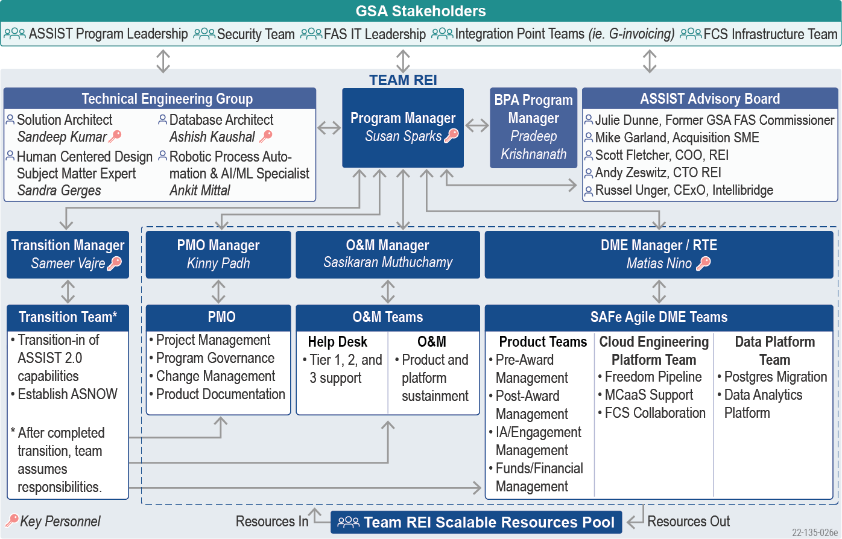

Figure 22: Team REI Organization Chart

Team REI's core of control and accountability features clear lines of authority and reporting relationships stemming from an experienced Program Manager.

* **Ms. Susan** Sparks brings ***hands-on technical leadership*** and provides a direct line of communication for the GSA ASSIST CO/COR and Program Leadership. She is responsible for all contractual decisions on the contract, including subcontract management and changes to the scope or budget. She also ensures we are meeting the vision and business objectives of ASSIST 3.0.   
  Ms. Sparks works directly with her Team Leads, who are responsible for day-to-day execution, ensuring continuous communication, transparency, problem identification/resolution, and timely decision-making. Team Leads have full authority to execute work within the bounds of their scope.
* Six SAFe Agile DME Teams support Optimization activities. This group is led by our DME Manager/RTE, **Mr. Matias Nino,** who brings ***true SAFe practices*** to the program. Under this team, we propose four Product Delivery Teams, each with an appropriate mix of skills focusing support on FAS' service areas (i.e., Pre-Award Management, Post-Award Management, IA/Engagement Management, and Funds/Financial Management). Our Cloud Platform and Data Platform Teams are comprised of resources focusing support on optimizing their respective areas.
* Our Transition-in Manager, **Mr. Sameer Vajre**, will provide focused transition-in support across all the ASSIST activities. Mr. Vajre is a Director with over 20+ years of experience managing large complex federal IT programs. He recently acted as a Transition-In Lead for the $79M DoD DMDC contract, where he 100% staffed a team of 54 personnel within 30 days of the award. As the transition progresses, these resources move into the PMO, O&M, and DME teams. Please see **Factor 3 – Phase-In/Transition Plan** for more details.
* Additional teams support O&M and Help Desk, led by our O&M Manager, **Mr.** **Sasikaran Muthuchamy**. Mr. Muthuchamy has over 10 years of experience in Technical Project Management and currently leads O&M and Help Desk teams for our NASA SBIR contract. The Help Desk and O&M Teams ensure ASSIST continues to perform optimally, conduct any required maintenance, support user adoption activities, and respond to issues when they occur.
* Our PMO Team, led by **Ms. Kinny Padh**, is comprised of resources that support each Agile Team by engaging in FAS' Change Management Process, developing training, documentation, and reports, as well as providing project oversight for specific initiatives. Ms. Padh has over 10 years of experience in Federal Project and Program Management, ensuring project standards are met and improving the overall project management process.

Each Team Lead is responsible and accountable for the resources on their team. This includes staffing decisions and overall performance assessments. REI has a proven, defined performance review process in place, which includes monthly check-ins, quarterly and annual reviews, and a 360-degree feedback process to receive feedback from those with whom the resources work closely. Through this process, resources receive comprehensive feedback regarding their performance, including strengths and areas for improvement, and focus on career growth.

***Proactive collaboration*** occurs through weekly Scrum of Scrums with our Team Leads, a SAFe technique that ensures dependencies and risks are escalated and mitigated. In addition to these primary teams, Team REI has a Technical Engineering Group made up of cross-functional experts who provide support across the entire program as needed. Our team is rounded out by our ASSIST Advisory Board, which is made up of senior leaders for reach-back for Acquisition, Functional, and Technical Advisory subject matter expertise. These experts include **Ms. Julie Dunne and Mr. Mike Garland**. Ms. Dunne has 25 years of experience as a leader in federal agencies and is a former FAS Commissioner and Acquisition Expert. Mr. Garland currently serves as the acquisition SME for the GSA CALM implementation, bringing IT business expertise and acquisition knowledge to help drive ASSIST Optimization. The following subsections describe Team REI's rationale, resources, and duties for our leadership.

## Proposed Key Personnel, Technical Experience, and Qualifications (PWS 6.4)

Team REI has assembled a team of highly qualified and capable professionals who oversee the activities of Team REI and act as primary points of contact for our government customers. As depicted above,our leadership team consists of experienced resources who can build on each other's talents and backgrounds, leveraging their experience to run a program with minimal risk for the government. Our Key Personnel will accept their proposed ASSIST positions upon contract award. **Table 24** belowshows our proposed Key Personnel and maps their experience to the PWS qualification requirements, demonstrating their unique qualification for the position and how they will be involved in the program.

Table 24: Personnel Qualifications, Relevant Experience, and Training

| **Person/LCAT** | **GSA Required Experience From PWS** | **Candidate's Relevant Experience** |
| --- | --- | --- |
| Susan Sparks, Program Manager (Master) | * PMP & ITIL Certifications * Experience managing software development teams of similar size/scope/complexity * Experience with resource and subcontractor management * Experience in a quality assurance environment * Extensive knowledge of the Federal Government's acquisition processes * Experience participating in CMMI and/or ISO quality audits | * Project Management Professional (PMP) * ITIL v4 Foundation Suite * 31+ years of experience managing Agile software development teams, including in a SAFe environment * Experience in the management of similar programs on government contracts over $200M and 200 resources * Provides leadership and direct supervision to employees and subcontractors, including monitoring performance, coaching, and evaluating results to ensure objectives are met * Over 20 years of experience with the Federal Government's acquisition processes * Manages ISO and CMMI compliance and Audits for multiple organizations |
| Matias Nino,  Program Manager (Senior) | * PMP Certification * Functions as an RTE, managing programs with multiple Agile Release Trains * Recognized SAFe Release Train Engineer Certification * Experience leading large-scale program executions using SAFe Agile methodologies * Demonstrated experience managing, guiding, and navigating complex Agile programs * Accountable for the overall planning, coordination, execution, and delivery of value through the program * Act as a mentor for sharing Agile and SAFe knowledge across the organization | * Project Management Professional * 10 years of Agile Management experience * 6+ years of experience as an RTE, leading programs with four or more Agile teams * Certified SAFe 5 Release Train Engineer * Worked with project and program management stakeholders to proactively mitigate risk, meet stakeholder expectations, and control project costs * Directed all aspects of a tailored Scrum process and coached full-time team Scrum Masters to effectively conduct product planning, backlog management, sprint planning, sprint execution, and retrospectives * Over six years of experience with the Federal Government's acquisition systems and processes |
| Sandeep Kumar,  Technical Architect (Master) | * 10+ years of comprehensive experience in architecting sustainable applications * Recognized AWS Certified Solutions Architect Professional certification * 8+ years experience in emerging technologies, one or more architecture domains * Experience architecting and implementing CICD automation and Zero Downtime deployments * Experience defining and driving container organization and SecDevOps best practices within large teams | * 10 years of experience architecting and modernizing enterprise and mission-critical systems for government agencies * AWS Solution Architect Professional Certified * 15 years of experience in emerging technologies, including Java and Javascript * Architected a completely serverless solution for the entire CI/CD pipeline using AWS CodeBuild, CodePipeline, and CodeDeploy * Technical Architect for GSA TAMS. Designed and developed based on a cloud-native microservices* architecture and built on FCS. * Over six years of experience with the Federal Government's acquisition systems and processes |
| Ashish Kaushal,  Database Architect (Senior) | * 10+ years of experience in data engineering with an emphasis on predictive data analytics, reporting, and visualization * Recognized AWS Certified Data Analytics - Specialty certificate * 8+ years of experience in the design and build of data ETL processes using data pipelines * 8+ years of ETL/ELT/Python programming skills * 8+ years of experience in SQL, data transformations, migration, statistical analysis, and troubleshooting | * 20+ years of experience with a focus on data analytics, database redesign, data migration, disaster recovery, data replication, and capacity planning * AWS Data Analytics Certified Specialty   8+ years of experience with ETL jobs, including writing complex PL/SQL packages to ETL data from very large tables, consisting of row counts in the billions   * At USCIS, currently architecting an enterprise-wide data streaming platform using Kafka |
| Sameer Vajre,  Program Manager (Senior) | * PMI-PMP and Bachelors' Degree * Provides leadership, oversight, and management of a complex program * Ensures performance against contract and program requirements * Consults and advises senior Federal leadership and ensures they have actionable information in a timely manner | * Project Management Professional * MBA, Finance and Marketing * Transition-In Lead for the $79 million DoD DMDC Quality Assurance (QA) and Automation contract * Worked with DMDC and the incumbent to align the transition-out and transition-in plan, defined the transition-in milestones and success measures * Within the first two weeks of the award, hired and stood up a team of 54 skilled personnel ready for transition-in * Performed incumbent capture to align with the contract requirements * Reported the weekly transition-in accomplishments, milestone progress, dependencies, risks, and mitigation |

Based on our carefully selected personnel with highly relevant expertise and experience, GSA can be confident that we will achieve results with the right-sized and right-focused teams with the right people for the successful modernization of GSA ASSIST.

## Approach to Effectively Deliver the PWS Requirements (PWS 2A.2. and 2A3)

GSA requires proven program management practices and oversight to effectively establish and maintain program and project status, execution, and cost and schedule control. As summarized in **Figure 23** on the following page**,** REI's Task Order Management Approach, currently used on COMET Task Orders, focuses on driving success throughout the contract period.

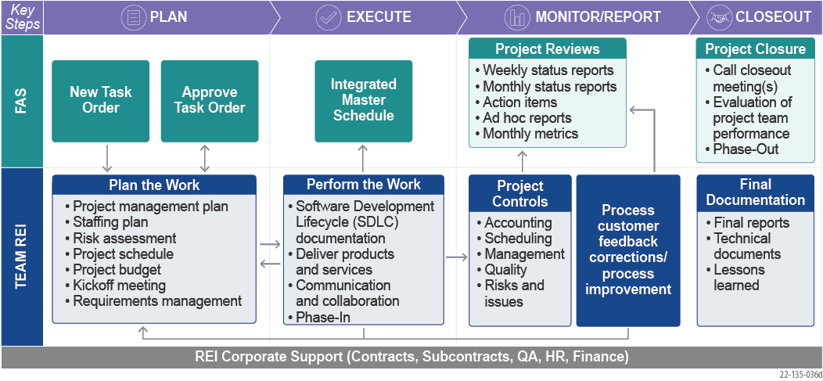

Figure 23: Team REI's Task Order Management Approach

***Plan.*** Upon receipt of a Task Order (TO), we initiate the Planning process by conducting a kickoff meeting (**PWS 2A.2.1**) with the COR and other key stakeholders. We develop a Project Management Plan (PMP) to define the scope, schedule, budget, personnel, stakeholders, risks, deliverables, communication strategy, and expected levels of quality for the TO. We provide our draft PMP in **Appendix D**. A key focus of this stage is phase-in activities (**PWS 2A.3.3**).

***Execute.*** We move into execution once we receive approval from the COR on the PMP. We proactively identify, monitor, and mitigate risks in accordance with our Risk Management process outlined in **Section 5.10**. As issues arise, we track, work, and communicate them with the COR and stakeholders until resolved. We complete work with quality baked in at every level and deliver all products to the COR for review and acceptance. We develop a Quality Control Plan (**PWS 3.1**) to address the approach and specific metrics we will apply across teams based on our experience working in a SAFe environment. We use a Release Train approach to ***drive quality and schedule***, working with FAS to prioritize scope. We conduct retrospectives at the end of every delivery sprint to adapt and adjust. Status is provided during monthly and ad hoc technical meetings (**PWS 2A.2.2**). For more information on our Quality plan, please see **Section 5.7.** We practice continuous evolution and ***Innovation as a Habit*** through Innovation and Planning Sprints.

***Monitor and Report.*** We monitor performance (**PWS 3.2**) weekly against the planned budget, schedule, and forecasts and provide financial and progress status. REI is committed to meeting and exceeding the performance metrics outlined in the Quality Assurance Surveillance Plan (QASP) **(PWS 3.3)**. Periodic quality reviews help us catch issues, report deviations from expected SLAs to the COR, and then apply a corrective action plan. We manage corrective actions to closure when a task's performance or results deviate from the plan and impact budget, schedule, quality, or user satisfaction.

**Closeout.** We close out the TO after the completion of all TO requirements and acceptance of all deliverables by the COR. We conduct lessons learned discussions with stakeholders to review project performance, celebrate good performance, and identify improvements for future TOs. We conduct a closeout meeting with project stakeholders and the COR to review task performance and reach an agreement on completion. The TO can only be closed once all project documentation is collected and archived. Transition out is a key activity during this phase (**PWS 2A.3.4**).

## Phase-In Support (PWS 2A.3.3)

Team REI provides our Plan for Phase-In Support in **Factor 3** above. This plan outlines our approach to ensure that 100% of the staff required for application responsibility and management of the system are available by Day 45 and that transition is completed by Day 60.

## Phase-Out Plan (PWS 2A.3.4)

As the contractor responsible for optimizing and supporting these systems and providing the benefit of single-point accountability, Team REI will ensure a smooth and orderly contract closeout and transition-out. We do this, in part, by keeping comprehensive documentation, records, and SOPs in place throughout the life of the contract. We will support GSA in transitioning all necessary project artifacts in accordance with the **PWS Section 2A.3.4** Phase-Out Support. Team REI will work with GSA to deliver a draft Phase-Out Plan no later than six months after the project start. This will include plans to transition the work products and conduct the knowledge transfer with minimal disruption to vital government business over the last 90 business days of the contract.

## Subcontract Management (PWS 2A.4)

Our Subcontractor Management approach establishes and maintains open communication channels based on clear roles and responsibilities with our subcontractors. Team REI operates as an integrated team and uses consistent processes, methods, and tools to evaluate performance across the team. Each Subcontractor is issued a subcontract with a clearly defined scope of work which defines areas of responsibility and performance standards, and contains a flow-down of contract terms to ensure full compliance with the COMET BPA, TO, and security requirements. Team REI's PM ensures all subcontractors meet and/or exceed the requirements for each proposed LCAT for which they are responsible. She oversees the performance of subcontractor staff, working with her Leadership Team to evaluate monthly each subcontract partner's status and identify any needed corrective actions, along with an action plan for implementation.

## Quality Assurance Approach and Performance Measures (PWS 3)

To monitor contract performance, Team REI employs a Quality Control Plan (QCP) that identifies and mitigates quality defects throughout the project life cycle. Monitoring and reporting of task deliverables are also guided by our QCP, which actively oversees performance and technical measures and provides monthly updates with details of progress and any needed Corrective Action Reports (CAR). For all tasks and deliverables, we review and audit our work to confirm we are following GSA-approved control procedures, maintaining required documentation, and providing reports that accurately reflect the status of activities. Our quality management method consists of four phases, as depicted in **Figure 2****4** below.

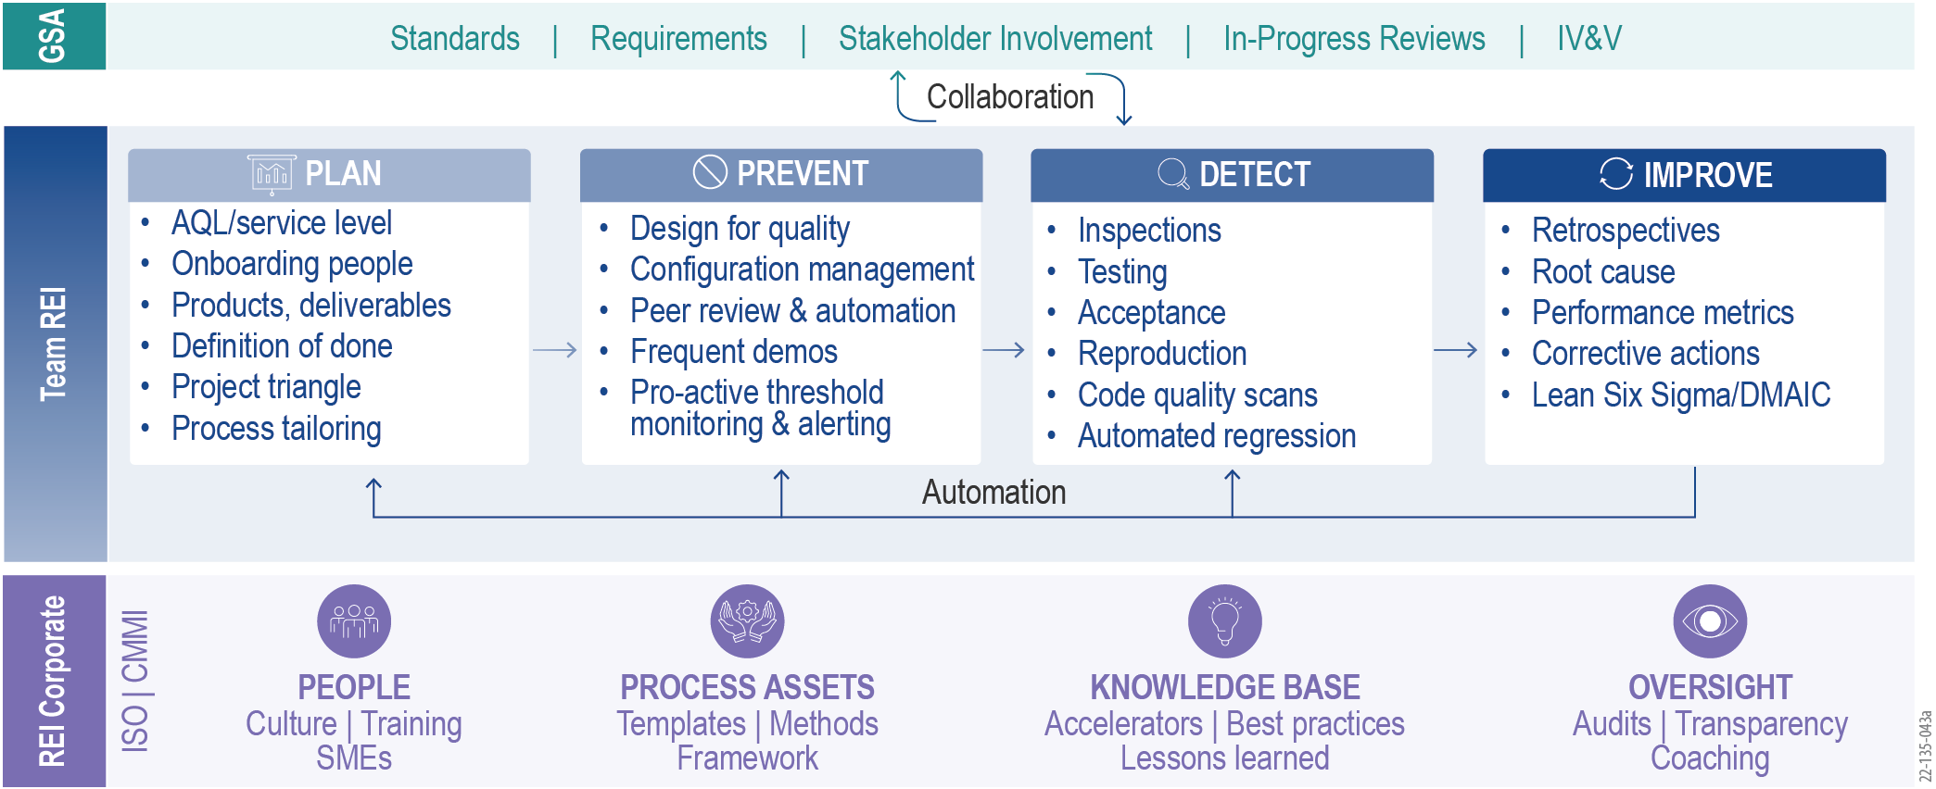

Figure 24: Team REI's Quality Assurance Methodology

* **Plan:** We begin by planning for quality and integrating it into each project activity.
* **Prevent:** We utilize established GSA practices in Incident, Problem, and Change management throughout the project to prevent and detect defects through our collection of quality checks.
* **Detect:** We audit our work to confirm that we follow proper control procedures, maintain required documentation, and provide accurate reports.
* **Improve:** For O&M improvements, we take a Lean Six Sigma approach to define, measure, analyze, improve, and control the solutions provided. Agile Teams implement improvements via Sprint retrospectives, led by a Scrum Master.

To provide optimal support and meet Availability, Business Processes, Help Desk, and Security requirements, we employ an ISO executable approach that drives metrics for establishing data-driven SOPs and reporting capabilities. This provides transparency and easily consumable metrics for all existing SLAs. We are committed to meeting and exceeding SLAs for all metrics in PWS Attachment C and have outlined our recommendations regarding SLAs in **Appendix A** based on our experience managing programs of this scope, size, and complexity. Team REI understands that meeting the SLAs are also dependent on AWS to maintain their SLAs. Following the acceptance of our QCP, we employ a variety of AQLs to delineate roles and responsibilities for executing processes in accordance with the deliverables.

## Deliverables (PWS 4)

Team REI will fully comply with all the Deliverables required in the **PWS Section 4.4** Deliverables Table. Because we have had many successful engagements at GSA, we are fully accustomed to the form and format of the deliverable reporting procedures and will comply.

## Other PWS Requirements (PWS 5, 7, 8, 9)

Team REI takes no exception to **PWS Sections 5, 7, 8, and 9** and commits to meeting all such requirements throughout the life of the contract. Team REI will provide all accountability and return all government-furnished property and other items stated.

## Risk Mitigation and Problem Resolution Methodology(PWS 2A.3.2)

With more than 12 years working to support GSA and experience supporting contracts of similar or larger size and scope at agencies such as HRSA, USCIS, and FDA, we have deep insight into the technical, programmatic, and management difficulties and risks likely to affect GSA ASSIST Optimization. Our risk management approach, based on ISO standards, is presented below in **Figure 25.**

|  |
| --- |
| Figure 25: Team REI's Risk Management Process |

We identify risks continuously and review them during daily Scrums, weekly Scrum of Scrums, and PI Planning sessions. We examine integration points and external dependencies to raise technical risks as early in the development cycle as possible. We assess risks to determine probability, impact, severity, and appropriate team responses. We track risks using a Risk Register, and the Agile Teams manage them to closure. The Risk Register is included in all contractual status reports sent to GSA weekly. The Program Manager monitors all risks to ensure they are correctly managed and escalated to senior management and GSA leadership when appropriate.

## Problem Resolution Methodology (RFQ 3.1)

REI's reactive or emergency problem resolution follows a similar process. We use a defined escalation model that designates clear accountability and communication channels and ensures that emergency situations are quickly addressed and appropriately escalated to minimize their impacts. **Figure** **26** below depicts the path for escalating preventive and reactive problems.

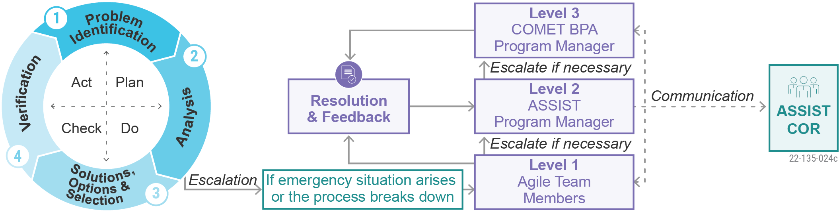

Figure 26: REI's Problem Resolution Methodology

This approach was derived from and matured through its application on similar programs, including several at GSA. For example, on IAE, REI implemented this approach that proved successful for the DUNS number replacement with UEI, one of the most complex government-wide IT implementations. Our process of empowering Agile Teams ensures that we quickly identify both technical and management risks and that we develop mitigation plans and appropriately escalate them to the Team REI PM and GSA leadership to minimize the impact on program success. **Table 2****5** below highlights how we apply our FAS and FCS operating environment knowledge to identify meaningful risks, responses, or mitigation plans.

Table 25: Team REI's Preliminary Risks

|  |  |
| --- | --- |
| **Risk** | **Response and/or Mitigation** |
| Lack of frequent code releases to production may lead to long deployment cycles | * Implement sprint releases which give the capability to deploy every sprint (two weeks) to Alpha/Beta. * Ensure automation is a priority for all development teams. |
| Failure to gain the buy-in of all user groups and stakeholders will minimize the realization of full system value | * Use OCM tactics early, often, and throughout the ASSIST design and deployment to shorten the time to implement and flatten the risk of resistance. * Engage users and stakeholders throughout to understand roles, processes, and training needs. * Utilize OCM, technical, and advisory SMEs to identify and determine strategies to improve interfaces and integration across platforms (e.g., FPDS, SAM, e-Buy). |
| Failing to meet established SLAs for production fixes | * Establish 'error budgets' for development teams, so risks to SLAs are addressed by focusing improvements on the root causes that lead to delays in roll-outs for fixes. |

## Approach to Hiring, Retaining, and Replacing Personnel (PWS 2A.1.7)

Achieving ASSIST's objectives means finding and keeping the right resources to ensure the highest productivity and collaboration throughout the contract. Team REI's staffing approach, outlined in **Figure 2****7** below, confirms creating and sustaining a deep and scalable pool of talented resources that are ready to work on ASSIST. This minimizes risk and provides team continuity through high-quality staff, flexibility, and quick turnaround times for delivering and retaining qualified, knowledgeable personnel.

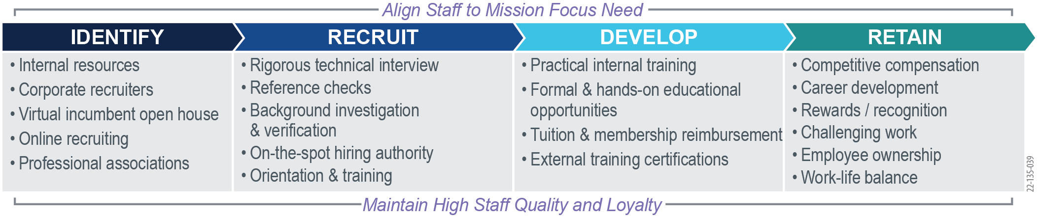

Figure 27: Team REI's Staffing and Retention Approach

Our proven approach was used during the "Great Resignation of 2021" to staff two new programs consisting of over 250 personnel, with a mix of existing employees, new hires, and some re-hires. Critical aspects of Team REI's resource pool management include the following.

* **Best Athlete.** REI utilizes a "best athlete approach" to fill vacancies with the best-qualified candidate, regardless of which teaming partner is involved. This infuses talent without constraints, brings in fresh ideas, and ensures teaming partners' specialized skillsets deliver value to the overall ASSIST optimization.
* **Surge Support.** Team REI continuously recruits for positions and pre-vets potential resources so we can call on them as soon as a requisition is opened. This helps us quickly fill any open positions required due to surge support needs.
* **Changeover Staffing.** In addition to our robust internal recruiting team, Team REI has collaborative relationships with 10+ competitive U.S. staffing organizations and additional connections worldwide. We can convert staff from completed contracts for immediate deployment.

REI’s Proven Staffing Approach

On DOD DMDC, 54 positions were staffed within 20 days.

Our staffing personnel recruit and hire talented individuals, offer the professional development necessary to help employees excel, drive competitive compensation and benefits to retain them, and enable a culture of support for future career growth. This process has been used successfully on all Team REI's projects – ***a*** ***testament to our 33 years of sustained success.***

***Identify and Recruit.*** Team REI maintains an in-house recruiting staff of more than 20 people to source and attract qualified, diverse staff. We apply a rigorous interview process, technical and management staff panel interviews, and coding excellence tests. We also screen for creativity and mission-oriented passion to ensure alignment with our purpose-focused culture. We use the following methods to establish a ready pipeline of candidates.

* **Proactive Recruiting.** Our forward-looking approach to recruiting staff involves market scans and interviews in anticipation of future resource needs. We use an assessment company, Derrico, to evaluate technical candidates in advance of client needs. Our team significantly reduces the time needed to onboard a candidate by engaging with prospective hires in advance.
* **Employee Referrals.** Team REI's employee referral program provides cash rewards (from $500 to $3,500) when employees refer a new applicant who gets hired and retained for at least three months. More than 20% of new hires in 2021 were referrals.
* **Incumbent Capture.** Our proven incumbent capture approach allows us to minimize risk by retaining the appropriate staff to facilitate institutional knowledge and maintain continued workstreams. We engage heavily in incumbent capture for new work transitioning to REI to ensure continuity of learning and retention of any staff deemed critical by GSA. This includes an open house (virtual or in-person) specifically for incumbents, which was utilized to great success for FDA SCAIL and led to the ***incumbent capture of 61 high-valued incumbents***.
* **Internal Employee Mobility Program.** At REI, mobility means that employees have a clear path to grow by changing positions or career paths or delivering on projects. We use this process to match an employee to a position on ASSIST that lets them move in a direction that fits their career objectives and best serves GSA.

***Develop and Retain.*** Team REI provides a supportive culture for our employees to develop their skills, advance their careers, and be recognized for excellent work. The Washington Post has ranked REI as a Top Workplace for the past six years.

* **Professional Development.** REI provides a full slate of in-house training, including dedicated classroom sessions, monthly brown bag sessions, online technical and soft skill development courses, and a personal and full-time professional coach. We also provide up to $4,000 a year for each employee to invest in their professional development through external training, education, and certifications.
* **Recognition and Rewards.** REI believes that recognition and rewards are equally important in motivating good work. We recognize individual performance with on-the-spot awards and bonuses, recognition awards, annual performance bonuses, and team impact awards.
* **Long-Term Benefits.** REI's Employee Stock Ownership Program is a key way for our employees to celebrate our organization's success and helps incentivize their continued hard work as an owner of our company. We require frequent touchpoints with our staff, including monthly one-on-one meetings, quarterly assessments, and an annual appraisal process – all of which ensure consistent and diligent touchpoints to evaluate progress and opportunities for growth, training, and expansion and enhancement of skills. We identify areas of improvement and apply course corrections as soonas gaps are identified.
* **Constant Communication.** We require frequent touchpoints with our staff, including monthly one-on-one meetings, quarterly assessments, and annual appraisals. All of these ensure consistent and diligent touchpoints to evaluate progress and opportunities for growth, training, and expansion of skills. We identify areas of improvement and apply course corrections as soon as gaps are identified.

## Surge Support (PWS 2B.3)

Based on our experience with GSA IAE, where we delivered a Minimum Viable Product (MVP) within 60 days, and similar programs like the USCIS Outcome-Based Delivery and DevOps Services (ODOS) II, where we stood up new Agile delivery teams in weeks and were recognized for our stellar startup process, Team REI has experience providing a ***scalable resource pool***. We are ready to staff, organize, and start delivery for both planned and unplanned surges. We accomplish this by starting pre-award activities for any new TOs to identify the needed staff.

* **Changeover Staffing.** We re-purpose existing staff finishing other assignments and augment with new hires.
* **Resource Pool Reach-Back.** Our Resource Pool enables us to rapidly scale and staff Agile Teams on-demand in support of ASSIST. The Resource Pool represents the combined qualified Agile resources of Team REI, consisting of more than 1,000 experienced Agile professionals – including specialized skills such as UI/UX and Help Desk (team members Intellibridge and TriPoint) and Financial Integration Expertise (team member cBEYONData).
* **Recruiting.** We mine our existing pipeline of candidates, conduct market scans, and aggressively pursue new candidates using our in-house and reach-back capabilities.

We leveraged this approach to rapidly staff up at FEMA, following an urgent surge support request, staffing across 37 different work orders, and promptly deploying 54 personnel over a period of 60 days. We used this approach to ramp up two Agile Teams on the GSA IAE program to deliver a critical functional MVP within 60 days of award.

*The remainder of this page is intentionally blank.*

1. Attachment C Performance Metrics

REI Systems, Inc. provides our Performance Metrics spreadsheet in a separate Microsoft Excel file entitled “*REI_ASSIST Vol 1 Apx A Attachment C Performance Metrics_06-16-22.xlsx*” as part of the submission package.

*The remainder of this page is intentionally blank.*

1. KEY PERSONNEL RESUMES (PWS 6.4) & LETTERS OF COMMITMENT

On the following pages, Team REI provides resumes and letters of commitment for our Key Personnel. We have marked with a red asterisk (*) evidence of PWS Requirements and Desired Qualifications.

* 1. Susan Sparks – Program Manager (PWS 6.4)

|  |  |  |  |  |  |  |  |
| --- | --- | --- | --- | --- | --- | --- | --- |
| Labor Category | | | Skill Level | | | Clearance | |
| Program Manager | | | Master | | | Secret – TS Eligible | |
| Education / Professional Achievement / Specialty Training | | | | | | | |
| Year | Degree | Major | | | Granting Institution | | |
| 1991 | BS* | Computer Science | | | Salve Regina College, Newport RI | | |
| Achievements, Training, Certifications | | | | | | | |
| SAFe 5 Product Owner Product Manager (POPM), 2021 | | | | ITIL v4 Foundation Suite, 2021**\*** | | | |
| SAFe 5 Agilist (SA), 2019 | | | | Certified Scrum Master (CSM), 2014 | | | |
| Certificate of Cloud Security Knowledge (CCSK), 2014 | | | | ITIL v3 Foundation Suite, 2004**\*** | | | |
| **Project Management Professional (PMP), 2005 to Present. *Current PMI Certification #226486***\* | | | | | | | |
| **Employment History and Experience** | | | | | | | |
| REI Systems, Inc.* | | | | | | | 05/2022 – Present |
| Emerging Accounts Directory | | | | | | | |
| * Oversees and grows a diverse portfolio of projects and programs. * Responsible for delivery, growth, people, and financial functions. * Manages the delivery across a portfolio of existing programs and potential new customers within the account. * Provides leadership and direct supervision to assigned employees, including Program and Project Managers. This includes setting goals, monitoring work performance, coaching, and evaluating results to ensure that objectives are met. * Responsible for achieving team utilization, gross margin, and revenue targets of $18M annually. Manages IT staff of 80 FTEs, including recruitment, performance management and evaluations, and professional development. * Responsible for client and people management, building and maintaining partner relationships, and innovation support. * Applies leadership to solution development teams using SAFe Agile methodologies and best practices. | | | | | | | |
| ManTech International (Formerly InfoZen) | | | | | | | 03/2016 – 04/2022 |
| Executive Director Mission IT & Engineering Solutions | | | | | | | 12/2021 – 04/2022 |
| * Provided thought leadership and worked with clients to develop solutions for challenges, including implementing an air-gapped Google Cloud environment for the Department of Defense (DoD) and ServiceNow for the Intel community. * Created competitive solution architectures, including developing the concept of operations, infrastructure solutions, COOP plans, management plans, and suggested process flows for implementation. | | | | | | | |
| DHS Transportation Security Administration (TSA) – Mission Assurance & Operations  Mission Lead – Vetting & Credentialing Systems | | | | | | | 09/2018 – 12/2021 |
| * Orchestrated the daily Operations and Maintenance (O&M) activities of a cross-functional ***team of more than 60 IT professionals*** to deliver 99.99% availability of a complex government vetting and credentialing system. * Managed the change and release management process across all technical disciplines, ensuring quality to mitigate potential outages or collisions. Was responsible for day-to-day operations of the Vetting & Credentialing Operations, including: * Supported the ***vetting of more than 35 million individuals per day*** against consolidated federal watch lists. * ***Implemented SAFe Methodology***\* across Vetting & Credentialing Infrastructure Teams. * Managed and directed the delivery of 24x7 operations with a ***total staff of 80 FTEs, including subcontractors.* \*** * Installed and maintained all related Vetting & Credentialing Infrastructure for 20 separate operating environments across multiple programs spanning multiple locations. * Ensured immediate resolution of critical security patch updates across 2000 systems within seven days. * Monitored federal customer performance satisfaction for end-user and citizen complaints and reactions to the updated TSA systems. * | | | | | | | |
| DHS USCIS – Support Platform Engineering and DevOps Integration (SPEDI)  Chief Technical Officer & Deputy Program Manager | | | | | | | 03/2016 – 09/2018 |
| * Directed and prioritized strategic planning, program management, and service delivery activities for a $208M federal contract*. Supervised more than 200 FTEs and multiple subcontractors, including monitoring work performance, coaching, and evaluating results to ensure that objectives were achieved. * * Devised and implemented schedules, roadmaps, and reporting processes. * Worked intensively with clients to assess needs, define requirements, and rapidly resolve problems across geographically dispersed support teams. * Managed Software Development Life Cycles (SDLCs) for multiple complex systems. * * Maintained CMMI compliance for Managed Service Practices, including audits for appraisal renewal from 2016 to 2018. * * Facilitated migration from Waterfall to Agile methodologies in the modernization and Optimization of the SPEDI system. * * Provided subject matter expertise for DevOps, Amazon Web Services (AWS) and Azure Cloud, and Large-Scale Scrum. * * Implemented Continuous Integration and Continuous Delivery (CI/CD) pipelines. * | | | | | | | |

|  |  |
| --- | --- |
| Smartronix | 03/2015 – 04/2016 |
| Cloud Assured Operations Manager | |
| * ***Applied ITIL centralization and standardization to optimize cloud operations*** (using AWS) for 20 clients, including numerous Fortune 500 enterprises and the Federal Reserve. Implemented Key Performance Indicators (KPI) and developed weekly and monthly reports, including Service-Level reporting, for each client. * Championed continuous process improvement throughout the organization and defined best practices and SOPs. * Managed 20 FTEs with a variety of skills and subject matter expertise and allocated their efforts across the 20 client accounts* to meet or exceed all delivery SLAs. * Established standards for onboarding new cloud customers. * Developed and implemented metric-based reporting to ensure successful high-quality client delivery. * * Provided DevOps leadership and implementation expertise compliant with CMMI for Development quality criteria. * | |
| Computer Sciences Corporation | 09/2014 – 03/2015 |
| DHS USCIS Records Portfolio – Principal Program Manager | |
| * Managed end-to-end operations within a $200M portfolio of a large government agency and managed a team of employees and subcontractors with 100 FTEs. * * Applied SAFe Agile and ITIL best practices to implement processes and procedures across software acquisition, life cycle planning, ISO/CMMI, and federal regulation compliance. Managed vendor contracts to ensure maintenance of all agreements across software licensing and services. * Implemented DevOps processes and Large-Scale Scrum. * Implemented CI/CD pipelines. Managed SDLCs. | |
| InfoZen, Inc. | 03/2013 – 09/2014 |
| NASA – Senior Program Director | |
| * Championed migration of 65 NASA web assets and 50 NASA Headquarter applications, websites, and www.nasa.gov to an AWS cloud* environment with new architecture and security. Completed one of the largest government cloud migrations within 22 weeks. * Managed $40M NASA WESTPrime Single Award BPA for Cloud Broker/Integrator and Cloud Services. Implemented new open-source CMS and trained end-users on new processes. * Realized 40% monthly savings for hosting and CMS software costs and saved 20% of overall costs by resizing infrastructure within the cloud. * Delivered expertise in ***AWS*\* *and DevOps*** as a Service, offering creation and implementation. * Introduced Large-Scale Scrum and use of CI/CD pipelines. Managed SDLCs. | |
| DELL (Formerly Perot Systems) | 03/2007 – 03/2013 |
| National Institute of Allergy and Infectious Disease (NIAID) – Senior Service Delivery Manager | 07/2012 – 03/2013 |
| * Transformed T&M-based contract to performance-based contract with ownership over $20M P&L. Managed diverse computer and storage environments for 4000 end-users with an international support team of 100 employees and subcontractor support teams. (CONUS and OCONUS FTEs)* Implemented rapid response to production-related problems. * Formulated and enforced work standards that increased team productivity and reduced turnover. * Resolved staff vacancy and turnover issues by implementing a pipeline and creative recruiting events. | |
| Federal Student Aid Virtual Data Center – Deputy Program Manager | 03/2009 – 07/2012 |
| * ***Successfully implemented a 10-year $900M*\* *contract for services with an annual $48M P&L.*** Managed all contract components, from contractual issues to delivery of technical services. * Developed and implemented a program to virtualize client infrastructure, reducing costs for both the client and Dell. * Created automated executive, client, and program level metric reporting. | |
| Federal Student Aid Virtual Data Center Account Operations and PMO – Director | 03/2008 – 03/2009 |
| * Brought in as Senior Program Management Specialist to execute Project Management Office (PMO) turnaround. Within 60 days, re-established PMO and program reporting credibility with clients and increased awareness and turnaround times on New Business Service Requests. * Developed, reviewed, and oversaw the design of hardware and software systems proposals and new business requests to facilitate the smooth and efficient flow of information to the Federal Student Aid VDC Account. * Established all project schedule construction criteria and maintained a program knowledge repository for PMO standards. * Implemented P3MM program management quality initiative to maintain ***ISO and CMMI standards.* \*** * Worked with Information System (IS) Leadership to guide and direct the development, production, promotion, and financial aspects of the IS Delivery of Services for the Federal Student Aid Virtual Data Center (VDC). * Established operating policies consistent with the Federal Student Aid VDC objectives and ensured their execution, improving the overall quality of Operations Delivery to the Federal Student Aid VDC Account. * Worked with Public School Information System (PSIS) to refine operational procedures to deliver efficiencies to the Federal Student Aid VDC Account. | |
| Federal Student Aid – Transition & Transformation Management – Senior Advisor | 03/2007 – 03/2008 |
| * Developed and installed procedures and controls to promote communication and adequate information flow between PSGS, PSIS, and the Federal Student Aid VDC Account. * Established operating policies consistent with the Federal Student Aid VDC objectives and ensured their execution, improving the overall quality of Operations Delivery to the Federal Student Aid VDC account. * Worked with PSIS to refine operational processes to deliver efficiencies to the Federal Student Aid VDC Account. * Responsible for ensuring Operations Delivery to the Federal Student Aid VDC account was contractually compliant | |

* + 1. Letter of Commitment – Susan Sparks

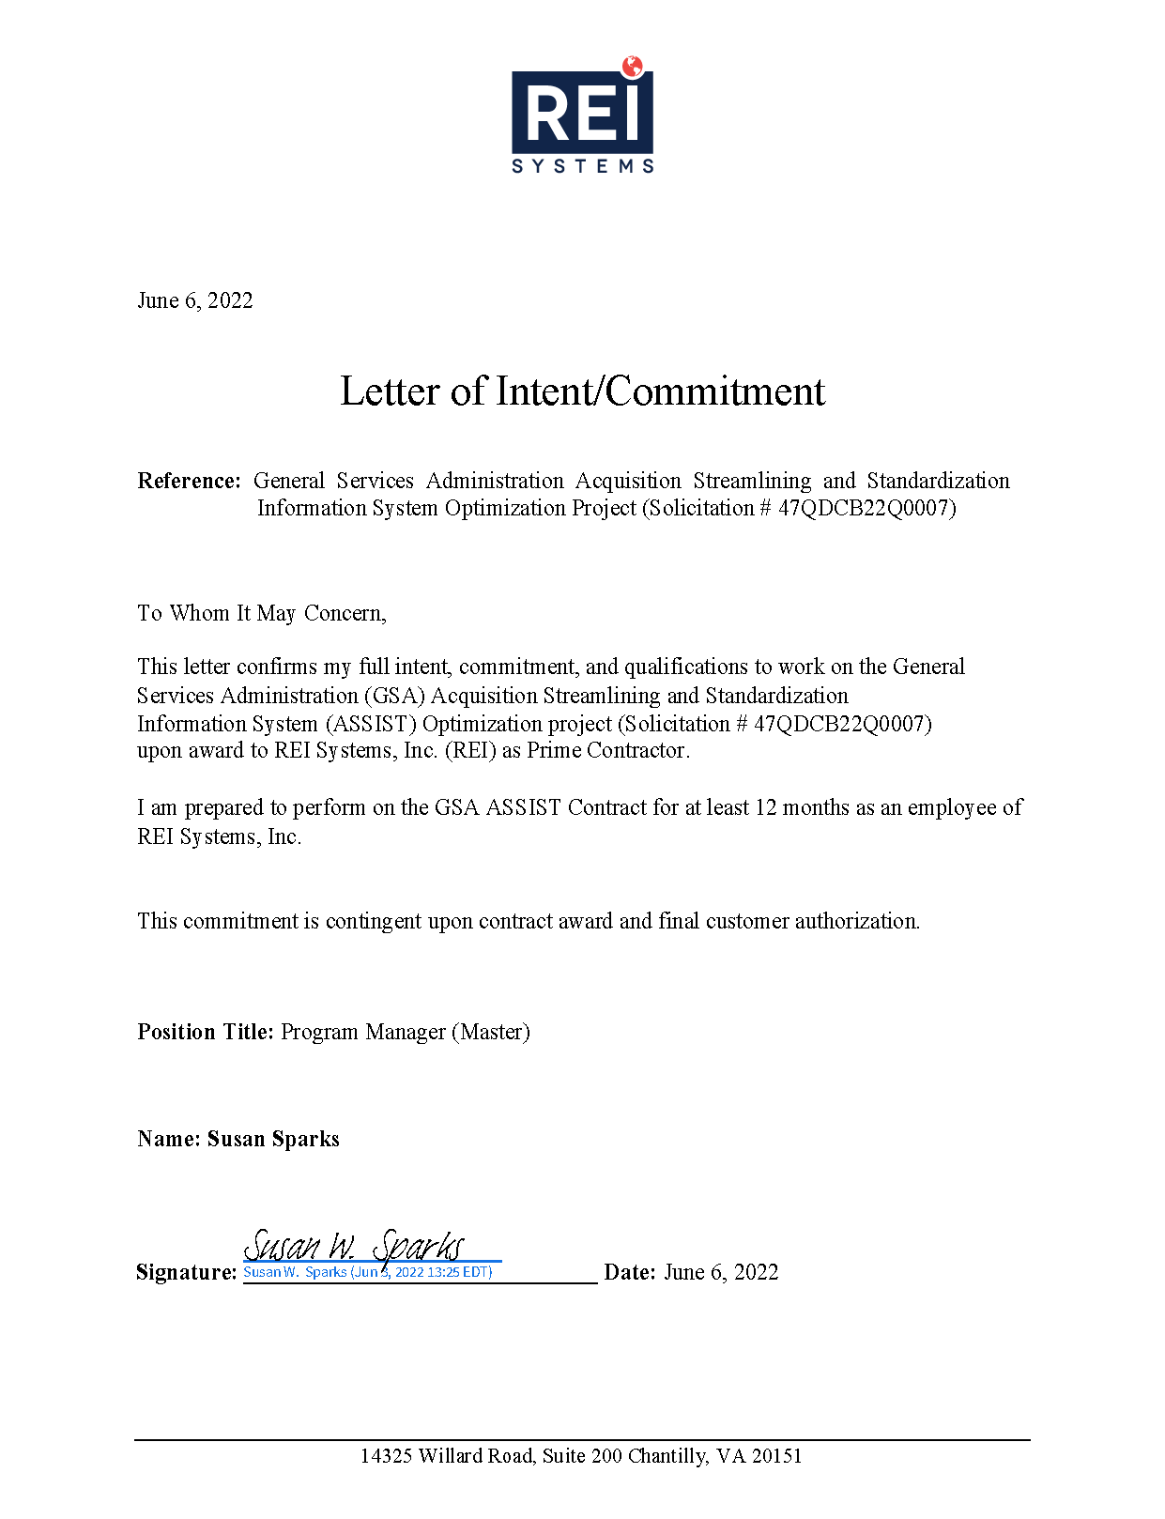

* 1. Matías Niño, PMP, ACP, CSP, SAFe RTE – DME Manager / RTE (PWS 6.4)

|  |  |  |  |  |  |  |  |
| --- | --- | --- | --- | --- | --- | --- | --- |
| Labor Category | | | Skill Level | | | Clearance | |
| Program Manager | | | Senior | | | GSA Public Trust | |
| Education /Professional Achievement/Specialty Training | | | | | | | |
| Year | Degree | Major | | Granting Institution | | | |
| 1999 | BS | Management Information Systems | | University of Connecticut, Storrs, Connecticut | | | |
| Achievements, Training, Certifications | | | | | | | |
| PMI Project Management Professional (PMP), 2019. Certificate #1679418* | | | | | | | |
| PMI Agile Certified Practitioner, 2021. Certificate #1827472 | | | | | | | |
| Scaled Agile Framework Safe Agilist (SA), 2021 | | | | | | | |
| Certified SAFe 5 Product Owner/Product Manager, 2021 | | | | | | | |
| Certified SAFe 5 Release Train Engineer, 2021* | | | | | | | |
| Certified Scrum Professional (CSP), 2018. Certificate #000728020* | | | | | | | |
| **Development Methods/Tools**: Agile / SAFe*, Scrum, JIRA, Confluence, Eclipse / Visual Studio Code, Github | | | | | | | |
| **UI/UX**: Ajax, CSS, JavaScript, jQuery, HTML5, XHTML | | | | | **APIs**: JSON, SOAP, REST, XML | | |
| **Programming Languages**: .NET C#/VB, J2EE, JDBC, JDeveloper | | | | | **Testing**: Selenium, Sauce Labs | | |
| Employment History and Experience | | | | | | | |
| REI Systems, Inc. (numerous positions) | | | | | | | 03/2013 – Present* |
| GSA IAE - Deputy Program Manager Senior Scrum Master / Agile Coach / Deputy Project Manager | | | | | | | 10/2015 – Present |
| * Coaches up to 11 concurrent teams of four to eight staff members each in Agile software development* for a modern open-source cloud-based CI/CD product pipeline as a part of the GSA IAE’s SAM.gov modernization effort using SAFe. * * Guides teams on adopting Agile software development practices such as Test Automation, Test-Driven Development (TDD), Continuous Integration, Deployment Automation, Pair Programming, and Continuous Improvement. * * Works with product owners, program leadership, development teams, and program governance to ensure all aspects of delivery and process adhere to the lean and ***Agile principles defined in the SAFe framework***. * * ***Directs all aspects of a tailored Scrum process used by REI Systems and coaches full-time team Scrum Masters***\* to effectively conduct product planning, backlog management, sprint planning, sprint execution, and retrospectives. * Works with project and program management stakeholders to proactively mitigate risk, meet stakeholder expectations, and control project costs. * * Leads large room planning and retrospective exercises with multiple teams. * Fulfills Release Train Engineer (RTE) responsibilities when there is a need to fill in for RTE. * | | | | | | | |
| Various REI Projects - Project Manager / Agile SME / Agile Coach / Analyst / Trainer | | | | | | | 03/2013 – 10/2015 |
| * Led the development of Alternative of Analysis (AoA) and Modernization Assessment reports to support the strategic planning of the IT modernization roadmap for GSA’s eRulemaking and RISC programs at GSA’s Office of Government-wide Policy. * * Provides project management support for Agile Release Trains (ART) as needed over the last five years. * * Consults ART teams in executing their Program Increment (PI) Planning and SoS sessions. * * Leads corporate training cohorts in the Agile Fundamentals training program. * Works with stakeholders across federal agencies and industry to obtain business and technical input for modernization assessments. * * Leads the REI Agile Center of Excellence in cultivating Agile best practices across business units. * Coordinated the writing of two 50+ page technical reports presenting all findings and recommendations for the modernization assessments. | | | | | | | |
| HHS HRSA Electronic Handbooks – Dedicated Scrum Master | | | | | | | 09/2014 – 10/2015 |
| * Led two software development teams of four to 10 staff members each in implementing major enterprise-level functionality for HRSA’s flagship federal grant application management system using scrum and continuous integration. * * Worked with the product owner, development team, and other stakeholders to meet expectations and requirements. * Managed and directed all aspects of the scrum process, including product planning, story mapping, sizing, sprint planning, sprint execution, and retrospectives. * Worked with project management staff to proactively mitigate risk, meet stakeholder expectations, and control project costs.* | | | | | | | |
| HHS HRSA Electronic Handbooks – Associate Project Manager | | | | | | | 3/2013 – 09/2014 |
| * Managed multiple software development projects ranging from three to eight staff members in implementing major enterprise-level functionality for HRSA’s flagship federal grant application management system centered on records management and federal property tracking. * Managed all aspects of the SDLC to successfully keep projects on scope, within budget, and on time. * Was instrumental in driving the adoption of Agile practices among the development teams and the business unit. * * Actively participated as a Health Systems Business Unit’s PMO member to facilitate and support the transition to Agile project management. * | | | | | | | |

|  |  |
| --- | --- |
| IMC, Inc. (numerous positions) | 12/2001 – 02/2013 |
| National Student Clearinghouse – Off-shore Agile Project Manager | 02/2012 – 02/2013 |
| * Was responsible for managing and leading the off-shore portion of a dual-shore test-driven agile*software development project comprising three off-shore J2EE developers, four on-shore developers, two testers, one business analyst, one business analyst scrum master, and one senior project manager. * As a Project manager, coordinated logistics between off-shore technical staff and business leadership to ensure all off-shore development fulfilled the requirements specified using a distributed Scrum process. * As a result, his off-shore development team cut client development costs by 45%. | |
| Commercial Products – Project Manager | 01/2011 – 01/2012 |
| * Provided account and project management for various small commercial projects valued between $30K and $150K. * ***Led full lifecycle software development and ECM integration projects***\* for teams of two to three staff, managed stakeholder expectations, and delivered executive presentations. | |
| HHS Substance Abuse and Mental Health Services Administration (SAMHSA) – Delivery Manager | 10/2005 – 10/2010 |
| * Served as the project delivery manager and technical lead for SAMHSA’s Block Grant Application System contract worth $1.6M (annual) with a staff of eight FTEs. * Managed all aspects of .NET software development and stakeholder engagement. | |
| HHS SAMHSA – Technical Lead | 12/2001 – 10/2005 |
| * Designed and implemented a Block Grant Application and Review Management System web application with an Oracle database backend from the ground up to process accountability for $1B in non-discretionary federal funds. * ***Led a major system platform migration, transitioned from a traditional CMM2 to an Agile Methodology***\****,*** implemented object-oriented design, ensured Section 508 compliance, supported end-users, and achieved the highest satisfaction ratings in the project’s history. | |
| Other Relevant Experience – Agile Professional Meetup | 06/2016 – Present |
| Organizer | |
| * ***Organizes and conducts the largest Agile-related meetup in the outer DC Metro Area***\*, featuring talks, workshops, and sessions facilitated by a diverse group of global and local speakers on subjects surrounding Agility and government. All sessions are recorded on video for meetup members. * Responsibilities include networking with the local Agile community, mentoring, bringing relevant and emerging technology topics to the meetup audience, and organizing meetup sessions. * | |
| Agile Center of Excellence | 06/2016 – Present |
| Working Group Chair | |
| * Chairs a working group of four to five Agile practitioners from various parts of the organization in assessing the progress of an ongoing Agile transformation, cultivating Agile knowledge-sharing, establishing communities of practice, and delivering internal Agile training and mentoring exercises for the organization. * | |

*The remainder of this page is intentionally blank.*

* + 1. Letter of Commitment – Matias Nino

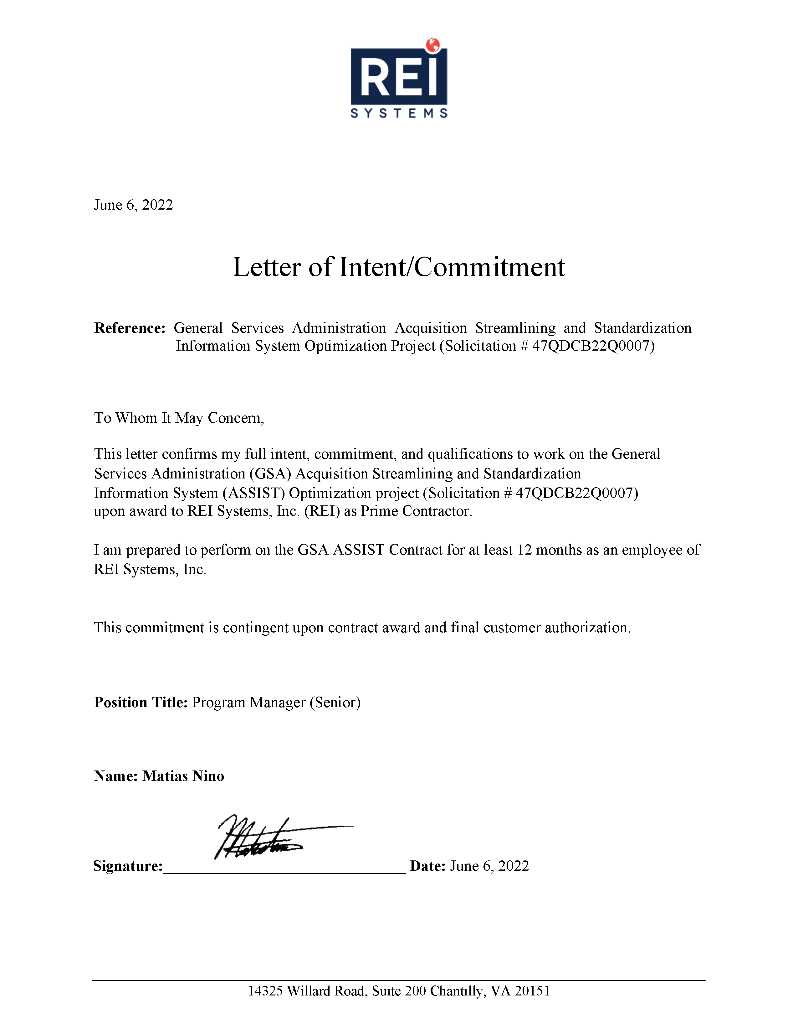

* 1. Sandeep Kumar – Solution Architect (PWS 6.4)

|  |  |  |  |  |  |  |  |
| --- | --- | --- | --- | --- | --- | --- | --- |
| Labor Category | | | Skill Level | | | Clearance | |
| Solution Architect | | | Master | | | GSA Public Trust | |
| Education /Professional Achievement/Specialty Training | | | | | | | |
| Year | Degree | Major | | | Granting Institution | | |
| 2009 | MS* | Software Engineering | | | BITS Pilani, India | | |
| 2004 | BS* | Mathematics | | | Ranchi University, India | | |
| Achievements, Training, Certifications | | | | | | | |
| AWS Solution Architect – Professional Certified*, 2018. # 153P1ZL21JBEQMGN* | | | | AWS Solution Architect - Associate*,2018  # B5CYVTVCDJ4E1W31* | | | |
| AWS Certified Developer - Associate (DVA), 2021  # 0GYKPCPJB1111P3G* | | | | Cloud: Cloud Architecture (AWS, Azure), Infrastructure as Code – IaC (AWS CloudFormation, Terraform) | | | |
| **Databases:** PostgreSQL (SQL), DynamoDB (NoSQL), Oracle, Microsoft SQL Server 2008 | | | | **Automation:** Containerization (Docker, Kubernetes, OpenShift, AWS EKS), Jenkins, Selenium, LoadRunner, Helm, Flux, UCP, SecDevOps* pipelines. | | | |
| Agile Methodologies, NET Application Development, Decision Analysis and Resolution (DAR), End User Training, Help System Development, and User Documentation | | | | Custom Salesforce Development, Visualforce, Lightning Components, Application Design, Requirements Management, Database Application Development | | | |
| **Languages*:** SPA (ReactJS, Angular), Java* SpringBoot* (Microservices), Node.js, Headless CMS (JAM Stack), C#, ASP.NET, C/C++, JavaScript, HTML, XML | | | | | | | |
| Employment History and Experience | | | | | | | |
| REI Systems, Inc. | | | | | | | 06/2012 – Present* |
| NASA and SIBR.gov – Solution Architect | | | | | | | 11/2020 – Present |
| * Provides technical guidance and supports NASA’s technical implementation of SBIR/STTR programs which aim to empower small businesses to deliver technological innovations that contribute to NASA’s missions, provide societal benefit, and grow the U.S. economy. * Leads the Technical Team, providing technical guidance, serving as a mentor, and acting as the liaison between developers, users, and program management. * Evaluates emerging technologies and recommends technology solutions, software architectures, and methodologies. * * Defined and leads the Cloud Readiness and the Application Architecture assessment of the NASA SBIR system. * * Designed and leads the implementation of API Gateway and Containerization on the SBIR program. * Created conceptual, logical, and physical design of data models. * Designed and developed awards RESTFUL APIs with Open API Specification for the NASA SPAR/Techport team. * Co-ordinated with the SBIR Infrastructure Team and the Development Team to introduce and adhere to Infrastructure as Code with the Containerization effort. * Worked with the Test Automation Engineer to define and build the API testing methodology for the SBIR program. * In coordination with the SBIR.gov Program Office, introduced the AWS Glue (Serverless ETL framework) and integrated it with the current architecture of SBIR.gov to help SBIR.gov resolve data accessibility-related issues. * Coordinates with the SBA OCIO office to define a strategy for the serverless model for SBIR.gov infrastructure. * Architected and leads the Authentication and Authorization microservice for SBIR.gov to leverage the AWS Cognito with SBA Connect and Login.gov. | | | | | | | |
| GSA Transportation Audits Management System (TAMS) Modernization – Solution Architect | | | | | | | 05/2019 – 11/2020 |
| *In alignment with GSA’s IT modernization approaches, TAMS is designed and developed based on a cloud-native microservices architecture* that allows re-use and delivers these business services and capabilities. It includes Change Management and Data Migration initiatives. The modernized solution is built on FAS Cloud Services.* *   * Worked with FAS IT to develop a roadmap to deprecate legacy applications and modernize large-scale TAMS application. * Led the technical team, providing technical guidance, mentorship, and liaisons between developers, users, and program management. Leads the design of infrastructure architecture of cloud platform with FCS. * Designed and implemented microservices using Domain-Driven Design and best practices such as API-first. * Analyzed and recommended technology solutions, software architecture, and methodologies for digital modernization. * Defined and led the ReactJS SPA-based framework for building the user interface with the development team. * Defined and led the microservices-based architecture for the backend API development. * Coordinated the third-party integrations with 10+ external interfaces and provided options for the integration framework. * * Designed the Data Migration workflow using ETL tools (Pentaho Data Integration) with Agile processes; coordinated with stakeholders to define the success criteria and provided incremental delivery for end-users review and feedback. * Managed the complete Agile delivery operations in a scrum environment by running the requirements-gathering and high-level design meetings, capacity planning, and sprint reviews directly with the end clients. * Provided unique solutions to overcome the challenges and build 100+ reports using “tabcmd” in Tableau. * Created conceptual, logical, and physical design of data models and developed RESTFUL APIs for business processes. * Architected a completely serverless solution for the entire CI/CD pipeline using the FCS freedom pipeline. * * Used spring config server for centralized configuration and Splunk for centralized logging. | | | | | | | |
| Federal Acquisition Institute and Training Applications System (FAITAS) AoA – Technical Architect | | | | | | | 09/2018 – 04/2019 |
| * For FAITAS, established analysis foundation /framework. Defined the analysis problem statement, context, scope, and framework for alternative comparison, including criteria to be used on behalf of GSA FAI and GSA IT. * Identified multiple alternatives that addressed the stated problem within the context and scope defined. The final set of alternatives evaluated was the product of thorough research, vetting, and filtering. * Assessed alternatives, evaluating each option against established decision framework criteria (e.g., cost, risk, effectiveness, benefit). * Evaluated implementing FAITAS application features in a custom-built Java-based solution using AngularJS and other open-source technologies. * Evaluated different Platform as a Services (PaaS) platforms like Appian, Salesforce, OutSystems, and Mendix by building prototypes of the sample use cases for the existing FAITAS application and provided recommendations for the right solution design. * Researched and analyzed the top Learning Management Systems(LMS) products using Decisions Analysis Resolution (DAR) methodologies and designed a solution based on top results. * Established all the user stories, point sizing, and coming up with infrastructure cost ROM in AWS cloud. * * Analyzed and defined the impact of each proposed alternative along with the total cost of ownership. * Developed and implemented best practices around AWS Infrastructure management for efficient usage. * | | | | | | | |
| SBIR.gov AWS Cloud Migration* – Technical Architect | | | | | | | 01/2017 – 08/2018 |
| * Migrated SBIR.gov infrastructure hosted on on-prem servers to a modernized, reliable, cost-effective, scalable, and secure high-performance cloud-based infrastructure hosted on AWS using the AWS well-architected framework. * * Used the IaC approach to orchestrate and provision all the infrastructure resources in the cloud environment. IaC serves as a single source of truth for the entire SBIR.GOV cloud environment. * Used event-driven architecture for asynchronous message-based communication using AWS serverless services such as SNS, SQS, Kinesis, etc. * Assisted in building reusable, open-source IaC based on Amazon EKS. * Identified the existing infrastructure and their corresponding dependencies concerning application and operations. * Defined the high-level design of the target infrastructure on the AWS cloud. * Provisioned the required infrastructure manually in the AWS cloud for testing purposes. * Once verified the target infrastructure was working correctly, translated it to code using AWS CloudFormation. * Implemented the best practices around Infrastructure management on the cloud for efficient usage. | | | | | | | |
| Multiple Overseas Private Investment Corporations (OPIC) and NASA SBIR Projects* – Technical Architect | | | | | | | 06/2012 – 11/2017 |
| * Worked on NASA SBIR, modernizing the legacy business applications to cloud-based microservices architecture. * Developed RESTful microservices using Spring boot/Java and 12-factor app methodology and SOAP services using Spring boot/Apache-CXF/Java. * Integrated Swagger for API documentation. Migrated the web applications from WebLogic to Tomcat. * Designed and developed UI using Angular JS, HTML5, JSP, JavaScript, jQuery, Ember, and Ajax technologies. * Implemented SSO using OpenAM for authentication. * Created custom objects and fields, tabs, and apps and configured profiles, roles, and security settings as a part of application design and development. Responsible for enhancement requests and bug fixes. * Used custom settings, static resources, e-mail services, workflows, approval processes, etc. * Followed and contributed to Agile/Scrum activities. * Conducted code reviews. Used JBehave for test automation and Mockito framework for JUnits/Mock tests. Used Jenkins and Docker for Auto Build and Deployment. Performed continuous inspection of code quality using SonarQube. Used JMeter integration for performance testing. * Provided technical leadership, mentoring, and support on production, release management, and technical documentation. * Interacted with various business users to gather requirements and develop them using Apex Classes, Apex Triggers, Visualforce, and web-services methods to suit complex business needs. * Created custom objects and fields, tabs, and apps and configured profiles, roles, and security settings as a part of application design and development. * Responsible for enhancement requests and bug fixes. Coordinated with business users to understand business processes. * Re-factored Apex triggers to improve performance and “bulkified” them using collections like maps, sets, and lists. * Deployed Apex using Force.com IDE, Changesets, and Force.com Migration Tool (ANT). Used Dynamic Apex to access sObjects and Field to describe information and execute dynamic SOQL, SOSL, and DML queries. * Demonstrated the application functionality and successfully deployed it into Production. * Used Apex Data Loader for migrating records to Salesforce. | | | | | | | |
| Wipro Technologies / Schwab.com Client Web Platform | | | | | | | 08/2005 – 06/2012* |
| Technical Lead / Senior Software Engineer | | | | | | | |
| * The Client Web Platform, a replacement of the Schwab.com (DWT) Web Trading Application, was intended to provide access to a portion of Schwab's services and features via the internet in a highly available, reliable, secure, navigable, and consistent manner. Involved in complete SDLC Project life cycle from requirements gathering and coding to Unit Testing and Deployment support on QA/UAT/Production servers. * Created database objects, including tables, views, materialized views, indexes, constraints, synonyms, and sequences to meet business requirements. | | | | | | | |

* + 1. Letter of Commitment – Sandeep Kumar

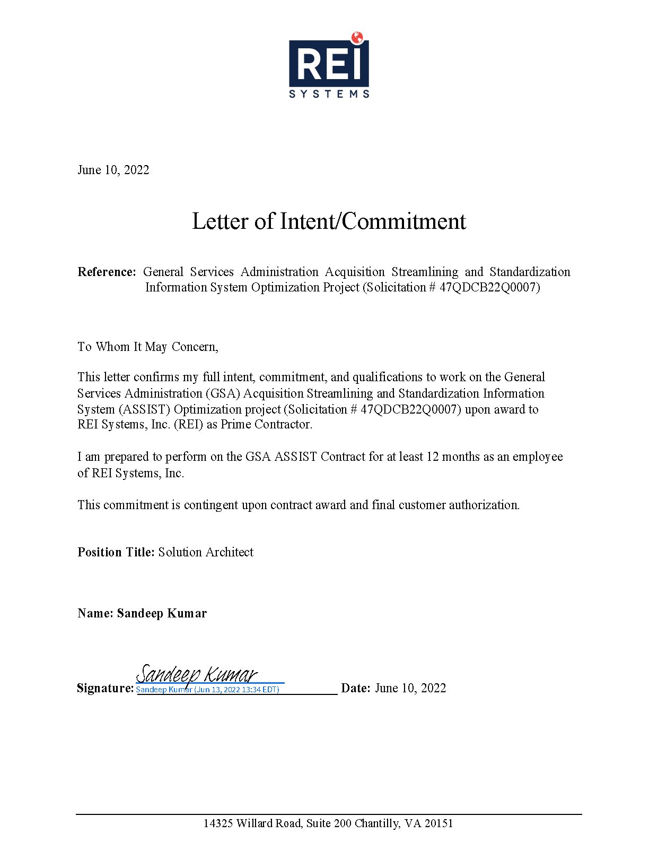

* 1. Ashish Kaushal – Database Architect (PWS 6.4)

|  |  |  |  |  |  |  |  |
| --- | --- | --- | --- | --- | --- | --- | --- |
| Labor Category | | | Skill Level | | | Clearance | |
| Database Architect | | | Senior | | | DHS | |
| Education /Professional Achievement/Specialty Training | | | | | | | |
| Year | Degree | Major | | | Granting Institution | | |
| 2007 | MS | Information Technology | | | University of Maryland, Global Campus, Maryland USA | | |
| 1993 | BSE | Electronic and Communication | | | University of Mysore, India | | |
| Achievements, Training, Certifications | | | | | | | |
| AWS Data Analytics Certified Specialty, 2020*  Validation Number 7RM9JJJ1G2FQQHS9  Validate at: <http://aws.amazon.com/verification> | | | | Oracle Certified Professional (OCP) 11g, 2013 | | | |
| IBM Blockchain Foundation for Developers, 2018 | | | | Microsoft Certified Database Admin (MCDBA) | | | |
| Microsoft Certified System Engineer (MCSE) Windows 2000 | | | | | | | |
| Employment History and Experience | | | | | | | |
| Independent Contractor (numerous concurrent positions) | | | | | | | 06/2014 – Present* |
| USCIS – Technical Lead (Data) *AWS | RDS | Ansible | CI/CD | MongoDB | Kafka | Data Lake | Python*\* | | | | | | | 06/2017 – Present |
| * Leads Technical Team responsible for architecting and implementing an enterprise-wide data platform using RDS, AWS Glue, EMR, Redshift, Data Lakes, Data governance, and Confluent Kafka, which is currently in production. Data is persisted in AWS Data Lake, where Databricks Spark is used for data analytics and Tableau for visualization. * Built and designed data ETL* processes using AWS Glue pipelines to move data from the transaction system to data lakes and data warehouses. * Planned and implemented migration roadmaps to migrate the on-prem database to AWS Postgres. * As Cloudbees Jenkins Architect, working on Cloudbees' new platform for CI/CD and automated testing, which includes setting up the Cloudbees Flow platform and migration to the new Cloudbees CI platform from the Jenkins enterprise. * Developed proofs-of-concept to incorporate new technologies like Databricks and to perform data analytics. * As Ansible Automation Developer, duties include the development of Ansible-based automation. The infrastructure, Kafka clusters, zookeeper, KSQL nodes, and Oracle Golden Gate cluster are “one-click” deployments, and the automation is done using Ansible and Ansible Tower.   **Technologies:** Apache Kafka, Python, RDS, Redshift, Amazon S3 Data Lake, AWS Glue, and Cloudbees CD. | | | | | | | |
| Federal Aviation Administration – Mongo Database Architect Consultant | | | | | | | 03/2018 – 10/2018 |
| * Helped backend migration from MS SQL Server to MongoDB, mentoring DBAs to get up to speed in MongoDB. * Worked on Mongo DB capacity planning, architecting, and setting up lower and upper environments. Data migration from SQL Server to Mongo DB. Production implementation was done with fall back strategy with initial SQL primary and MongoDB in shadow, then Mongo DB primary and SQL Server in shadow. | | | | | | | |
| USCIS – Mongo Database SME / Senior DevOps Engineer | | | | | | | 06/2014 – 06/2017 |
| * Architected and deployed multiple MongoDB environments in AWS Cloud. Designed MongoDB data model and sharing strategies for scaling and performance. Responsible for MongoDB administration, including no downtime upgrades and deployments. Automated MongoDB deployment and scaling using Chef. * Migration of data from Oracle to MongoDB. * Developed containerized application and MongoDB solutions using Docker and EC2 CS. * Worked with AWS and Chef Development regularly to automate the infrastructure deployment. * Routine work included, but was not limited to deployment, troubleshooting, performance tuning, and enhancing various software and database components. * **Technologies:** MongoDB, Oracle, AWS, Docker, Chef, Git, Jenkins, Java, and Spring Framework. | | | | | | | |
| SAIC, Washington DC – USCIS | | | | | | | 01/2013 – 06/2014 |
| Senior Oracle Administrator: *Data Modeling | PL/SQL | ODS Design | Diverse Replication Methodologies* | | | | | | | |
| * Provided Tier IV support from a database perspective. Worked closely with O&M database administrators to find optimal solutions to enhance application response time, storage optimization, and overall system performance. * Work involved a full life cycle of backend design, development, build, and deployment for various applications. Worked closely with Java/Tibco development teams. Mentored development teams and adhered to database best practices. * Designed strategy, developed and deployed solutions to migrate terabytes of data from nonpartitioned tables to partitioned tables with zero downtime. All databases were available throughout migration with no noticeable performance impact.   **Oracle Technologies applied:** PL/SQL procedures/packages development, Performance analysis and tuning, SQL tuning, data migration, partitioning, SSIS, SQL scripting and procedures, and other administrative duties for development and QA environments. | | | | | | | |
| Computer Sciences Corporation (CSC) | | | | | | | 01/2009 – 01/2013 |
| USCIS – eCISCOR Senior Oracle DW Architect: *Data Modeling | PL/SQL | ODS Design | Diverse Replication Methodologies* | | | | | | | |
| *CSC was helping its client in their effort to create a Data Warehouse solution, involving transferals of large volumes of data from varied data sources, including Oracle, IDMS, Pervasive to Operational Data Store (ODS), and then to Data Warehouse/Data Marts project named as eCISCOR.*   * Created replication solution using Oracle Materialized Views that enabled transfers of large volumes of data 30+ TB in record time. Design and development of Oracle Active Data Guard. * Wrote complex PL/SQL packages to ETL data from very large tables, consisting of row count in billions with a runtime of few hours for Validation Instrument for Business Enterprises (VIBE) application. * Full life cycle of backend design and development for various applications. Mentored and worked closely with development teams. Provided tier IV support from Oracle and database-related issues. * Oracle Technologies included ERWin for Data modeling and for ETL - Materialized Views, SQL Loader, Oracle Streams, Oracle RAC, Performance analysis, and tuning. | | | | | | | |
| Learning Tree International | | | | | | | 12/2007 – 01/2009 |
| Lead Database Administrator: *High-Availability Solutions | Geographical Sites Replication | Database Team Leadership* | | | | | | | |
| *Database environment consisted of SQL Server 2005/2008. Challenges included inadequate, error-prone replication solutions, ad-hoc reporting, lack of automation, and continuous break-fixes that kept three out of four members of the team fully occupied.*   * Designed and implemented a more stable data replication solution between various data sites spread through Europe, Canada, and the U.S. * Designed and implemented high-availability and fault-tolerance solutions by using available resources and keeping the cost within control. * Automated database tasks and alerts that could start a self-repairing mechanism while keeping DBA posted on the progress, thereby reducing billable hours. * Implemented a dynamic reporting solution using SSRS for SQL Server, thereby tremendously reducing ad-hoc requests, allowing the team to concentrate on progressive development. | | | | | | | |
| Revolution Health Group | | | | | | | 02/2006 – 11/2007 |
| Senior MySQL/SQL Server Database Administrator: Ground-up DBMS Infrastructure | Developer Guidance & Mentoring | | | | | | | |
| *Revolution Health was a start-up health portal founded by Steve Case (AOL founder) to empower consumers to regulate their health. The database environment was a mix of MySQL on Red Hat Enterprise and SQL Server 2005 on Windows.*   * Web Portal 30M Hits/Month. * Performed detailed capacity planning, system resource estimation, software specification, installation, and configuration. * Successfully built complete SQL Server and MySQL database environments for production, Test, and Development environments from scratch. * Built MySQL load balance solution by splitting write and read traffic between read-write and read-only replicated instances of MySQL. Portal had 25-30 million hits per month. * Created in-house monitoring and alerting solutions using open-source Nagios that helped this start-up avoid the immediate purchase of expensive monitoring/alerting software. | | | | | | | |
| 4GL Technologies | | | | | | | 09/2003 – 02/2006 |
| Independent Database Consultant: Wide-ranging Clients | Challenging Issues | Successful Solutions | | | | | | | |
| * Worked with different clients with unique issues that their database teams could not resolve and requested an outside consultant with specialized experience. * Hanger Orthopedics, Bethesda, MD: Successfully redesigned SQL Server databases for the main medical billing application. Re-wrote most of the business logic with custom stored procs and functions. * National Grid, Syracuse, NY: Successfully completed .NET application performance bottlenecks and resolved SQL Server locking and dead-lock issues in the VLDB environment. * National Public Radio, DC: Successfully completed log-shipping-based disaster-recovery, implemented database security, auditing. * America Coming Together, DC: ETL unstructured data from excel, flat files, and other sources. Complex data retrieval and data mining for 2004 Presidential elections. * WeatherBug, Gaithersburg, MD: Re-wrote critical software with extremely complex logic and scanned large volumes of data. Software’s revenue 4 million/year; increased this process’s throughput by approx. 1000%, as a byproduct, it relieved the obstructing SQL servers. * Pearson, Arlington, VA: Worked as a trainer on a per-call basis and served as adjunct faculty in some of the premier technical institutions in the DC Metro area, such as Pearson, ITT-Tech, and Phoenix U. | | | | | | | |
| DIGEX (Verizon) | | | | | | | 10/2000 – 09/2003 |
| Senior Datacenter Engineer: Complex Product Development | Multiple-Release Implementations | Smart Web Application | | | | | | | |
| *Digex, a Verizon Business, was a dedicated hosting company comprised of data centers on both coasts.*   * Supported 650 database servers in data center operations, mainly Oracle, SQL Servers, and some Sybase. Duties included configuring, securing, and maintaining customers’ hosts and keeping optimum running time. Built database clusters, including building, racking, cabling to switches, and configuring OS and database application clusters. | | | | | | | |
| Senior Software Engineer | | | | | | |  |
| * Re-developed the company’s vital application on .NET using C#, JavaScript, and XML. Application received much praise from its clients who struggled with the old, slow application with many limitations. * Designed and developed an enterprise-wide diagnostic and management portal that displayed the health of clients’ servers showing backup histories, query performances, resource utilization, etc. | | | | | | | |
| SYTEL – U.S. Department of Agriculture | | | | | | | 10/1998 – 10/2000 |
| Senior Software Developer: *Flagship Software Development | Software Architecture & Design* | | | | | | | |
| SSSI – Small Business Administration | | | | | | | 08/1997 – 10/1998 |
| Programmer: *Successful Prototype | Government Contract Award | Client/Server GUI Development* | | | | | | | |

* + 1. Letter of Commitment - Ashish Kaushal

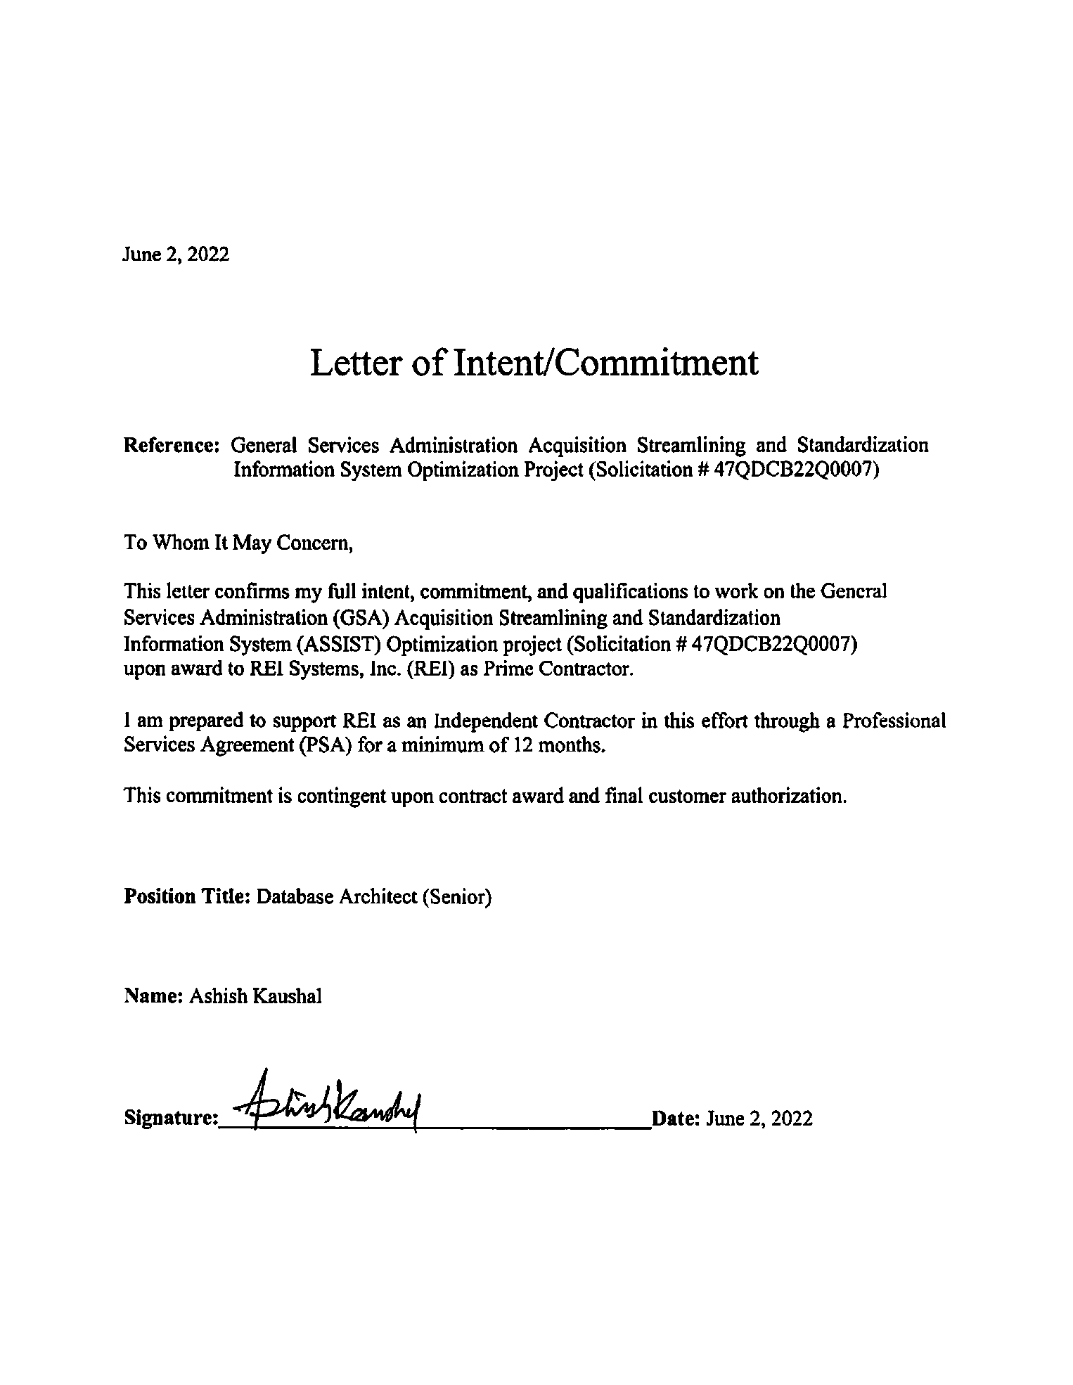

* 1. Sameer Vajre – Transition Manager

|  |  |  |  |  |  |  |
| --- | --- | --- | --- | --- | --- | --- |
| Labor Category | | | Skill Level | | Clearance | |
| Program Manager | | | Senior | | None | |
| **Education** | | | | | | |
| **Year** | **Degree** | **Major** | | **Granting Institution** | | |
| 1997 | MBA | Finance and Marketing | | Nagpur University, India | | |
| 1995 | Advanced Diploma | Computer Applications | | Nagpur University, India | | |
| 1994 | BS | Mathematics | | Nagpur University, India | | |
| **Training and Certifications** | | | | | | |
| Certified Scrum Master ([www.scrumalliance.org](http://www.scrumalliance.org)), 2010 | | | | | | |
| **Employment History and Experience** | | | | | | |
| **REI Systems, Inc.** | | | | | | **10/2011 – Present** |
| **Transition Lead for Defense Manpower Data Center (DMDC)\*** | | | | | |  |
| * Led the 30-day transition-in of a new program from the existing incumbent to REI Systems. * The transition included staffing 57 FTEs within 21 days and transitioning 204 DMDC applications and knowledge to REI. * Owned the transition-in risk management and mitigation plan. * Collaborated with the incumbent vendor to marry the transition-out and transition-in plans to ensure business continuity. * Maintain a shared roster of REI personnel clearly demonstrating labor category and clearance compliance with DMDC requirements. * Understand the DMDC clearance requirements to ensure the REI staff is fully operational and has the necessary DMDC access. * Report weekly transition-in progress, risks, issues, and mitigation plan to the DMDC executive leadership. * Accountable for the successful transition-in and handover to the REI DMDC Program team. | | | | | | |
| NASA, DoD, HRSA – Account Director | | | | | | 01/2020 – Present |
| * Manages an organization unit of 163 employees and a Profit and Loss (P&L) of $36M servicing NASA, DoD, Small Business Administration (SBA), Environmental Protection Agency (EPA), DMDC, and HRSA. * Accountable for contractual commitments and delivering mission impact solutions. * Fostered a trusted relationship with decision-makers based on a deep understanding of customer needs and a track record of delivery. * Collaborate with customers to devise IT strategy and technology roadmaps. * Optimized resource utilization, project execution, and contract fulfillment to meet and exceed customer objectives. * Deep focus on people – hiring, retaining, and growing with the intention to create a learning and delivery excellence culture. * Work with agency-specific technology leadership to formulate modernization, transformation, and cloud strategy. | | | | | | |
| HRSA Electronic Handbooks (EHBs) – Program Manager | | | | | | 10/2011 – 01/2020 |
| * Oversaw a $14M annual budget and 65 resources, which included six cross-functional teams/project managers spanning eight call orders. * Managed all enterprise-level initiatives as directed by the Chief Information Officer (CIO) to ensure the EHBs met key strategic goals and program outcomes. Examples included a start to finish the implementation of a $6M application modernization initiative. * Provided continuous stakeholder engagement and thought leadership to various levels within HRSA, for example, how to invest HRSA’s IT dollars to meet their strategic goals and mission. Doubled annual revenue from $10M to $22M by architecting technology roadmaps and advising senior HSRA OIT leadership. * Increased system quality through process innovation and improvement initiatives, such as the adoption of Unit Testing and Behavior-driven Development. * Enhanced team productivity by transitioning multiple teams from Waterfall to Agile. | | | | | | |
| **Infosys Technologies – British Telecom** | | | | | | **09/2005 – 09/2011** |
| **Project Manager/Agile Delivery Manager** | | | | | | |
| * Led a suite of projects under the Trouble to Resolve domain. * Responsible for managing the schedule, efforts, and costs of the 65-member team. * Participated in management reviews of progress on projects, monitoring of program activities, issue resolution, decision making, and dashboard status reporting. * Instrumental in defining and implementing an Agile delivery model for project releases. * Delivered multiple releases with "0" defects and within budget. | | | | | | |
| **Kanbay (now CapGemini) – Morgan Stanley** | | | | | | **09/2004 – 09/2005** |
| **Project Manager** | | | | | | |
| * Responsible for requirement analysis, Planning, Prioritization, Quality monitoring, schedule adherence, resourcing, cost control, and risks and dependencies management. * Spearheaded the project as a Technical Lead for the .Net platform. * Conceptualized the audit module, thereby giving the reviewer the benefit of reviewing the changes by the user. | | | | | | |
| **Mahindra British Telecom – British Telecom** | | | | | | **04/2003 – 09/2004** |
| **Senior Technical Associate** | | | | | | |
| * Responsible for development activities, technical solutions, and data modeling. * Analyzed requirements from a technical perspective, prepared design documents, and conducted code review deployment and post-release maintenance. * Led the technical solution from the ground up, starting from the technical solution document to the deployment strategy. | | | | | | |
| **Bay Systems Pvt. Ltd.** | | | | | | **01/2001 – 02/2003** |
| **Programmer/Analyst** | | | | | | |
| * Responsible for requirement elicitation, analysis, and implementation using ASP.Net and VB.Net, developing and testing system enhancements vis-à-vis the requirements. * Wrote unit test cases and developed integration test plans. | | | | | | |
| **Wipro – Transco** | | | | | | **06/2000 – 12/2000** |
| **Senior Systems Engineer** | | | | | | |
| * Responsible for development and maintenance of Billing and Invoicing module for Transco, the largest gas provider in Europe in the retail and utilities domains. Also wrote unit test cases and developed integration test plans. | | | | | | |

*The remainder of this page is intentionally blank.*

* + 1. Letter of Commitment – Sameer Vajre

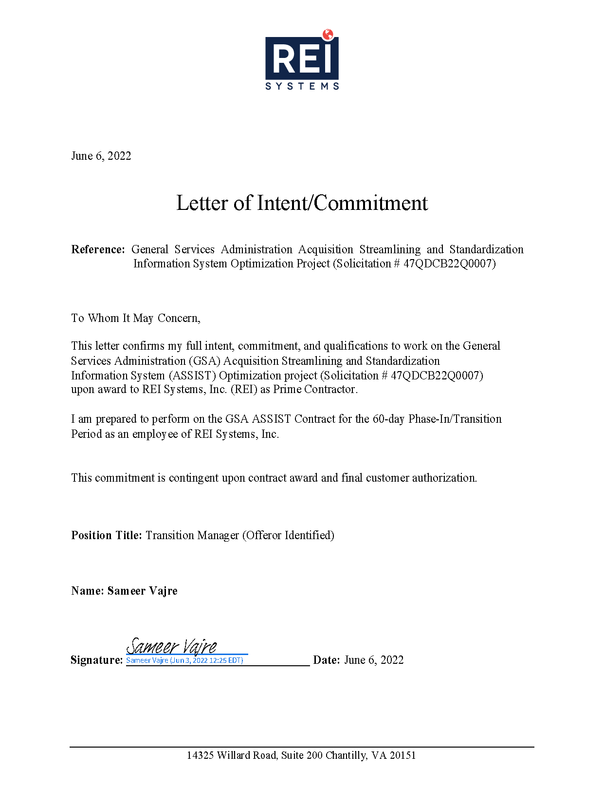

1. ASSUMPTIONS

REI Systems, Inc. takes no exception to the GSA ASSIST Optimization solicitation’s contents, including Amendment 1. In the following sections, we provide our performance assumptions grouped by factor.

* 1. Technical Assumptions (Factor 1)

1. We assume the ASSIST migration to the cloud in MCaaS will be completed prior to the start of the new contract.
2. We also assume that BIRT custom code and configurations for reporting will also be available in MCaaS.
3. We assume ASSIST transactional data is available in a single source, and no data sync exists between on-premises data and cloud data.
4. We assume the ASSIST Product Owners and Subject Matter Experts (SME) will be available and participate during implementation planning, architecture reviews, backlog prioritization, backlog refinement, and requirement analysis.
5. We assume FCS-D provides infrastructure and hosting support for AI/ML.
6. We assume GSA provides UiPath RPA licenses and administration support.
7. We assume the FCS team is available and provides support for infrastructure, network, and security aspects of the ATO process and related POA&M procedures for shared services such as MCaaS.
8. We assume the incumbent vendor provides existing ServiceNow configurations and data.
9. We assume GSA will provide the required approval to ServiceNow for the transition of existing configurations and data to the new ASNOW Help Desk.
10. We assume that the incumbent vendor provides available configurations for the existing Mitel Phone system.
    1. Staffing and Management Plan Assumptions (Factor 2)
11. Our roadmap assumes close coordination with external teams to meet Year 1 Priorities. Any external constraints or blockers that are not resolved in a reasonable amount of time may impact the delivery of these priorities.
12. We assume a reduction in DME hours for Security, Cloud, and Database Developer Resources once the migration to FCS is completed.
13. We assume a well-defined shared responsibility model between FCS and ASSIST teams to stabilize ASSIST in MCaaS.
14. We assume a reduction in DME hours for Security, Cloud, and Database Developer Resources once the migration to FCS is completed.
15. Our estimates are based on our experience and industry knowledge of similar tasks. We used this experience to classify each business objective as low, medium, high, and very high complexity to plan and staff the teams. As the RFQ provided limited information on each initiative, our solution teams also leveraged other sources such as ASSIST Industry Day meetings and partner knowledge to provide additional context to structure the teams.
16. We assume the timeframes for staff to begin work depend upon completing the GSA’s onboarding processes.
    1. Phase-In/Transition Plan Assumptions (Factor 3)
17. We assume the Government will provide a single point of contact for close coordination and engagement. This point of contact will help resolve any issues between vendors.
18. We assume the incumbent team will be fully available during the Phase-In period for transition activities. Any delays in knowledge transfer will cause a risk to a successful and on-time assumption of responsibility.
19. We assume all incumbent environments will be transitioned to MCaaS prior to the start of Transition-in.
20. As part of the Transition, we assume the incumbent will provide a complete list of known issues and technical debt that AAS can prioritize for future remediation.
21. We assume all documentation related to ASSIST 2.0 is up-to-date and ready for the transition to the new vendor.
    1. Management Approach Assumptions (Factor 5)
22. We assume GSA will work with the awardee to finalize all SLAs and performance metrics upon award.
23. We assume AAS will provide inputs, support, and participation for our DME Teams to ensure Optimization success.
24. We assume GSA will grant necessary permissions for telework for non-client-facing personnel.

*The remainder of this page is intentionally blank.*

1. Draft Project management Plan
2. Qualification Certification Letter

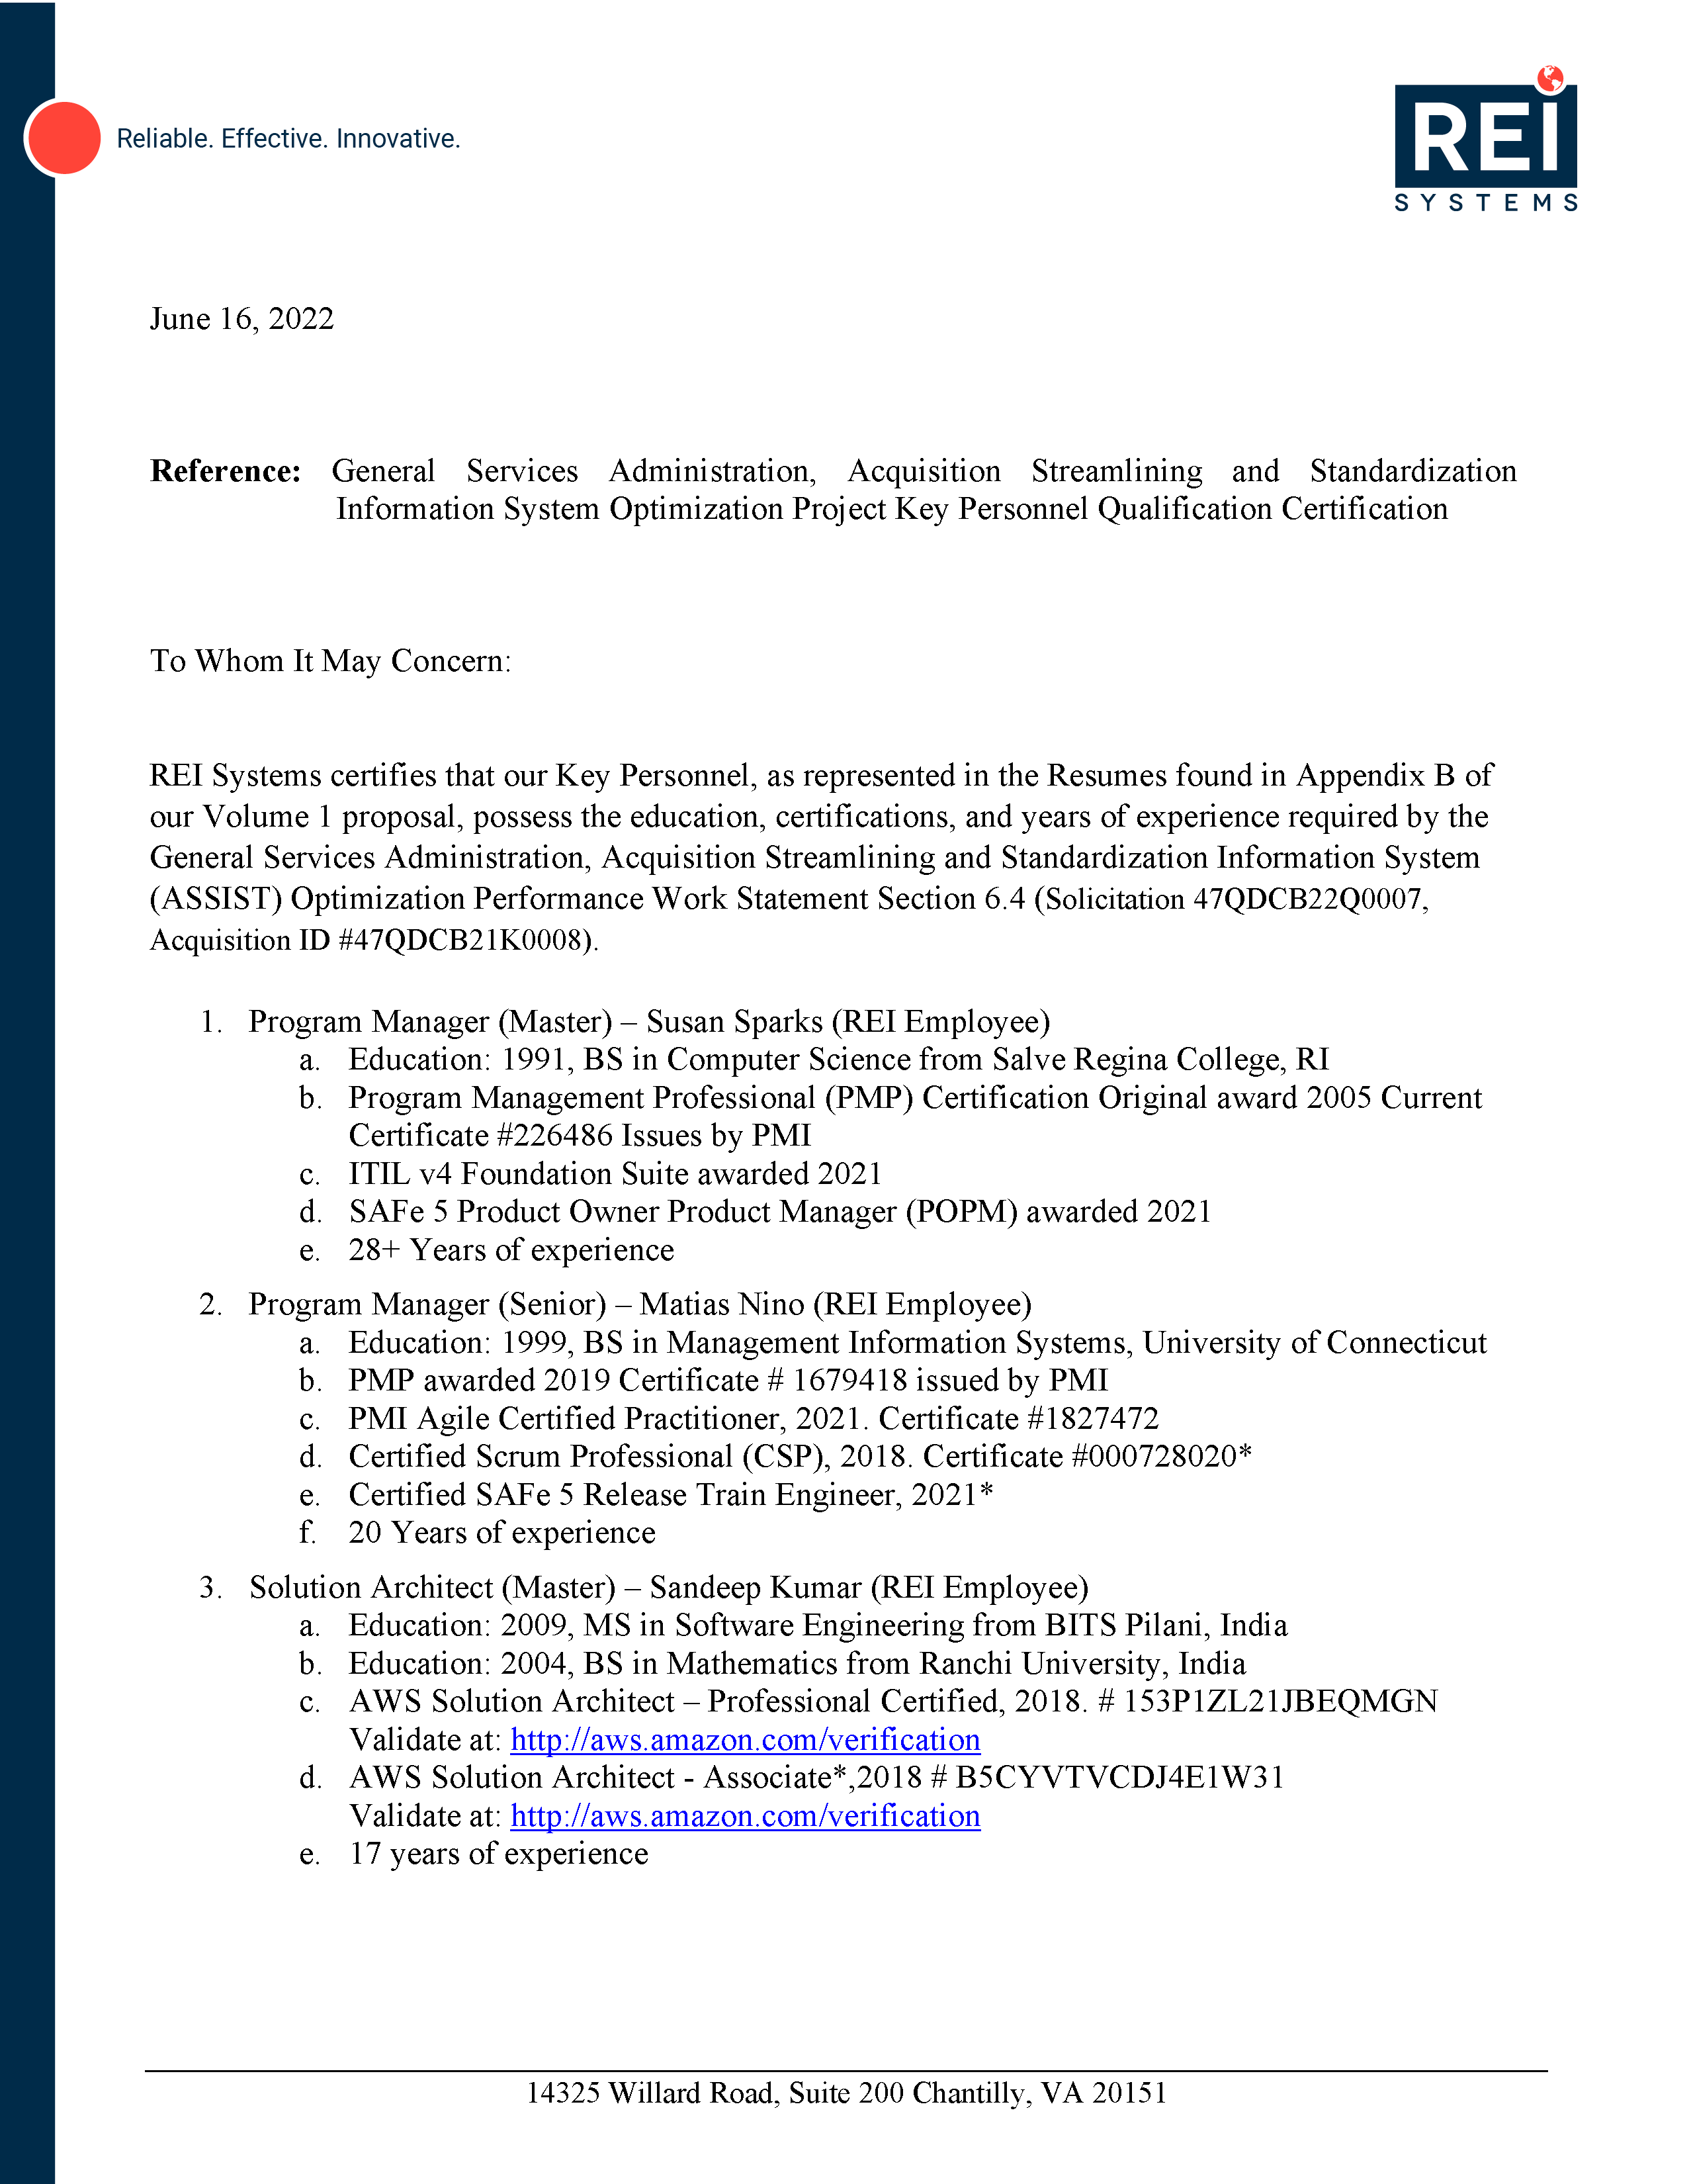

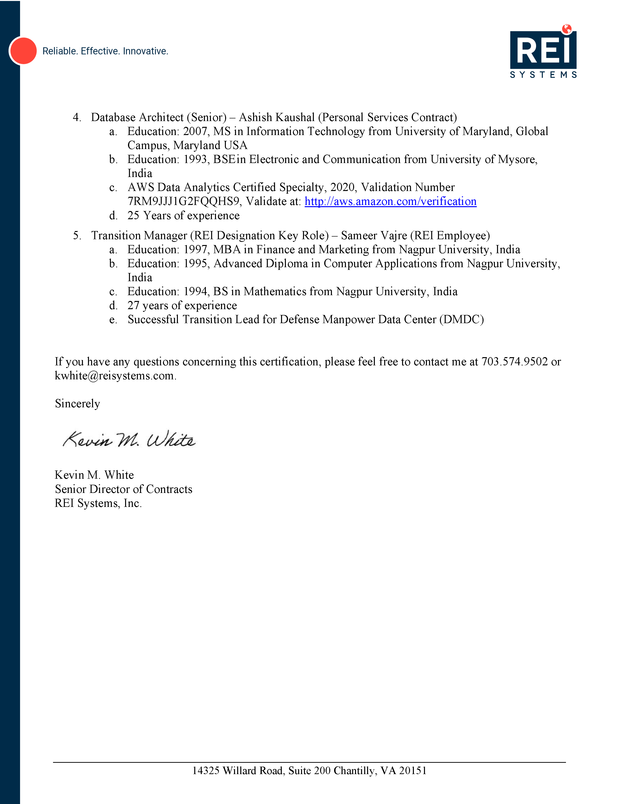

1. ATTACHMENT 3 – FAR 52.204-24 through 26

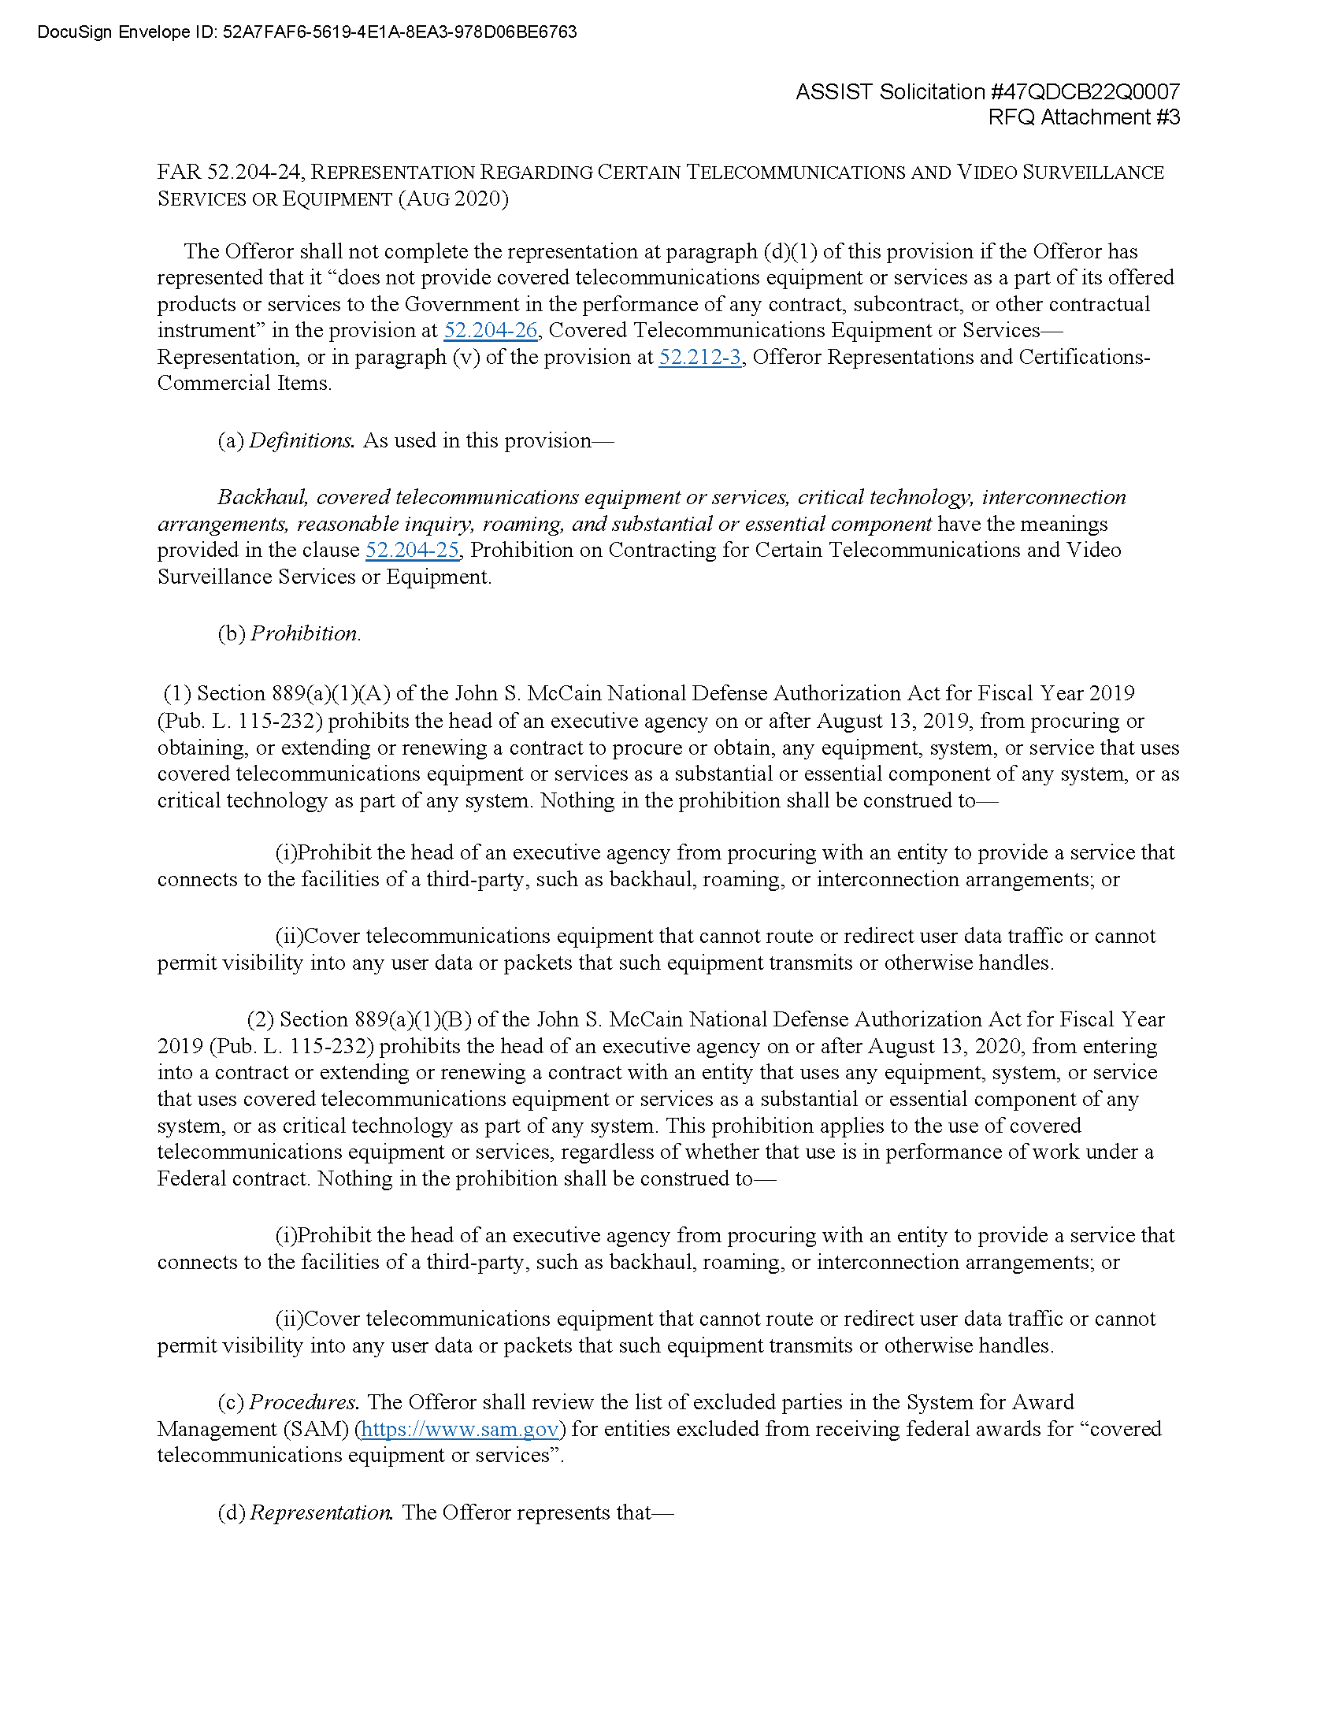

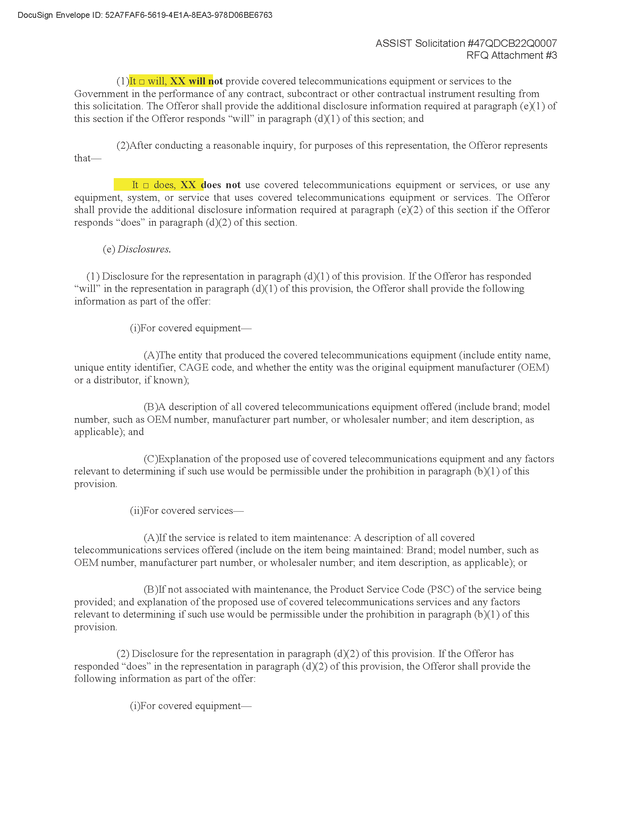

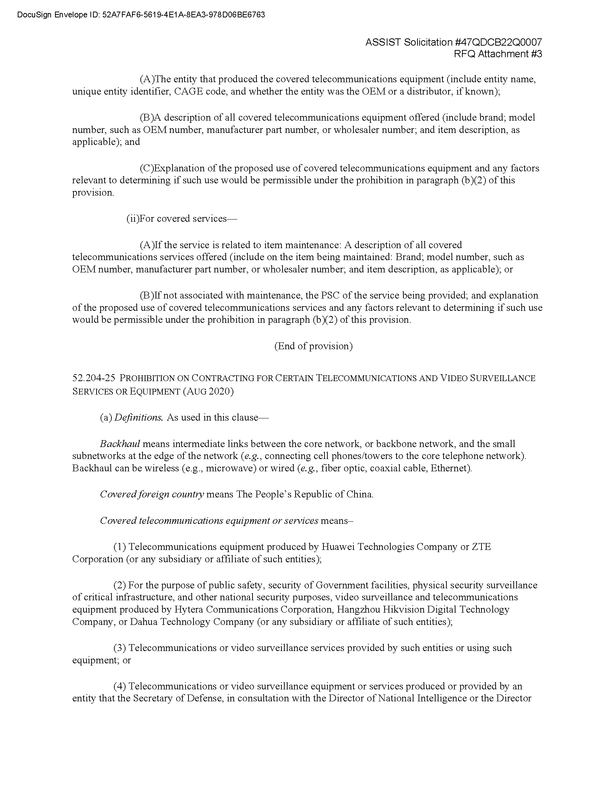

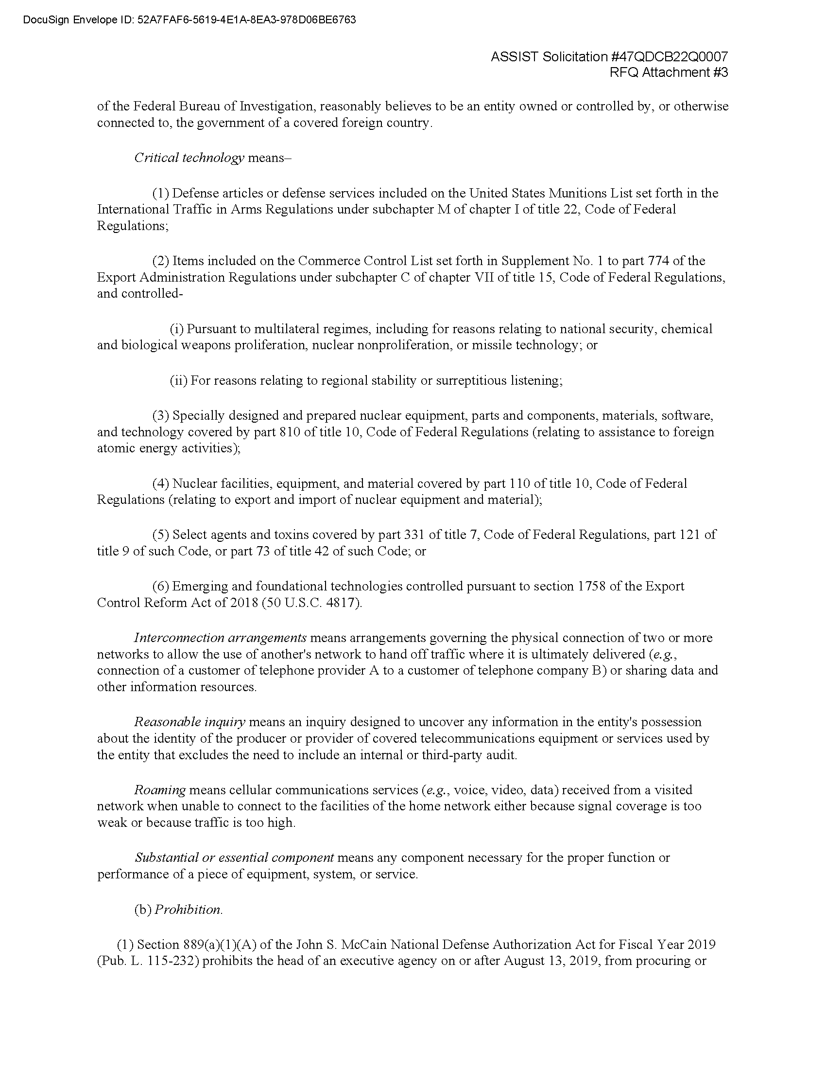

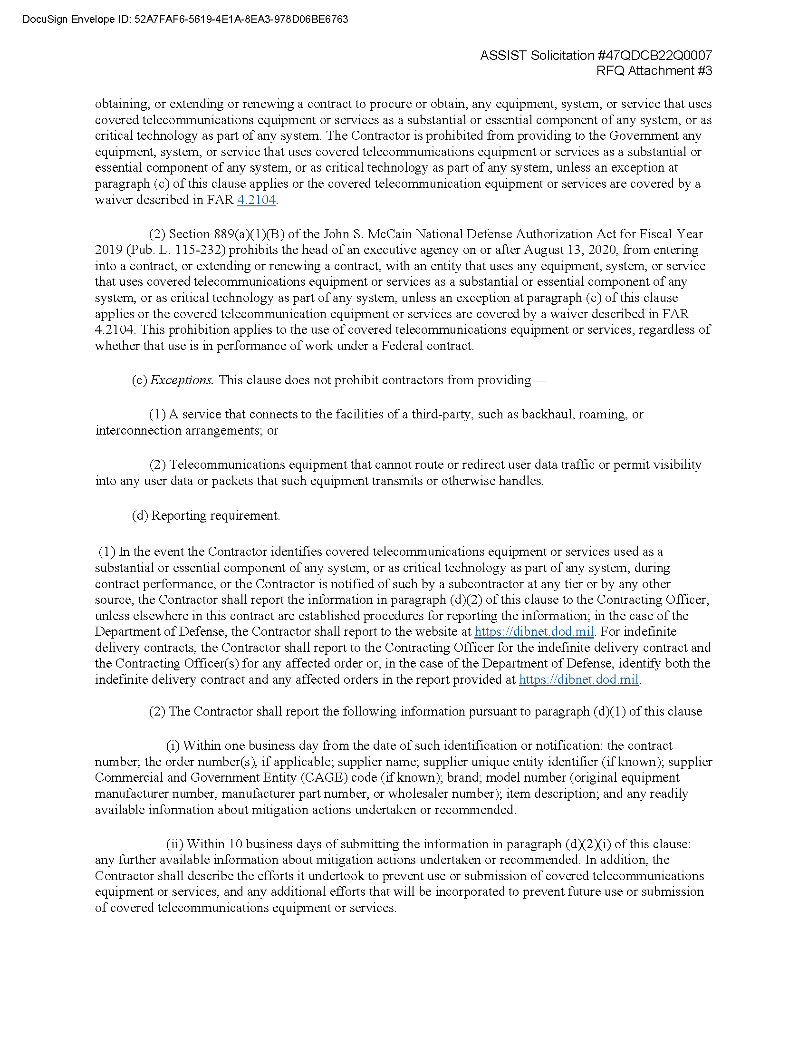

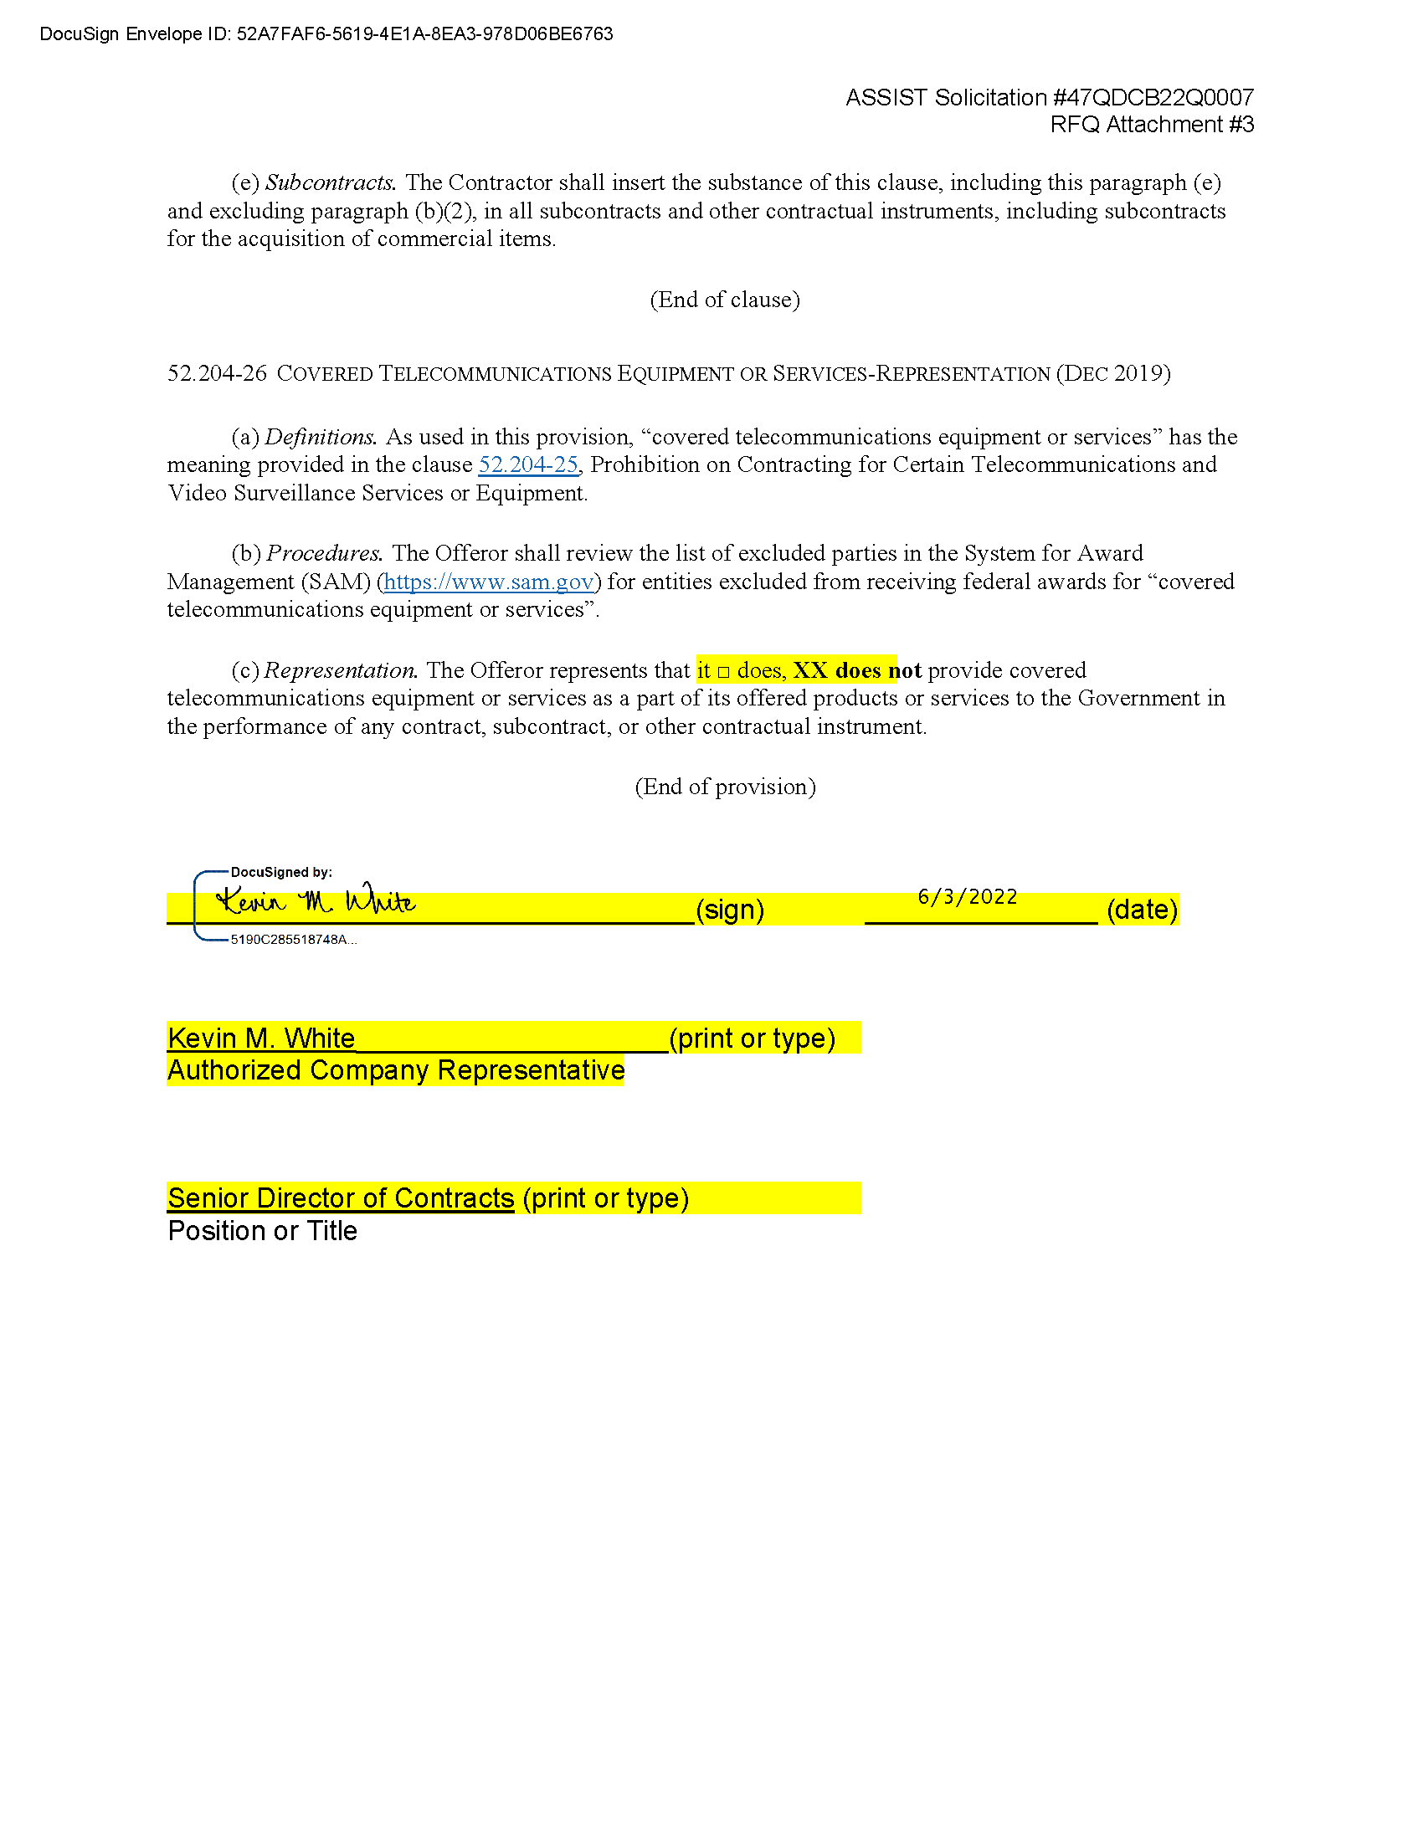

1. Attachment 4 – Conflict of Interest Clauses & Certification

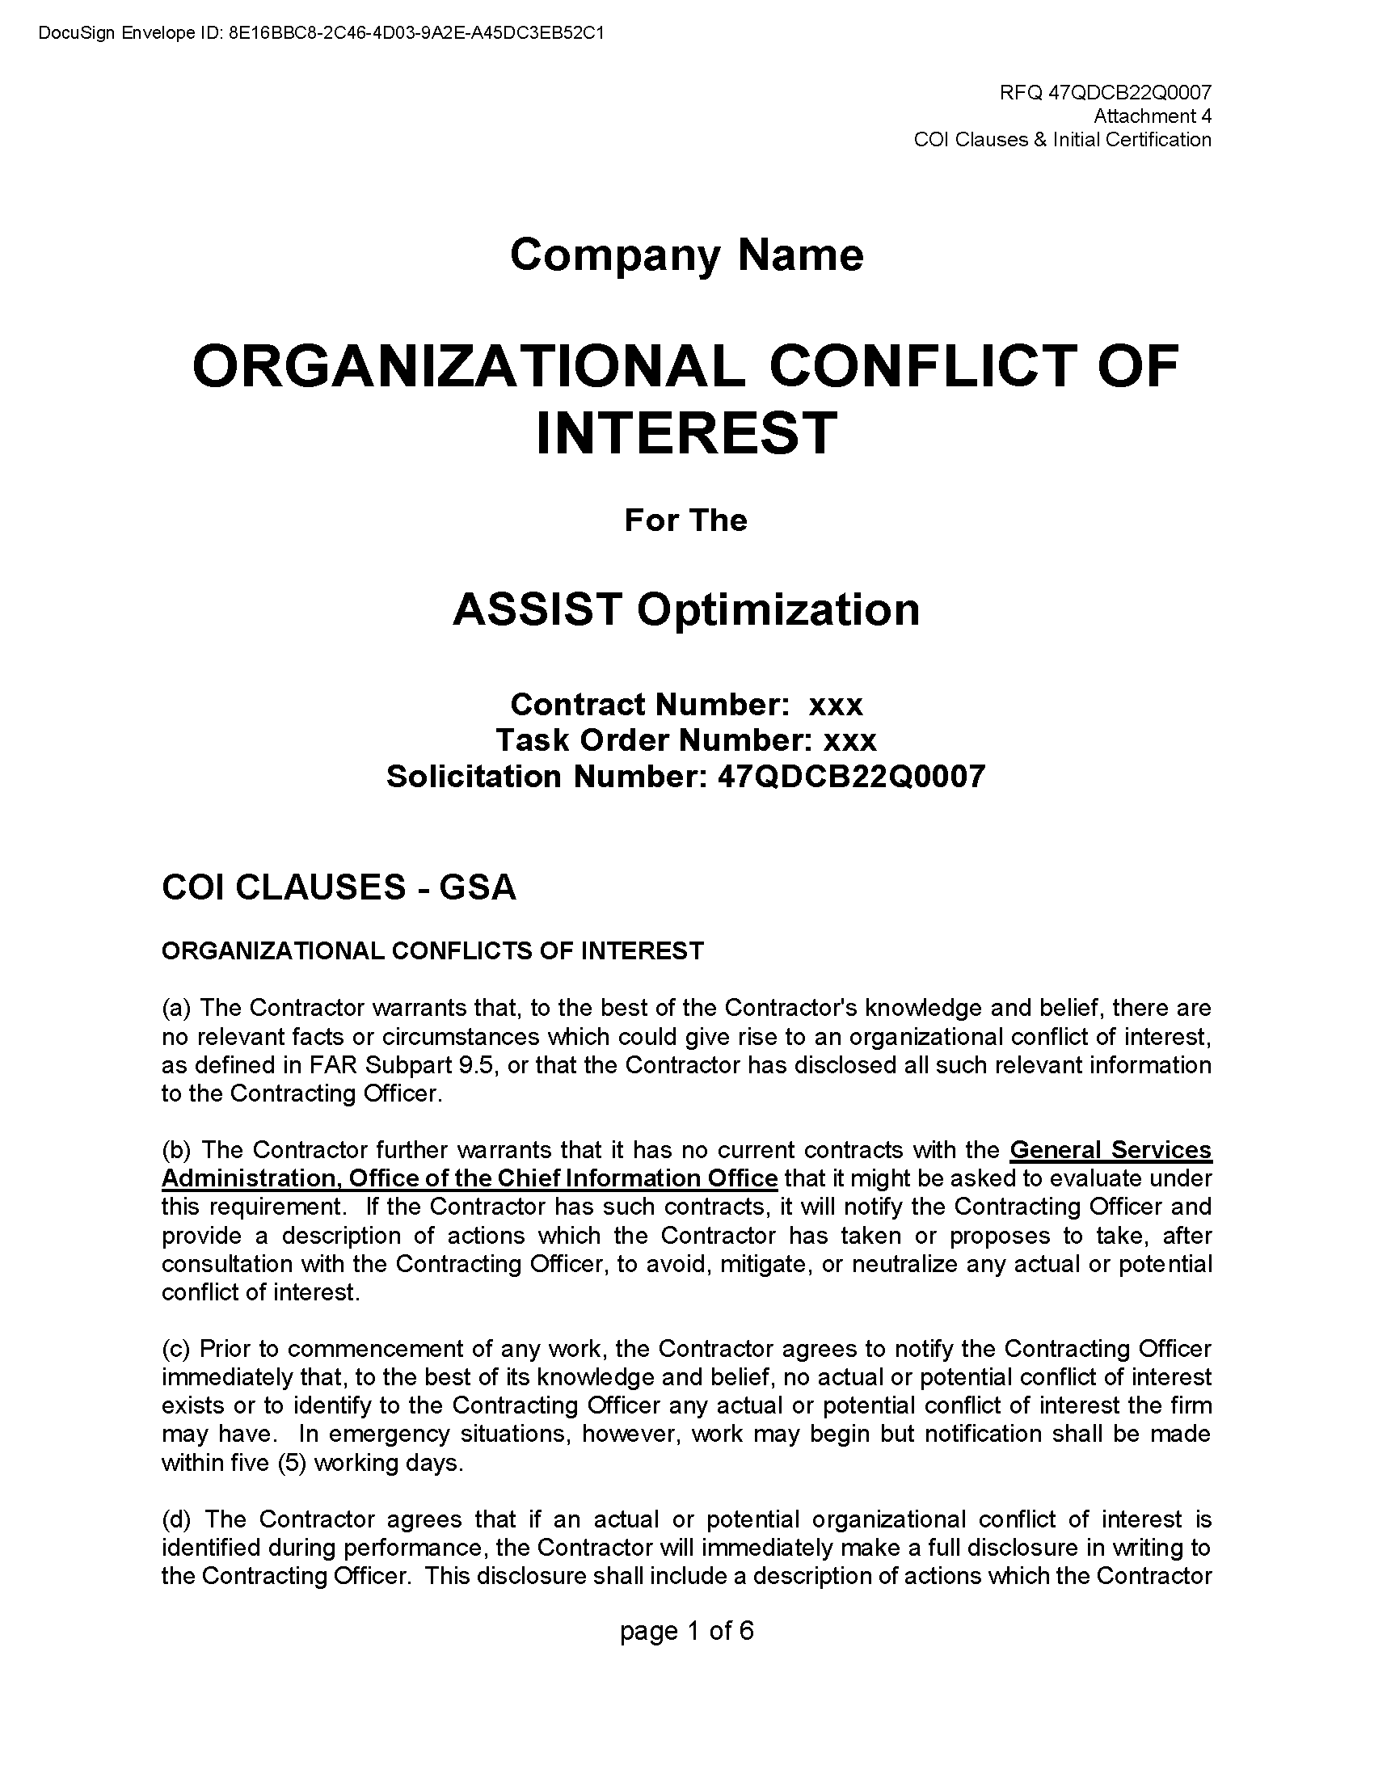

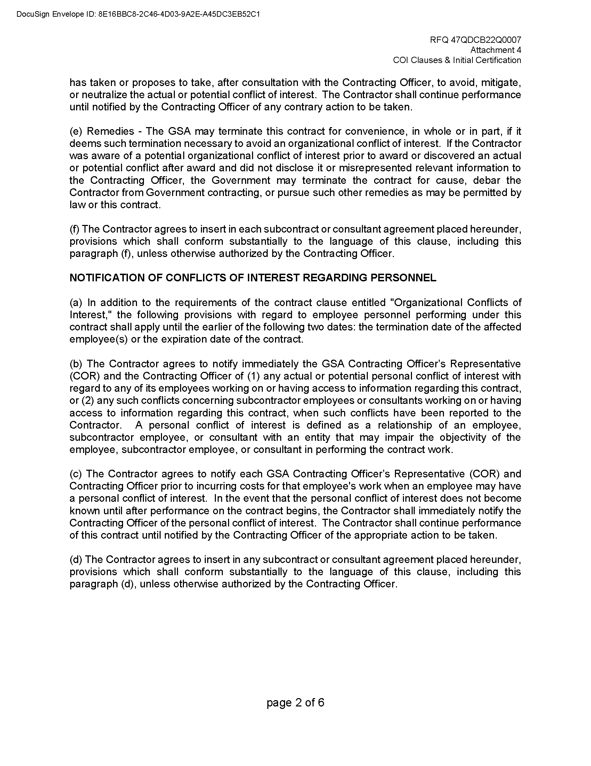



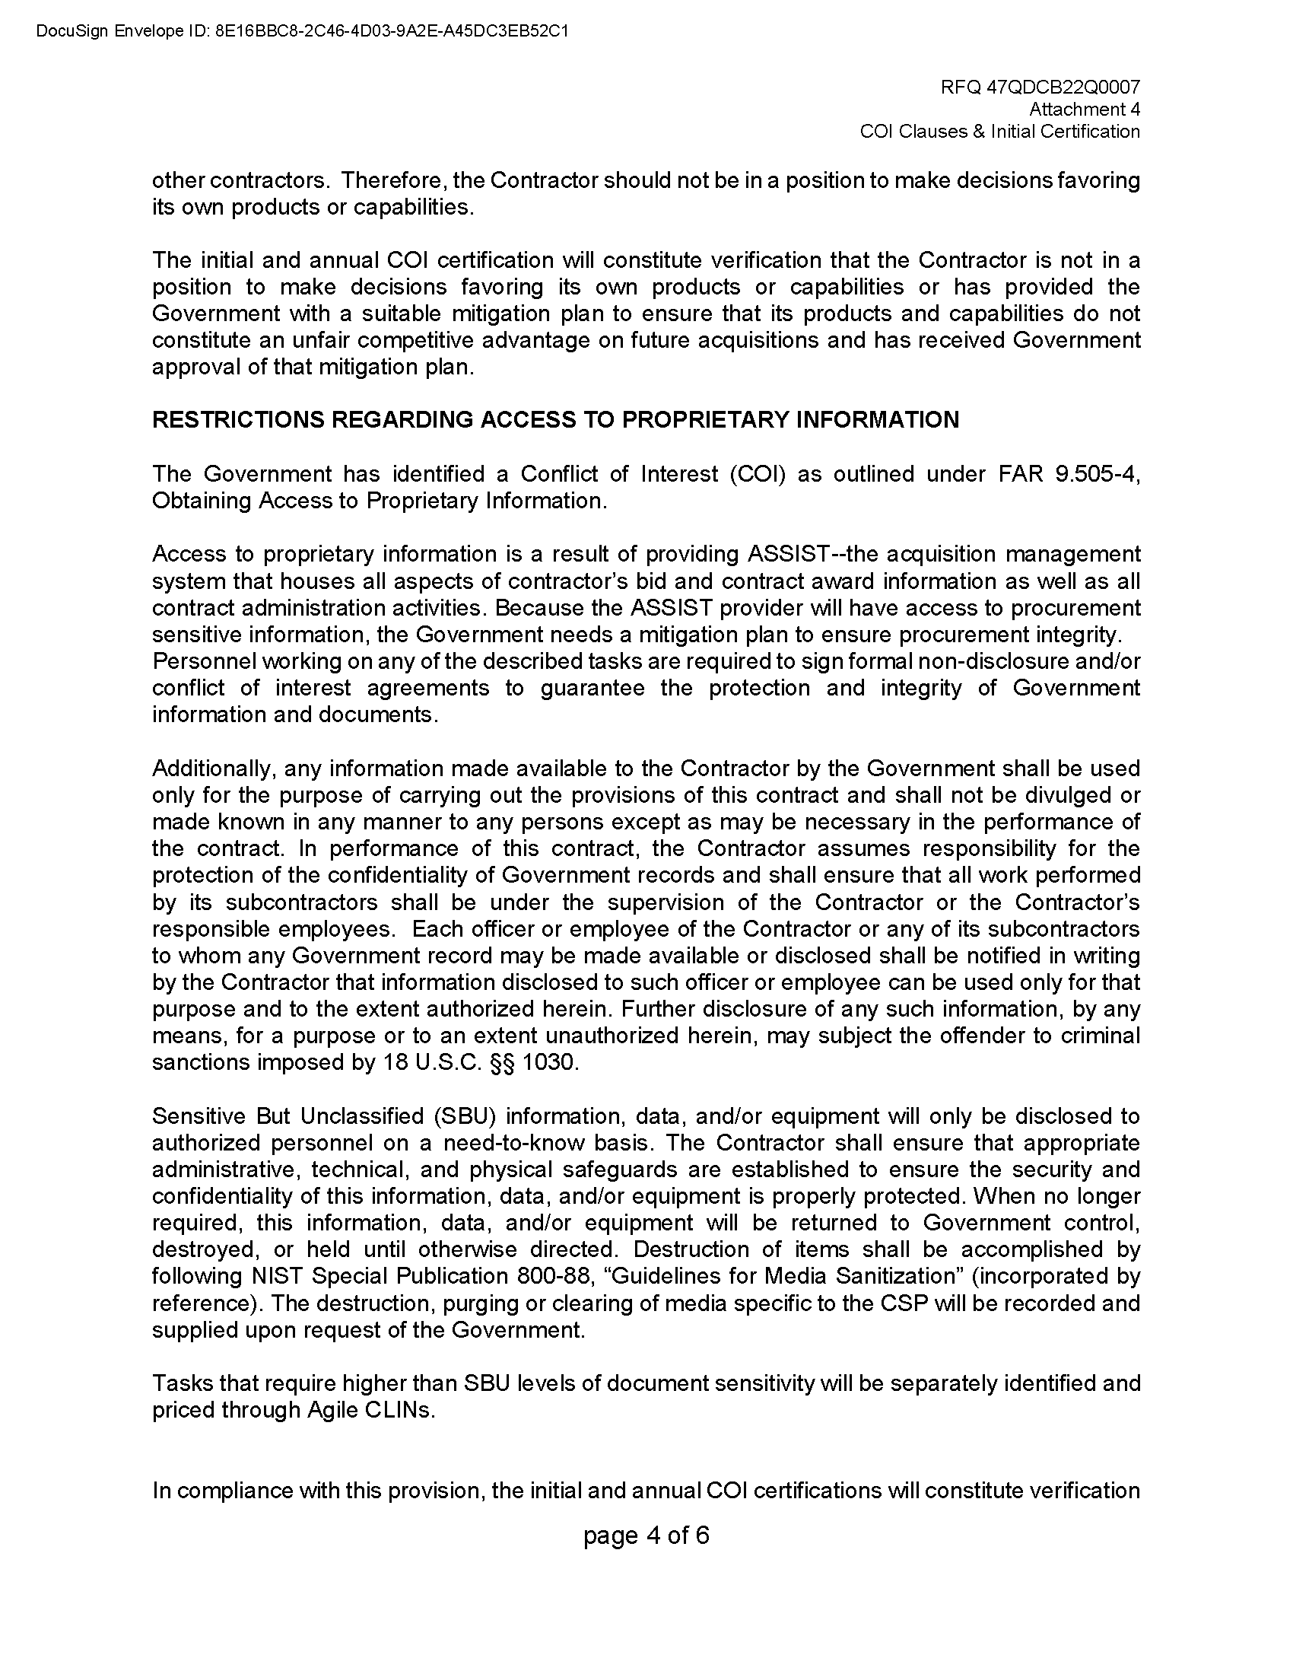

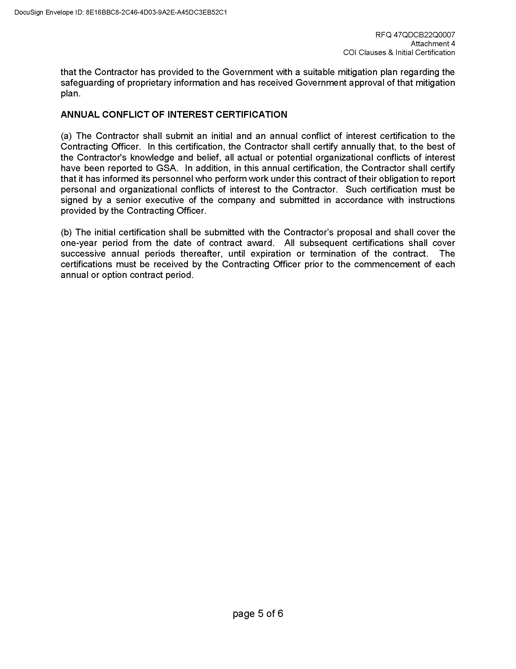

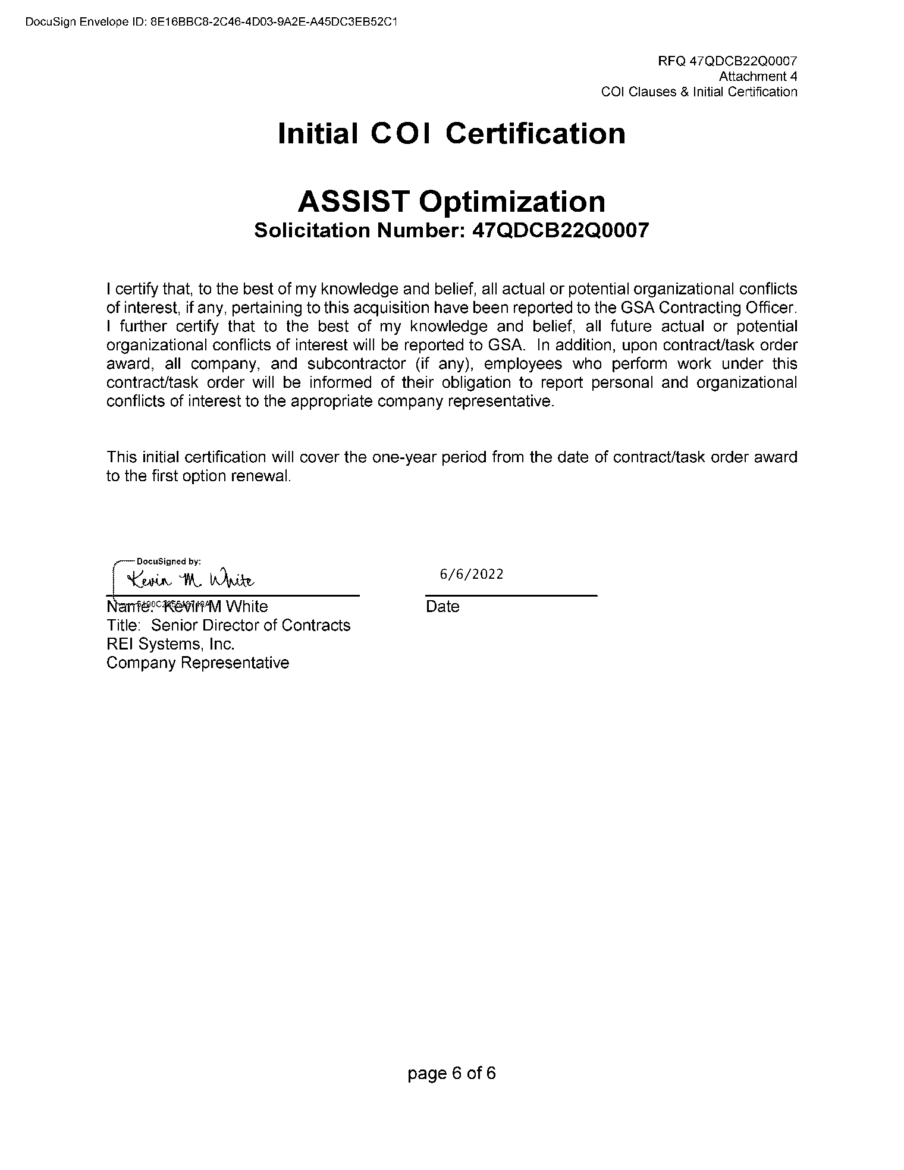

1. Subcontracting Plan

REI Systems, Inc. provides below a copy of the small business subcontracting plan submitted for Solicitation number FCIS-JB-980001-B / MAS Contract number 47QTCA19D00DR under which the COMET BPA was awarded. REI agrees to maintain the subcontracting goals established for the MAS contract.

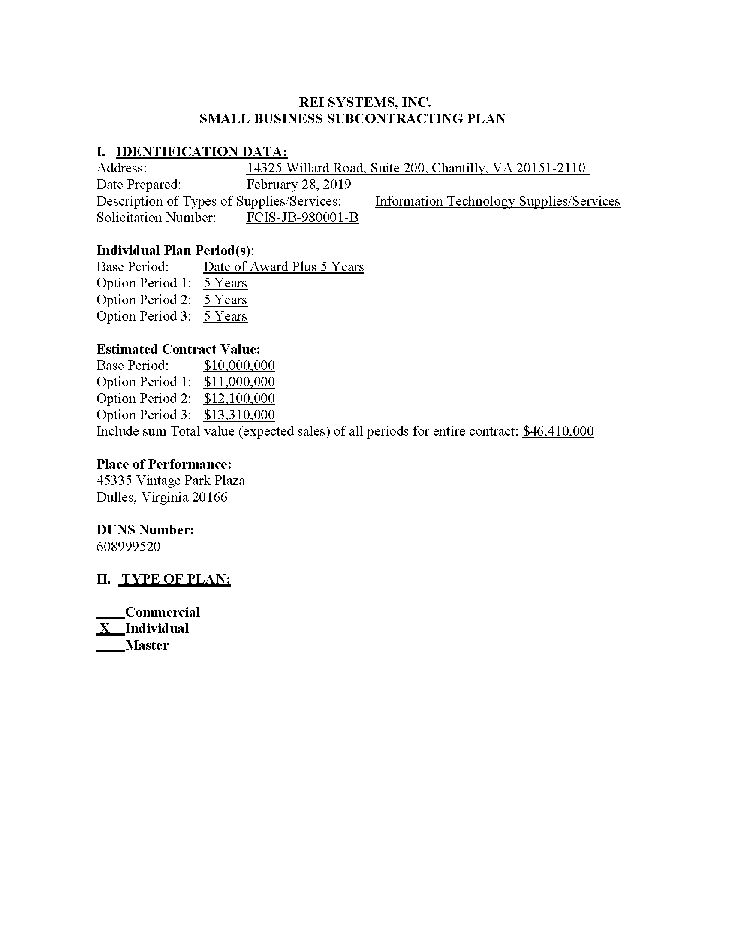

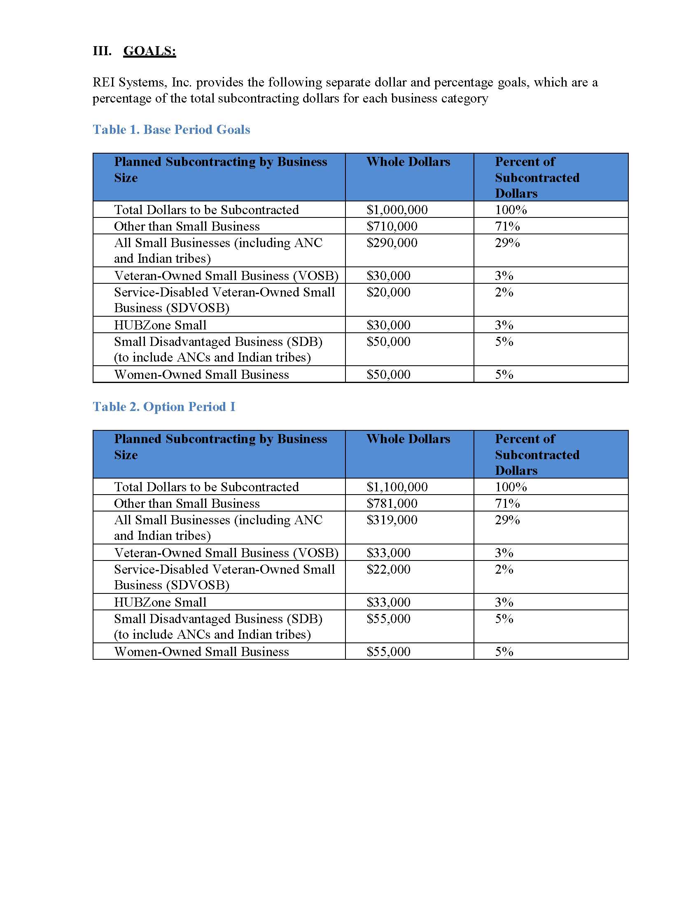

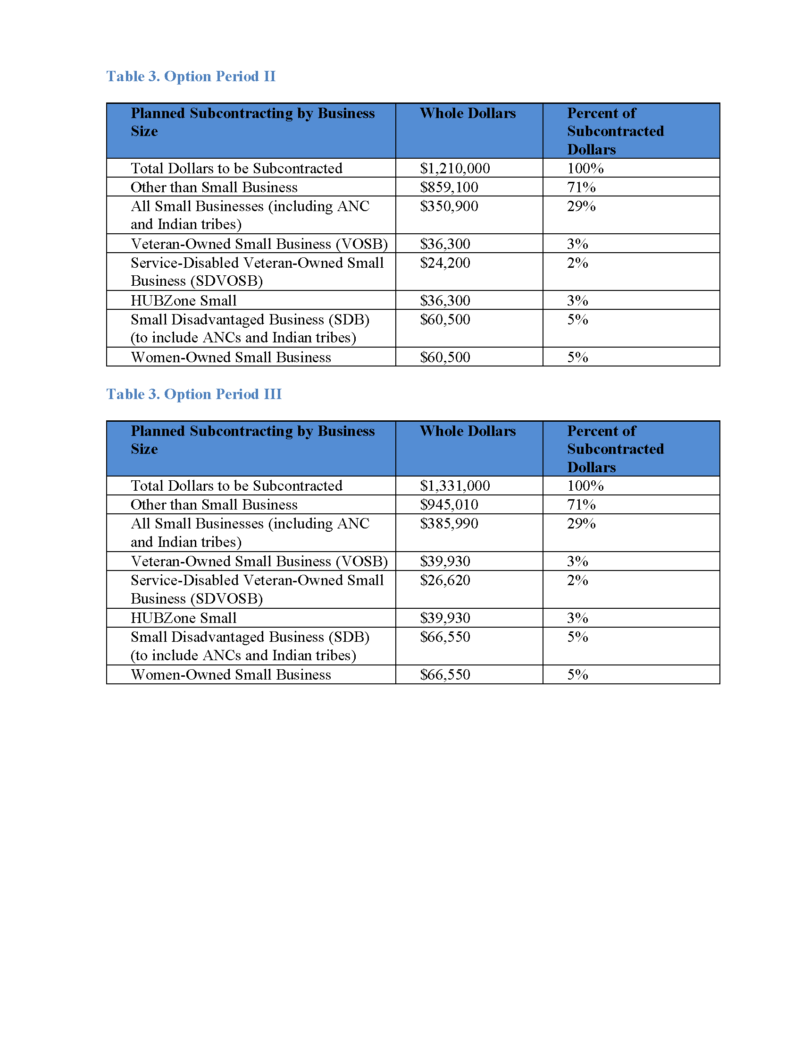

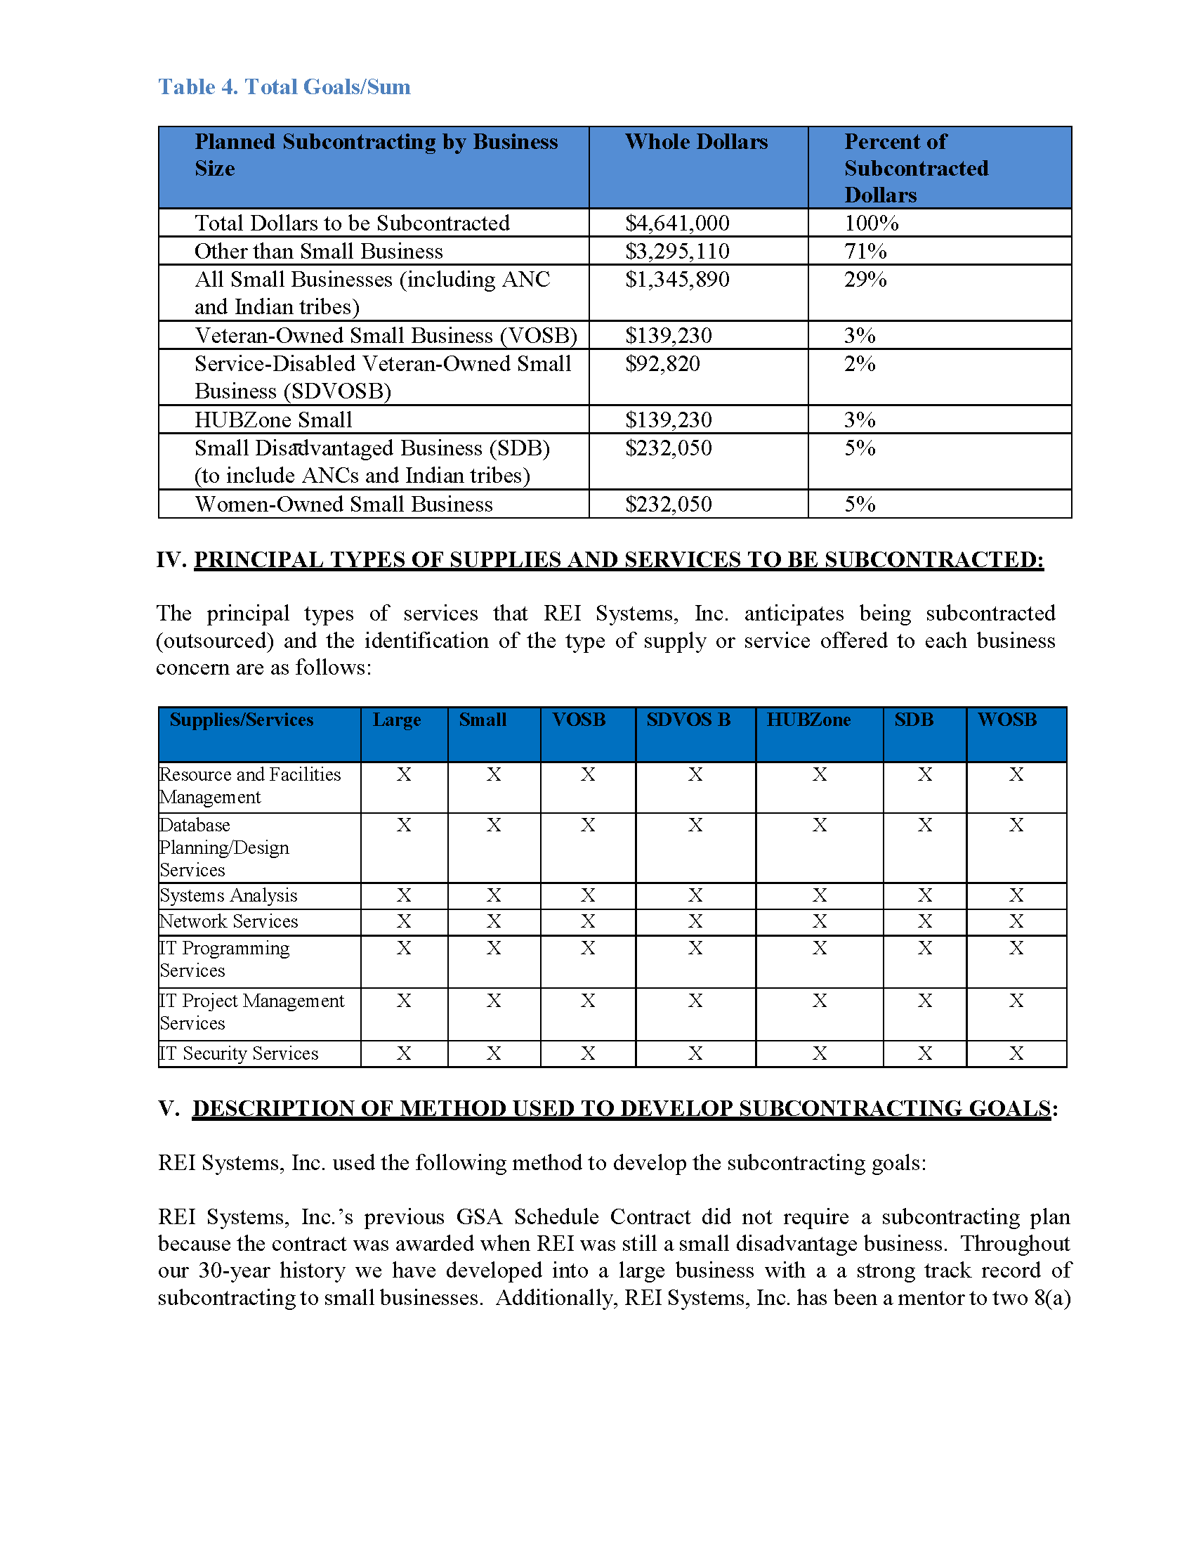

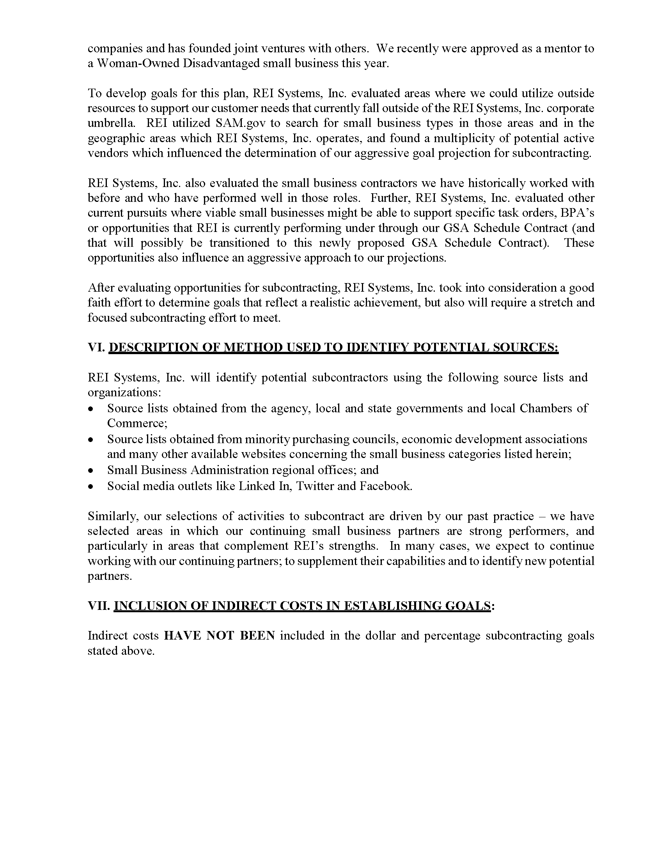

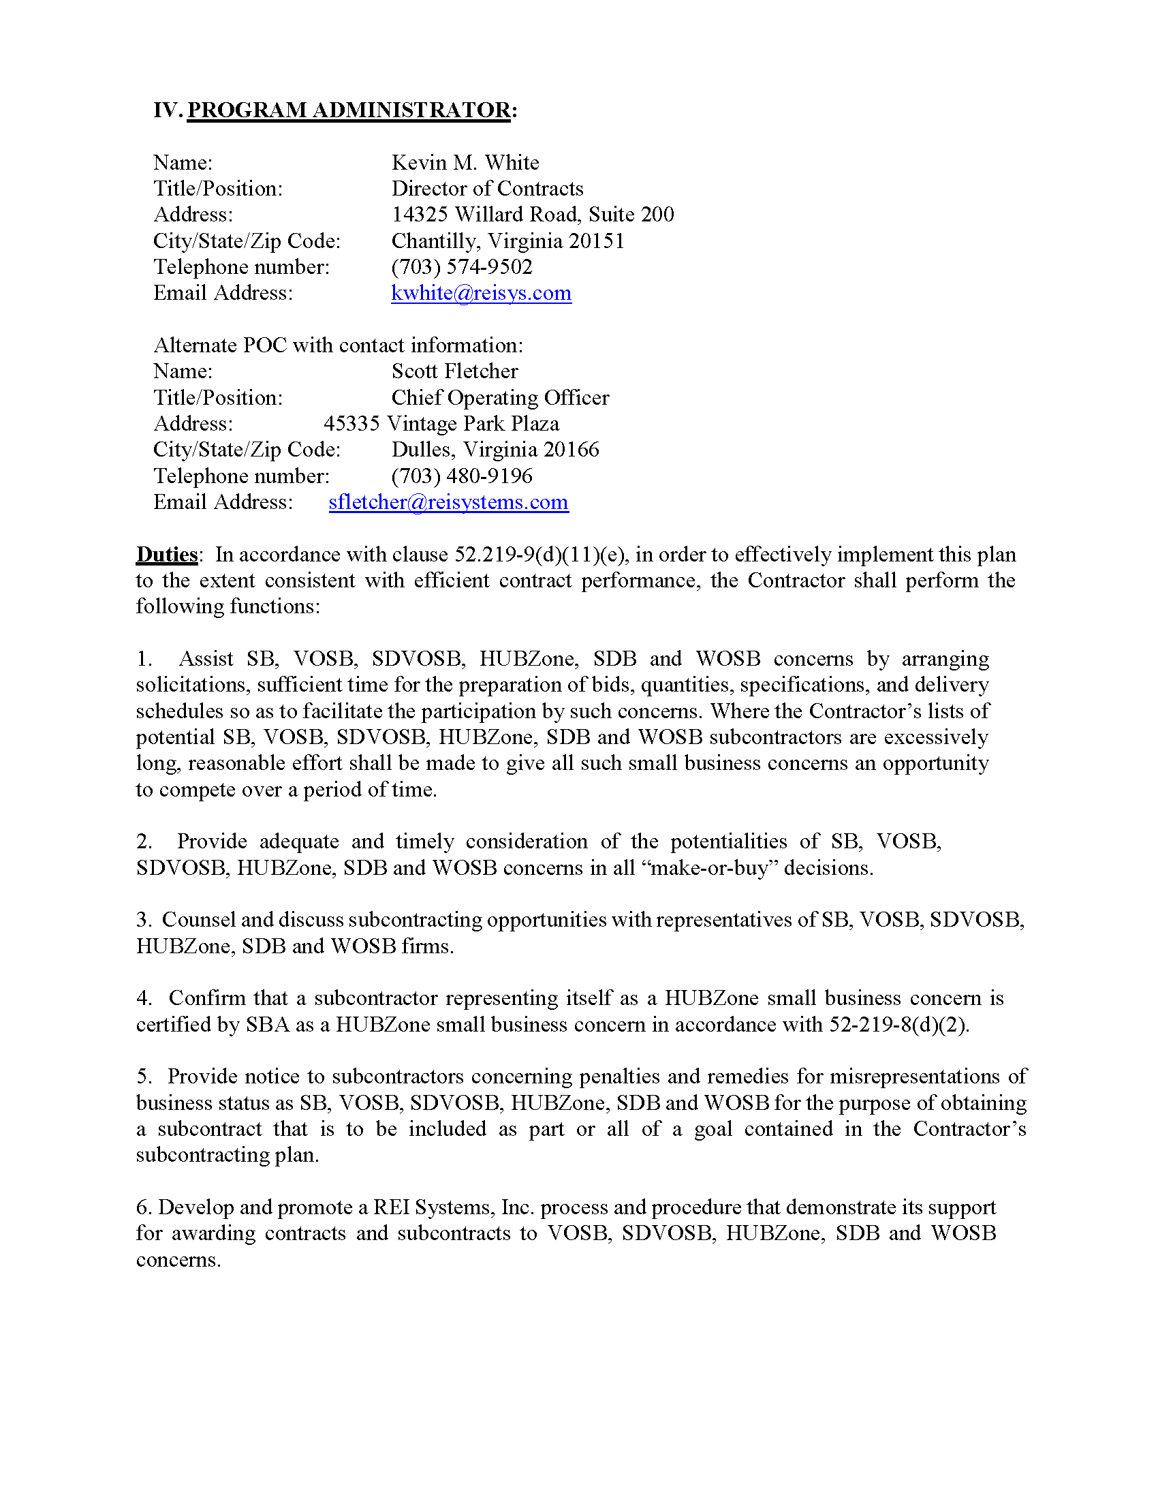

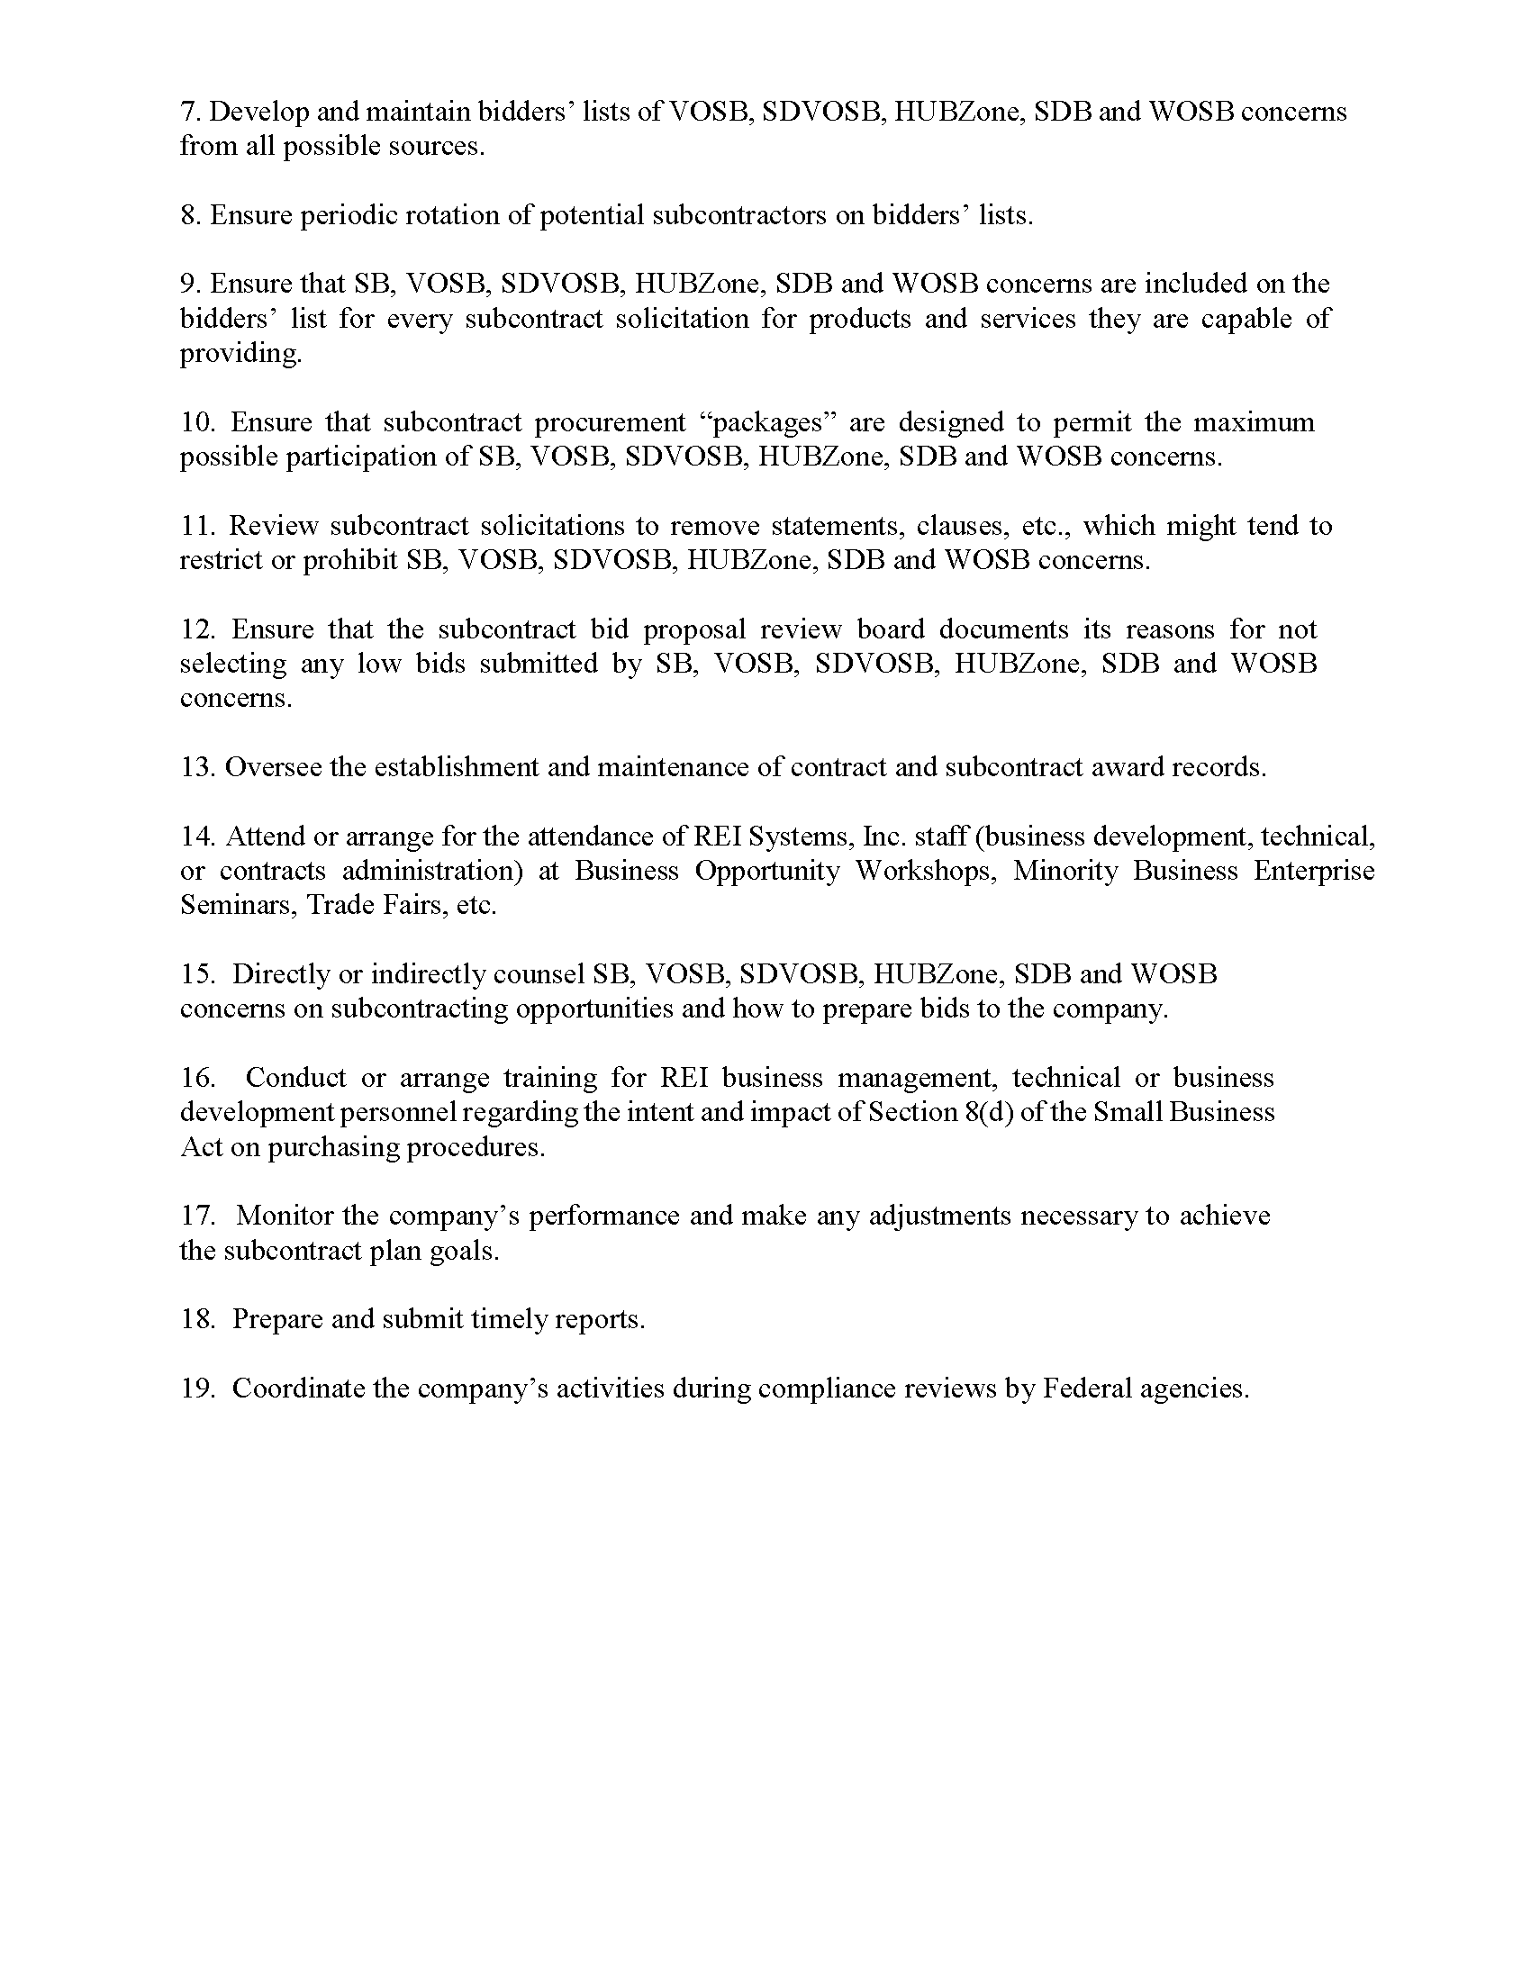

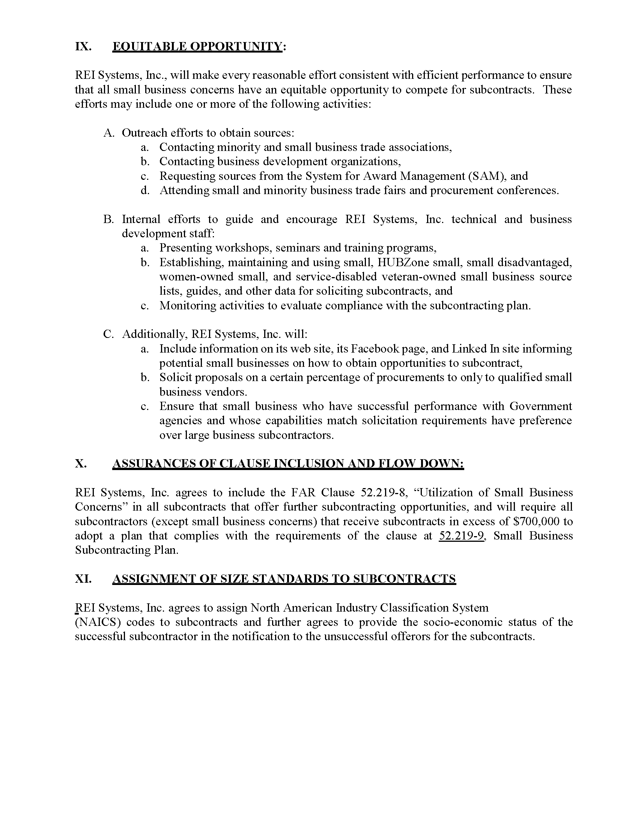

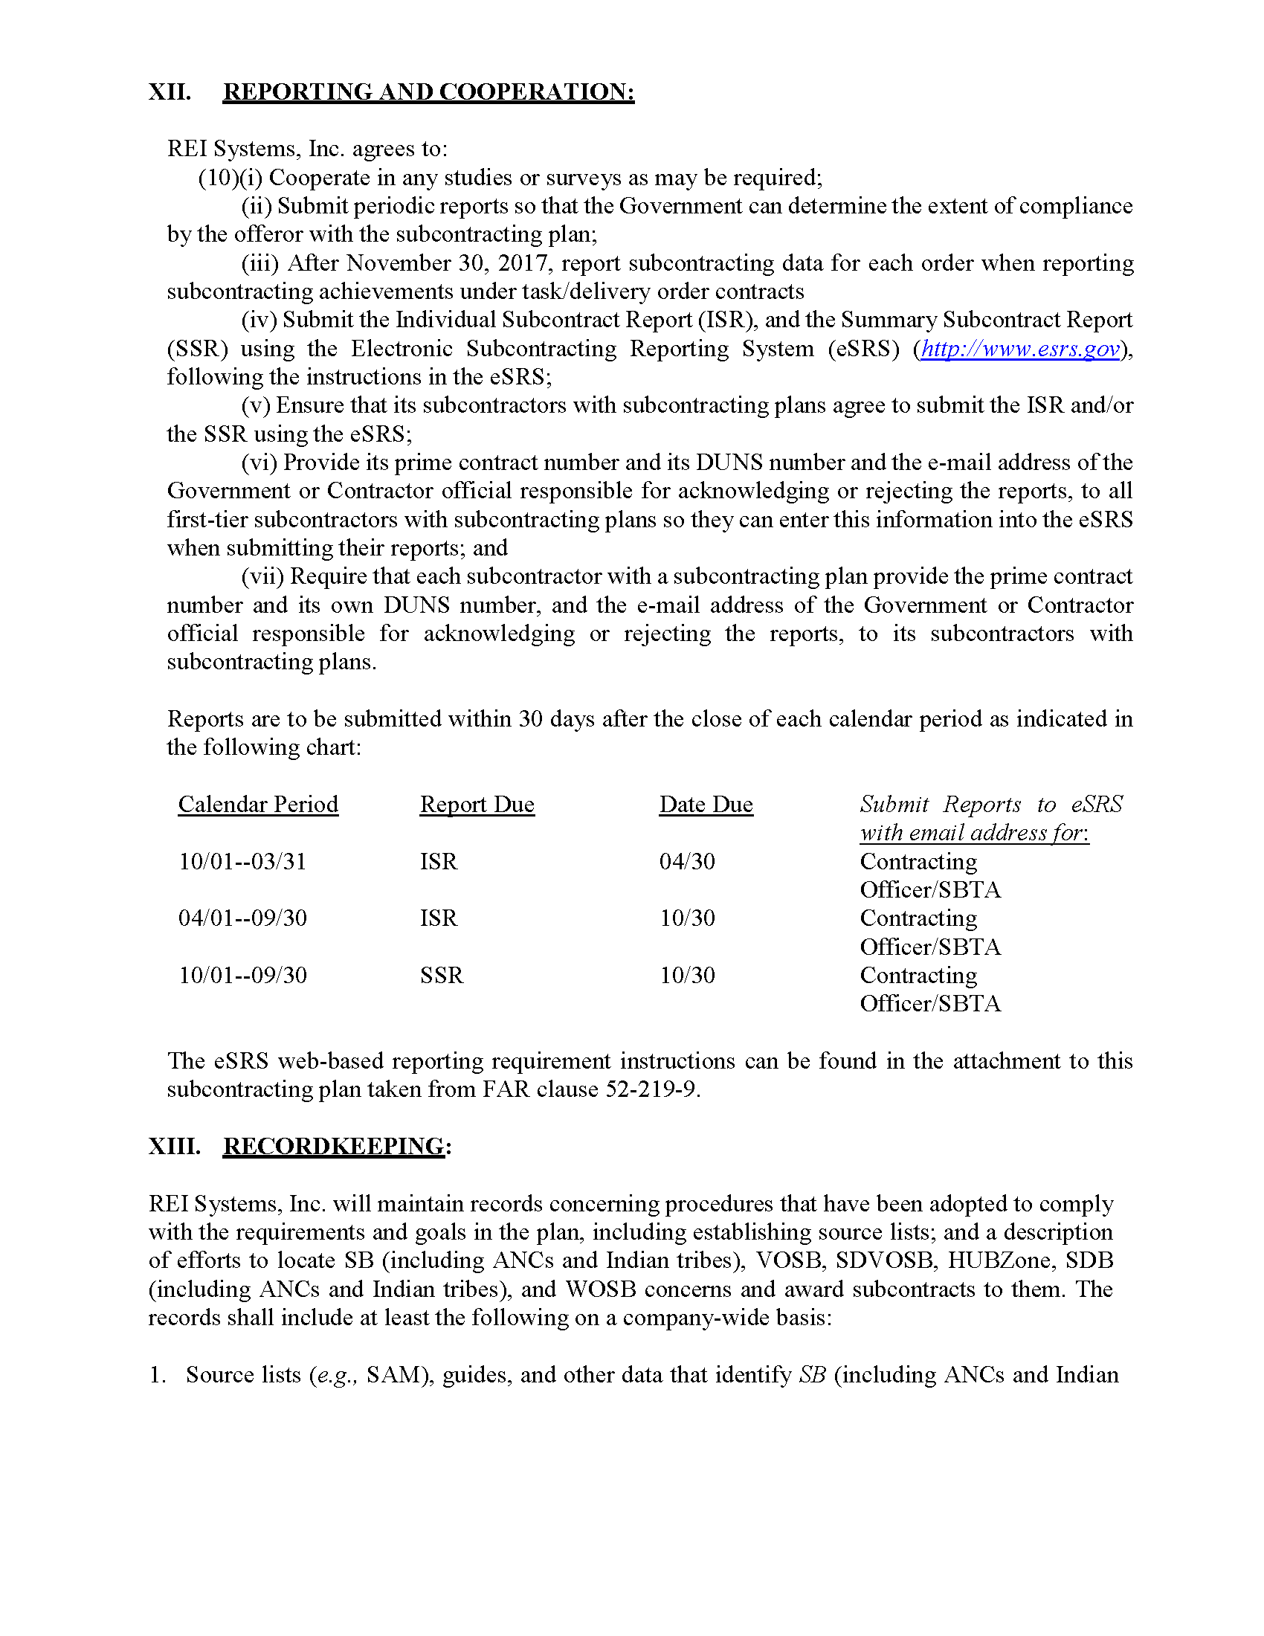

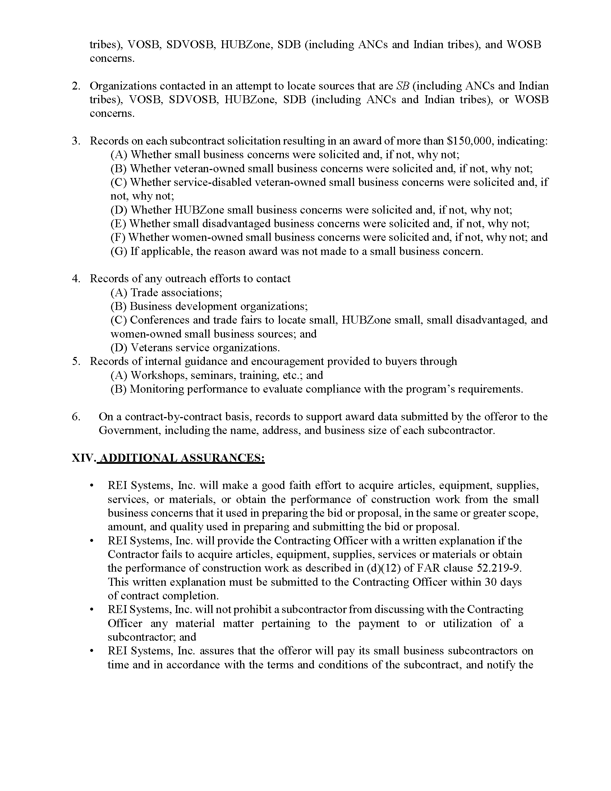

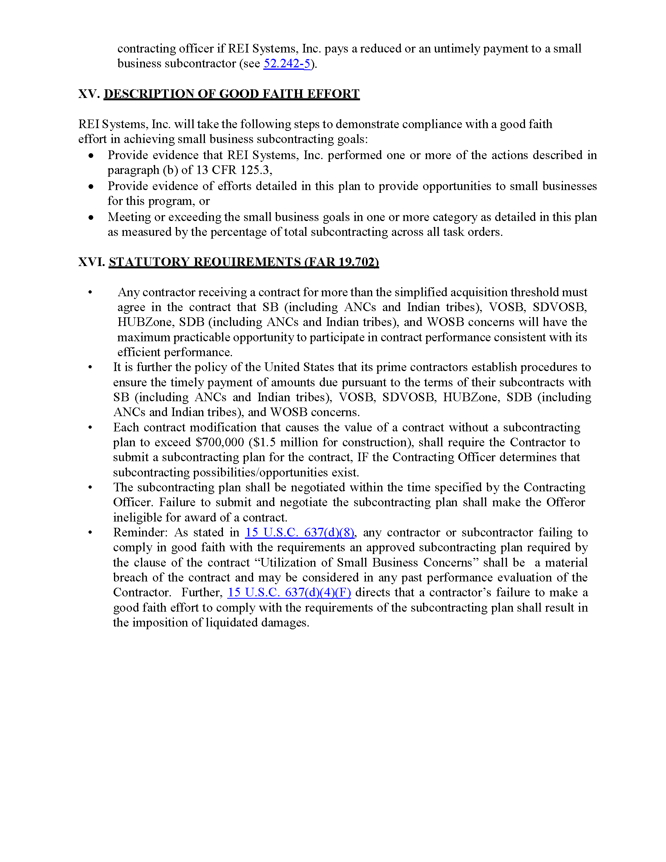

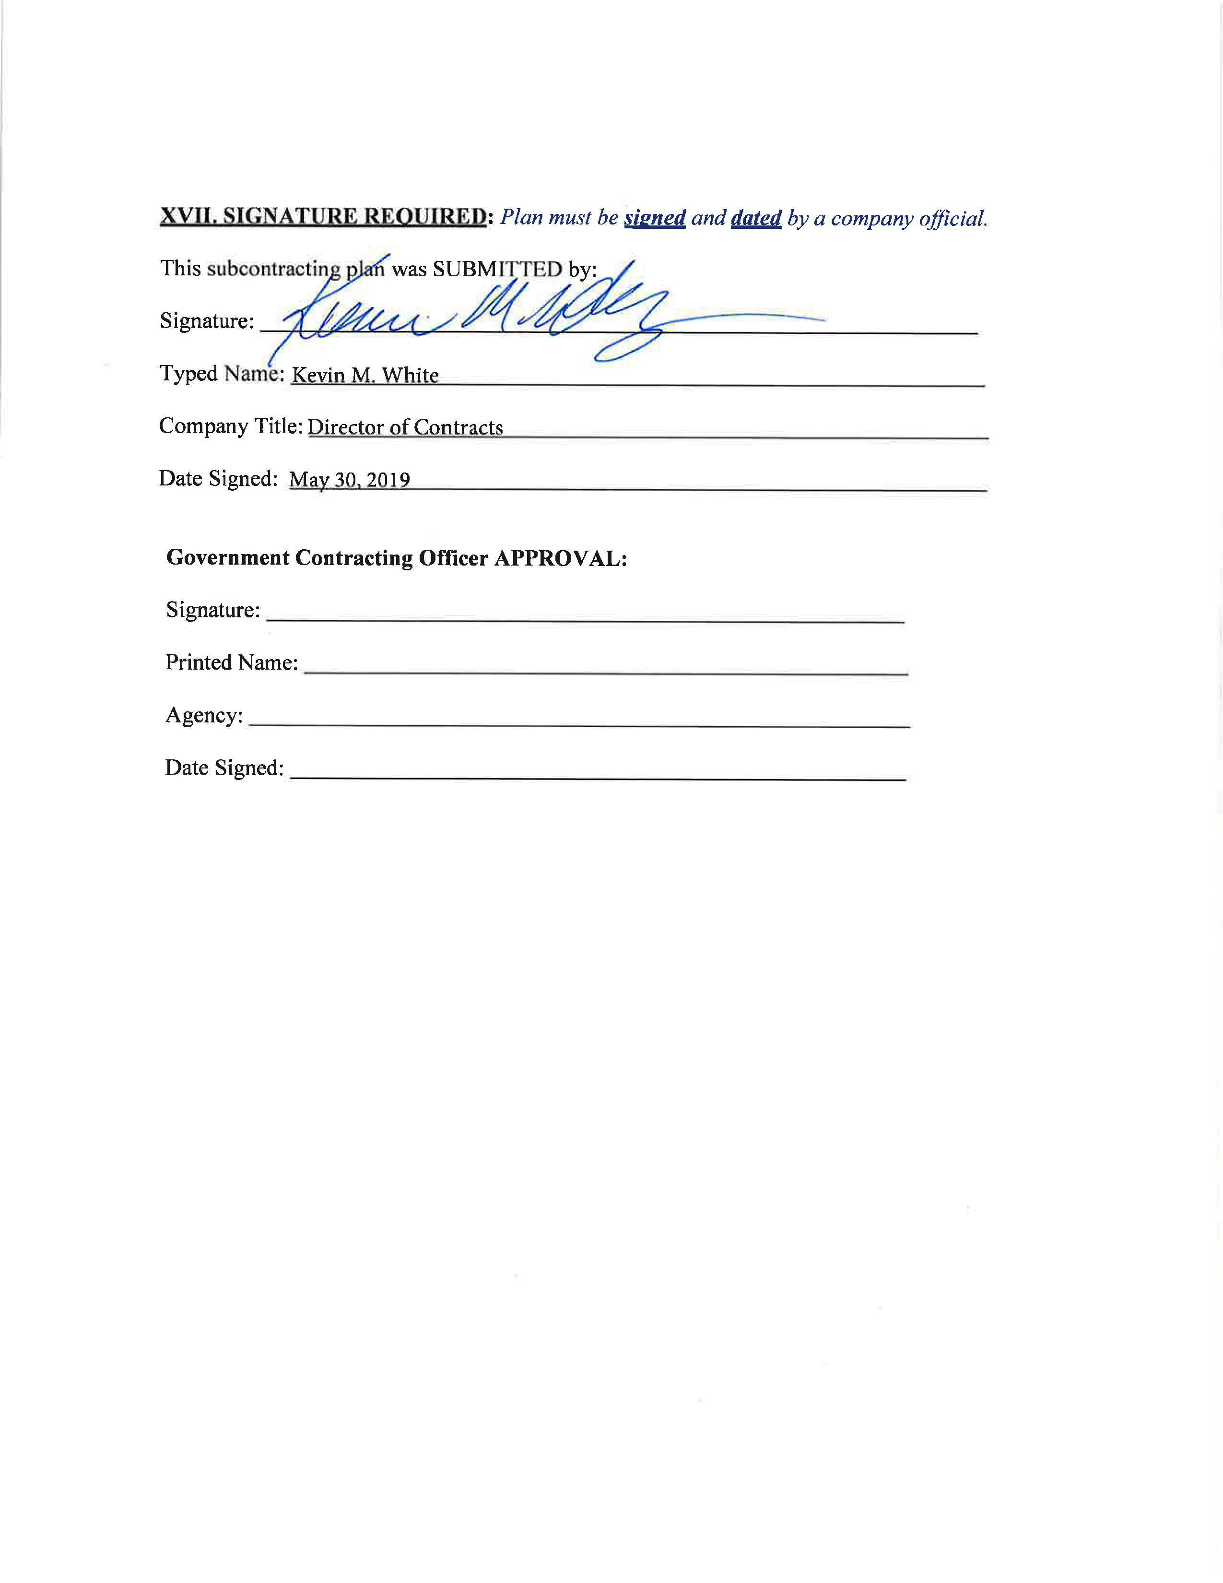

1. Teaming Agreements
   1. IntelliBridge, LLC Teaming Agreement

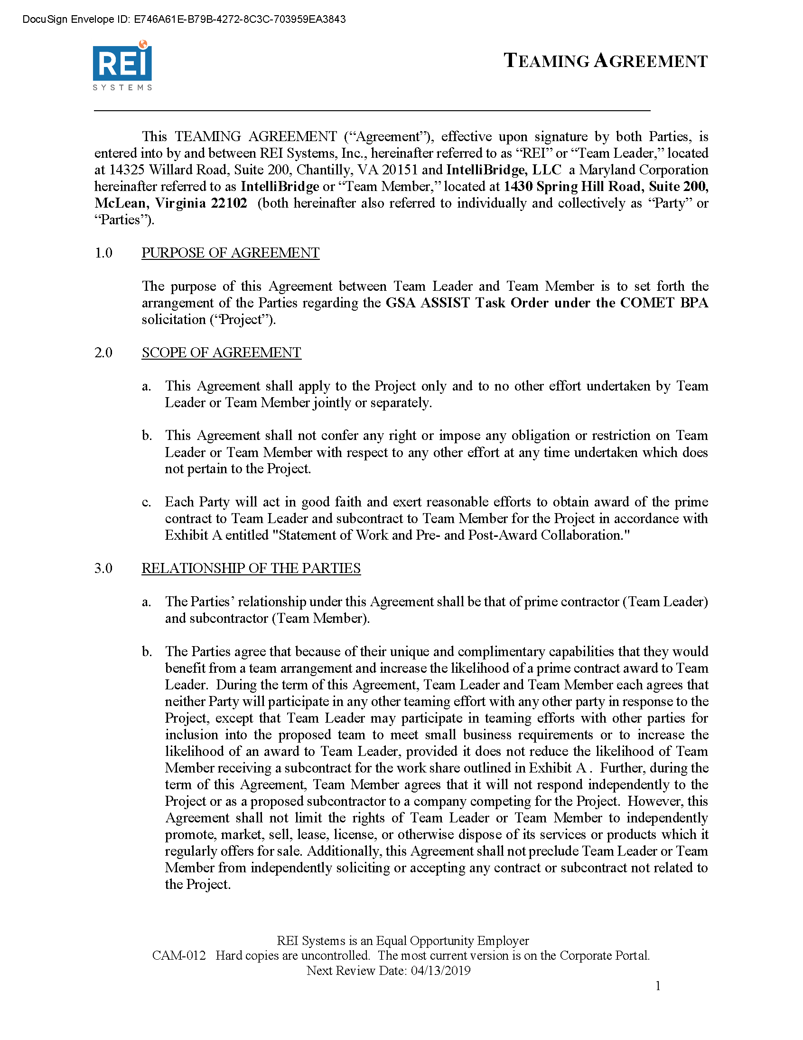

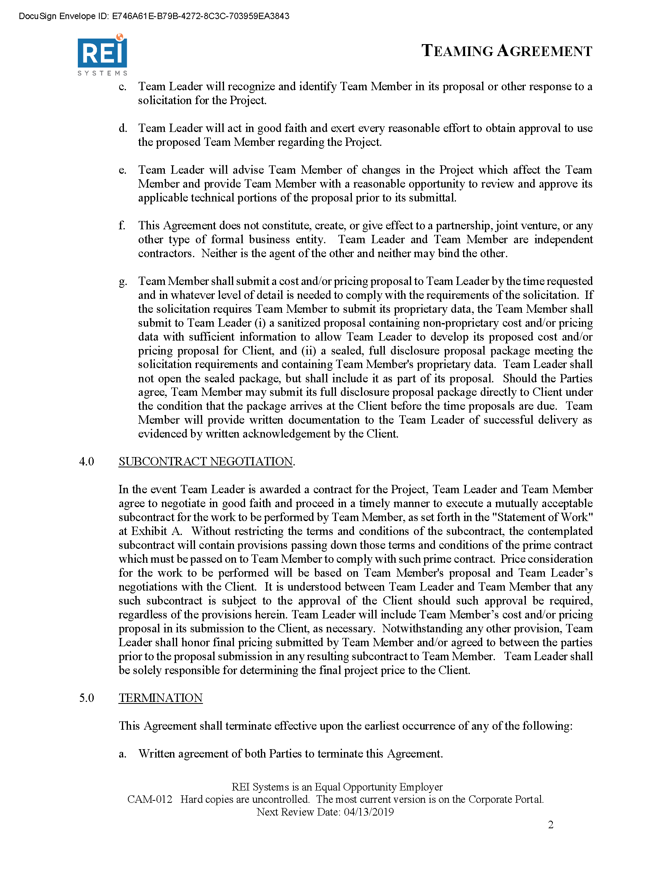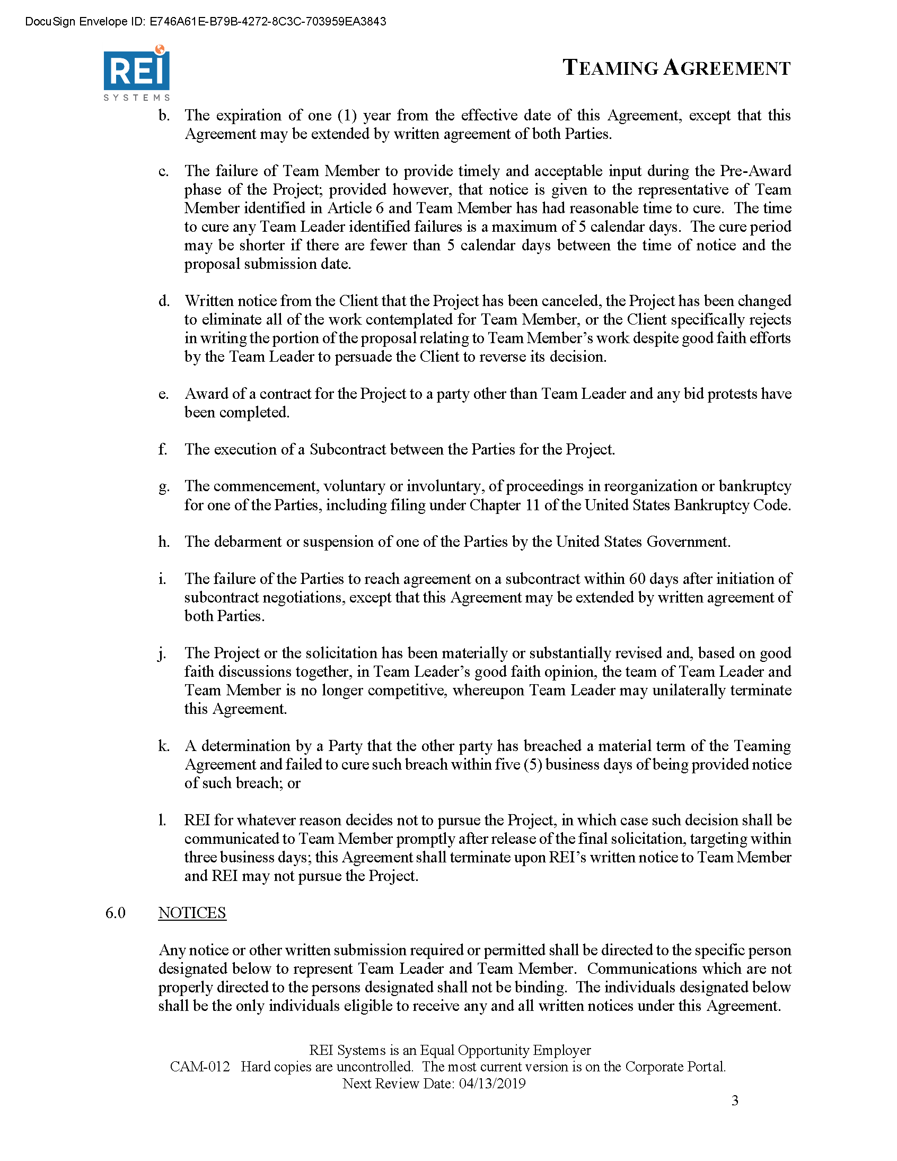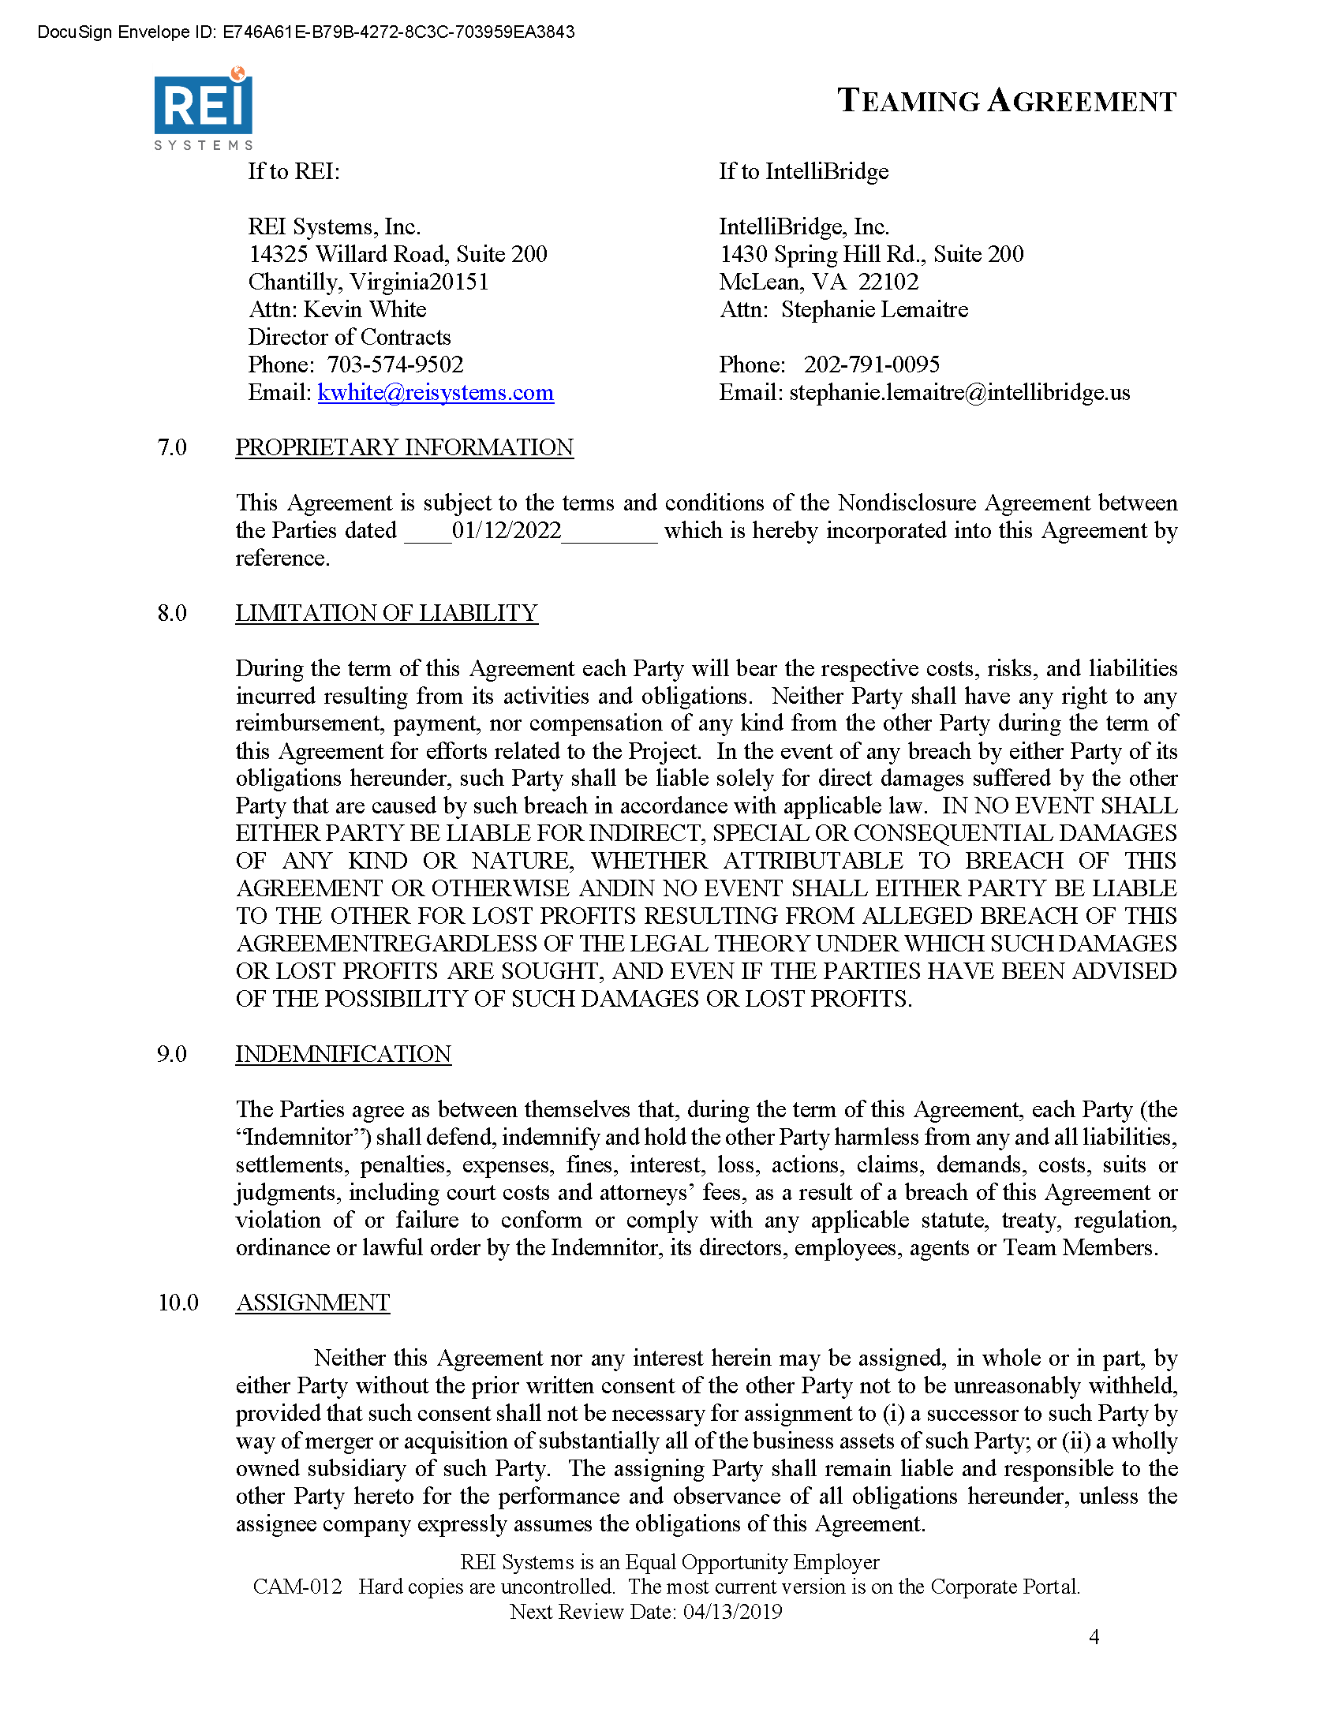

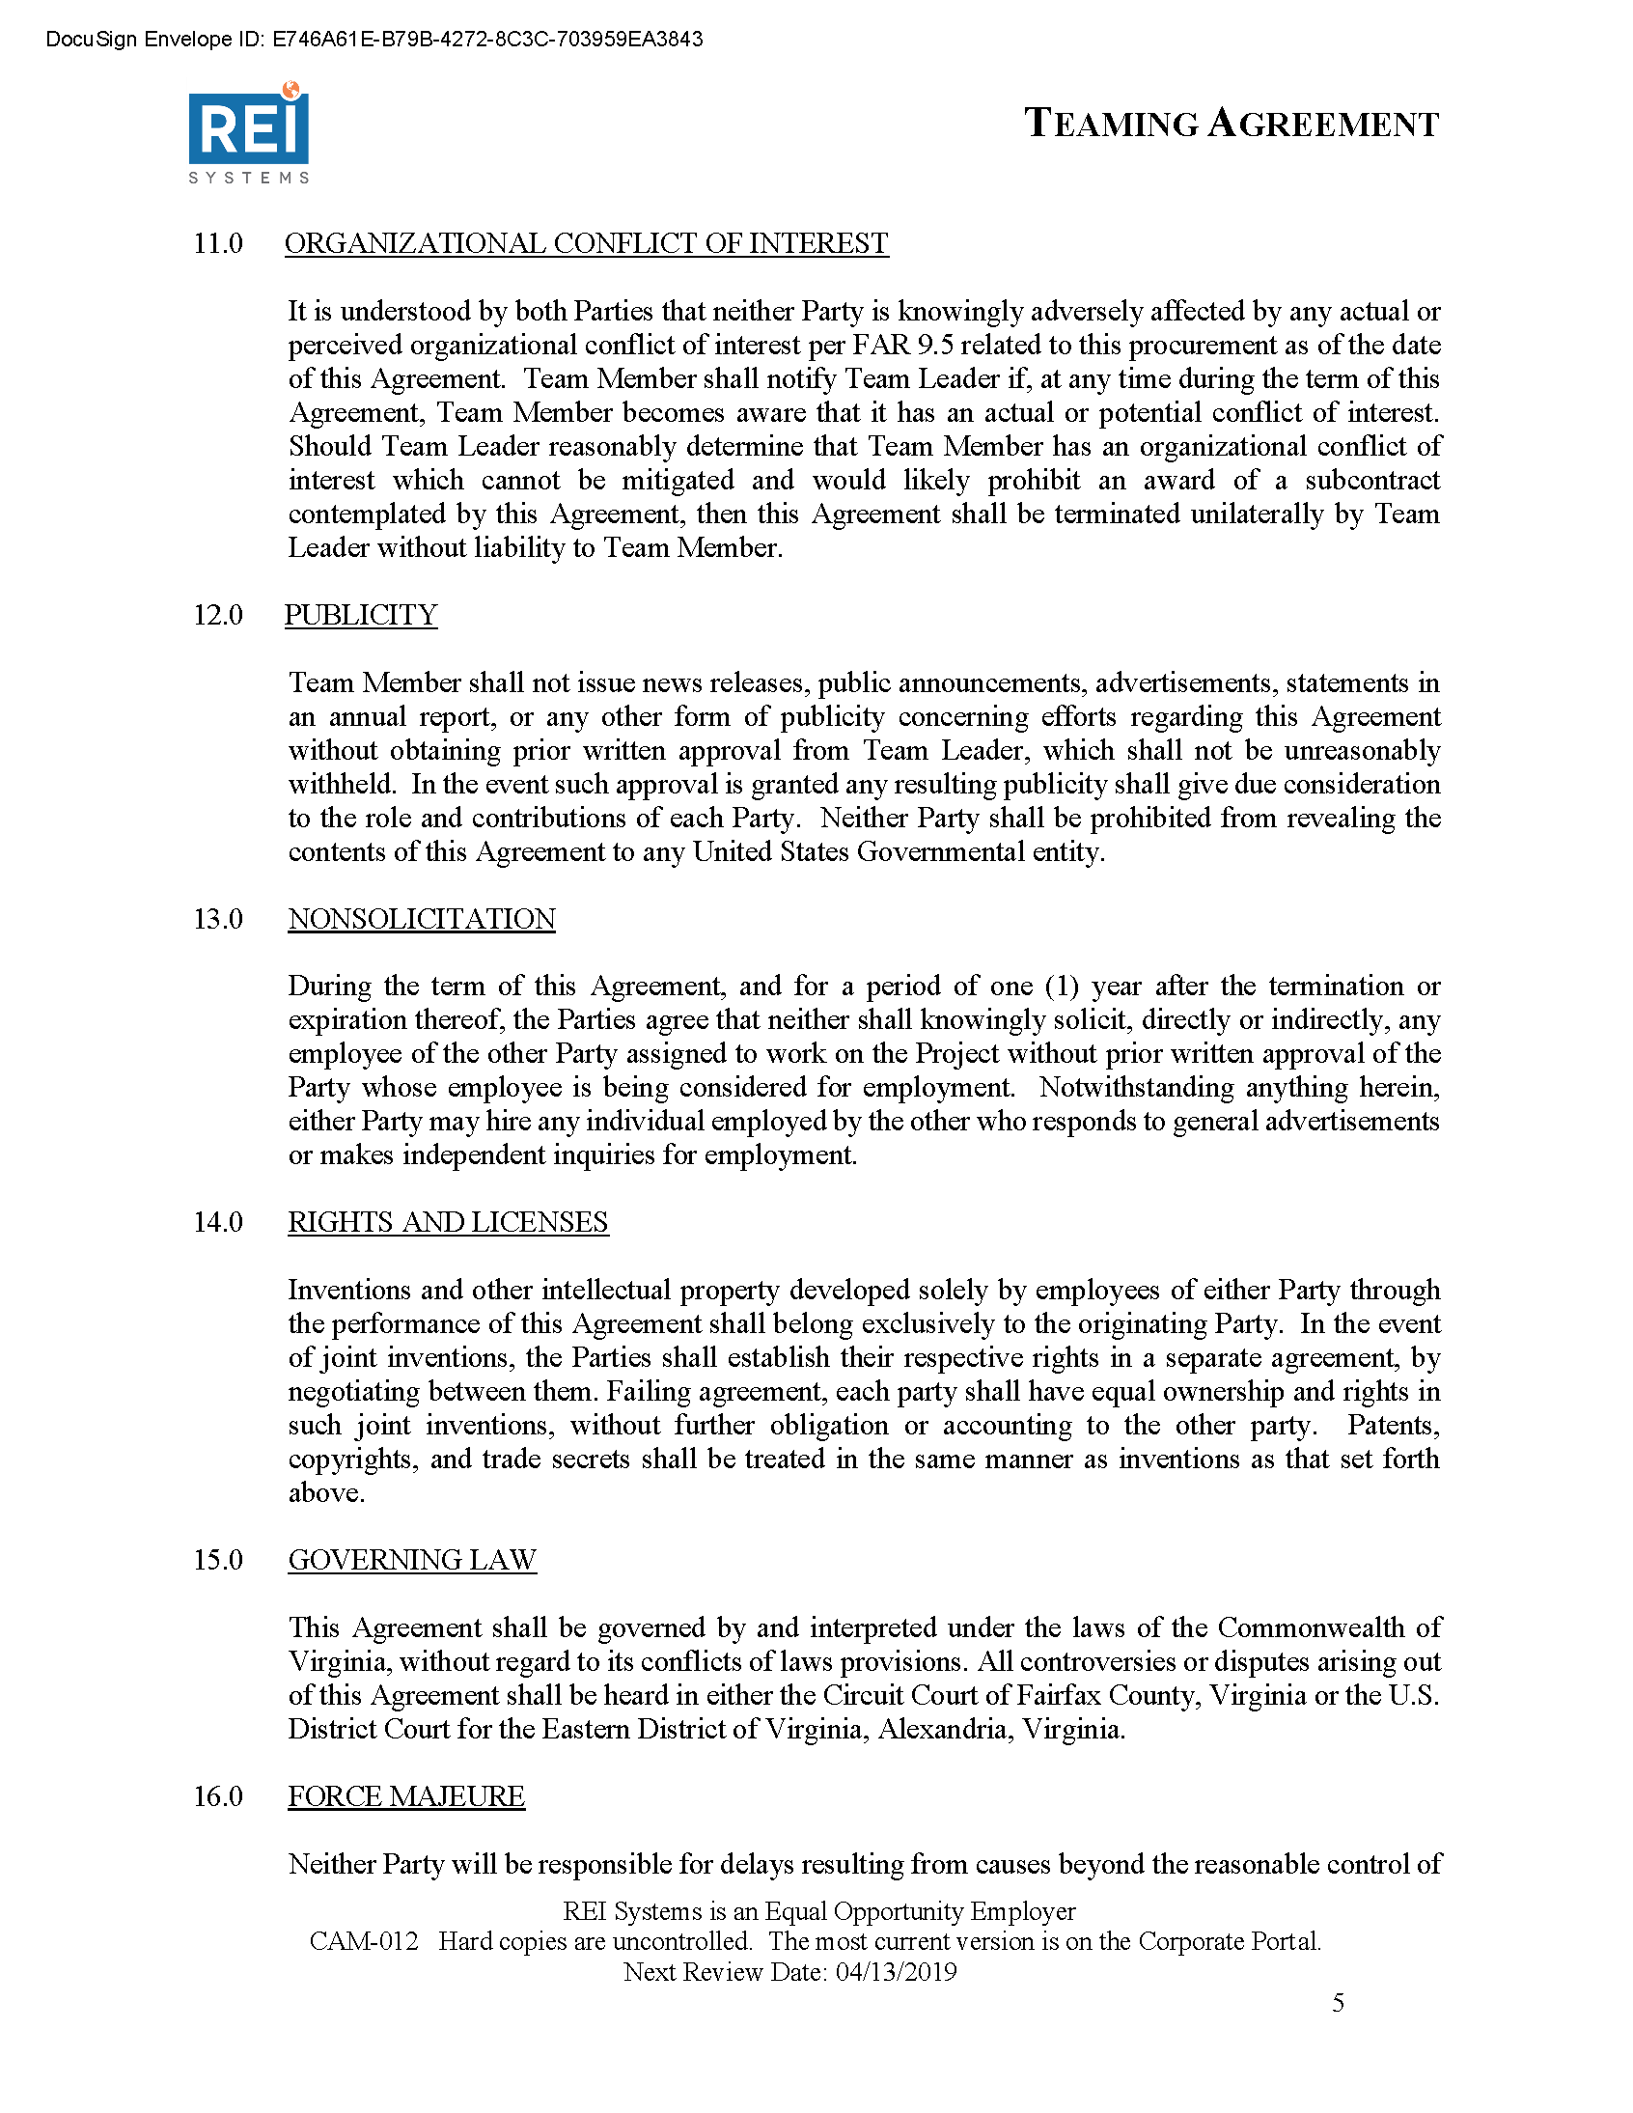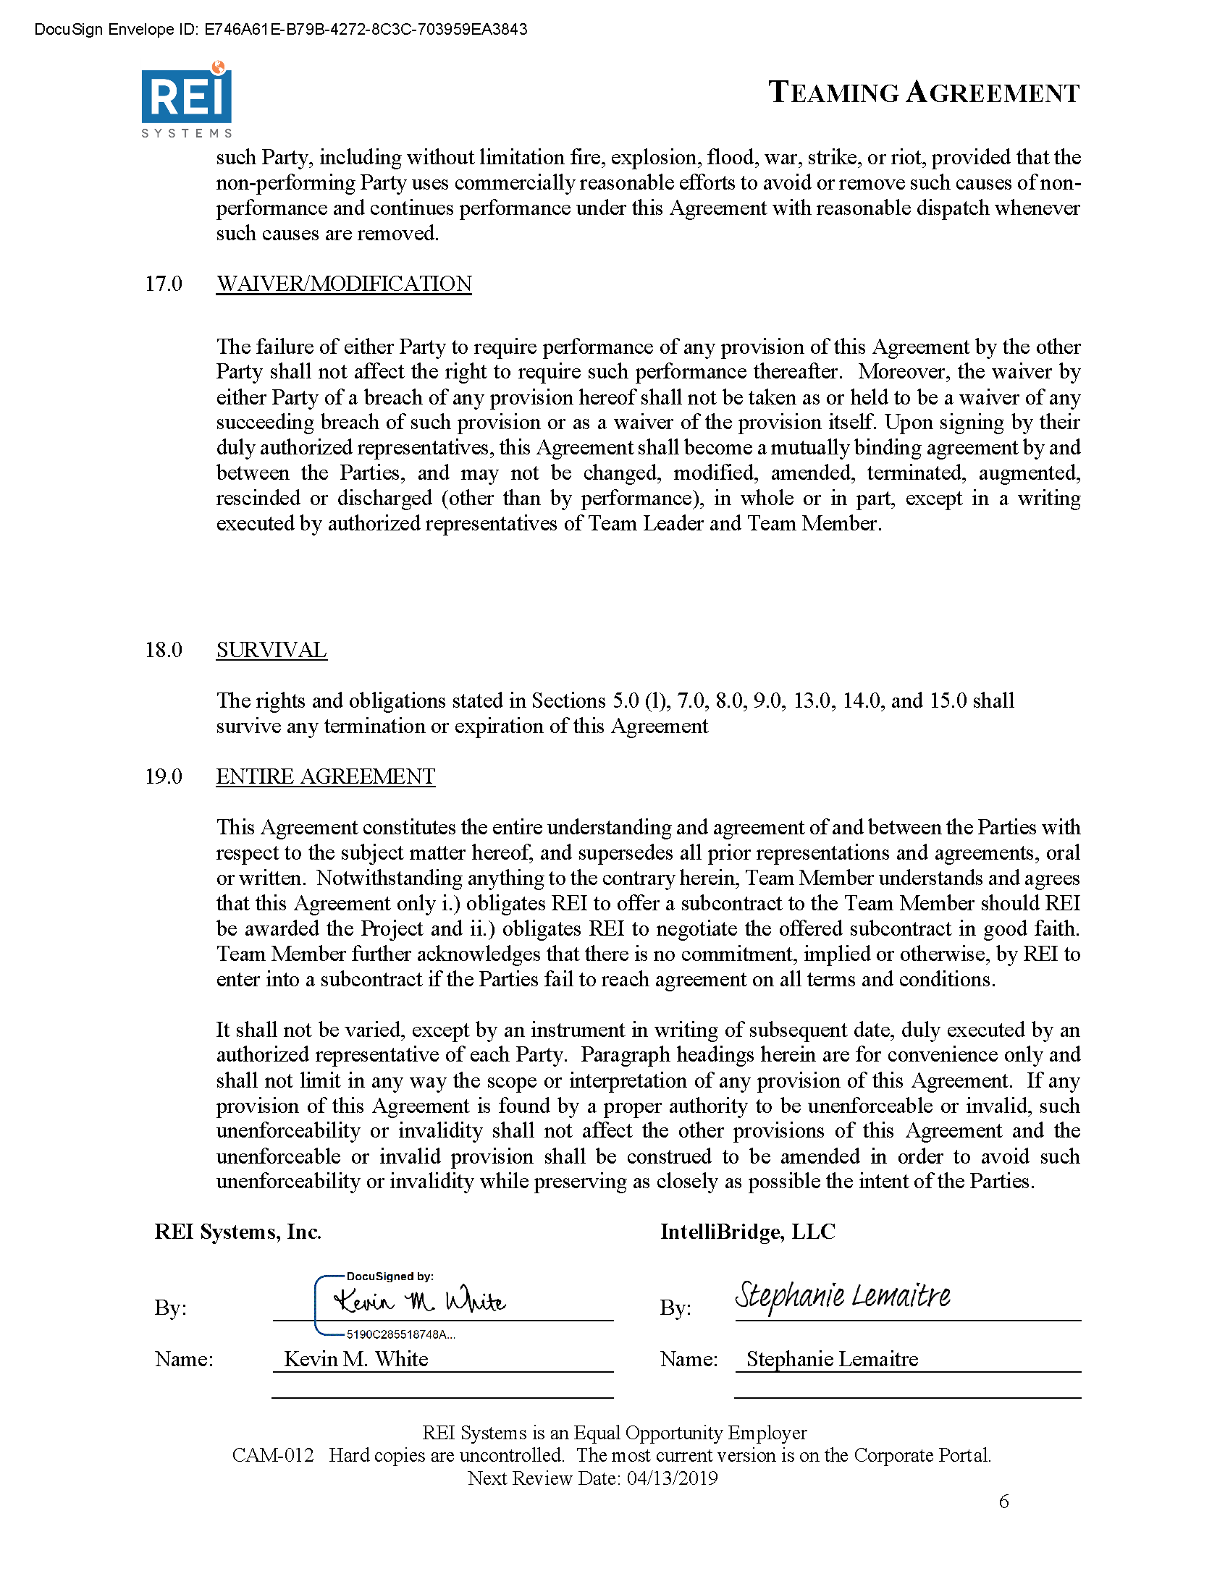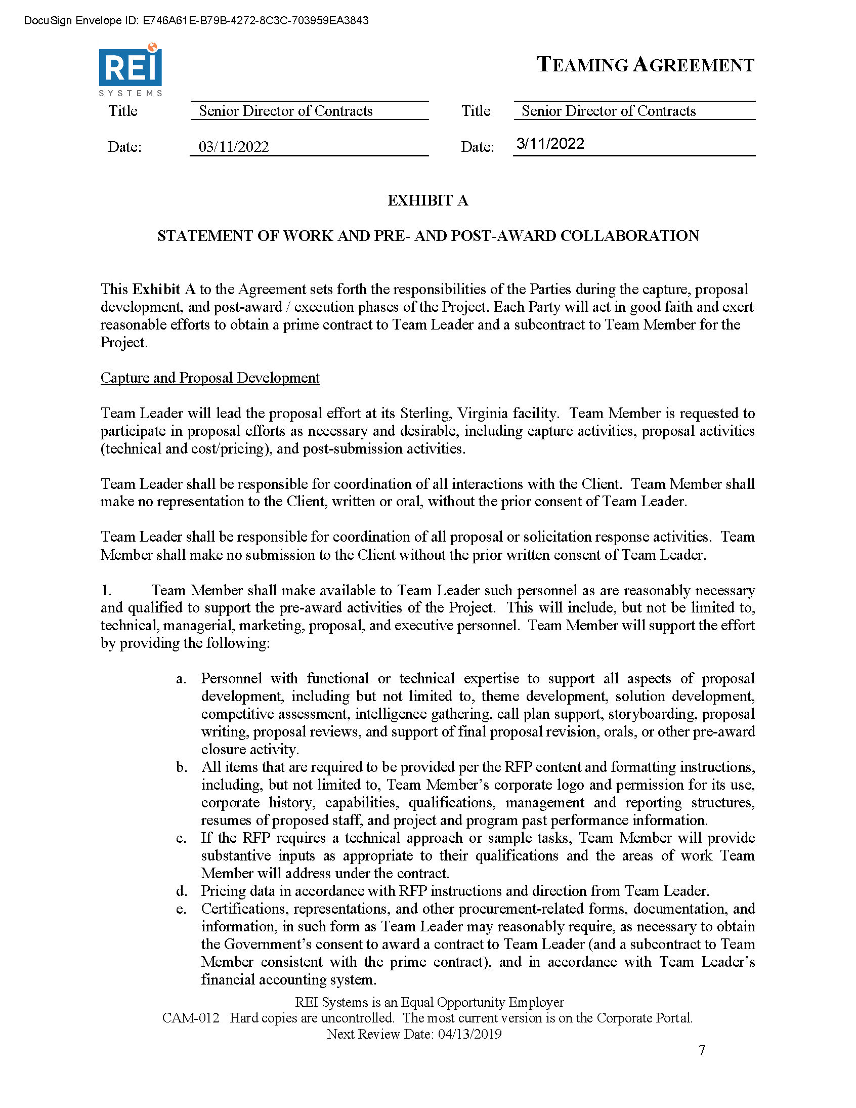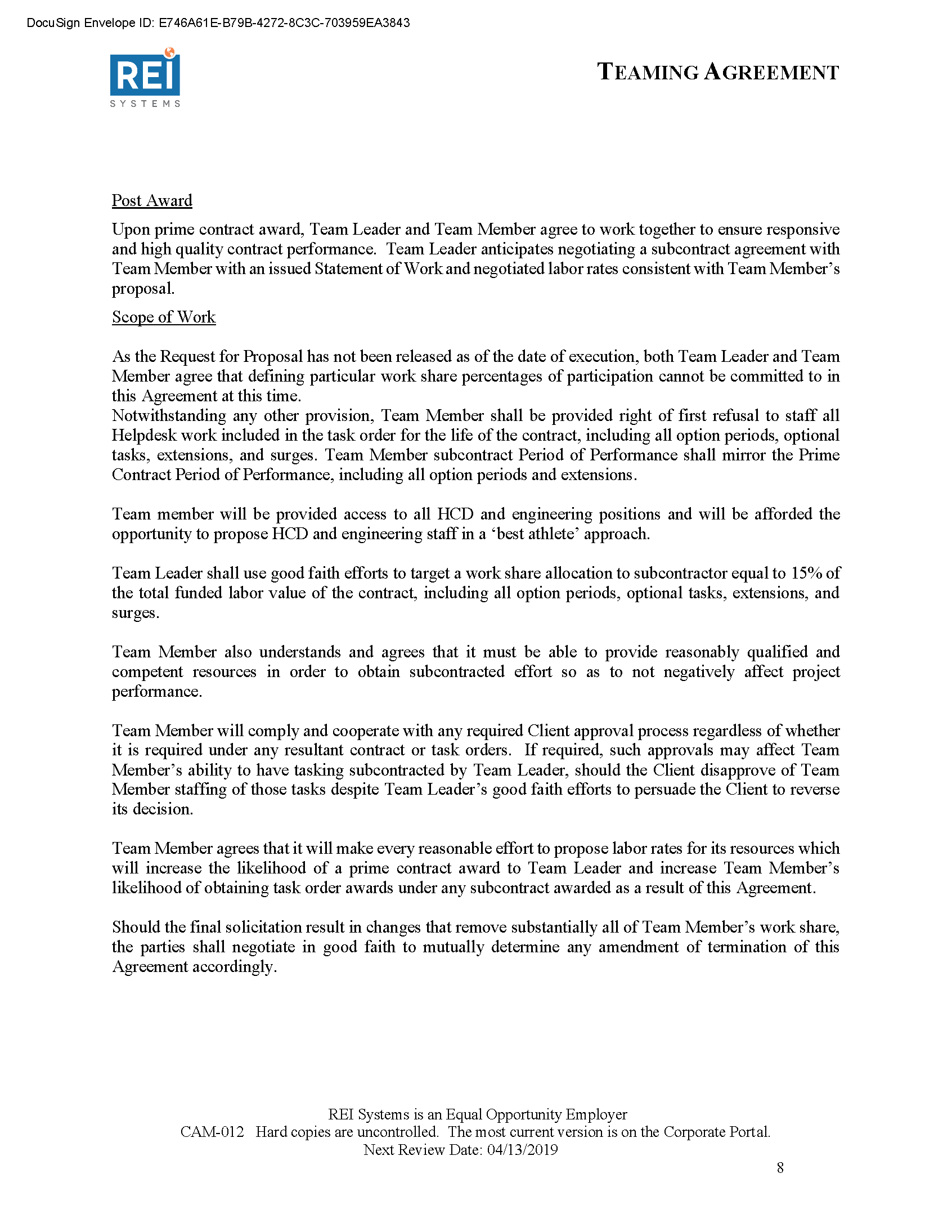

* 1. Tripoint Solutions, LLC Teaming Agreement

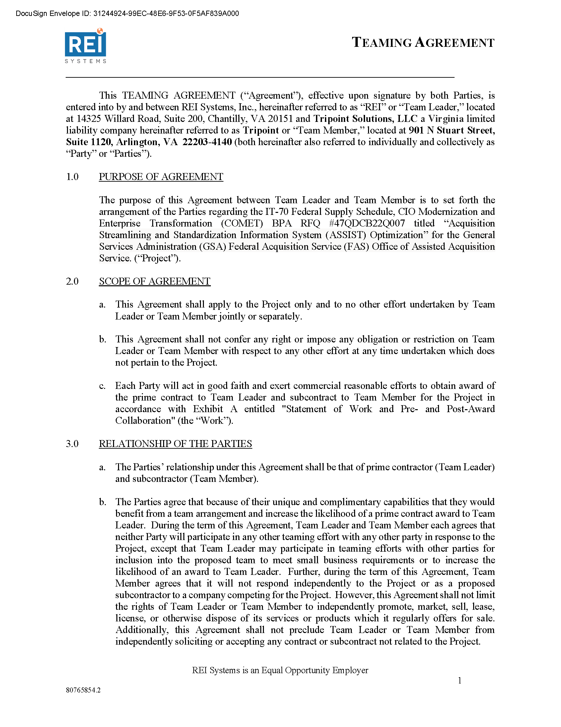

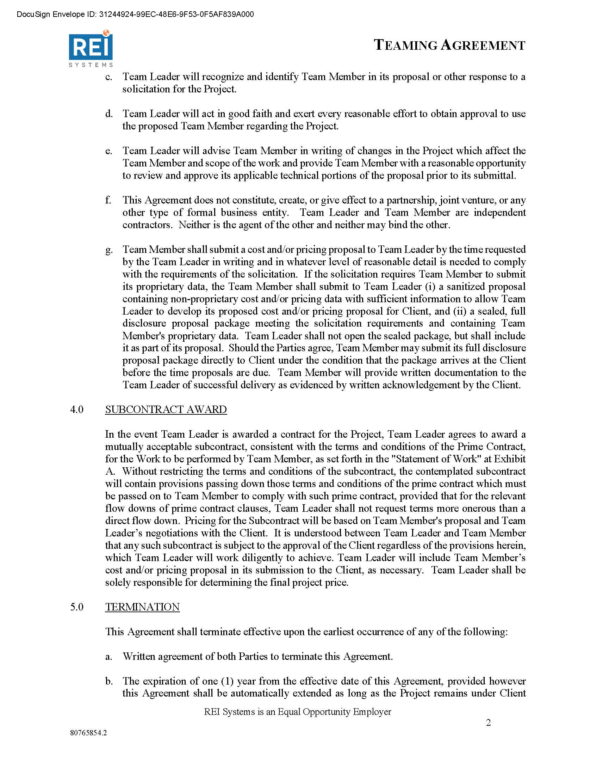

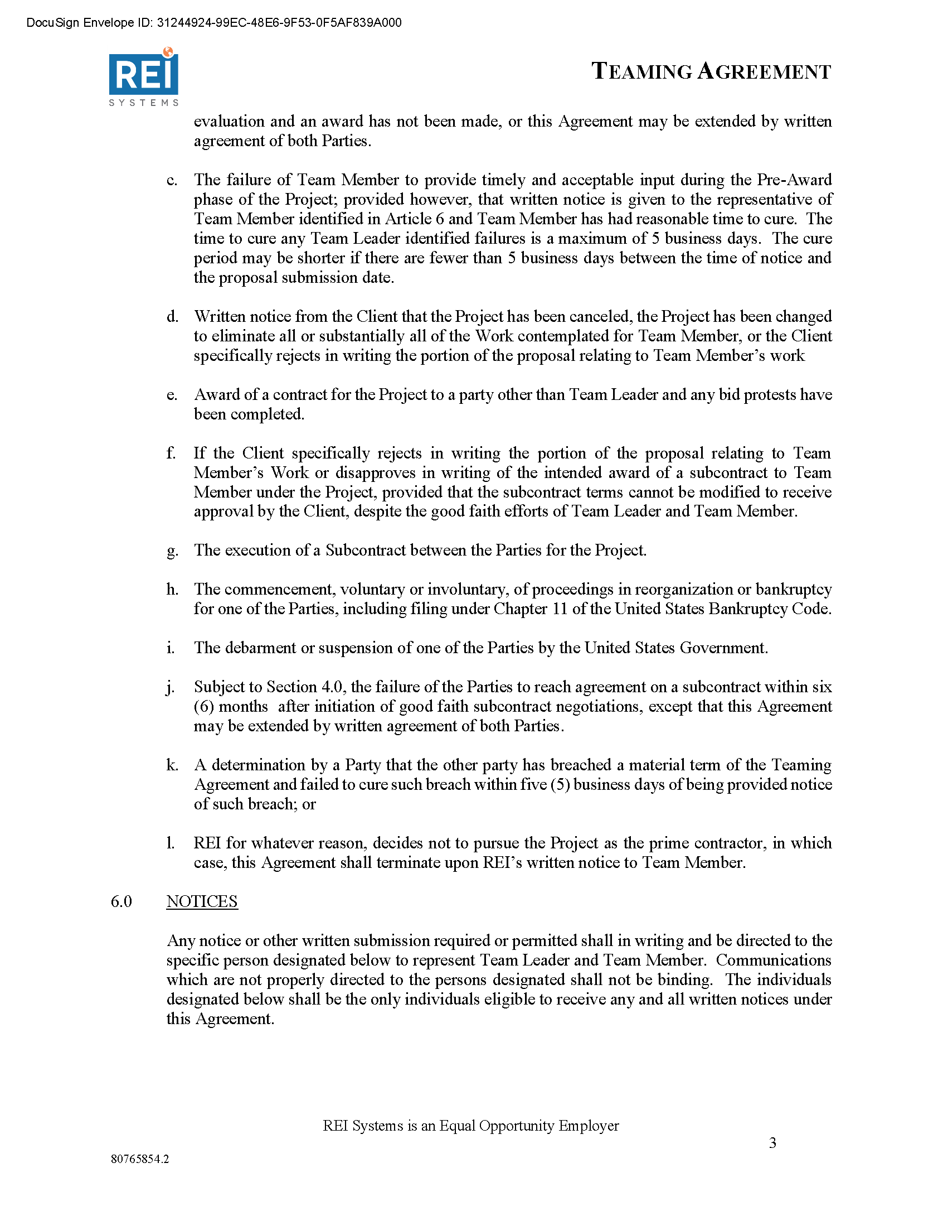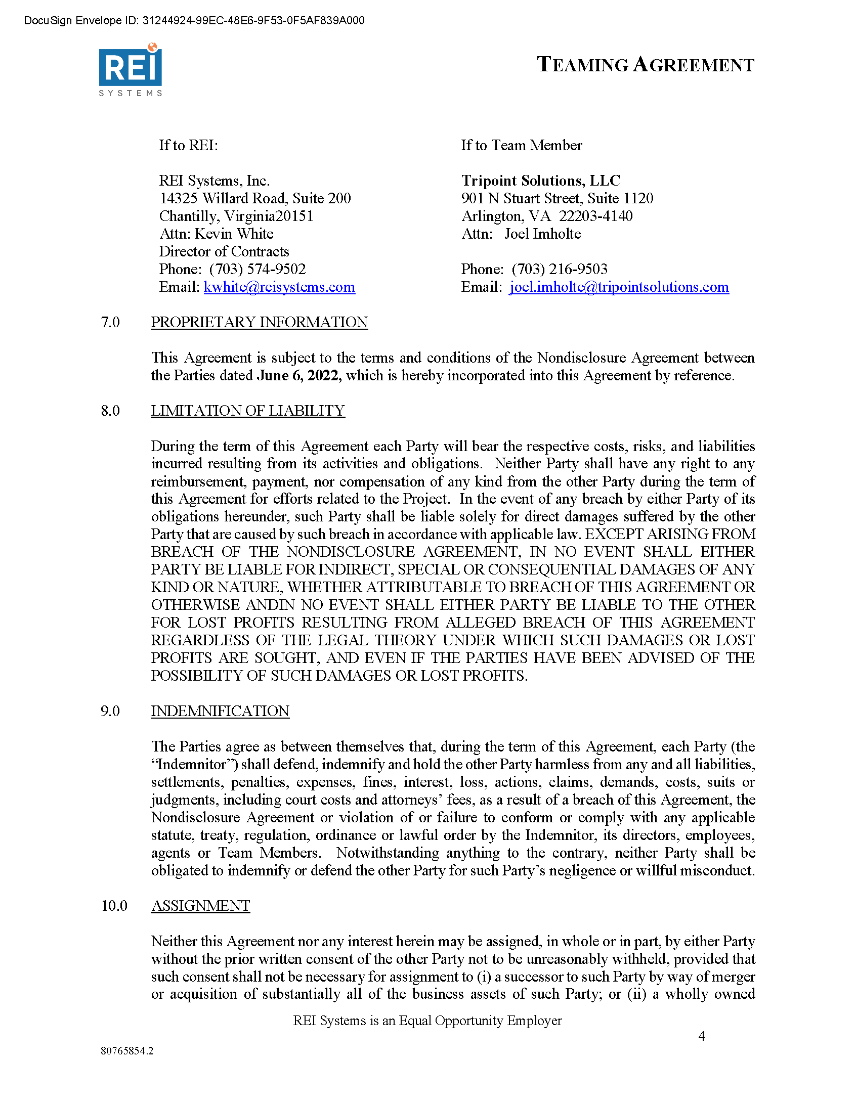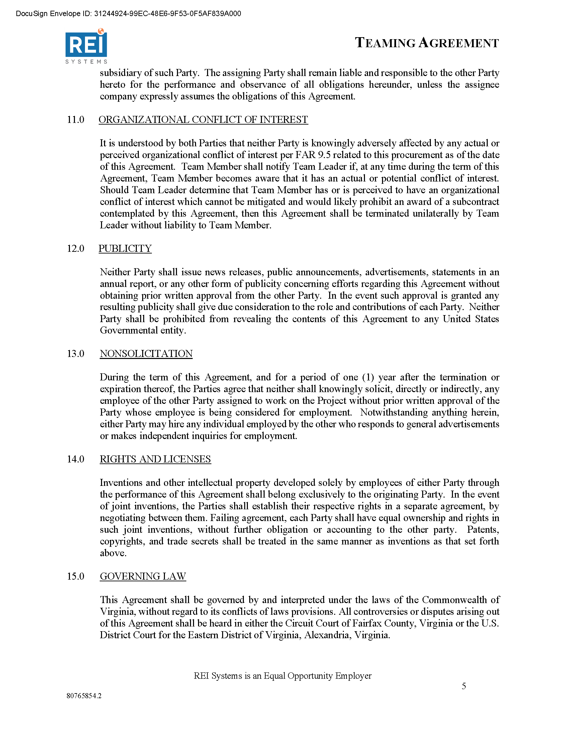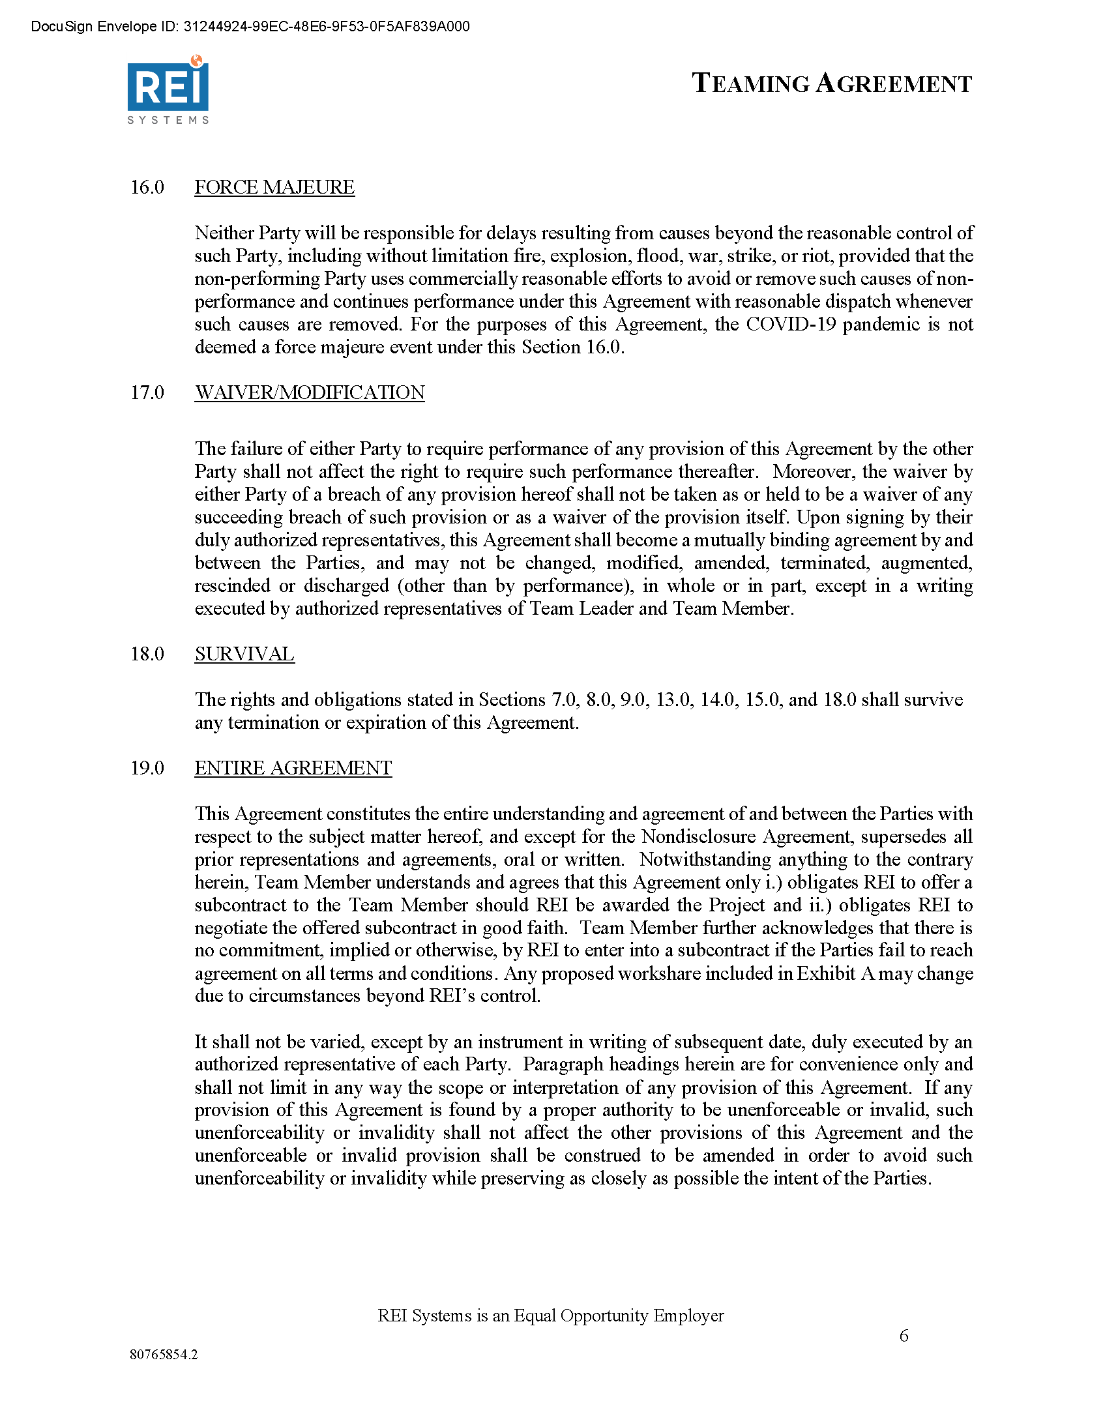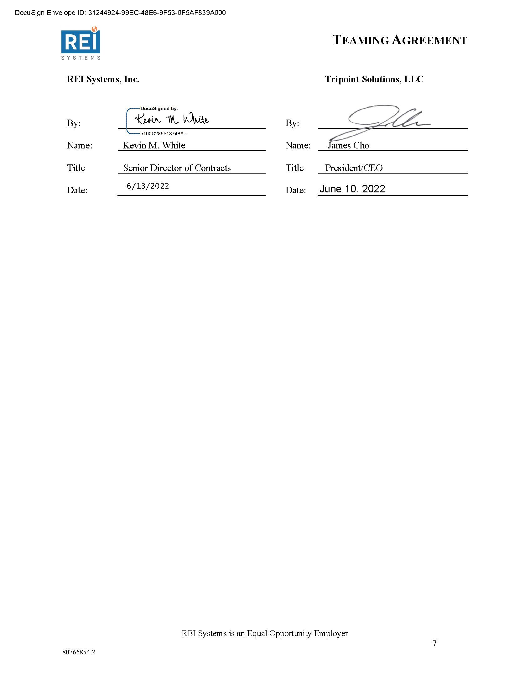

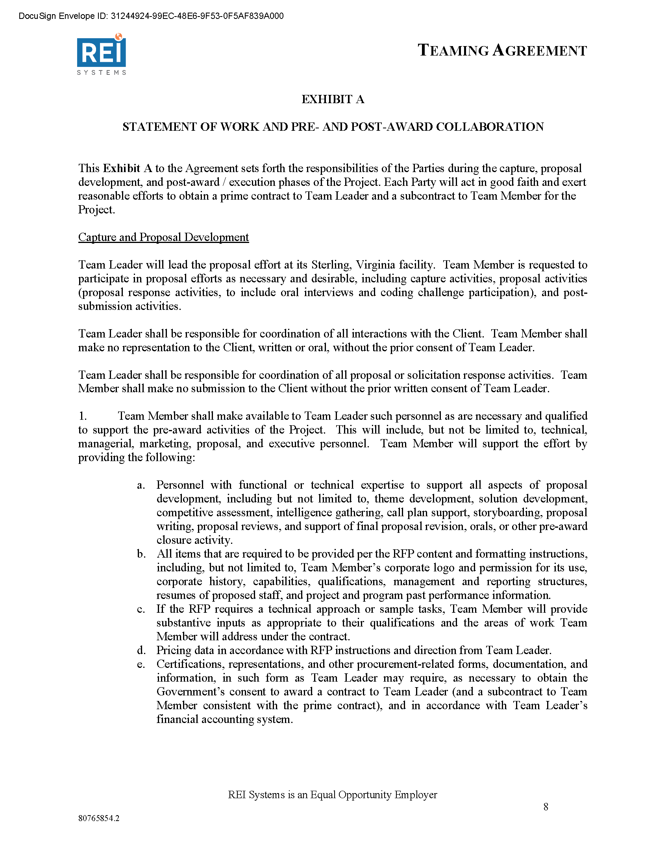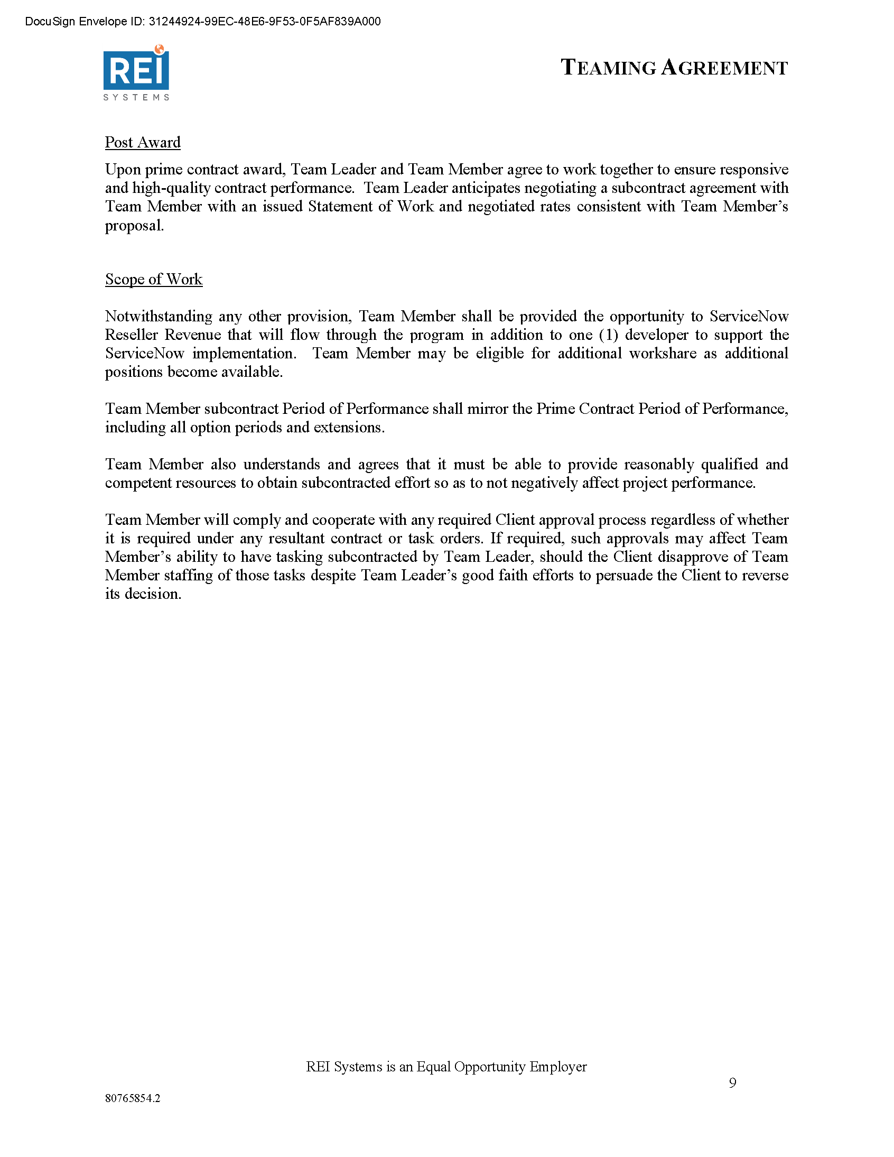

* 1. cBEYONData, Inc. Teaming Agreement

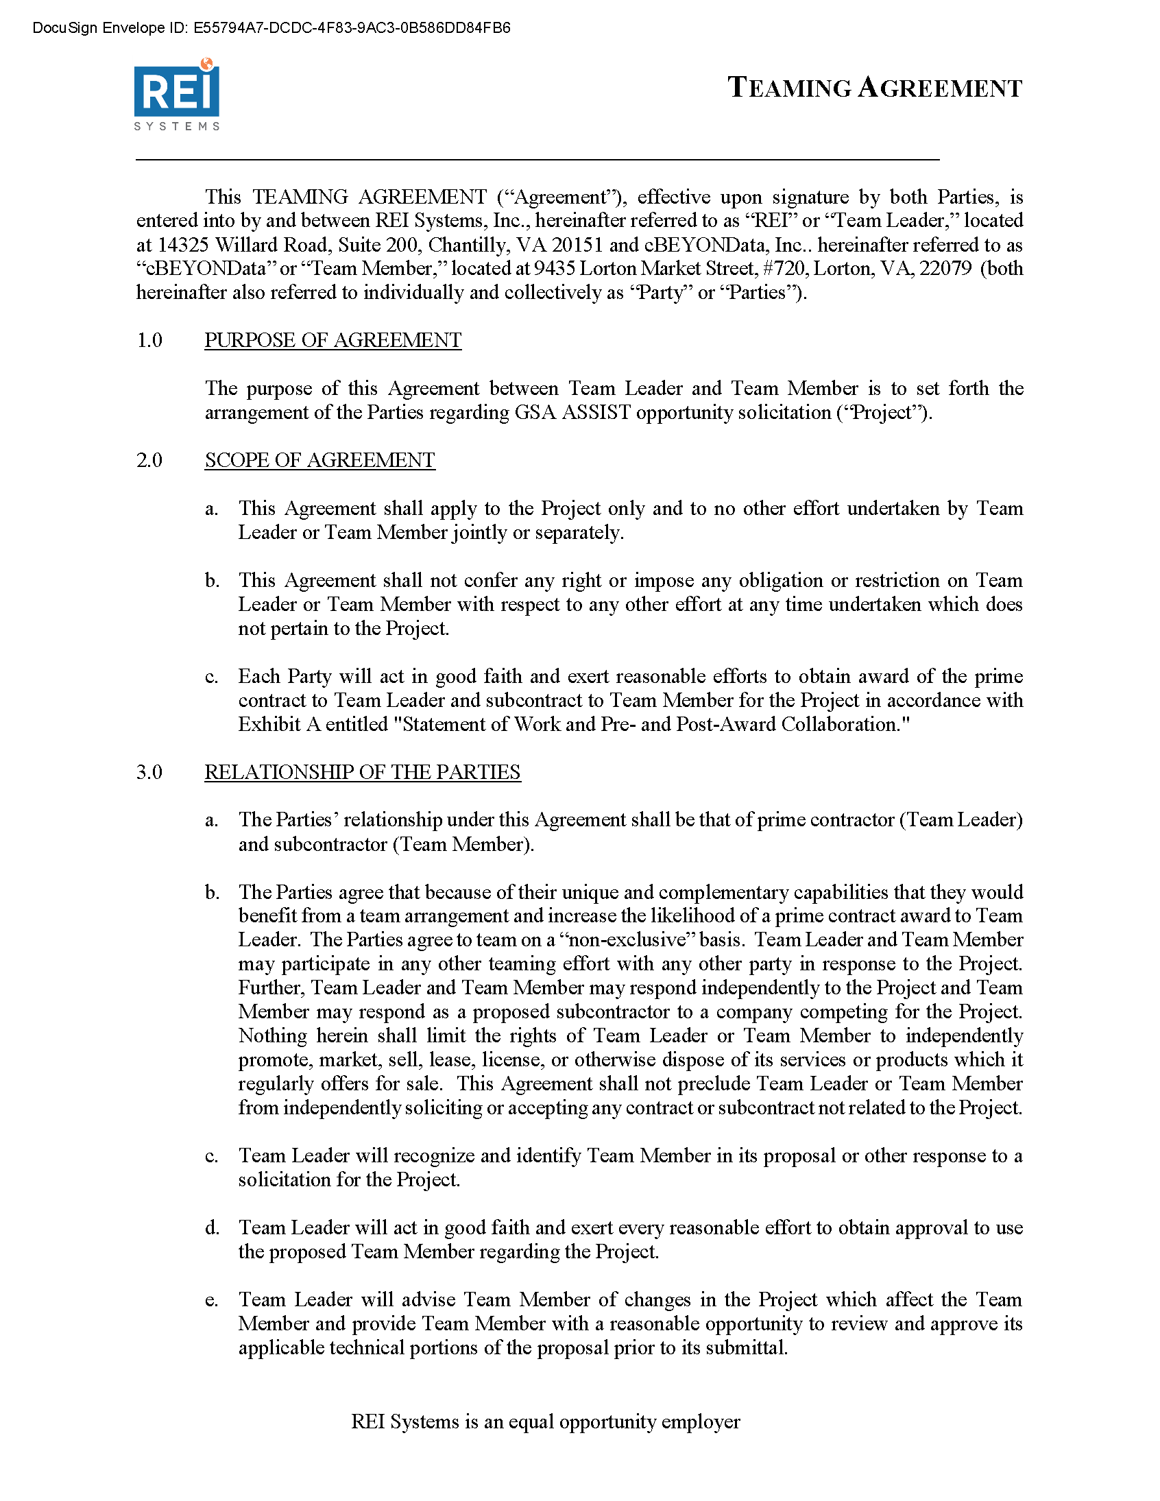

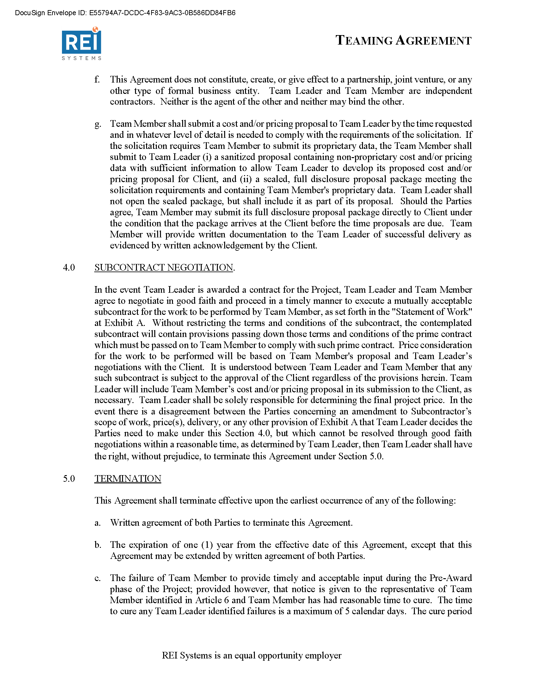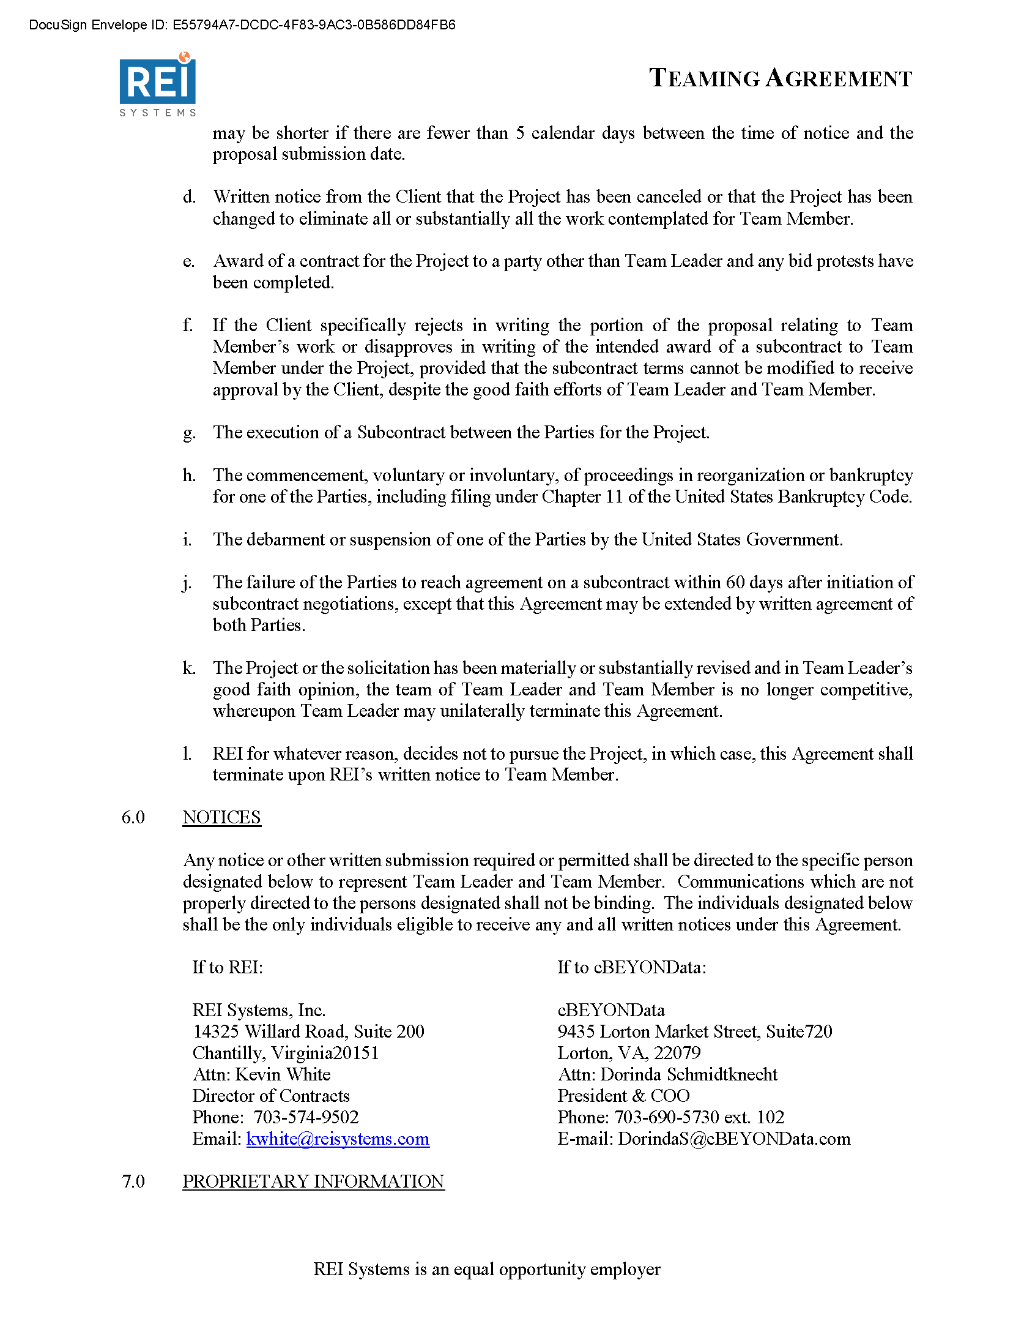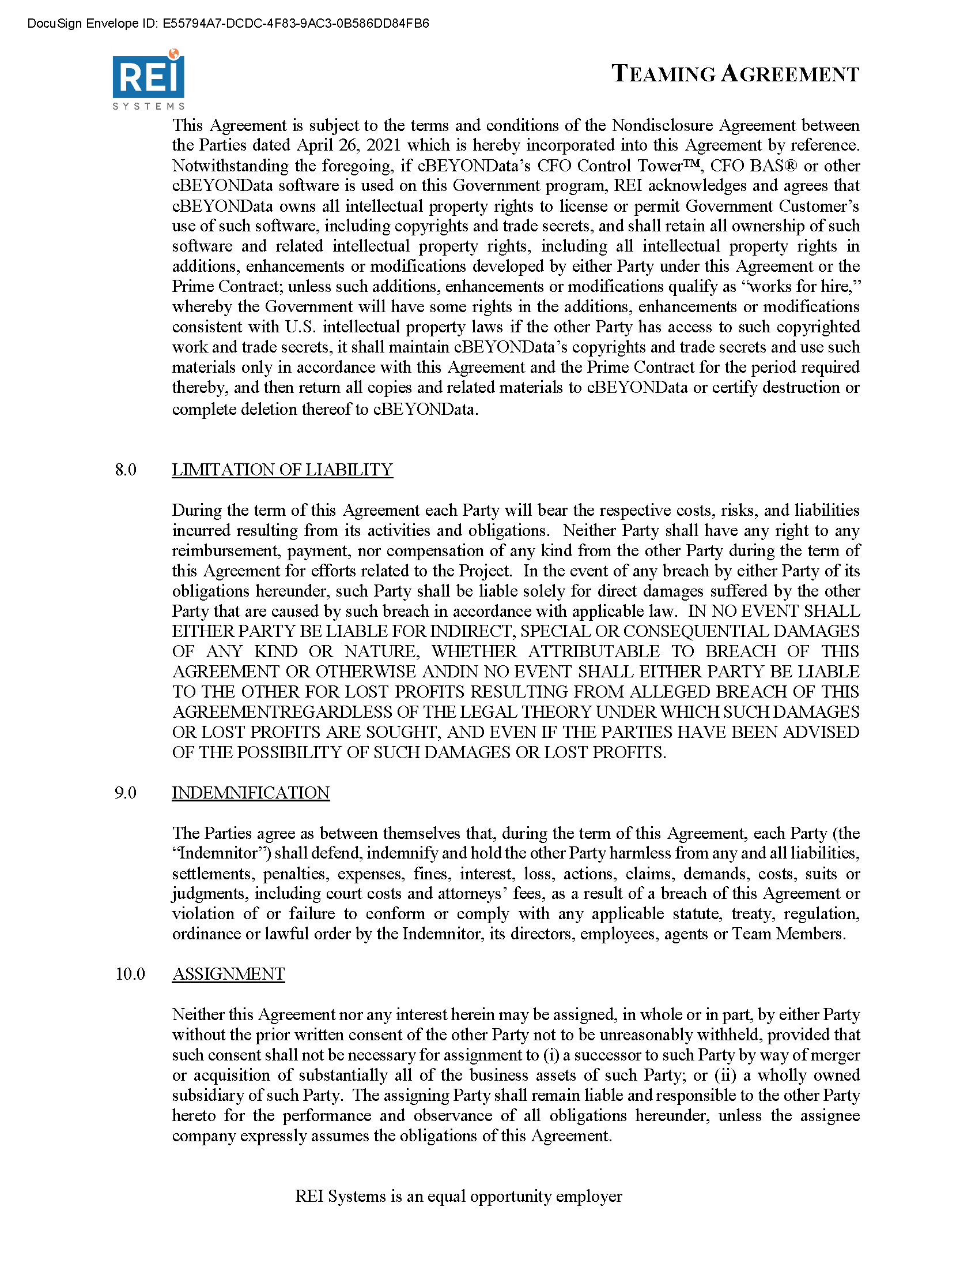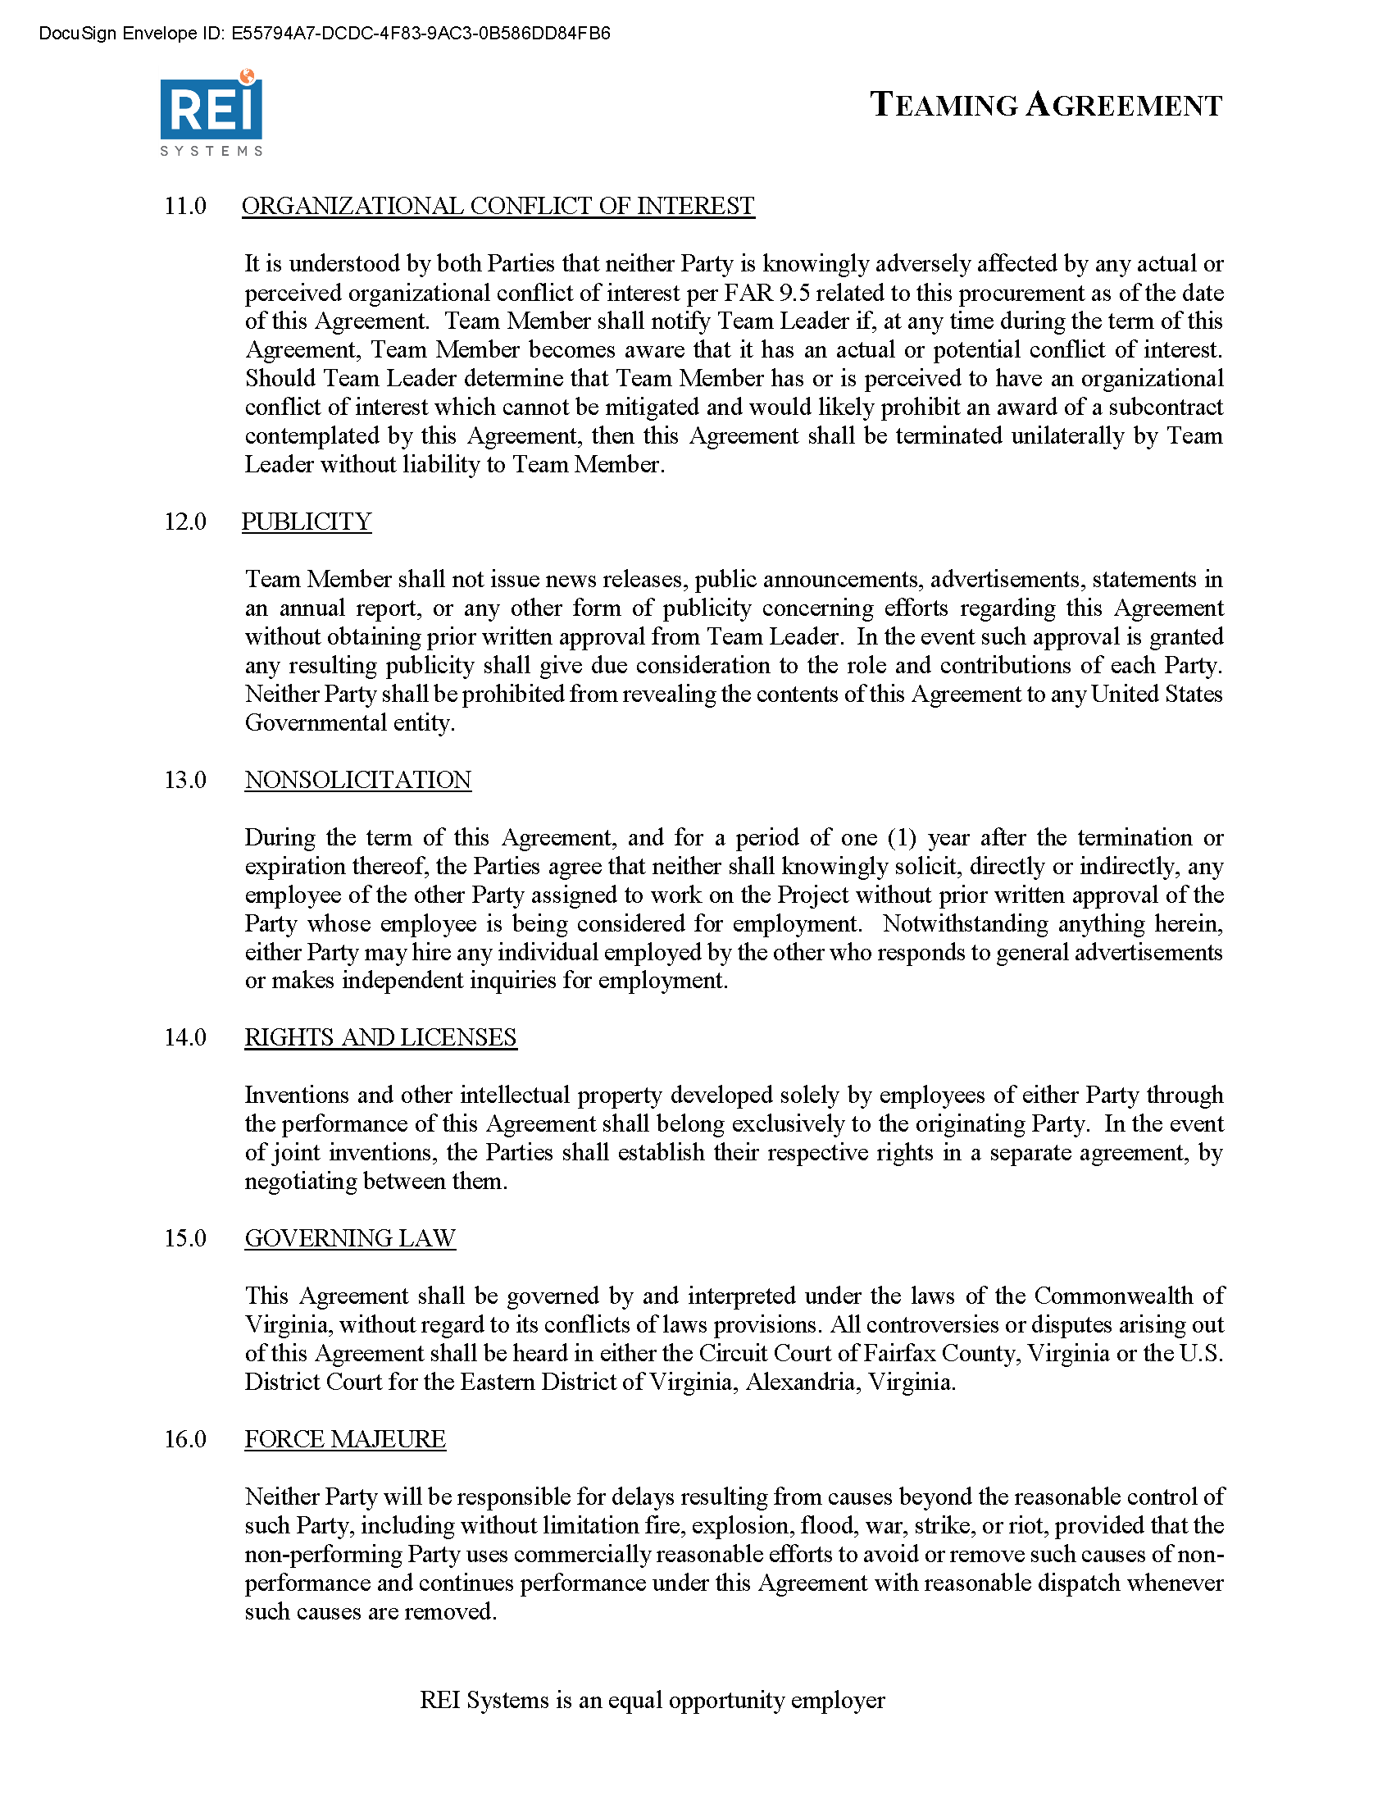

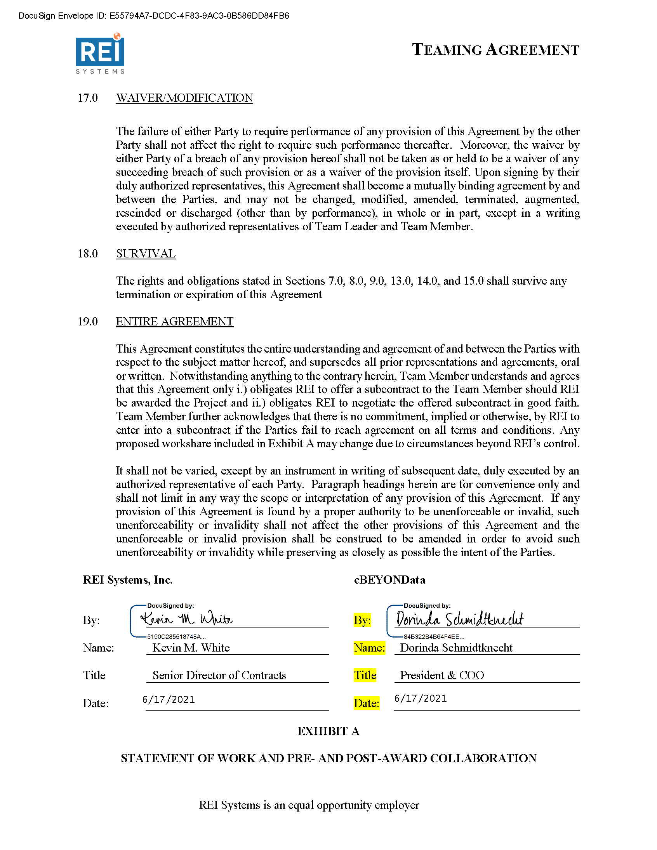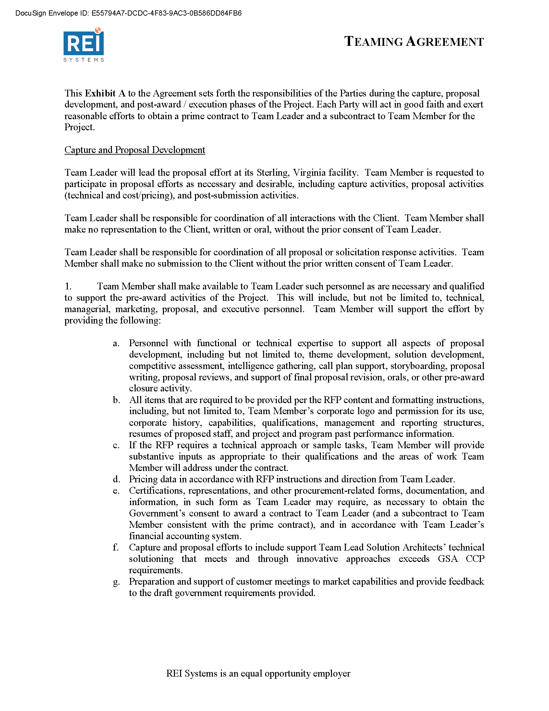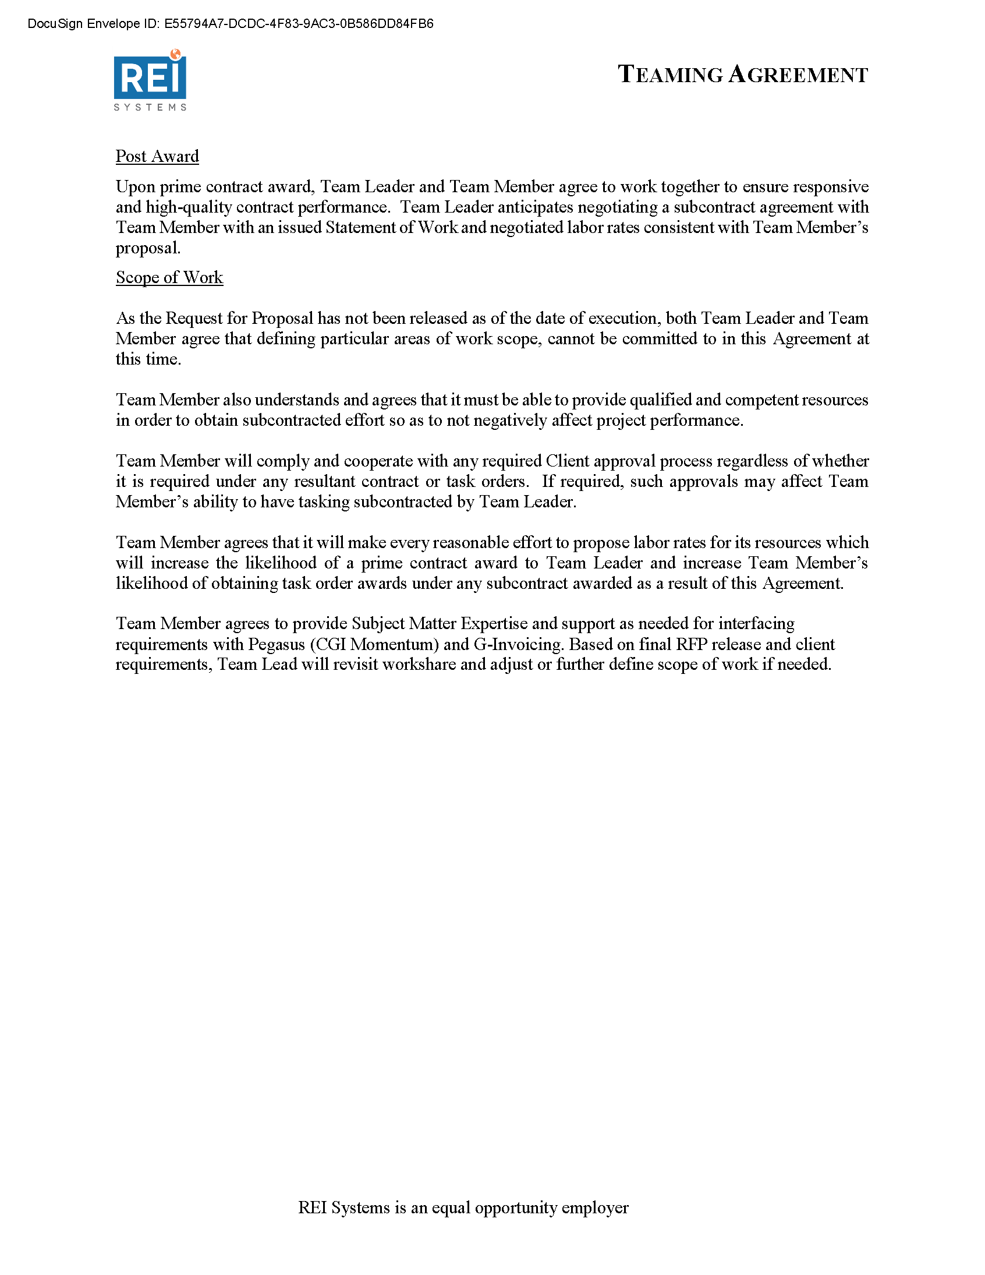

* 1. TechSur Solutions Teaming Agreement

